|  |
| --- |
|  |

Contents

Introduction 3

The Python Standard Library and Extension Modules 3

Python Implementations 3

Python Development and Versions 6

Python Resources 6

User groups and organizations 7

Visual Studio 7

Setting up 7

Debugging 31

Environments 42

Requirements.txt file 49

Python in a Container 55

Deploy Python Web Apps 55

Version Control – Git 55

Python Interpreter 85

Environment Variables 85

Options 86

Windows py Launcher 87

The PyPy Interpreter 87

Interactive Sessions 87

Development Environments 88

Running Python programs 89

Conventions and Best Practices 90

Python Language 93

Data Types 93

Variables and Other References 106

Expressions and Operators 110

Numeric Operations 114

Sequence Operations 116

Functions 142

Object Oriented Python 156

Special Methods 174

Metaclasses 187

Type Annotations 195

Exceptions 213

Modules and Packages 231

Module Loading 235

Packages 238

Distribution Utilities (distutils) and setuptools 239

Python Environments 240

Core Built-ins and Standard Library Modules 246

Strings and Things 276

Unicode 293

Regular Expressions 295

File and Text Operations 308

Text Input and Output 354

Internationalization 358

From the book – [Python in a Nutshell – 3rd Edition](https://wesmckinney.com/book/)

# Important Shortcuts

|  |  |
| --- | --- |
| General Shortcuts | |
| Command Palette | Ctrl + Shift + P |
| Extensions | Ctrl + Shift + x |
| Debugging Shortcuts | |
| Toggle Breakpoint | F9 |
| Step Over Line by Line | F10 |
| Step Into | F11 |
| Step Out | Shift + F11 |
| Start Debugging/ Run to the next breakpoint | F5 |
| Continue | F5 |
| Restart | Ctrl + Shift + F5 |
| Stop | Shift + F5 |
|  |  |
|  |  |
|  |  |
|  |  |
|  |  |
|  |  |

Good Docs: <https://docs.python.org/3/contents.html>

Errors and Exceptions: [https://docs.python.org/3/tutorial/errors.html#](https://docs.python.org/3/tutorial/errors.html)

# Introduction

Python is a well-established general-purpose programming language, first released by its creator, Guido van Rossum, in 1991. This stable and mature language is high-level, dynamic, object-oriented, and cross-platform — all very attractive characteristics.

Python runs on macOS, most current Unix variants including Linux, Windows, and, with some tweaks, mobile platforms.1

Python is an object-oriented programming language, but it lets you program in both object-oriented and procedural styles, with a touch of functional programming too, mixing and matching as your application requires. Python’s object-oriented features are conceptually similar to those of C++ but simpler to use.

In terms of language level, Python is comparable to other powerful VHLLs like JavaScript, Ruby, and Perl. The advantages of simplicity and regularity, however, remain on Python’s side.

Python is a very high-level language (VHLL). This means that it uses a higher level of abstraction, conceptually further away from the underlying machine, than classic compiled languages such as C, C++, and Rust, traditionally called “high-level languages.” Python is simpler, faster to process (both for humans and for tools), and more regular than classic high-level languages. This affords high programmer productivity, making Python a strong development tool.

In terms of language level, Python is comparable to other powerful VHLLs like JavaScript, Ruby, and Perl. The advantages of simplicity and regularity, however, remain on Python’s side. Python is an object-oriented programming language, but it lets you program in both object-oriented and procedural styles, with a touch of functional programming too, mixing and matching as your application requires. Python’s object-oriented features are conceptually similar to those of C++ but simpler to use.

## The Python Standard Library and Extension Modules

There is more to Python programming than just the language: the standard library and other extension modules are almost as important for Python use as the language itself. The Python standard library supplies many well-designed, solid Python modules for convenient reuse. It includes modules for such tasks as representing data, processing text, interacting with the operating system and filesystem, and web programming, and works on all platforms supported by Python.

Extension modules, from the standard library or elsewhere, let Python code access functionality supplied by the underlying operating system or other software components, such as graphical user interfaces (GUIs), databases, and networks. Extensions also afford great speed in computationally intensive tasks such as XML parsing and numeric array computations. Extension modules that are not coded in Python, however, do not necessarily enjoy the same cross-platform portability as pure

Python code.

You can write extension modules in lower-level languages to optimize performance for small, computationally intensive parts that you originally prototyped in Python. You can also use tools such as Cython, ctypes, and CFFI to wrap existing C/C++ libraries into Python extension modules, as covered in “Extending Python Without Python’s C API” in Chapter 25 (available online). You can also embed Python in applications coded in other languages, exposing application functionality to Python via app-specific Python extension modules.

## Python Implementations

At the time of this writing, Python has two full production-quality implementations (CPython and PyPy) and several newer, high-performance ones in somewhat earlier stages of development, such as Nuitka, RustPython, GraalVM Python, and Pyston,

which we do not cover further. In “Other Developments, Implementations, and Distributions” on page 5 we also mention some other, even earlier-stage implementations. This book primarily addresses CPython, the most widely used implementation, which we often call just “Python” for simplicity. However, the distinction between a language and its implementations is important!

### CPython

Classic Python—also known as CPython, often just called Python—is the most up-to-date, solid, and complete production-quality implementation of Python. It is the “reference implementation” of the language. CPython is a bytecode compiler, interpreter, and set of built-in and optional modules, all coded in standard C.

### PyPy

PyPy is a fast and flexible implementation of Python, coded in a subset of Python itself, able to target several lower-level languages and virtual machines using advanced techniques such as type inferencing. PyPy’s greatest strength is its ability to generate native machine code “just in time” as it runs your Python program; it has substantial advantages in execution speed. PyPy currently implements 3.8 (with 3.9 in beta).

Choosing Between CPython, PyPy, and Other Implementations

If your platform, as most are, is able to run CPython, PyPy, and several of the other Python implementations we mention, how do you choose among them? First of all, don’t choose prematurely: download and install them all. They coexist without problems, and they’re all free (some of them also offer commercial versions with added value such as tech support, but the respective free versions are fine, too). Having them all on your development machine costs only some download time and a little disk space, and lets you compare them directly. That said, here are a few general tips.

If you need a custom version of Python, or high performance for long-running programs, consider PyPy (or, if you’re OK with versions that are not quite productionready yet, one of the others we mention).

To work mostly in a traditional environment, CPython is an excellent fit. If you don’t have a strong alternative preference, start with the standard CPython reference implementation, which is most widely supported by third-party add-ons and extensions and offers the most up-to-date version.

In other words, to experiment, learn, and try things out, use CPython. To develop and deploy, your best choice depends on the extension modules you want to use and how you want to distribute your programs. CPython, by definition, supports all Python extensions; however, PyPy supports most extensions, and it can often be faster for long-running programs thanks to just-in-time compilation to machine code—to check on that, benchmark your CPython code against PyPy (and, to be sure, other implementations as well).

Nowadays, most Unix-based systems include Python—typically version 3.x for some value of x—as the “system Python.”

### Jython and IronPython

Jython, supporting Python on top of a JVM, and IronPython, supporting Python on top of .NET, are open source projects that, while offering production-level quality for the Python versions they support, appear to be “stalled” at the time of this writing, since the latest versions they support are substantially behind CPython’s. Any “stalled” open source project could, potentially, come back to life again: all it takes is one or more enthusiastic, committed developers to devote themselves to “reviving” it. As an alternative to Jython for the JVM, you might also consider GraalVM Python, mentioned earlier.

### Numba

Numba is an open source just-in-time (JIT) compiler that translates a subset of Python and NumPy. Given its strong focus on numeric processing, we mention it again in Chapter 16.

### Pyjion

Pyjion is an open source project, originally started by Microsoft, with the key goal of adding an API to CPython to manage JIT compilers. Secondary goals include offering a JIT compiler for Microsoft’s open source CLR environment (which is part of .NET) and a framework to develop JIT compilers. Pyjion does not replace CPython; rather, it is a module that you import from CPython (it currently requires 3.10) that lets you translate CPython’s bytecode, “just in time,” into machine code for several different environments. Integration of Pyjion with CPython is enabled by PEP 523; however, since building Pyjion requires several tools in addition to a C compiler (which is all it takes to build CPython), the Python Software Foundation (PSF) will likely never bundle Pyjion into the CPython releases it distributes.

### IPython

IPython enhances CPython’s interactive interpreter to make it more powerful and convenient. It allows abbreviated function call syntax, and extensible functionality known as magics introduced by the percent (%) character. It also provides shell escapes, allowing a Python variable to receive the result of a shell command. You can use a question mark to query an object’s documentation (or two question marks for extended documentation); all the standard features of the Python interactive interpreter are also available.

IPython has made particular strides in the scientific and data-focused world, and has slowly morphed (through the development of IPython Notebook, now refactored and renamed Jupyter Notebook, discussed in “Jupyter” on page 31) into

an interactive programming environment that, among snippets of code,3 also lets you embed commentary in literate programming style (including mathematical notation) and show the output of executing code, optionally with advanced graphics produced by such subsystems as matplotlib and bokeh. An example of matplotlib graphics embedded in a Jupyter Notebook is shown in the bottom half of Figure 1-1. Jupyter/IPython is one of Python’s prominent success stories.

### Anaconda and Miniconda

One of the most successful Python distributions4 in recent years is Anaconda. This open source package comes with a vast number5 of preconfigured and tested extension modules in addition to the standard library. In many cases, you might find that it contains all the necessary dependencies for your work. If your dependencies aren’t supported, you can also install modules with pip. On Unix-based systems, it installs very simply in a single directory: to activate it, just add the Anaconda bin

subdirectory at the front of your shell PATH.

Anaconda is based on a packaging technology called conda. A sister implementation, Miniconda, gives access to the same extensions but does not come with them preloaded; it instead downloads them as required, making it a better choice forcreating tailored environments. conda does not use the standard virtual environments, but contains equivalent facilities to allow separation of the dependencies for multiple projects.

### pyenv: Simple support for multiple versions

The basic purpose of pyenv is to make it easy to access as many different versions of Python as you need. It does so by installing so-called shim scripts for each executable, which dynamically compute the version required by looking at various sources of information in the following order:

1. The PYENV_VERSION environment variable (if set).

2. The .pyenv_version file in the current directory (if present)—you can set this with the pyenv local command.

3. The first .pyenv_version file found when climbing the directory tree (if one is found).

4. The version file in the pyenv installation root directory—you can set this with the pyenv global command.

pyenv installs its Python interpreters underneath its home directory (normally ~/.pyenv), and, once available, a specific interpreter can be installed as the default

Python in any project directory. Alternatively (e.g., when testing code under multiple versions), you can use scripting to change the interpreter dynamically as the script proceeds.

The pyenv install –list command shows an impressive list of over 500 supported distributions, including PyPy, Miniconda, MicroPython, and several others, plus every official CPython implementation from 2.1.3 to (at the time of writing) 3.11.0rc1.

### Transcrypt: Convert your Python to JavaScript

Many attempts have been made to make Python into a browser-based language, but JavaScript’s hold has been tenacious. The Transcrypt system is a pip-installable Python package to convert Python code (currently, up to version 3.9) into browserexecutable JavaScript. You have full access to the browser’s DOM, allowing your code to dynamically manipulate window content and use JavaScript libraries. Although it creates minified code, Transcrypt provides full sourcemaps that allow you to debug with reference to the Python source rather than the generated Java‐ Script. You can write browser event handlers in Python, mixing it freely with HTML and JavaScript. Python may never replace JavaScript as the embedded browser language, but Transcrypt means you might no longer need to worry about that. Another very active project that lets you script your web pages with Python (up to 3.10) is Brython, and there are others yet: Skulpt, not quite up to Python 3 yet but moving in that direction; PyPy.js, ditto; Pyodide, currently supporting Python 3.10 and many scientific extensions, and centered on Wasm; and, most recently, Anaconda’s PyScript, built on top of Pyodide. We describe several of these projects in more detail in “Running Python in the Browser” on page 30.

### Licensing and Price Issues

CPython is covered by the Python Software Foundation License Version 2, which is GNU Public License (GPL) compatible but lets you use Python for any proprietary, free, or other open source software development, similar to BSD/Apache/MIT licenses.

Licenses for PyPy and other implementations are similarly liberal. Anything you download from the main Python and PyPy sites won’t cost you a penny. Further these licenses do not constrain what licensing and pricing conditions you can use for software you develop using the tools, libraries, and documentation they cover. However, not everything Python-related is free from licensing costs or hassles. Many third-party Python sources, tools, and extension modules that you can freely download have liberal licenses, similar to that of Python itself. Others are covered by the GPL or Lesser GPL (LGPL), constraining the licensing conditions you can place on derived works. Some commercially developed modules and tools may require you to pay a fee, either unconditionally or if you use them for profit.6 There is no substitute for careful examination of licensing conditions and prices. Before you invest time and energy into any software tool or component, check that you can live with its license. Often, especially in a corporate environment, such legal matters may involve consulting lawyers. Modules and tools covered in this book, unless we explicitly say otherwise, can be taken to be, at the time of this writing, freely downloadable, open source, and covered by a liberal license akin to Python’s. However, we claim no legal expertise, and licenses can change over time, so double-checking is always prudent.

## Python Development and Versions

Python is developed, maintained, and released by a team of core developers led by Guido van Rossum, Python’s inventor, architect, and now “ex” Benevolent Dictator for Life (BDFL). This title meant that Guido had the final say on what became part

of the Python language and standard library. Once Guido decided to retire as BDFL, his decision-making role was taken over by a small “Steering Council,” elected for yearly terms by PSF members.

Python’s intellectual property is vested in the PSF, a nonprofit corporation devoted to promoting Python, described in “Python Software Foundation” on page 13. Many PSF Fellows and members have commit privileges to Python’s reference source repositories, as documented in the “Python Developer’s Guide”, and most Python committers are members or Fellows of the PSF.

Proposed changes to Python are detailed in public docs called Python Enhancement Proposals (PEPs). PEPs are debated by Python developers and the wider Python community, and finally approved or rejected by the Steering Council. (The Steering

Council may take debates and preliminary votes into account but are not bound by them.) Hundreds of people contribute to Python development through PEPs, discussion, bug reports, and patches to Python sources, libraries, and docs.

The Python core team releases minor versions of Python (3.x for growing values of x), also known as “feature releases,” currently at a pace of once a year.

Each minor release (as opposed to bug-fix microreleases) adds features that make Python more powerful, but also takes care to maintain backward compatibility. Python 3.0, which was allowed to break backward compatibility in order to remove redundant “legacy” features and simplify the language, was first released in December 2008. Python 3.11 (the most recent stable version at the time of publication) was first released in October 2022.

Each minor release 3.x is first made available in alpha releases, tagged as 3.xa0, 3.xa1, and so on. After the alphas comes at least one beta release, 3.xb1, and after the betas, at least one release candidate, 3.xrc1. By the time the final release of 3.x (3.x.0) comes out, it is solid, reliable, and tested on all major platforms. Any Python programmer can help ensure this by downloading alphas, betas, and release candidates, trying them out, and filing bug reports for any problems that emerge.

Once a minor release is out, part of the attention of the core team switches to the next minor release. However, a minor release normally gets successive point releases (i.e., 3.x.1, 3.x.2, and so on), one every two months, that add no functionality but can fix errors, address security issues, port Python to new platforms, enhance documentation, and add tools and (100% backward compatible!) optimizations. Python’s backward compatibility is fairly good within major releases. You can find code and documentation online for all old releases of Python, and the Appendix contains a summary list of changes in each of the releases covered in this book.

## Python Resources

The richest Python resource is the web: start at Python’s home page, which is full of links to explore

<https://www.python.org/>

Documentation

Both CPython and PyPy come with good documentation. You can read CPython’s manuals online (we often refer to these as “[the online docs](https://docs.python.org/3/)”), and various downloadable formats suitable for offline viewing, searching, and printing are also available.

The Python [documentation page](https://www.python.org/doc/) contains additional pointers to a large variety of other documents. There is also a documentation page for PyPy, and you can find online FAQs for both [Python](https://docs.python.org/3/faq/) and [PyPy](https://doc.pypy.org/en/latest/faq.html).

## User groups and organizations

The Python community has local user groups on every continent except Antarctica8— more than 1,600 of them, according to the list on the [LocalUserGroups wiki](https://wiki.python.org/moin/LocalUserGroups). There are Python [meetups](https://www.meetup.com/topics/python/) around the world. [PyLadies](https://pyladies.com/) is an international mentorship group, with local chapters, to promote women in Python; anyone with an interest in Python is welcome. [NumFOCUS](https://numfocus.org/), a nonprofit charity promoting open practices in research, data, and scientific computing, sponsors the PyData conference and other projects.

Mailing lists

The [Community Mailing Lists](https://www.python.org/community/lists/) page has links to several Python-related mailing lists (and some Usenet groups, for those of us old enough to remember Usenet!). Alternatively, search [Mailman](https://mail.python.org/archives/) to find active mailing lists covering a wide variety of interests. Python-related official announcements are posted to the [python-announce list](https://mail.python.org/mailman3/lists/python-announce-list.python.org/). To ask for help with specific problems, write to help@python.org. For help learning or teaching Python, write to tutor@python.org, or, better yet, join the list. For a useful weekly roundup of Python-related news and articles, subscribe to [Python Weekly](https://www.pythonweekly.com/). You can also follow Python Weekly at @python_discussions@mastodon. social.

Social media

For an [RSS feed](https://en.wikipedia.org/wiki/RSS) of Python-related blogs, see [Planet Python](http://planetpython.org/). If you’re interested in tracking language developments, check out [discuss.python.org](http://discuss.python.org/)—it sends useful summaries if you don’t visit regularly. On Twitter, follow @ThePSF. [Libera.Chat](https://libera.chat/) on [IRC](https://en.wikipedia.org/wiki/IRC) hosts several Python-related channels: the main one is #python. LinkedIn has many Python groups, including [Python Web Developers](https://www.linkedin.com/uas/login?session_redirect=https%3A%2F%2Fwww.linkedin.com%2Fgroups%2F101591). On Slack, join the [PySlackers](https://pyslackers.com/web) community. On Discord, check out Python Discord. Technical questions and answers about Python programming can also be found and followed on [Stack Overflow](http://stackoverflow.com/) under a variety of tags, including [python]. Python is currently the [most active](https://stackoverflow.com/questions/tagged/python) programming language on Stack Overflow, and many useful answers with illuminating discussions can be found there. If you like podcasts, check out Python podcasts, such as [Python Bytes](https://pythonbytes.fm/).

# Visual Studio

## Setting up

First screen ( check shortcuts and things you can do )

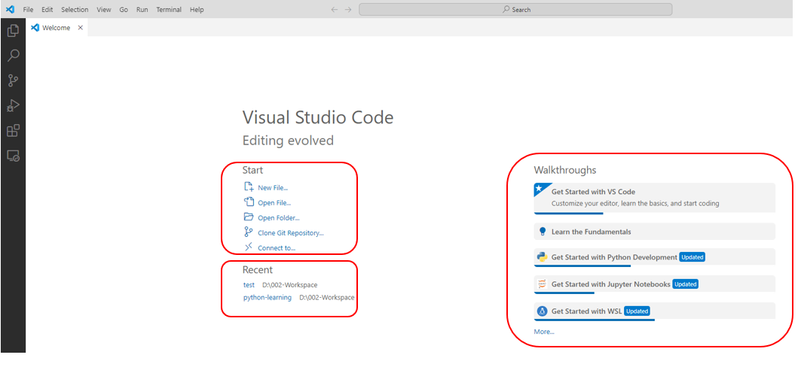

If your platform is popular and current, you’ll easily find prebuilt, packaged binary versions of Python ready for installation. Binary packages are typically selfinstalling, either directly as executable programs or via appropriate system tools, such as the Red Hat Package Manager (RPM) on some versions of Linux, and the Microsoft Installer (MSI) on Windows. After downloading a package, install it by running the program and choosing installation parameters, such as the directory where Python is to be installed. In Windows, select the option labeled “Add Python 3.10 to PATH” to have the installer add the install location into the PATH in order to easily use Python at a command prompt (see “The python Program” on page 21).

You can get the “official” binaries from the [Downloads page](https://www.python.org/downloads/) on the Python website: click the button labeled “Download Python 3.11.x” to download the most recent binary suitable for your browser’s platform.

Many third parties supply free binary Python installers for other platforms. Installers exist for Linux distributions, whether your distribution is [RPM-based](https://rpmfind.net/) (Red Hat, Fedora, Mandriva, SUSE, etc.) or [Debian-based](https://www.debian.org/) (including Ubuntu, probably the most popular Linux distribution at the time of this writing). The [Other Platforms page](https://www.python.org/download/other/) provides links to binary distributions for now somewhat exotic platforms such as AIX, OS/2, RISC OS, IBM AS/400, Solaris, HP-UX, and so forth (often not the latest Python versions, given the now “quaint” nature of such platforms), as well as one for the very current [iOS platform](http://omz-software.com/pythonista/index.html), the operating system of the popular iPhone and iPad devices.

Step 1: Select Version to Install Python

Visit the official page for Python <https://www.python.org/downloads/> on the Windows operating system. Locate a reliable version of Python 3, preferably version 3.10.11, which was used in testing this tutorial. Choose the correct link for your device from the options provided: either Windows installer (64-bit) or Windows installer (32-bit) and proceed to download the executable file.

Step 2: Downloading the Python Installer

Once you have downloaded the installer, open the .exe file, such as python-3.10.11-amd64.exe, by double-clicking it to launch the Python installer. Choose the option to Install the launcher for all users by checking the corresponding checkbox, so that all users of the computer can access the Python launcher application.Enable users to run Python from the command line by checking the Add python.exe to PATH checkbox.

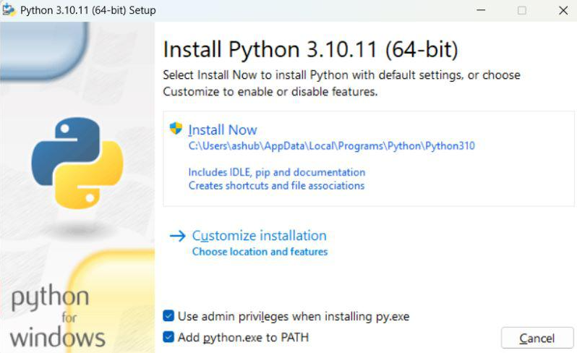

After Clicking the Install Now Button the setup will start installing Python on your Windows system.

Step 3: Running the Executable Installer

After completing the setup. Python will be installed on your Windows system. You will see a successful message.

Step 4: Verify the Python Installation in Windows

Close the window after successful installation of Python. You can check if the installation of Python was successful by using either the command line or the Integrated Development Environment (IDLE), which you may have installed. To access the command line, click on the Start menu and type “cmd” in the search bar. Then click on Command Prompt.

python –version

You can also check the version of Python by opening the IDLE application. Go to Start and enter IDLE in the search bar and then click the IDLE app, for example, IDLE (Python 3.10.11 64-bit). If you can see the Python IDLE window then you are successfully able to download and installed Python on Windows.

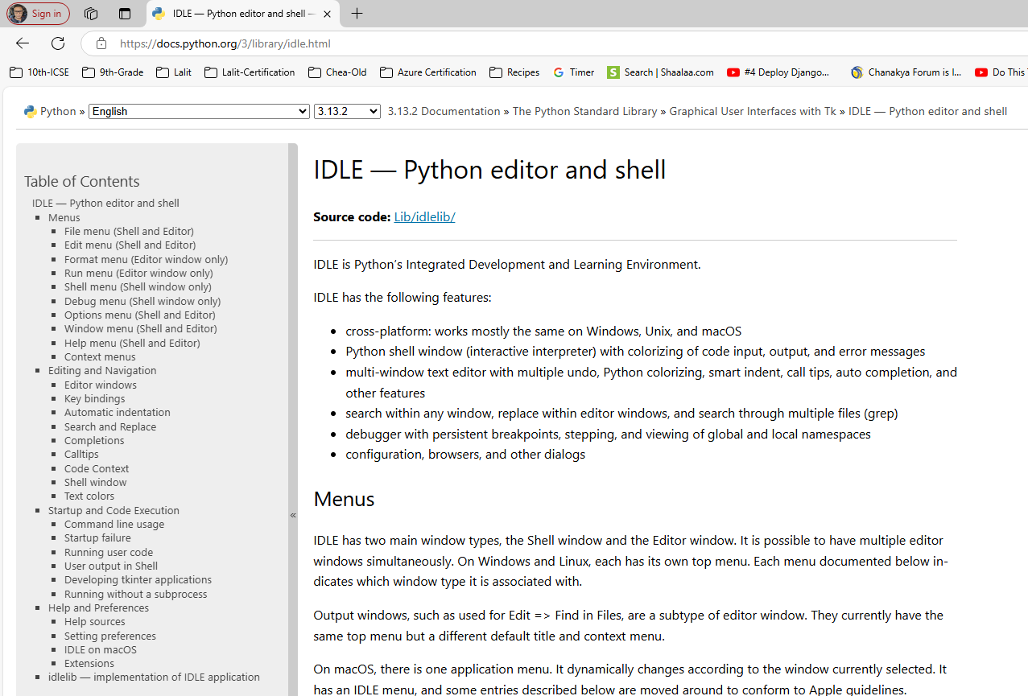

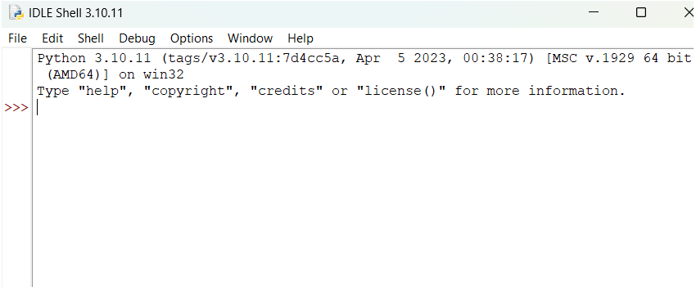

<https://code.visualstudio.com/docs/python/python-tutorial>

<https://code.visualstudio.com/docs/introvideos/basics>

By using the Python extension, you turn VS Code into a great, lightweight Python editor.

Install a Python interpreter

Along with the Python extension, you need to install a Python interpreter. Which interpreter you use is dependent on your specific needs, but some guidance is provided below.

Windows

Install Python from python.org. Use the Download Python button that appears first on the page to download the latest version.

Note: If you don't have admin access, an additional option for installing Python on Windows is to use the Microsoft Store. The Microsoft Store provides installs of supported Python versions.

For additional information about using Python on Windows, see Using Python on Windows at Python.org

Start VS Code in a workspace folder

By starting VS Code in a folder, that folder becomes your "workspace".

Using a command prompt or terminal, create an empty folder called "hello", navigate into it, and open VS Code (code) in that folder (.) by entering the following commands:

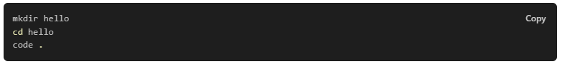

mkdir hello

cd hello

code .

Alternately, you can create a folder through the operating system UI, then use VS Code's File > Open Folder to open the project folder.

### Create a virtual environment

A best practice among Python developers is to use a project-specific virtual environment. Once you activate that environment, any packages you then install are isolated from other environments, including the global interpreter environment, reducing many complications that can arise from conflicting package versions. You can create non-global environments in VS Code using Venv or Anaconda with Python: Create Environment.

Open the Command Palette (Ctrl+Shift+P) or press F1, start typing the Python: Create Environment command to search, and then select the command.

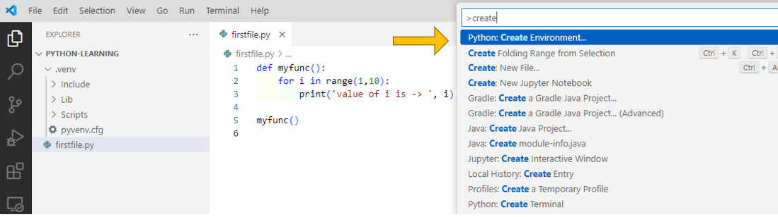

The command presents a list of environment types, Venv or Conda. For this example, select Venv.

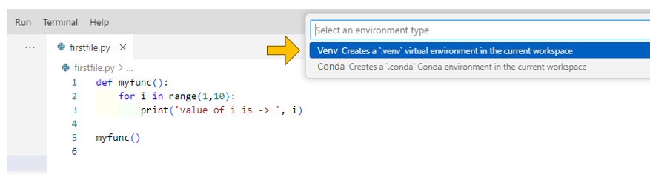

We can see now that the virtual environment is created.

If the command terminal gives a error for powershell – open the command palette and set the default terminal to command ( on windows ) and then it should run properly.

The error message seems to tell it all. You're probably pointing to bash.exe in your settings file but you don't have it installed. Open the command palette (F1) and run the select default shell command and use cmd or powershell (or install a WSL distro).

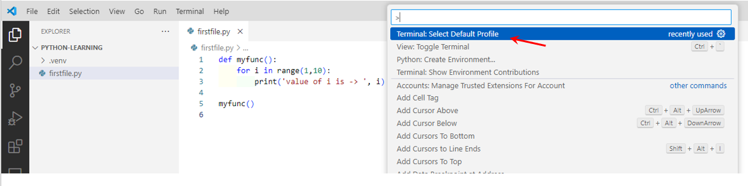

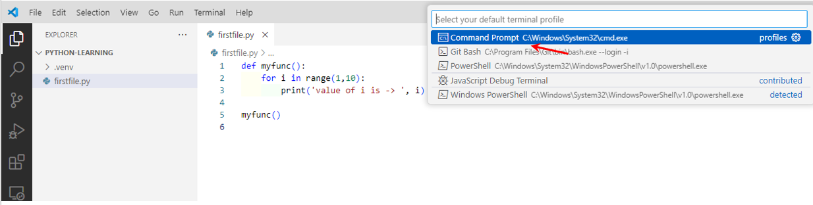

Now run the python file and it should run

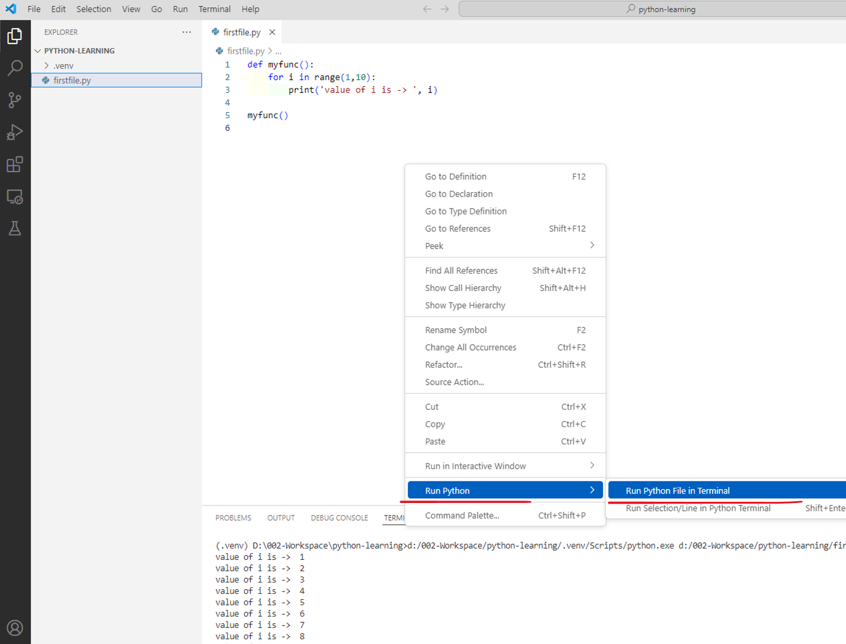

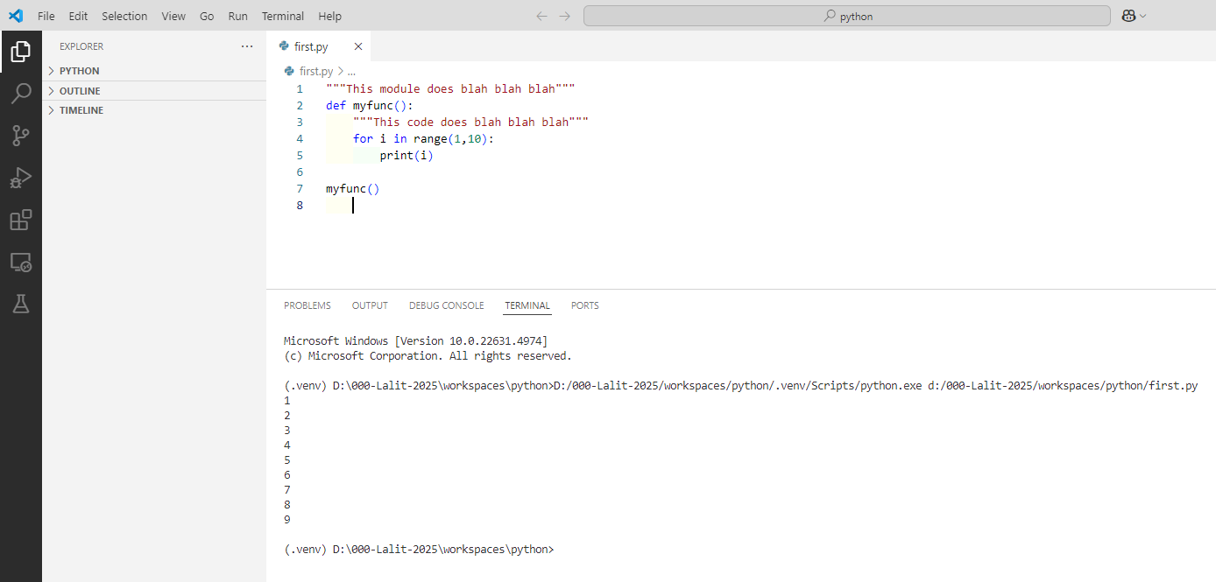

To run selective lines

Select one or more lines, then press Shift+Enter or right-click and select Run Selection/Line in Python Terminal. This command is convenient for testing just a part of a file.

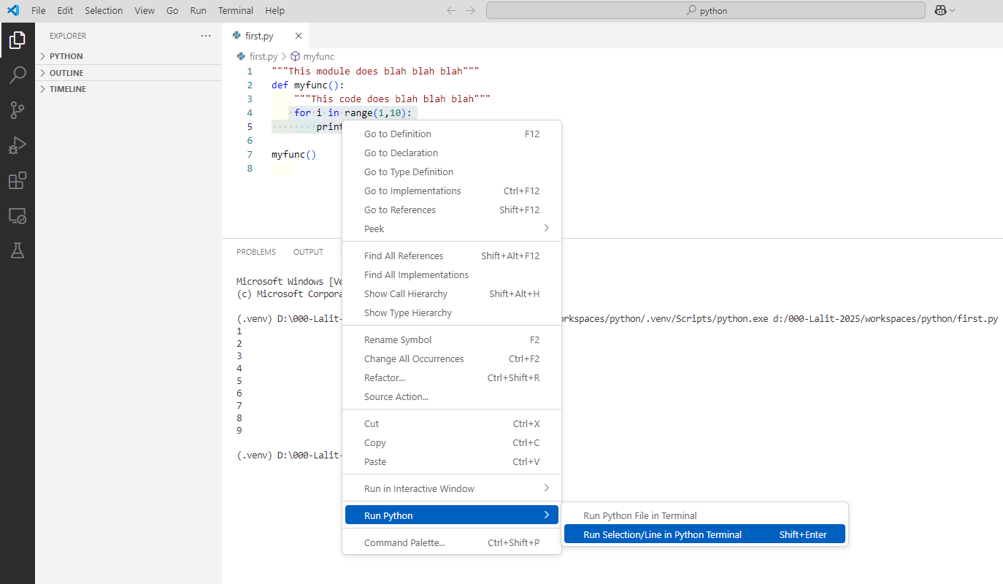

REPL

From the Command Palette (Ctrl+Shift+P), select the Python: Start REPL command to open a REPL terminal for the currently selected Python interpreter. In the REPL, you can then enter and run lines of code one at a time.

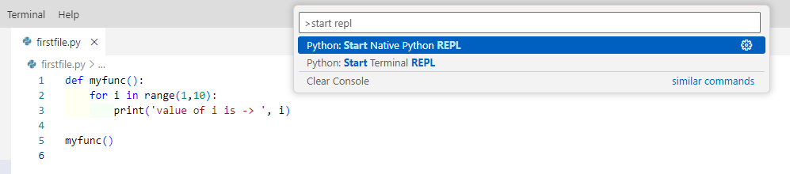

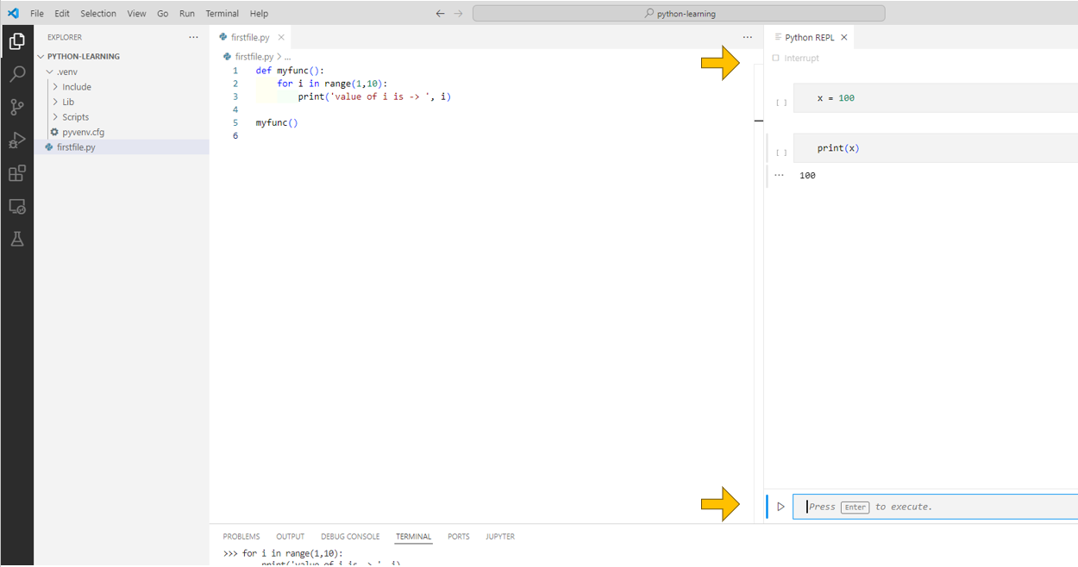

### Navigation

Oh hovering on the code

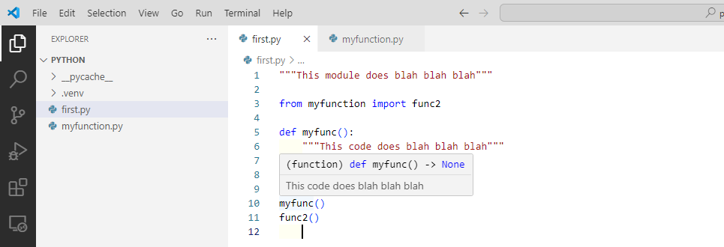

While editing, you can right-click different identifiers to take advantage of several convenient commands

Go to Definition (F12) jumps from your code into the code that defines an object. This command is helpful when you're working with libraries. For example when I click on F12 on the highlighted line in left screen below

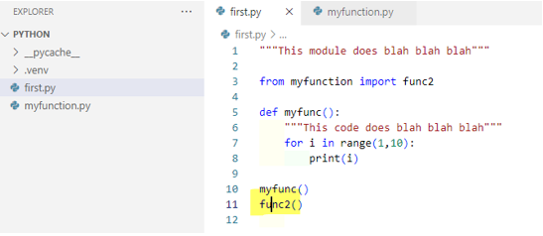

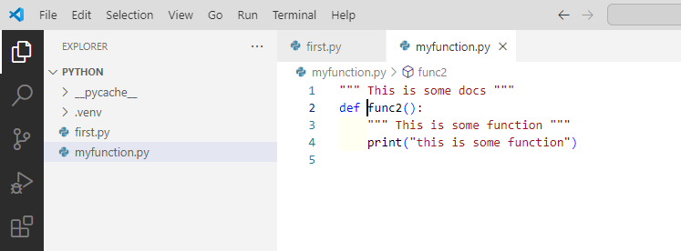

Peek Definition (Alt+F12), is similar, but displays the definition directly in the editor (making space in the editor window to avoid obscuring any code). Press Escape to close the Peek window or use the x in the upper right corner.

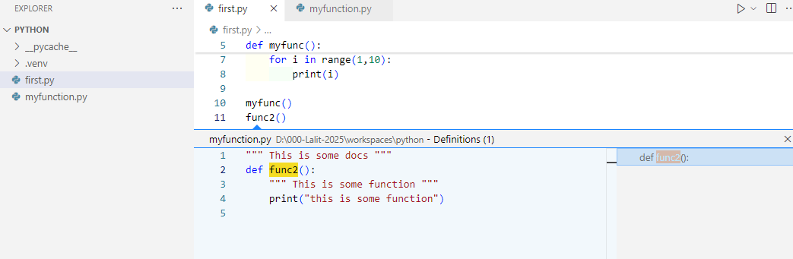

Press escape to come out of this view

Go to Declaration jumps to the point at which the variable or other object is declared in your code.

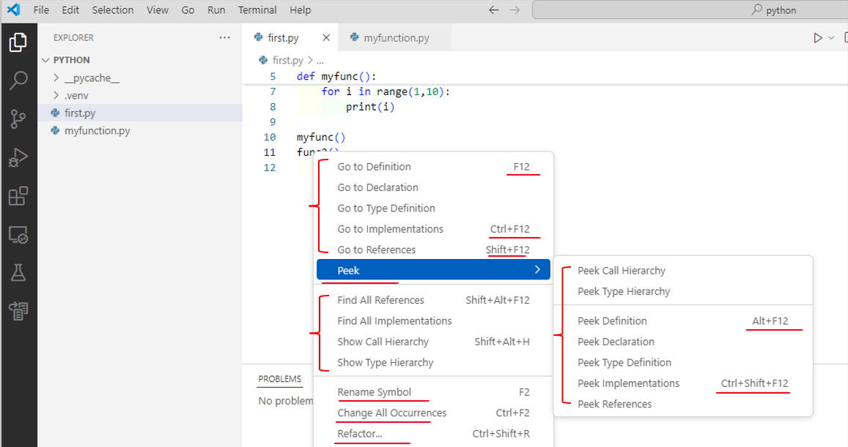

Peek Declaration is similar, but displays the declaration directly in the editor. Again, use Escape or the x in the upper right corner to close the Peek window

### Quick Fixes

Extensions

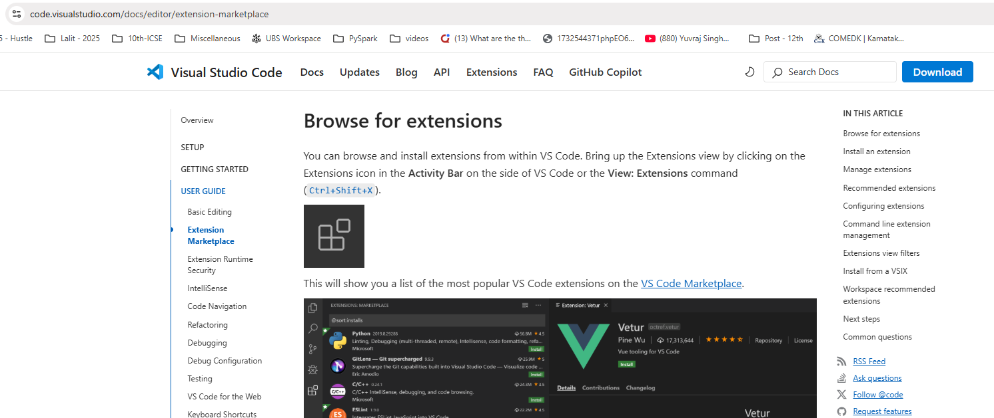

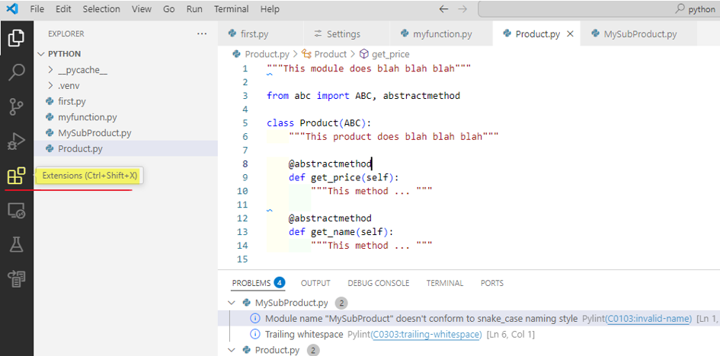

Ctrl + Shift + P to go to the command palette

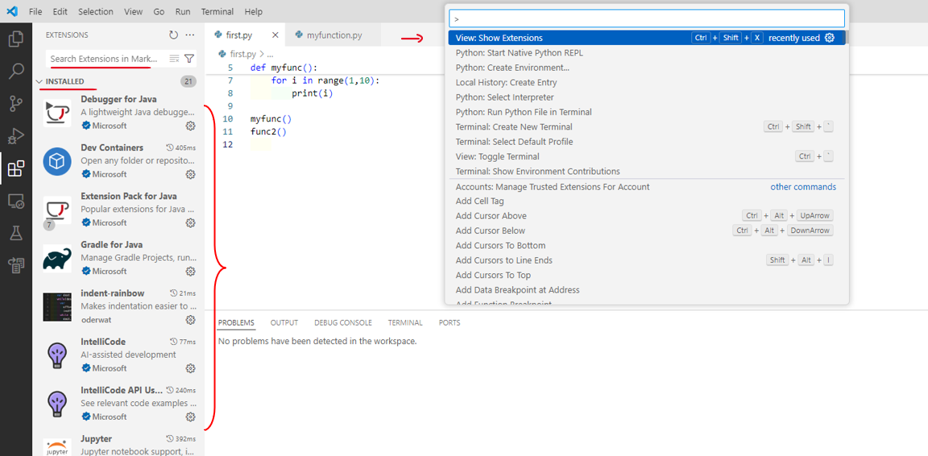

Pylance is already installed here.

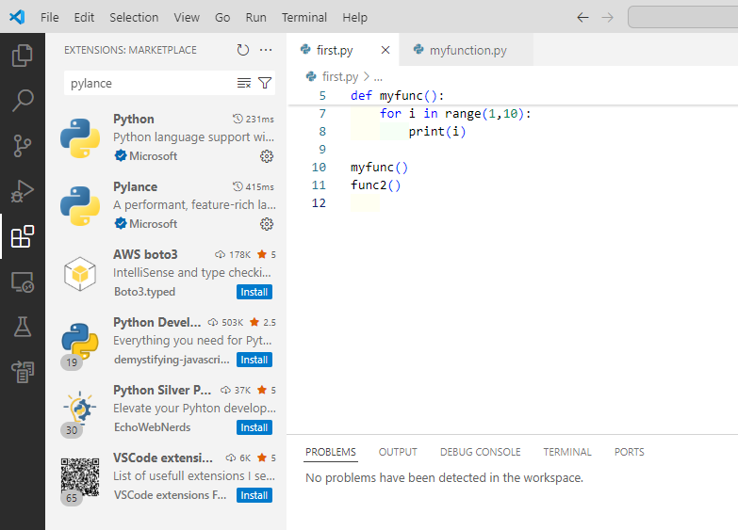

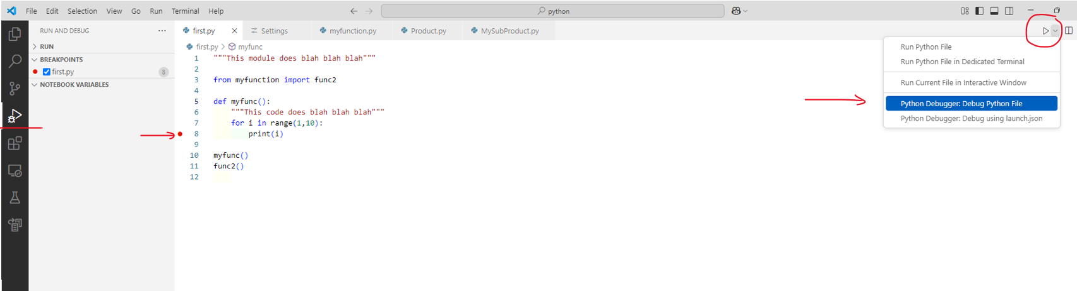

Add import

When using Pylance, the add import Quick Fix enables you to quickly complete import statements for modules that are installed in your environment. As you start typing a package name in the editor, a Code Action is available to automatically complete the line of source code. Hover over the text (marked with a squiggle) and select the Code Action light bulb. You can then select from the list of potential imports.

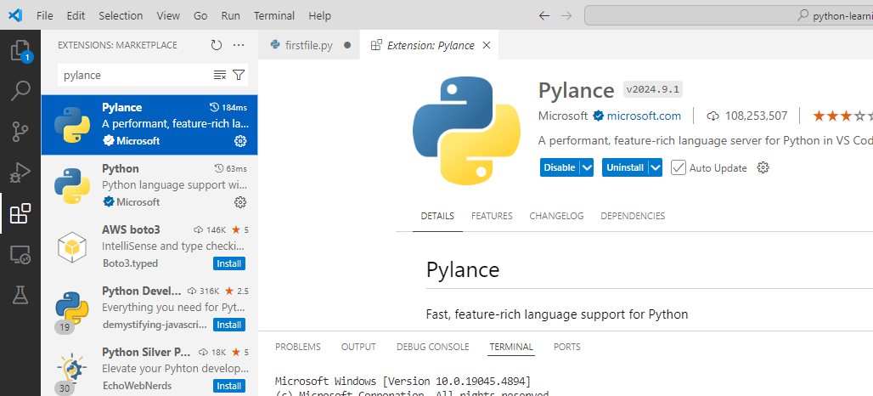

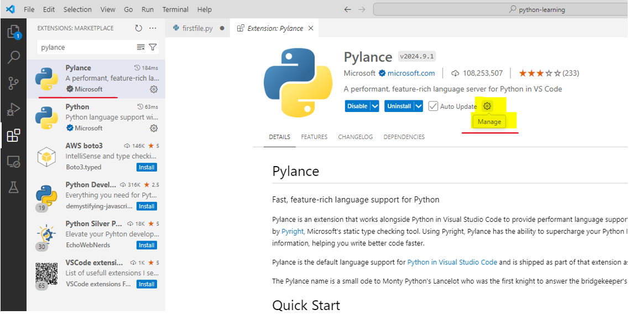

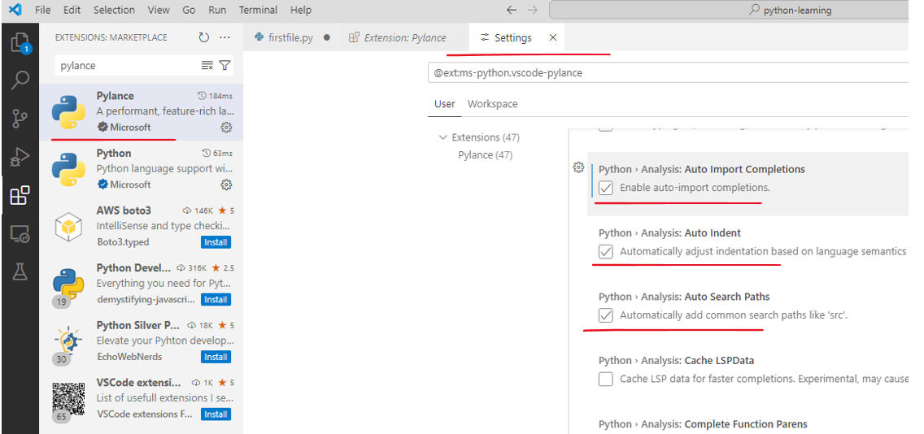

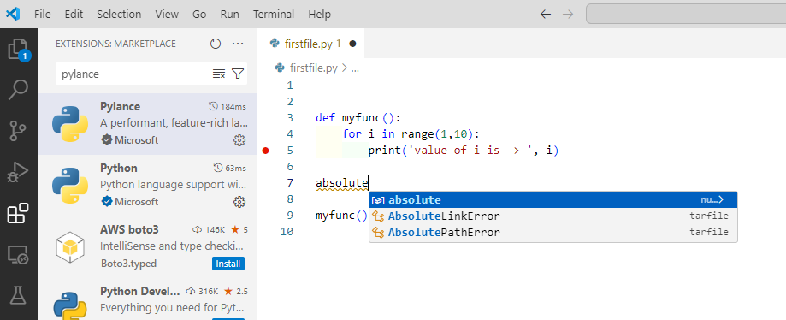

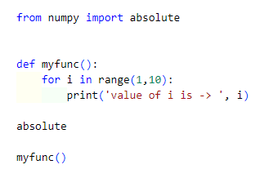

Auto completed

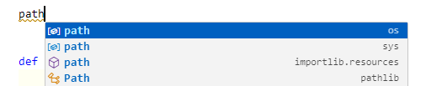

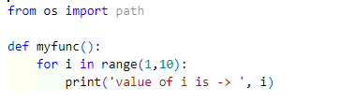

This Code Action also recognizes some of the popular abbreviations for the following common Python packages: numpy as np, tensorflow as tf, pandas as pd, matplotlib.pyplot as plt, matplotlib as mpl, math as m, scipi.io as spio, and scipy as sp, panel as pn, and holoviews as hv.

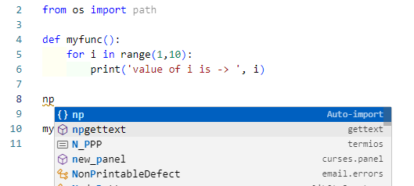

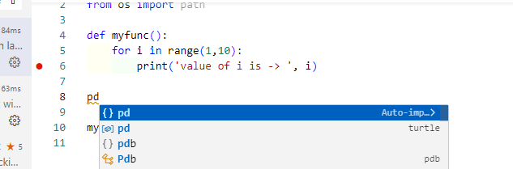

Autocompleted as below ( as long as you have pandas installed already in your virtual environment )

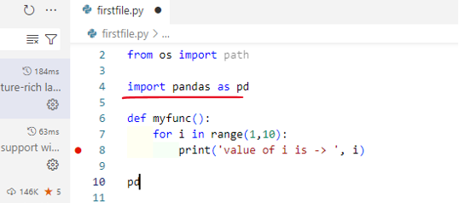

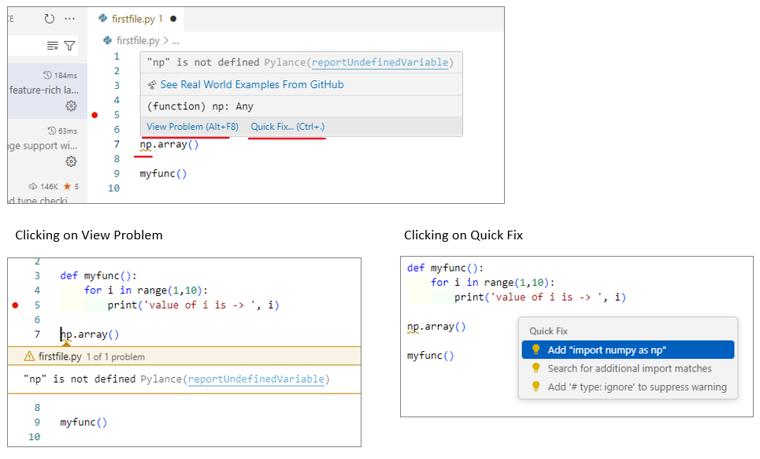

Search for additional import matches

By default, the add import Quick Fix only shows 3 high-confidence import options. If they don't list what you are looking for, you can use the Pylance Search for additional import matches Quick Fix for missing import errors. This Quick Fix displays a quick pick menu that enables you to search for import options that prefix-match the missing import symbol.

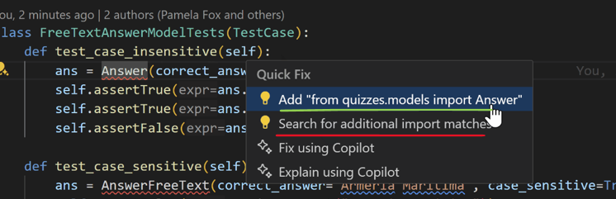

Also supports change spellings etc

### Install and use packages

Let's build upon the previous example by using packages.

In Python, packages are how you obtain any number of useful code libraries, typically from PyPI, that provide additional functionality to your program. For this example, you use the numpy package to generate a random number.

Return to the Explorer view (the top-most icon on the left side, which shows files), open hello.py, and paste in the following source code:

import numpy as np

msg = "Roll a dice"

print(msg)

print(np.random.randint(1,9))

Tip: If you enter the above code by hand, you may find that auto-completions change the names after the as keywords when you press Enter at the end of a line. To avoid this, type a space, then Enter.

Next, run the file in the debugger using the "Python: Current file" configuration as described in the last section.

You should see the message, "ModuleNotFoundError: No module named 'numpy'". This message indicates that the required package isn't available in your interpreter. If you're using an Anaconda distribution or have previously installed the numpy package you may not see this message.

To install the numpy package, stop the debugger and use the Command Palette to run Terminal: Create New Terminal (Ctrl+Shift+`). This command opens a command prompt for your selected interpreter.

To install the required packages in your virtual environment, enter the following commands as appropriate for your operating system:

Install the packages

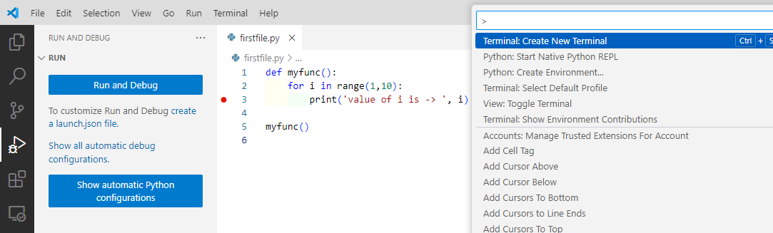

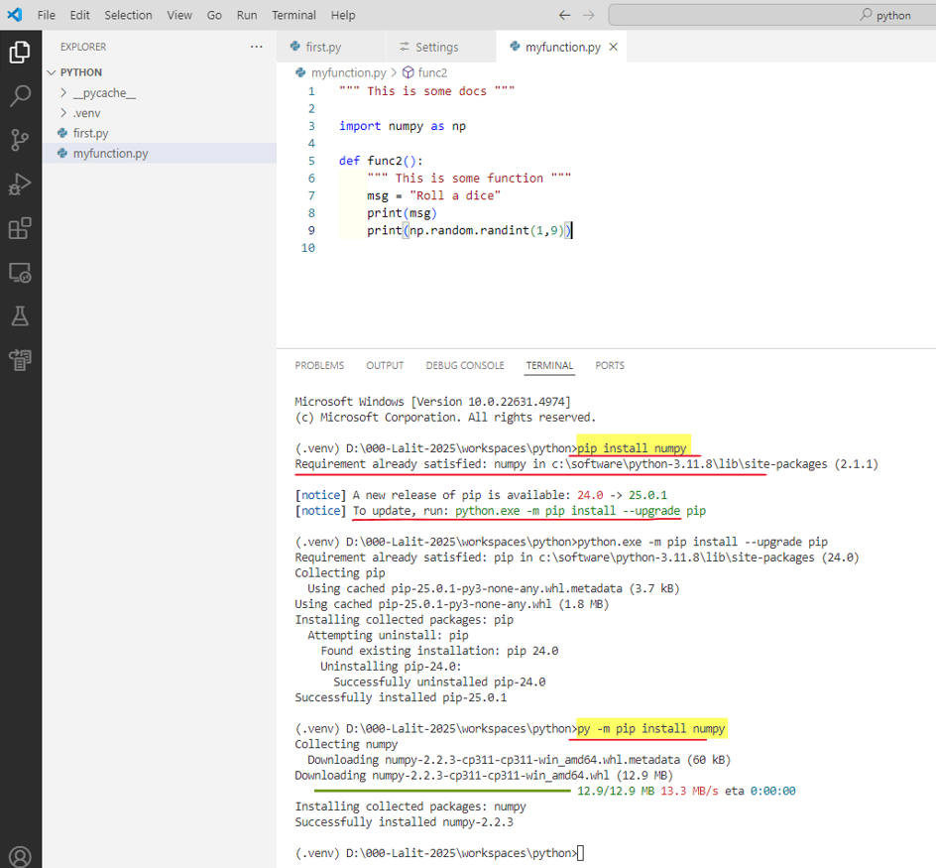

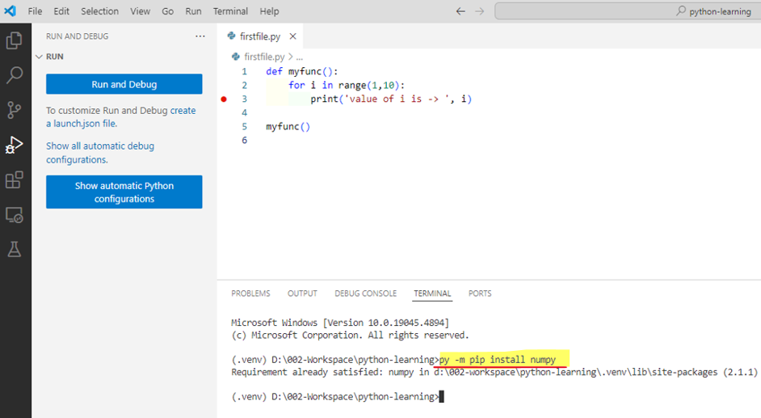

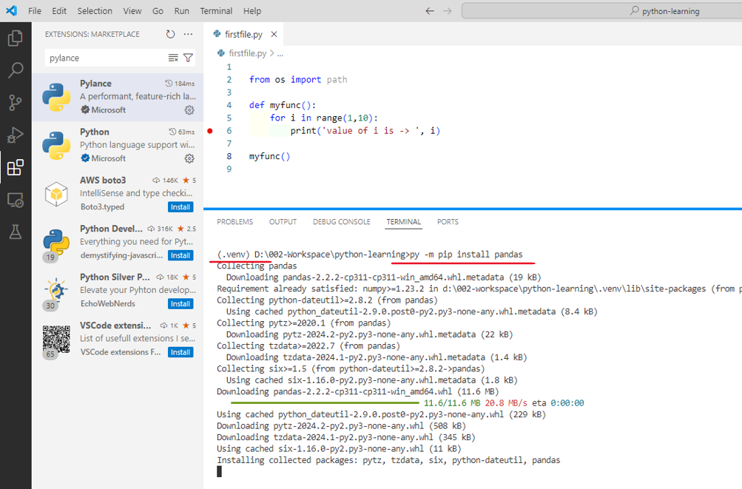

>>> py -m pip install numpy

>>> py -m pip install pandas

Now, rerun the program, with or without the debugger, to view the output!

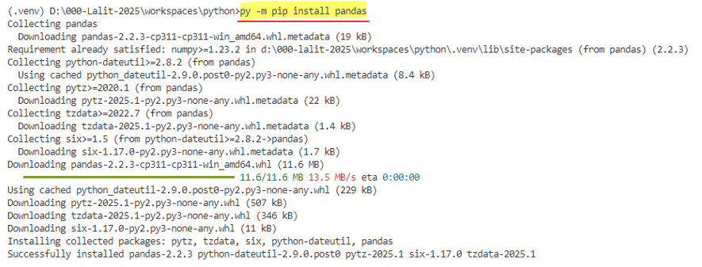

### Extensions

#### Autocomplete and Intellisense

IntelliSense is a general term for code editing features that relate to code completion.

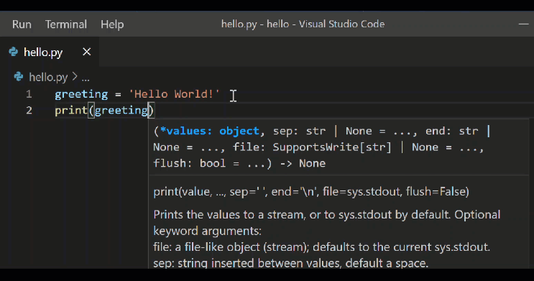

Autocomplete and IntelliSense are provided for all files within the current working folder. They're also available for Python packages that are installed in standard locations.

Pylance is the default language server for Python in VS Code, and is installed alongside the Python extension to provide IntelliSense features.

Pylance is based on Microsoft’s Pyright static type checking tool, leveraging type stubs (.pyi files) and lazy type inferencing to provide a highly-performant development experience.

For more on IntelliSense generally, see [IntelliSense](https://code.visualstudio.com/docs/editor/intellisense).

Tip: Check out the [IntelliCode extension for VS Code](https://go.microsoft.com/fwlink/?linkid=2006060). IntelliCode provides a set of AI-assisted capabilities for IntelliSense in Python, such as inferring the most relevant auto-completions based on the current code context. For more information, see the [IntelliCode for VS Code FAQ](https://learn.microsoft.com/visualstudio/intellicode/intellicode-visual-studio-code)

Customize IntelliSense behavior

Enabling the full set of IntelliSense features by default could end up making your development experience feel slower, so the Python extension enables a minimum set of features that allow you to be productive while still having a performant experience. However, you can customize the behavior of the analysis engine to your liking through multiple settings.

Enable Auto Imports

Pylance offers auto import suggestions for modules in your workspace and for packages you installed in your environment. As you type in the editor, you might get completion suggestions. When you accept the suggestion, auto import automatically adds the corresponding import statement to your file.

You can enable auto imports by setting python.analysis.autoImportCompletions to true in your settings. By default, auto imports are disabled.

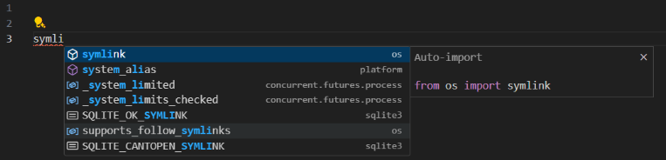

Enable IntelliSense for custom package locations

To enable IntelliSense for packages that are installed in non-standard locations, add those locations to the python.analysis.extraPaths collection in your settings.json file (the default collection is empty). For example, you might have Google App Engine installed in custom locations, specified in app.yaml if you use Flask. In this case, you'd specify those locations as follows:

Windows:

"python.analysis.extraPaths": [

"C:/Program Files (x86)/Google/google_appengine",

"C:/Program Files (x86)/Google/google_appengine/lib/flask-0.12"]

macOS/Linux:

"python.analysis.extraPaths": [

"~/.local/lib/Google/google_appengine",

"~/.local/lib/Google/google_appengine/lib/flask-0.12" ]

#### Linting Python in Visual Studio Code

Linting highlights semantic and stylistic problems in your Python source code, which often helps you identify and correct subtle programming errors or coding practices that can lead to errors. For example, linting can detect the use of an undefined variable, calls to undefined functions, missing parentheses, and even more subtle issues such as attempting to redefine built-in types or functions. Linting is distinct from Formatting because linting analyzes how the code runs and detects errors, whereas formatting only restructures how code appears.

Note: Syntax error detection is enabled by default in the Python extension's Language Server. To learn how you can configure the Language Server, see Language Server Settings. This document covers how you can enable linting for additional code detection, including stylistic checks.

Choose a linter

Search the VS Code Marketplace for the linter extension of your choice. You can use multiple linters at the same time if you'd like.

Microsoft publishes the following linting extensions for Python:

Linter Extension

Pylint <https://marketplace.visualstudio.com/items?itemName=ms-python.pylint>

flake8 <https://marketplace.visualstudio.com/items?itemName=ms-python.flake8>

mypy <https://marketplace.visualstudio.com/items?itemName=ms-python.mypy-type-checker>

Linting extensions offered by the community:

Linter Extension

Ruff <https://marketplace.visualstudio.com/items?itemName=charliermarsh.ruff>

mypy <https://marketplace.visualstudio.com/items?itemName=matangover.mypy>

Note: If you don't find your preferred linter in the table above or in the Marketplace, you can add support for it via an extension. You can use the Python Extension Template to integrate new Python tools into VS Code.

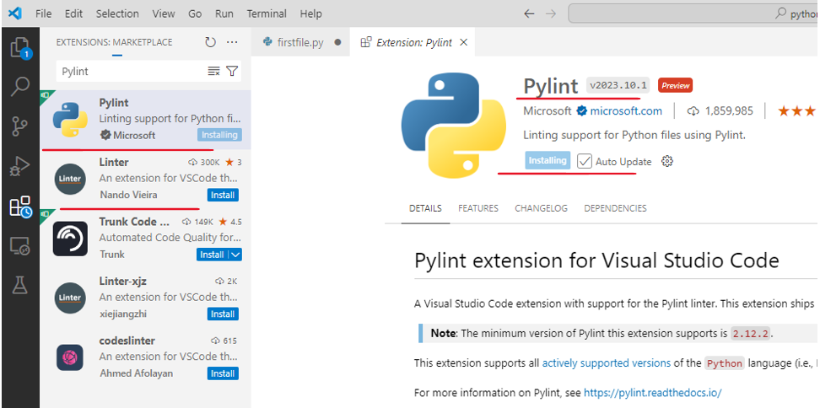

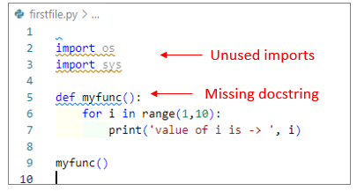

After fixing

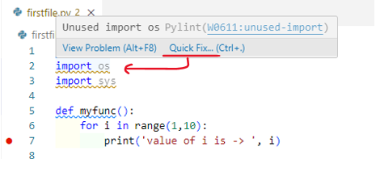

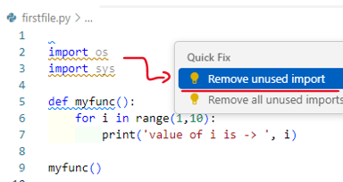

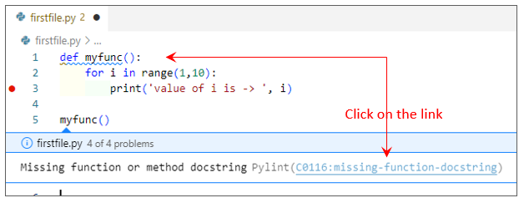

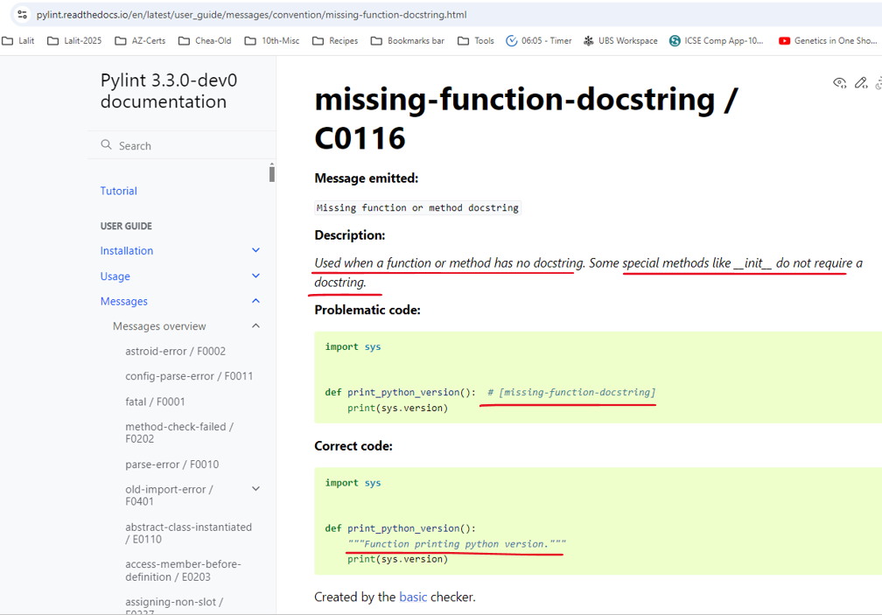

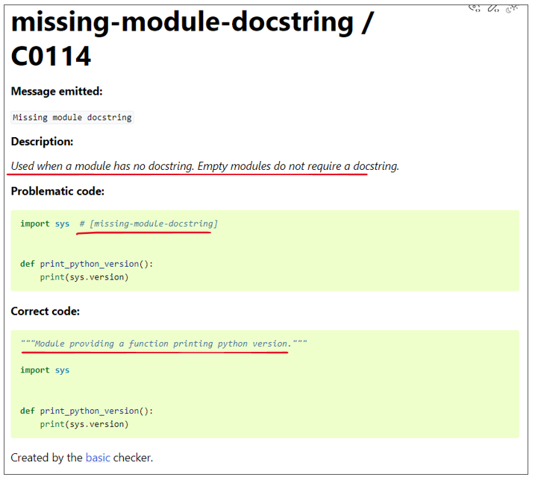

After all the fixes are done

test.py

"""This is my module that . . . """

def myfunc():

"""This is some function that does . . . """

for i in range(1,10):

print('value of i is -> ', i)

myfunc()

General Settings

You can refer to each linter extension's README for more details on the supported settings. The following settings are supported by most linter extensions:

|  |  |  |
| --- | --- | --- |
| Setting | Default | Description |
| args | [] | Arguments to be passed to the linter. Note: The officially supported linters run on individual open files. Make sure your configuration applies in that scenario. |
| importStrategy | useBundled | When set to useBundled, the extension uses the version of the tool that it ships with. When set to fromEnvironment, it attempts to load from your selected Python environment first, otherwise it falls back to the bundled version. |
| path | "" | Path to the linter binary to be used for linting. Note: Using this option may slow down formatting. |
| Interpreter | [] | When set to a path to a Python executable, the extension will use that to launch the linting server and its subprocesses. |
| showNotifications | off | Controls when notifications are displayed by the extension. Supported values are off, always, onError, and onWarning. |

Disable linting

Linters, if installed, are enabled by default. You can disable them by disabling the extension per workspace

Run linting

Linting will automatically run when a Python file is opened or saved.

Errors and warnings are shown in the Problems panel (Ctrl+Shift+M) for open files, and are also highlighted in the code editor. Hovering over an underlined issue displays the details:

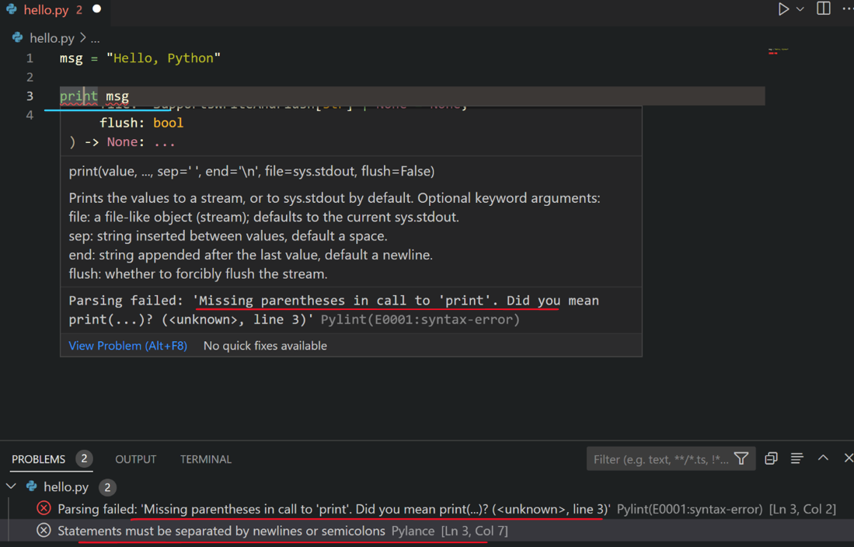

Code Actions

Some linters may offer Code Actions that can help address reported problems. You can refer to the Feature Contributions section under your preferred linter extension to find out what Code Actions it offers.

Logging

Logs for linters are available in the Output panel (Ctrl+Shift+U) when you select <linter name> from the drop down menu.

You can change the log level for a linter extension by running the Developer: Set Log Level command from the Command Palette (Ctrl+Shift+P). Select the extension from the Extension Logs group, and then select the desired log level.

Severity

Linters report issues with some predefined severity. This can be changed using severity setting for the linter. Refer to each linter extension's README for more details on the supported values and severity levels.

#### Refactorings

The Python extension adds the following refactoring functionalities via the Pylance extension: Extract Variable, Extract Method, Rename Module, Move Symbol and Implement All Inherited Abstract Classes. It also supports extensions that implement additional refactoring features, such as Sort Imports.

Extract Variable

Extracts all similar occurrences of the selected text within the current scope, and replaces it with a new variable.

You can invoke this command by selecting the line of code you wish to extract as a variable. Then select the light-bulb that is displayed next to it.

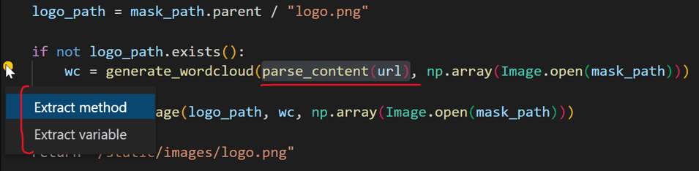

Extract Method

Extracts all similar occurrences of the selected expression or block within the current scope, and replaces it with a method call.

You can invoke this command by selecting the lines of code you wish to extract as a method. Then select the light-bulb that is displayed next to it.

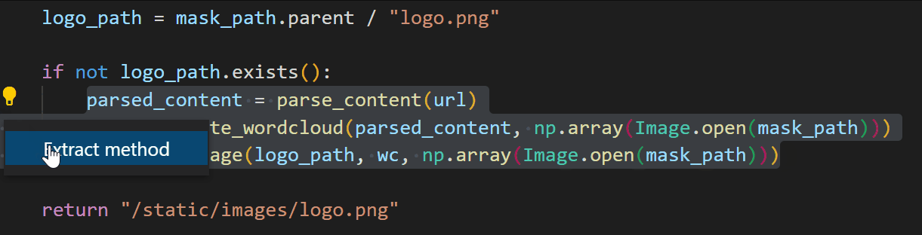

The 3 lines are extracted to a method – it allows you to specify the name for the method

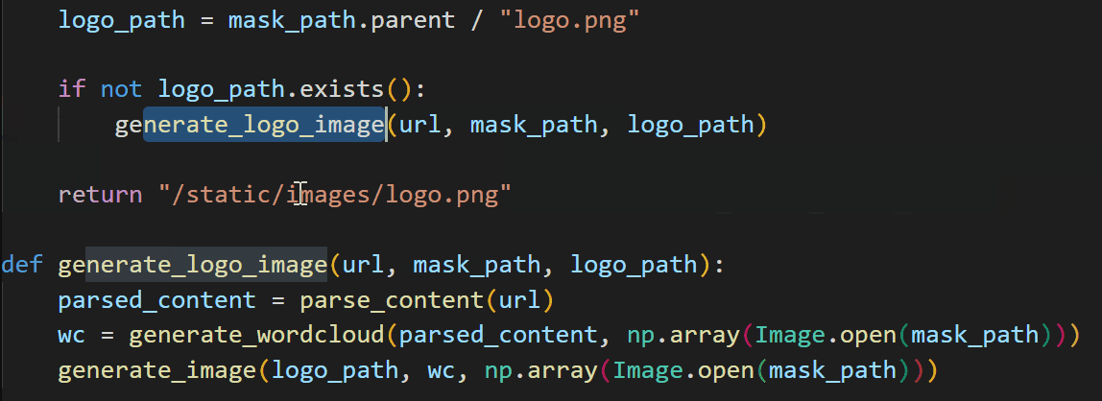

Rename Module

After a Python file/module is renamed, Pylance can find all instances that may need to be updated and provide you with a preview of all the changes.

To customize which references need to be updated, you can toggle the checkboxes at the line or from the file level in Refactor Preview. Once you've made your selections, you can select Apply Refactoring or Discard Refactoring.

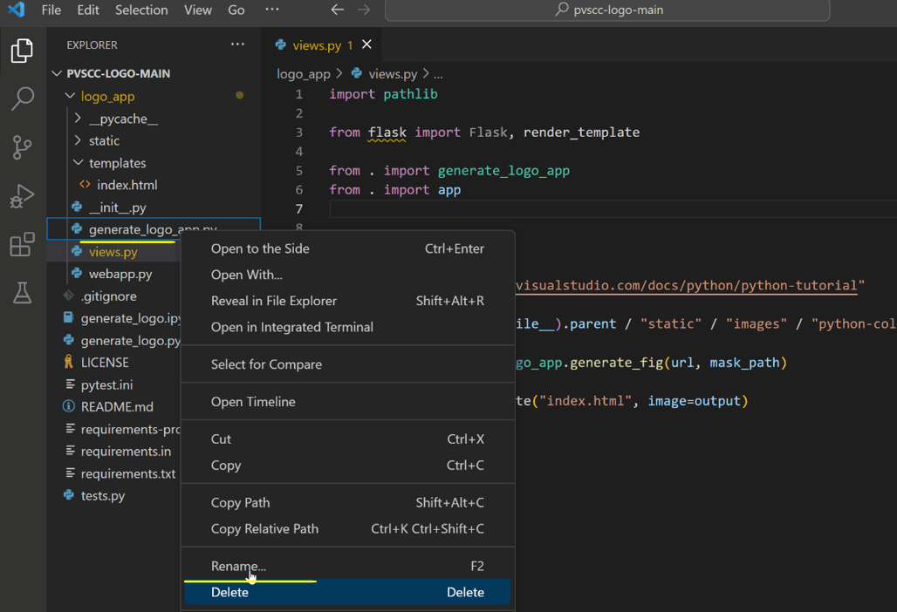

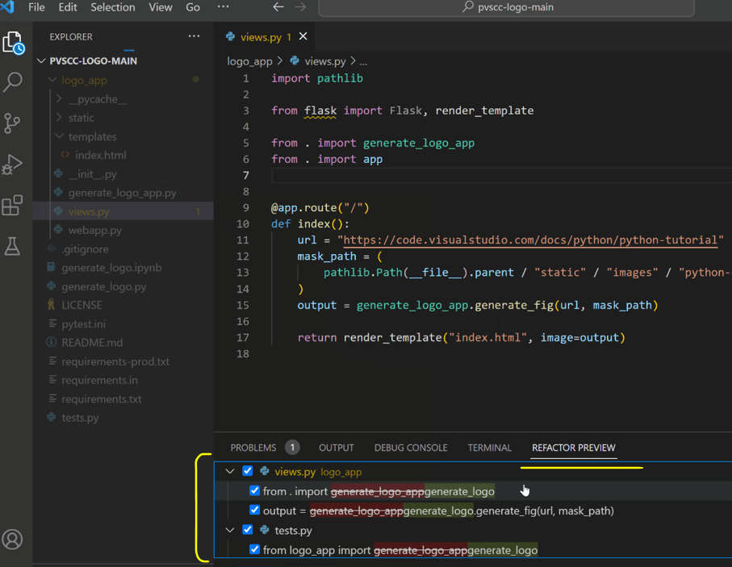

Implement All Inherited Abstract Classes

|  |  |
| --- | --- |
|  | In Python, abstract classes serve as "blueprints" for other classes and help build modular, reusable code by promoting clear structure and requirements for subclasses to adhere to. To define an abstract class in Python, you can create a class that inherits from the ABC class in the abc module, and annotate its methods with the @abstractmethod decorator. Then, you can create new classes that inherit from this abstract class, and define an implementation for the base methods.  Pylance offers a Code Action to simplify the process of creating these classes. When you define a new class that inherits from an abstract one, you can now use the Implement all inherited abstract classes Code Action to automatically implement all abstract methods and properties from the parent class: |

Sort Imports

The Python extension supports extensions such as isort and Ruff that implement the Sort Imports functionality. This command consolidates specific imports from the same module into a single import statement, and organizes import statements in alphabetical order.

You can invoke this by installing an extension that supports sorting imports, then opening the Command Palette (Ctrl+Shift+P) and running Organize Imports.

Tip: you can assign a keyboard shortcut to the editor.action.organizeImports command.

Right Click 🡪 Source Action 🡪

|  |  |
| --- | --- |
|  |  |

#### Formatting Python in VS Code

Formatting makes source code easier to read by human beings. By enforcing particular rules and conventions such as line spacing, indents, and spacing around operators, the code becomes more visually organized and comprehensible. You can view an example on the autopep8 page. Keep in mind, formatting doesn't affect the functionality of the code itself.

Linting helps to prevent errors by analyzing code for common syntactical, stylistic, and functional errors and unconventional programming practices. Although there is a little overlap between formatting and linting, the two capabilities are complementary.

Choose a formatter

Search the VS Code Marketplace for the formatter extension of your choice.

Microsoft publishes the following formatting extensions:

Formatter Extension

autopep8 https://marketplace.visualstudio.com/items?itemName=ms-python.autopep8

Black formatter https://marketplace.visualstudio.com/items?itemName=ms-python.black-formatter

Formatter extensions offered by the community:

Formatter Extension

Ruff https://marketplace.visualstudio.com/items?itemName=charliermarsh.ruff

yapf https://marketplace.visualstudio.com/items?itemName=eeyore.yapf

Furthermore, below are formatter extensions that support import sorting:

Formatter Extension

Ruff https://marketplace.visualstudio.com/items?itemName=charliermarsh.ruff

isort https://marketplace.visualstudio.com/items?itemName=ms-python.isort

Set a default formatter

Once you install a formatter extension, you can select it as the default formatter for Python files in VS Code by following the steps below:

1. Open a Python file in VS Code.
2. Right-click on the editor to display the context menu.
3. Select Format Document With....
4. Select Configure Default Formatter... from the drop-down menu.
5. Select your preferred formatter extension from the list.

Alternatively, you can set it as the default formatter for all Python files by setting "editor.defaultFormatter" in your User settings.json file, under a [python] scope. You can open settings.json with the Preferences: Open User Settings (JSON) command.

For example, to set Black Formatter as the default formatter, add the following setting to your User settings.json file:

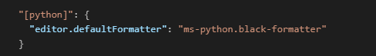

In order to set a formatter extension as an import sorter, you can set your preference under "editor.codeActionsOnSave" in your User settings.json file or your Workspace settings.json file, under a [python] scope. You can open these settings.json files using the Preferences: Open User Settings (JSON) and Preferences: Open Workspace Settings (JSON) commands respectively. This will enable import sorting on save for all Python files.

For example, to set Ruff as your preferred import sorter, you can add the following setting to your User settings.json or your Workspace settings.json file:

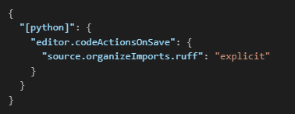

Format your code

You can format your code by right-clicking on the editor and selecting Format Document, or by using the Shift+Alt+F keyboard shortcut.

You can also add the following setting to your User settings.json file to enable formatting on save for your code:

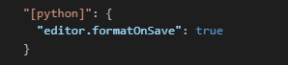

### Shortcuts

Show on the Visual Studio page when no file is open

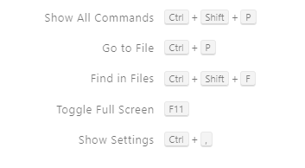

**Show Settings – Ctrl + ,**

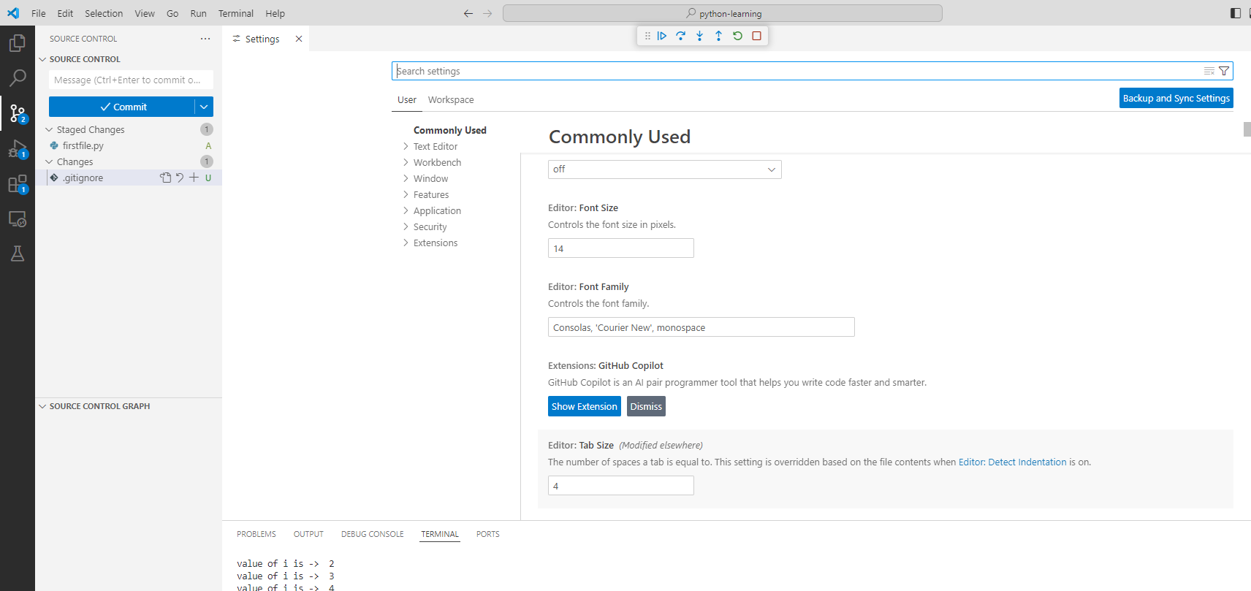

## Debugging

<https://code.visualstudio.com/docs/python/debugging>

The Python Debugger extension is automatically installed along with the Python extension for VS Code. It offers debugging features with debugpy for several types of Python applications, including scripts, web apps, remote processes and more.

To verify it's installed, open the Extensions view (Ctrl+Shift+X) and search for @installed python debugger. You should see the Python Debugger extension listed in the results.

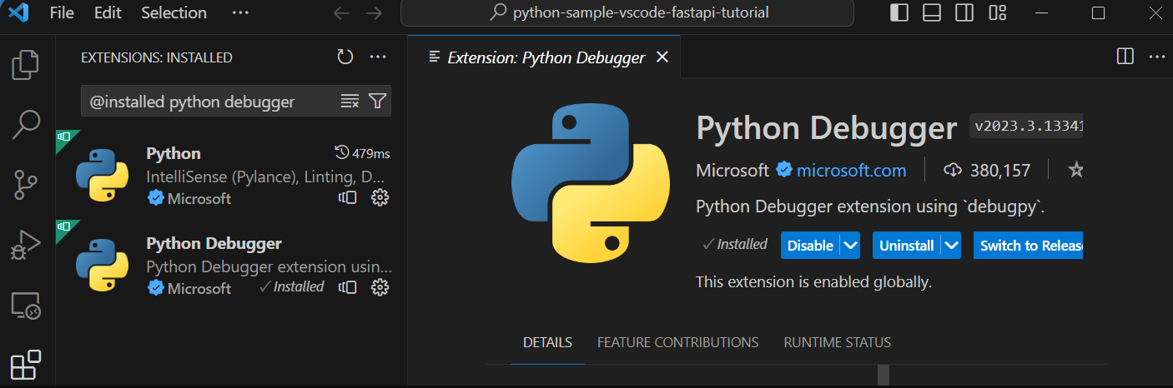

Initialize configurations

A configuration drives VS Code's behavior during a debugging session. Configurations are defined in a launch.json file that's stored in a .vscode folder in your workspace.

Note: To change debugging configuration, your code must be stored in a folder.

To initialize debug configurations, first select the Run view in the sidebar:

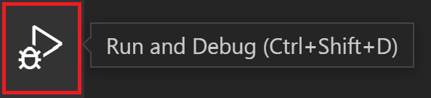

If you don't yet have any configurations defined, you'll see a button to Run and Debug and a link to create a configuration (launch.json) file:

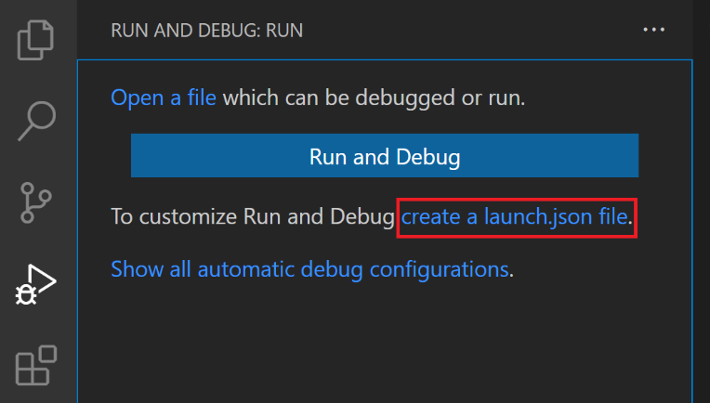

To generate a launch.json file with Python configurations, do the following steps:

* Select the create a launch.json file link (outlined in the image above) or use the Run > Open configurations menu command.
* Select Python Debugger from the debugger options list.
* A configuration menu will open from the Command Palette allowing you to choose the type of debug configuration you want to use for our Python project file. If you want to debug a single Python script, select Python File in the Select a debug configuration menu that appears.

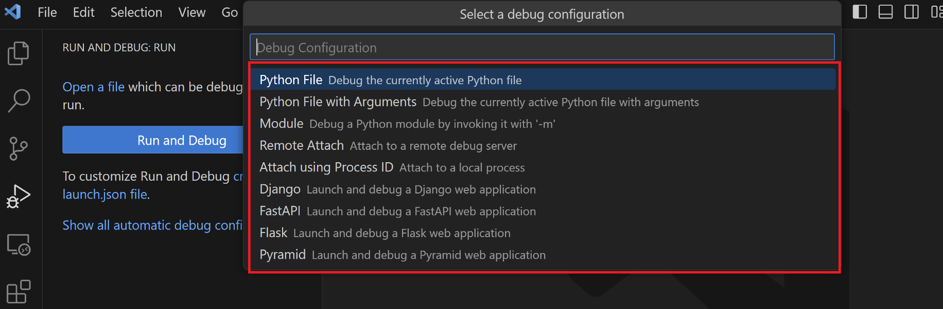

Note: Starting a debugging session through the Debug Panel, F5 or Run > Start Debugging when no configuration exists will also bring up the debug configuration menu, but will not create a launch.json file.

1. The Python Debugger extension then creates and opens a launch.json file that contains a pre-defined configuration based on what you previously selected, in this case, Python File. You can modify configurations (to add arguments, for example), and also add custom configurations.

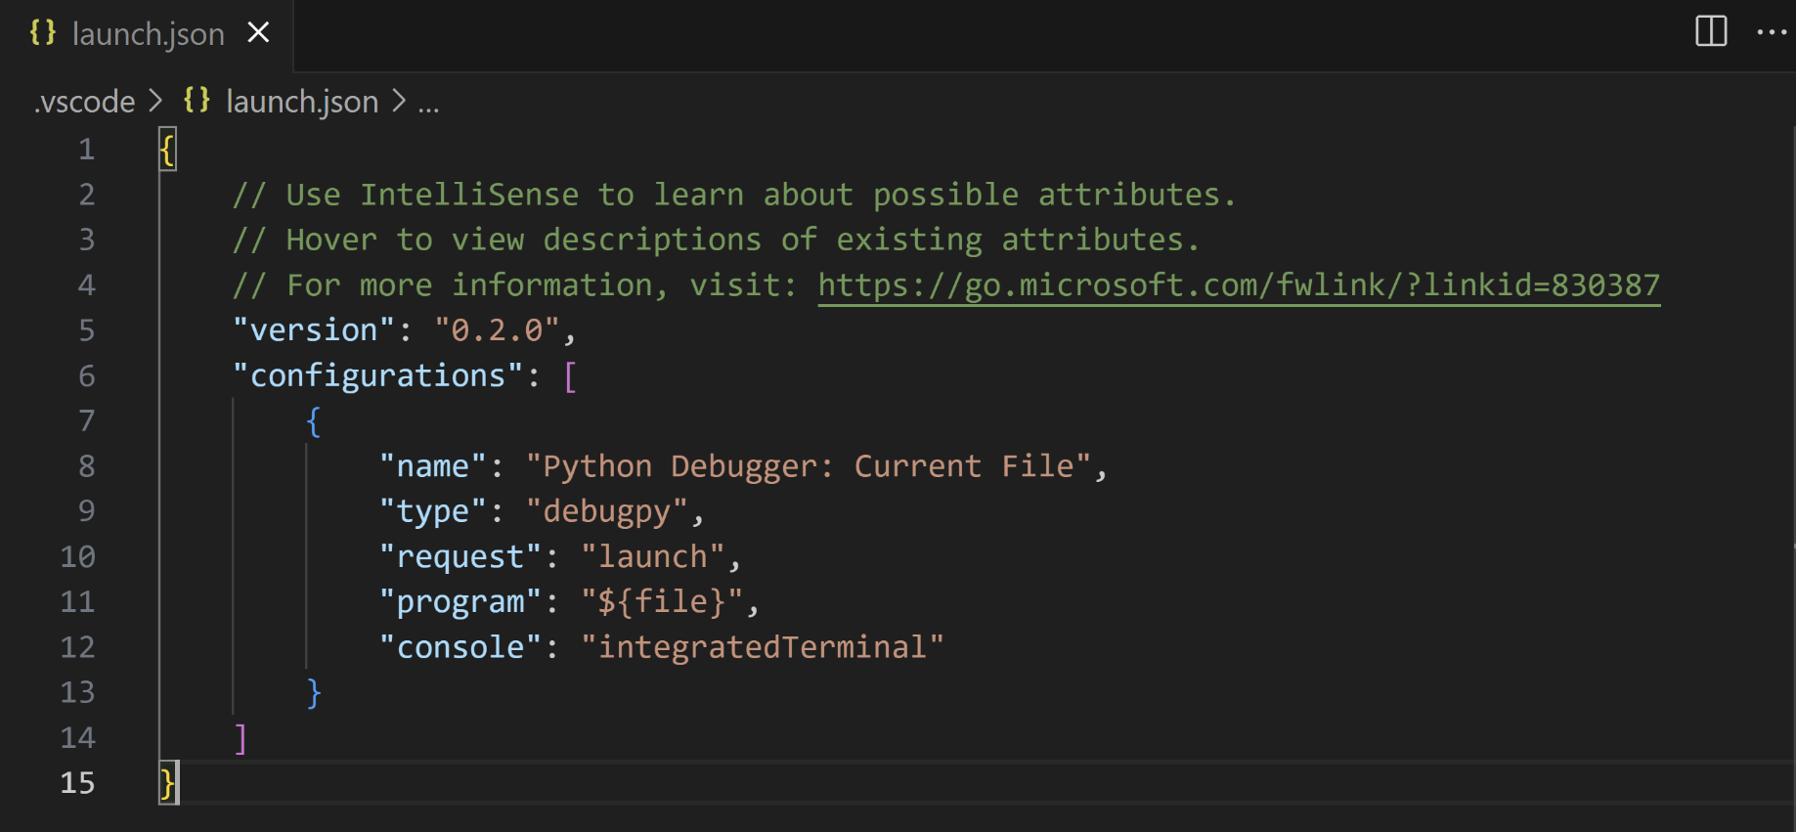

Additional configurations

By default, VS Code shows only the most common configurations provided by the Python Debugger extension. You can select other configurations to include in launch.json by using the Add Configuration command shown in the list and the launch.json editor. When you use the command, VS Code prompts you with a list of all available configurations (be sure to select the Python option):

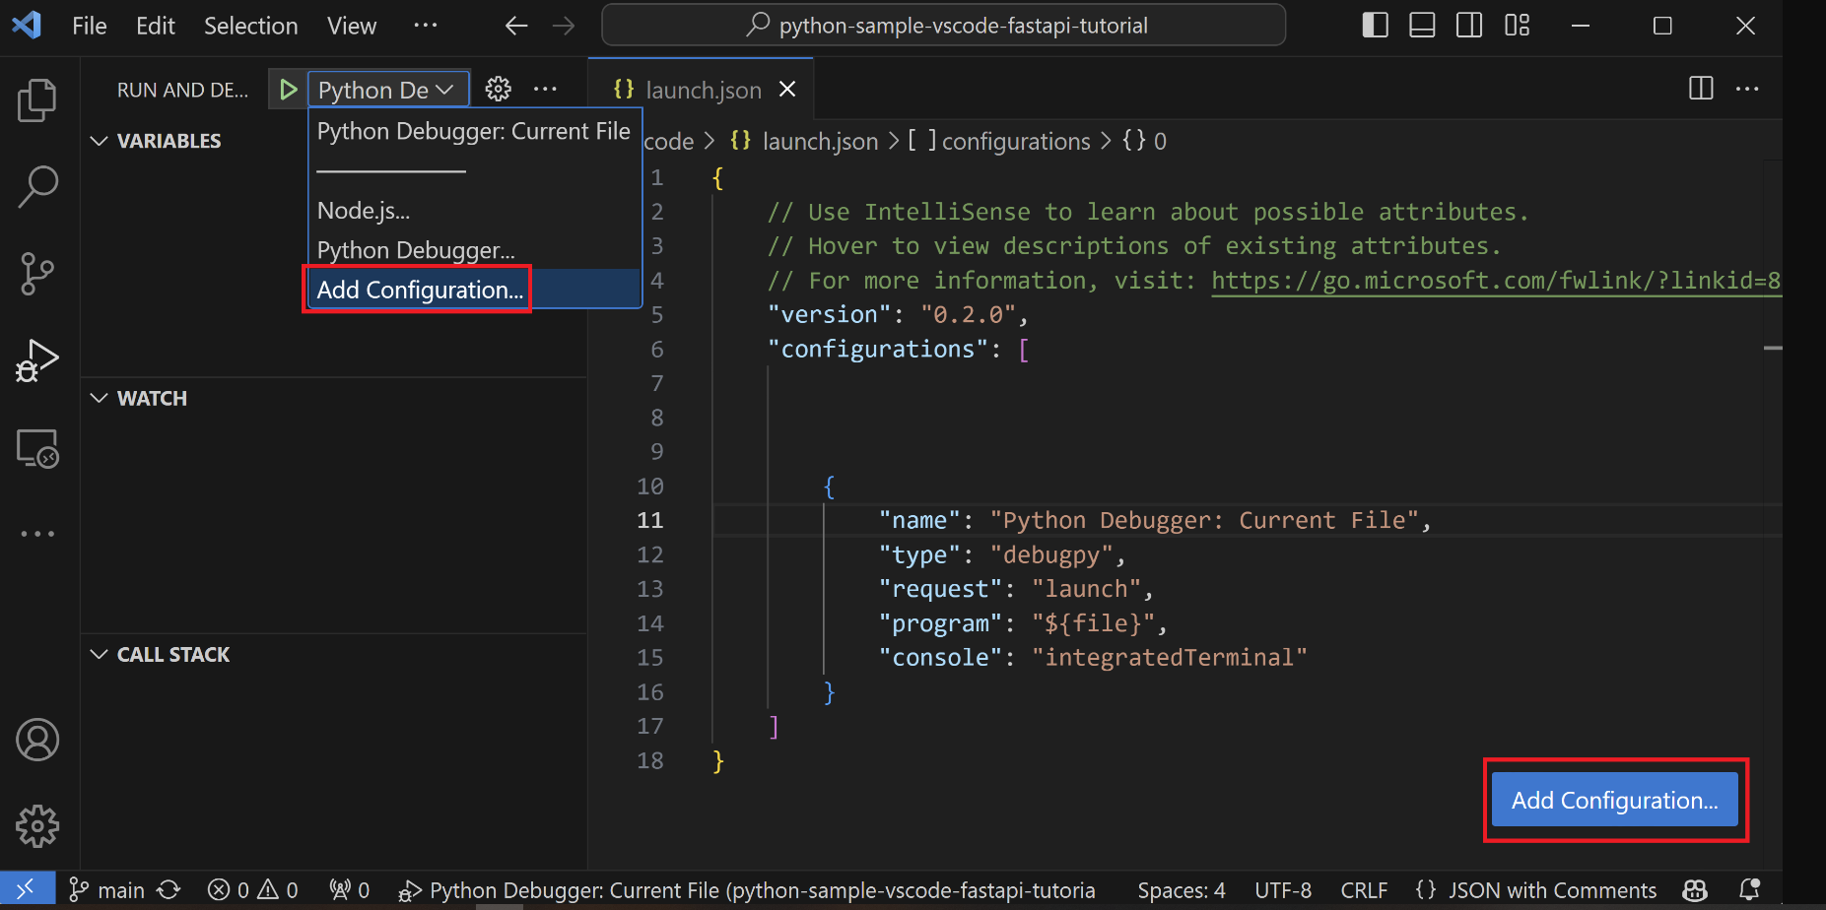

Selecting the Attach using Process ID one yields the following result:

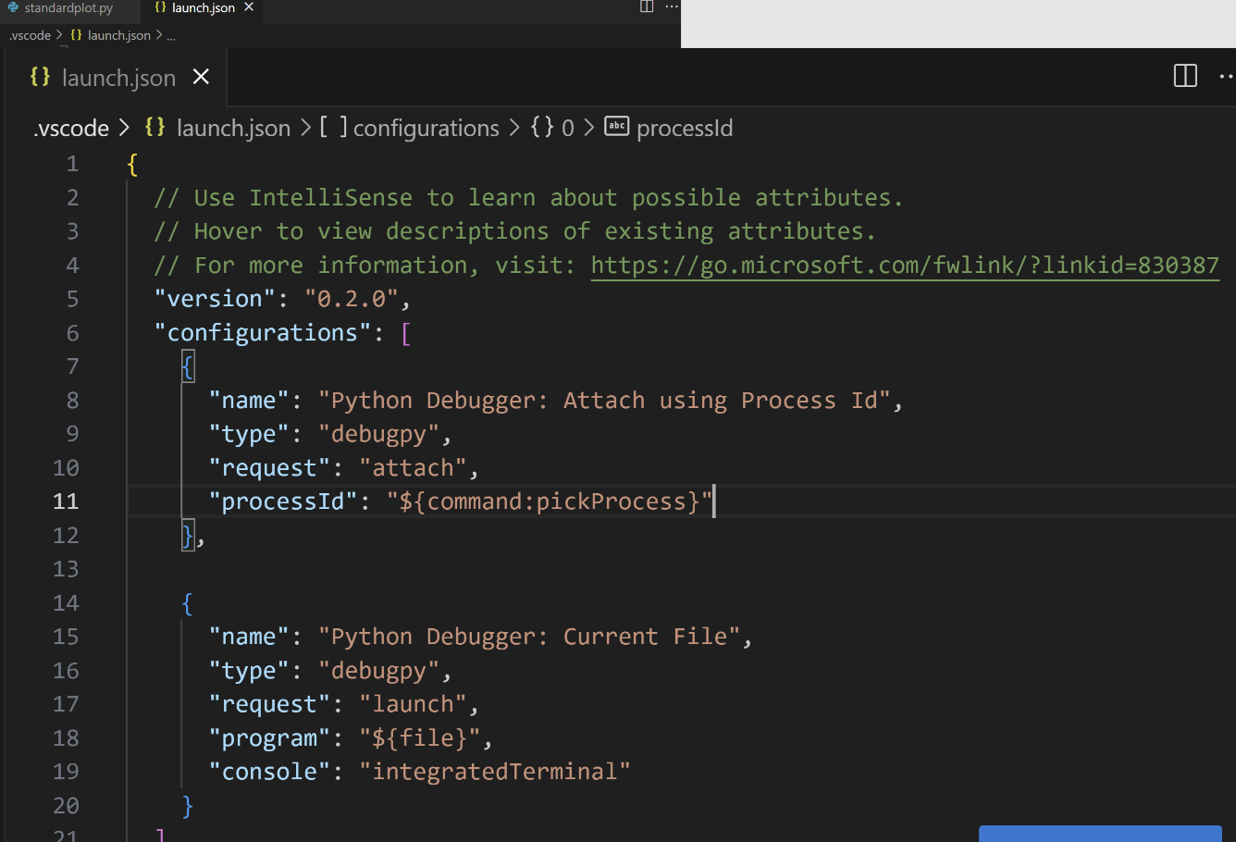

See Debugging specific app types for details on all of these configurations.

During debugging, the Status Bar shows the current configuration and the current debugging interpreter. Selecting the configuration brings up a list from which you can choose a different configuration:



Debugging Status Bar

By default, the debugger uses the same interpreter selected for your workspace, just like other features of Python extension for VS Code. To use a different interpreter for debugging specifically, set the value for python in launch.json for the applicable debugger configuration. Alternately, use the Python interpreter indicator on the Status Bar to select a different one.

Basic debugging

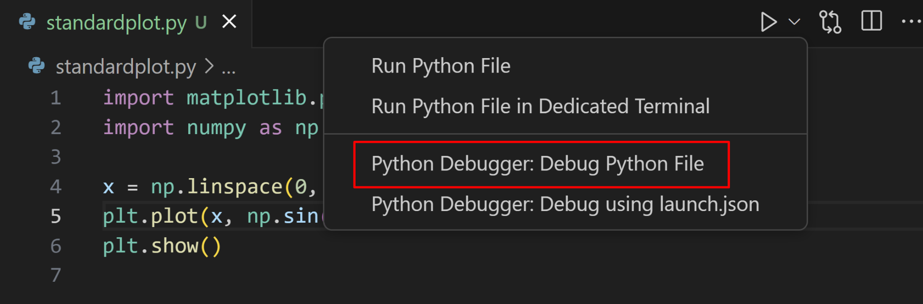

If you're looking to debug a web application using Flask, Django or FastAPI, the Python Debugger extension provides dynamically created debug configurations based on your project structure under the Show all automatic debug configurations option, through the Run and Debug view.

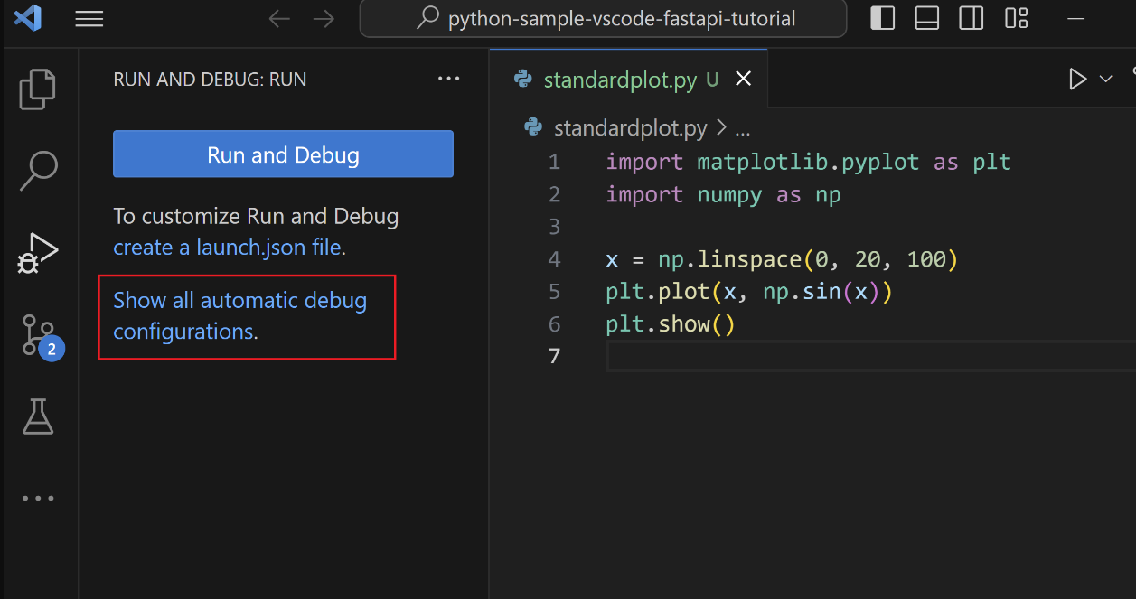

But if you're looking to debug other kinds of applications, you can start the debugger through the Run view by clicking on the Run and Debug button.

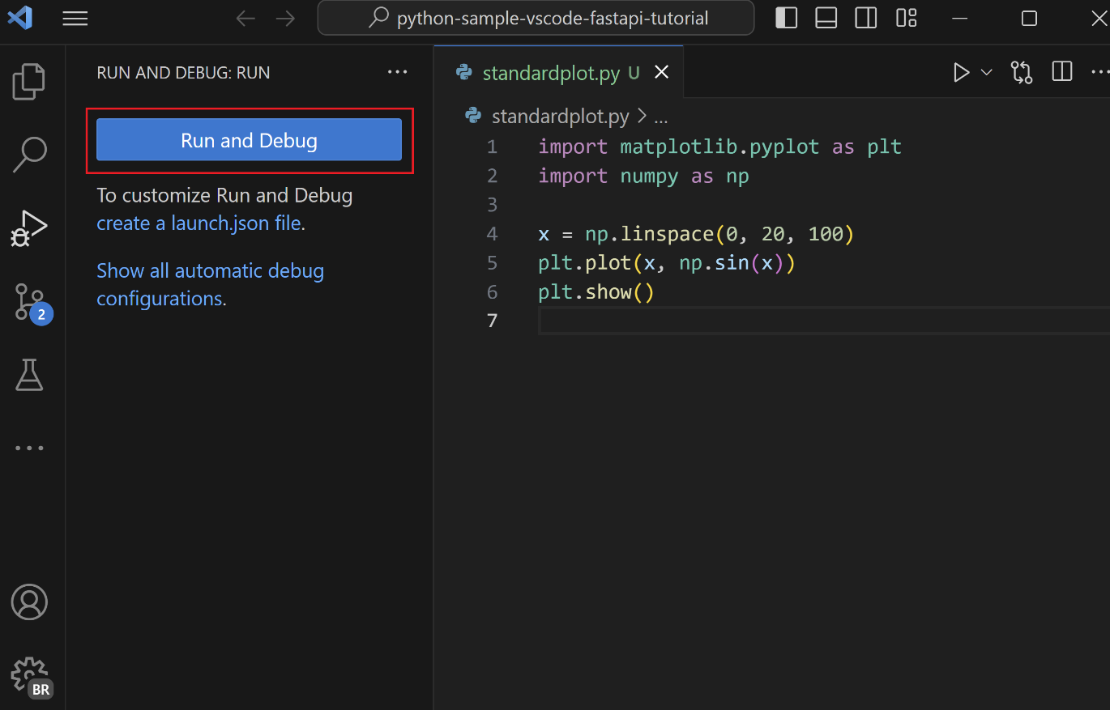

When no configuration has been set, you'll be given a list of debugging options. Here, you can select the appropriate option to quickly debug your code.

Two common options are to use the Python File configuration to run the currently open Python file or to use the Attach using Process ID configuration to attach the debugger to a process that is already running.

For information about creating and using debugging configurations, see the Initialize configurations and Additional configurations sections. Once a configuration is added, it can be selected from the dropdown list and started using the Start Debugging button (F5).

On Pressing F5 you get into the Debug Mode then use the other shortcuts like F10 to step over line by line, F11 to step in etc.

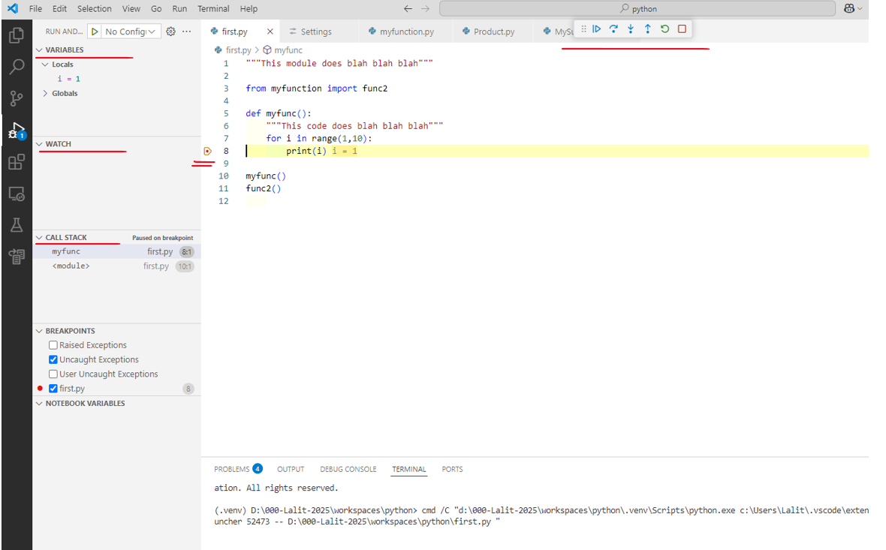

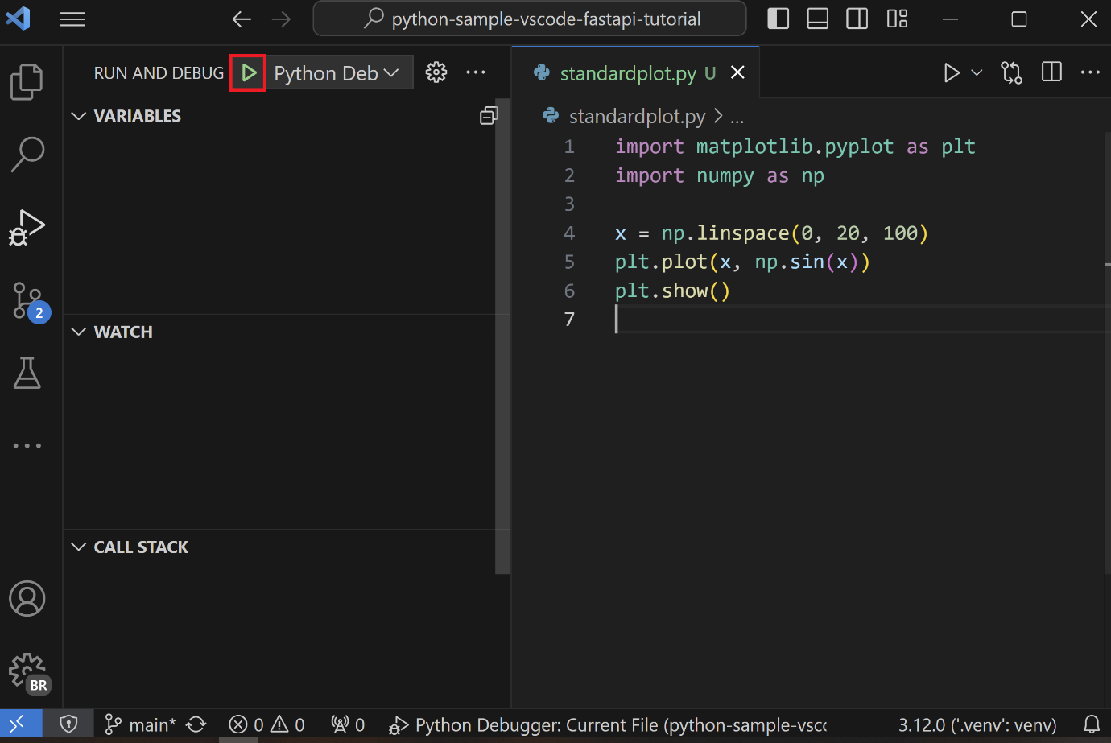

Command line debugging

The debugger can also be run from the command line, if debugpy is installed in your Python environment.

Install debugpy

You can install debugpy using

python -m pip install --upgrade debugpy

into your Python environment.

Tip: While using a virtual environment is not required, it is a recommended best practice. You can create a virtual environment in VS Code by opening the Command Palette (Ctrl+Shift+P) and running the Python: Create Virtual Environment command (unassigned).

Command line syntax

The debugger command line syntax is as follows:

python -m debugpy

--listen | --connect

[<host>:]<port>

[--wait-for-client]

[--configure-<name> <value>]...

[--log-to <path>] [--log-to-stderr]

<filename> | -m <module> | -c <code> | --pid <pid>

[<arg>]...

Example

From the command line, you could start the debugger using a specified port (5678) and script using the following syntax. This example assumes the script is long-running and omits the --wait-for-client flag, meaning that the script will not wait for the client to attach.

python -m debugpy --listen 5678 ./myscript.py

You would then use the following configuration to attach from the VS Code Python Debugger extension.

{

"name": "Python Debugger: Attach",

"type": "debugpy",

"request": "attach",

"connect": {

"host": "localhost",

"port": 5678

}

}

Note: Specifying host is optional for listen, by default 127.0.0.1 is used.

If you wanted to debug remote code or code running in a docker container, on the remote machine or container, you would need to modify the previous CLI command to specify a host.

python -m debugpy --listen 0.0.0.0:5678 ./myscript.py

The associated configuration file would then look as follows.

{

"name": "Attach",

"type": "debugpy",

"request": "attach",

"connect": {

"host": "remote-machine-name", // replace this with remote machine name

"port": 5678

}

}

Note: Be aware that when you specify a host value other than 127.0.0.1 or localhost you are opening a port to allow access from any machine, which carries security risks. You should make sure that you're taking appropriate security precautions, such as using SSH tunnels, when doing remote debugging.

Command line options

|  |  |  |
| --- | --- | --- |
| **Flag** | **Options** | **Description** |
| **--listen** or  **--connect** | **[<host>:]<port>** | **Required**. Specifies the host address and port for the debug adapter server to wait for incoming connections (--listen) or to connect with a client that is waiting for an incoming connection (--connect). This is the same address that is used in the VS Code debug configuration. By default, the host address is localhost (127.0.0.1). |
| **--wait-for-client** | none | **Optional**. Specifies that the code should not run until there's a connection from the debug server. This setting allows you to debug from the first line of your code. |
| **--log-to** | **<path>** | **Optional**. Specifies a path to an existing directory for saving logs. |
| **--log-to-stderr** | none | **Optional**. Enables debugpy to write logs directly to stderr. |
| **--pid** | **<pid>** | **Optional**. Specifies a process that is already running to inject the debug server into. |
| **--configure-<name>** | <value> | **Optional**. Sets a debug property that must be known to the debug server before the client connects. Such properties can be used directly in *launch* configuration, but must be set in this manner for *attach* configurations. For example, if you don't want the debug server to automatically inject itself into subprocesses created by the process you're attaching to, use --configure-subProcess false. |

Note: [<arg>] can be used to pass command-line arguments along to the app being launched.

more on this is . . . [here](https://code.visualstudio.com/docs/python/debugging)

### Configure and run the debugger

Let's now try debugging our Python program. Debugging support is provided by the Python Debugger extension, which is automatically installed with the Python extension. To ensure it has been installed correctly, open the Extensions view ( Ctrl+Shift+X ) and search for @installed python debugger. You should see the Python Debugger extension listed in the results.

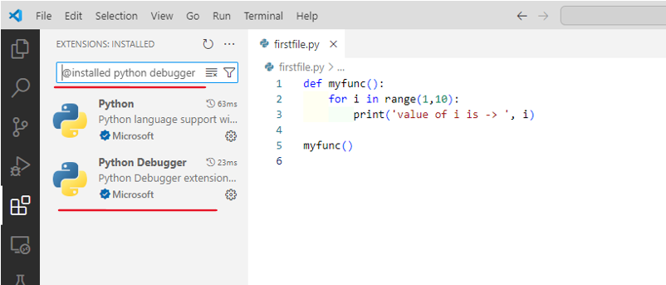

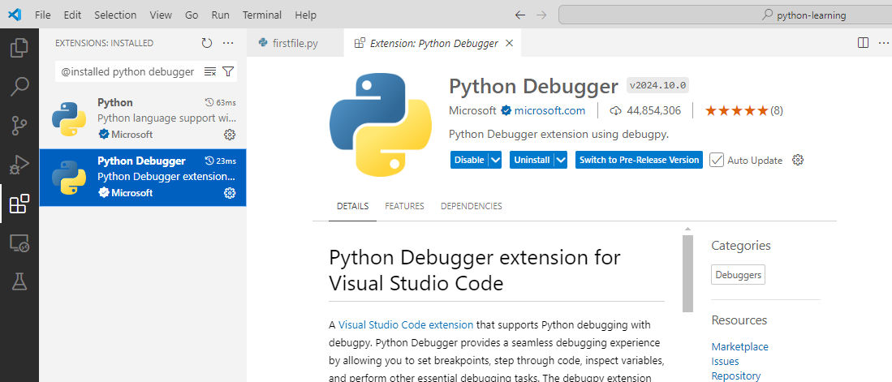

Next, set a breakpoint on line 2 of hello.py by placing the cursor on the print call and pressing F9. Alternately, click in the editor's left gutter, next to the line numbers. When you set a breakpoint, a red circle appears in the gutter.

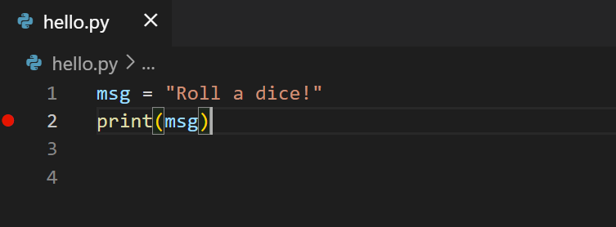

Next, to initialize the debugger, press F5. Since this is your first time debugging this file, a configuration menu will open from the Command Palette allowing you to select the type of debug configuration you would like for the opened file.

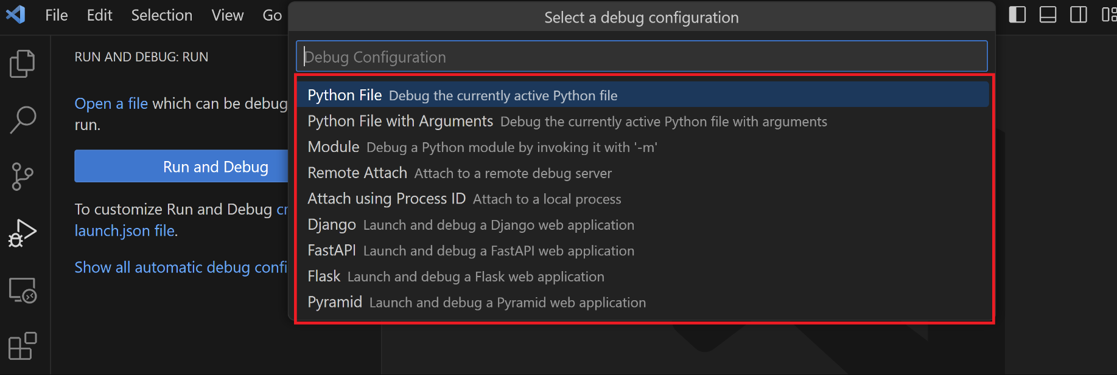

F5 🡪 Start Debugging/ Run to the next breakpoint

Ctrl + Shift + F5 🡪 Restart

F9 🡪 Toggle Breakpoint

F10 🡪 Step Over Line by Line

F11 🡪 Step Into

Shift + F11 🡪 Step Out

continue (F5), step over (F10), step into (F11), step out (Shift+F11), restart (Ctrl+Shift+F5), and stop (Shift+F5).

Note: VS Code uses JSON files for all of its various configurations; launch.json is the standard name for a file containing debugging configurations.

Select Python File, which is the configuration that runs the current file shown in the editor using the currently selected Python interpreter.

The debugger will start, and then stop at the first line of the file breakpoint. The current line is indicated with a yellow arrow in the left margin. If you examine the Local variables window at this point, you can see that the msg variable appears in the Local pane.

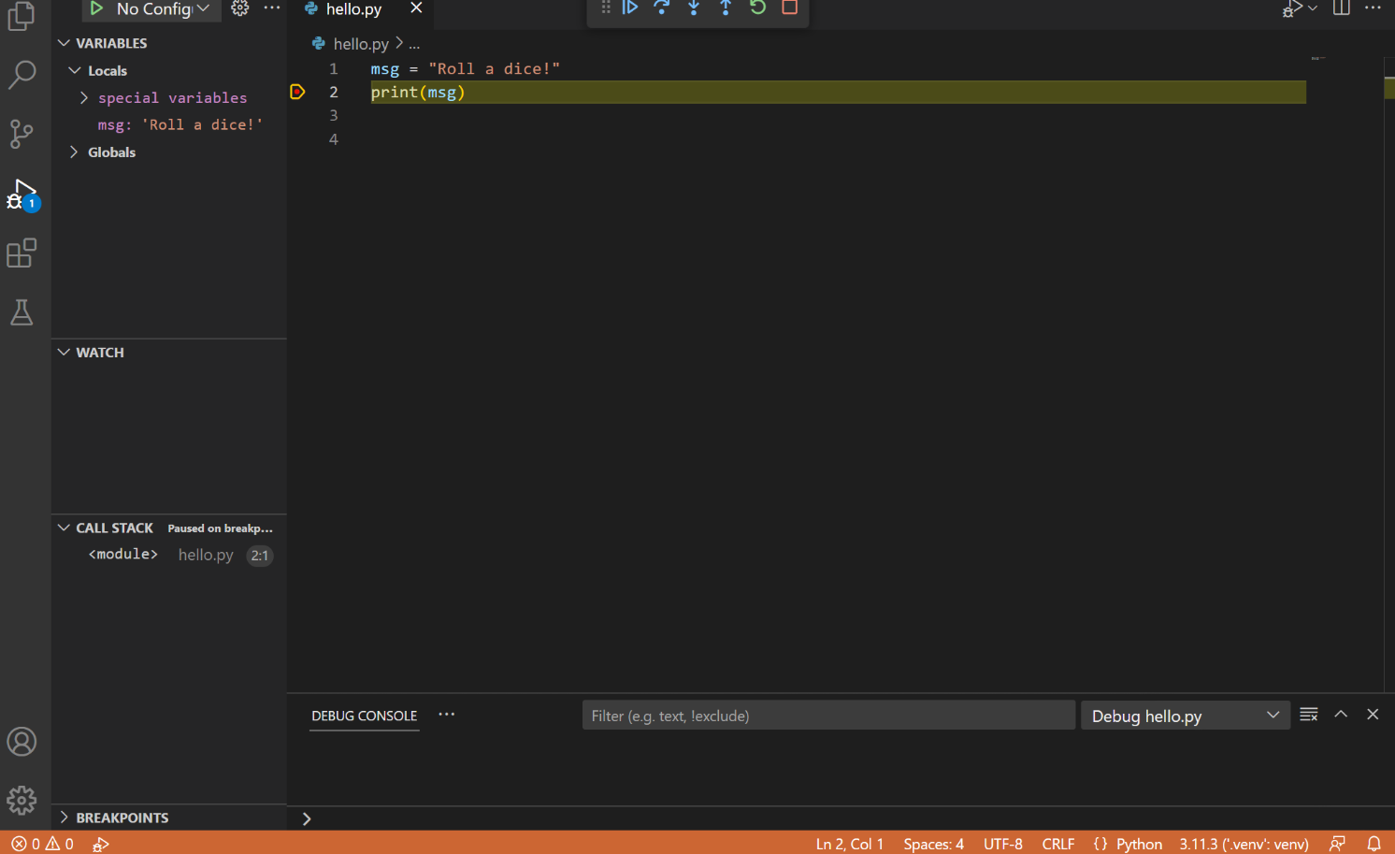

A debug toolbar appears along the top with the following commands from left to right: continue (F5), step over (F10), step into (F11), step out (Shift+F11), restart (Ctrl+Shift+F5), and stop (Shift+F5).

The Status Bar also changes color (orange in many themes) to indicate that you're in debug mode. The Python Debug Console also appears automatically in the lower right panel to show the commands being run, along with the program output.



To continue running the program, select the continue command on the debug toolbar (F5). The debugger runs the program to the end.

Tip Debugging information can also be seen by hovering over code, such as variables. In the case of msg, hovering over the variable will display the string Roll a dice! in a box above the variable.

You can also work with variables in the Debug Console (If you don't see it, select Debug Console in the lower right area of VS Code, or select it from the ... menu.) Then try entering the following lines, one by one, at the > prompt at the bottom of the console:

msg

msg.capitalize()

msg.split()

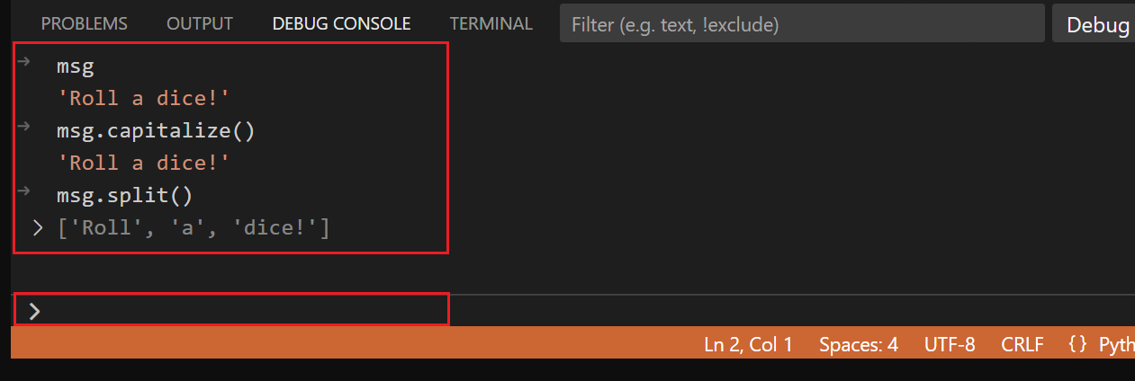

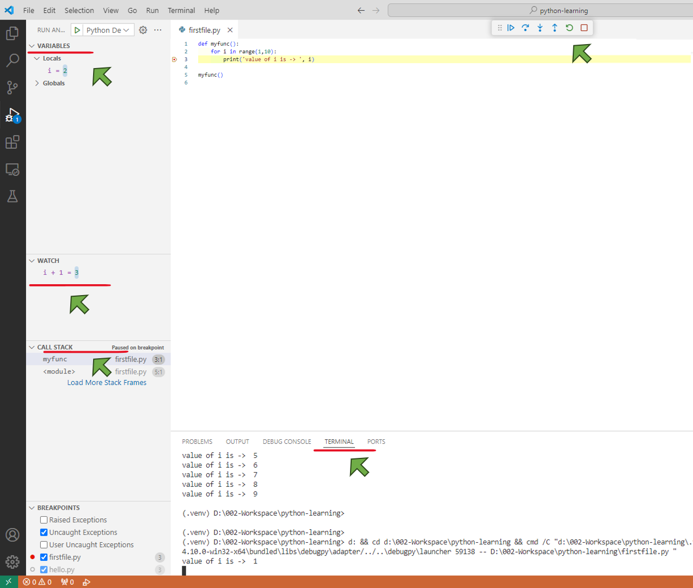

Select the blue Continue button on the toolbar again (or press F5) to run the program to completion. "Roll a dice!" appears in the Python Debug Console if you switch back to it, and VS Code exits debugging mode once the program is complete.

If you restart the debugger, the debugger again stops on the first breakpoint.

To stop running a program before it's complete, use the red square stop button on the debug toolbar (Shift+F5), or use the Run > Stop debugging menu command.

For full details, see Debugging configurations, which includes notes on how to use a specific Python interpreter for debugging.

Tip: Use Logpoints instead of print statements: Developers often litter source code with print statements to quickly inspect variables without necessarily stepping through each line of code in a debugger. In VS Code, you can instead use Logpoints. A Logpoint is like a breakpoint except that it logs a message to the console and doesn't stop the program. For more information, see Logpoints in the main VS Code debugging article.

F5 🡪 Start Debugging/ Run to the next breakpoint

Ctrl + Shift + F5 🡪 Restart

F9 🡪 Toggle Breakpoint

F10 🡪 Step Over Line by Line

F11 🡪 Step Into

Shift + F11 🡪 Step Out

## Environments

An "environment" in Python is the context in which a Python program runs that consists of an interpreter and any number of installed packages.

Note: If you'd like to become more familiar with the Python programming language, review [More Python resources](https://code.visualstudio.com/docs/python/environments#_more-python-resources).

### Types of Python environments

Global environments

By default, any Python interpreter installed runs in its own global environment. For example, if you just run python, python3, or py at a new terminal (depending on how you installed Python), you're running in that interpreter's global environment. Any packages that you install or uninstall affect the global environment and all programs that you run within it.

Tip: In Python, it is best practice to create a workspace-specific environment, for example, by using a local environment.

Local environments

There are two types of environments that you can create for your workspace: virtual and conda. These environments allow you to install packages without affecting other environments, isolating your workspace's package installations.

**VIRTUAL ENVIRONMENTS**

A virtual environment is a built-in way to create an environment. A virtual environment creates a folder that contains a copy (or symlink) to a specific interpreter. When you install packages into a virtual environment it will end up in this new folder, and thus isolated from other packages used by other workspaces.

Note: While it's possible to open a virtual environment folder as a workspace, doing so is not recommended and might cause issues with using the Python extension.

**CONDA ENVIRONMENTS**

A conda environment is a Python environment that's managed using the conda package manager (see Getting started with conda). Choosing between conda and virtual environments depends on your packaging needs, team standards, etc

Python environment tools

The following table lists the various tools involved with Python environments:

|  |  |
| --- | --- |
| Tool | Definition and Purpose |
| pip | The Python package manager that installs and updates packages. It's installed with Python 3.9+ by default (unless you are on a Debian-based OS; install python3-pip in that case). |
| venv | Allows you to manage separate package installations for different projects and is installed with Python 3 by default (unless you are on a Debian-based OS; install python3-venv in that case) |
| conda | Installed with Miniconda. It can be used to manage both packages and virtual environments. Generally used for data science projects. |

Creating environments

### Using the Create Environment command

To create local environments in VS Code using virtual environments or Anaconda, you can follow these steps: open the Command Palette (Ctrl+Shift+P) or press F1, search for the Python: Create Environment command, and select it.

The command presents a list of environment types: Venv or Conda.



If you are creating an environment using Venv, the command presents a list of interpreters that can be used as a base for the new virtual environment.

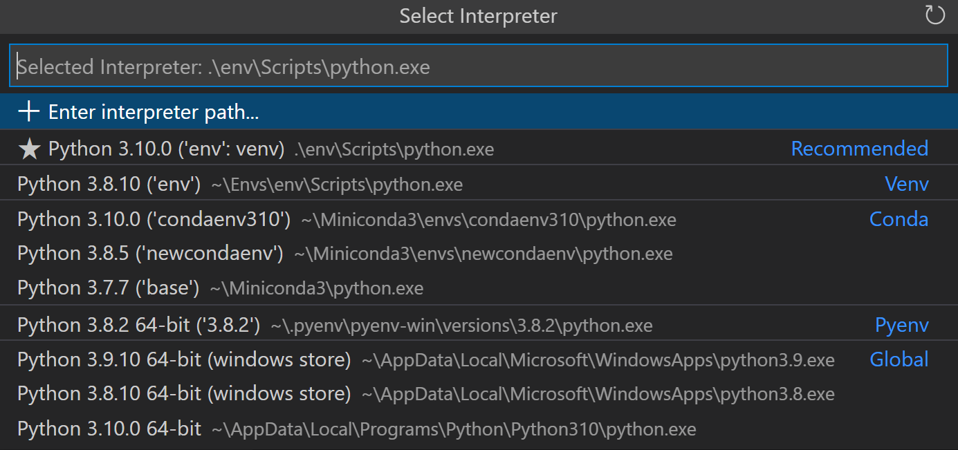

If you are creating an environment using Conda, the command presents a list of Python versions that can be used for your project.

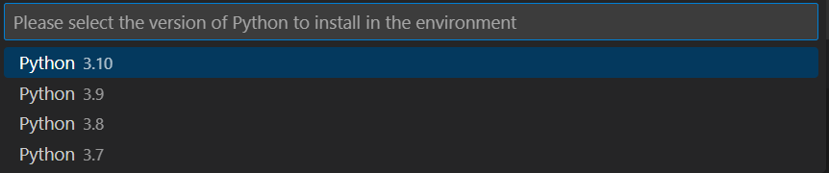

After selecting the desired interpreter or Python version, a notification will show the progress of the environment creation and the environment folder will appear in your workspace.

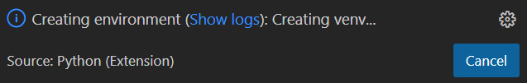

Note: The command will also install necessary packages outlined in a requirements/dependencies file, such as requirements.txt, pyproject.toml, or environment.yml, located in the project folder. It will also add a .gitignore file to the virtual environment to help prevent you from accidentally committing the virtual environment to source control.

### Create a virtual environment in the terminal

If you choose to create a virtual environment manually, use the following command (where ".venv" is the name of the environment folder):

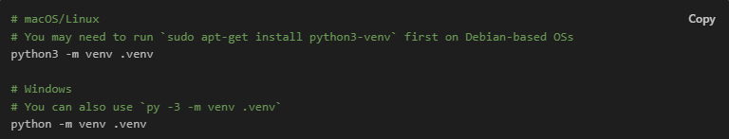

$ python3 -m venv .venv

$ python -m venv .venv

Note: To learn more about the venv module, read Creation of virtual environments on Python.org.

When you create a new virtual environment, a prompt will be displayed in VS Code to allow you to select it for the workspace.

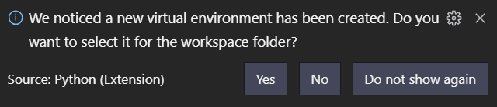

Tip: Make sure to update your source control settings to prevent accidentally committing your virtual environment (in for example .gitignore). Since virtual environments are not portable, it typically does not make sense to commit them for others to use.

### Create a conda environment in the terminal

The Python extension automatically detects existing conda environments. We recommend you install a Python interpreter into your conda environment, otherwise one will be installed for you after you select the environment. For example, the following command creates a conda environment named env-01 with a Python 3.9 interpreter and several libraries:

conda create -n env-01 python=3.9 scipy=0.15.0 numpy

Note: For more information on the conda command line, you can read Conda environments.

Additional notes:

If you create a new conda environment while VS Code is running, use the refresh icon on the top right of the Python: Select Interpreter window; otherwise you may not find the environment there.

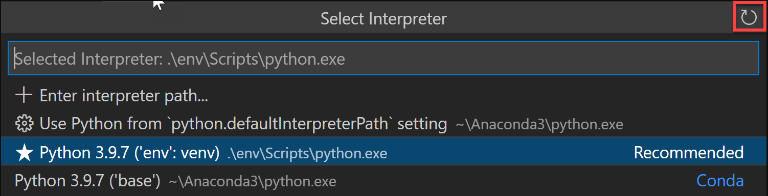

* To ensure the environment is properly set up from a shell perspective, use an Anaconda prompt and activate the desired environment. Then, you can launch VS Code by entering the code command. Once VS Code is open, you can select the interpreter either by using the Command Palette or by clicking on the status bar.
* Although the Python extension for VS Code doesn't currently have direct integration with conda environment.yml files, VS Code itself is a great YAML editor.
* Conda environments can't be automatically activated in the VS Code Integrated Terminal if the default shell is set to PowerShell. To change the shell, see Integrated terminal - Terminal profiles.
* You can manually specify the path to the conda executable to use for activation (version 4.4+). To do so, open the Command Palette (Ctrl+Shift+P) or press F1 and run Preferences: Open User Settings. Then set python.condaPath, which is in the Python extension section of User Settings, with the appropriate path

Working with Python interpreters

Select and activate an environment

The Python extension tries to find and then select what it deems the best environment for the workspace. If you would prefer to select a specific environment, use the Python: Select Interpreter command from the Command Palette (Ctrl+Shift+P) or press the F1 key.

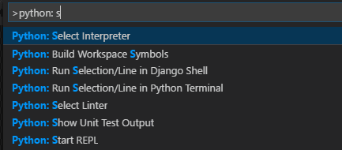

Note: If the Python extension doesn't find an interpreter, it issues a warning. On macOS 12.2 and older, the extension also issues a warning if you're using the OS-installed Python interpreter as it is known to have compatibility issues. In either case, you can disable these warnings by setting python.disableInstallationCheck to true in your user settings.

The Python: Select Interpreter command displays a list of available global environments, conda environments, and virtual environments. (See the Where the extension looks for environments section for details, including the distinctions between these types of environments.) The following image, for example, shows several Anaconda and CPython installations along with a conda environment and a virtual environment (env) that's located within the workspace folder:

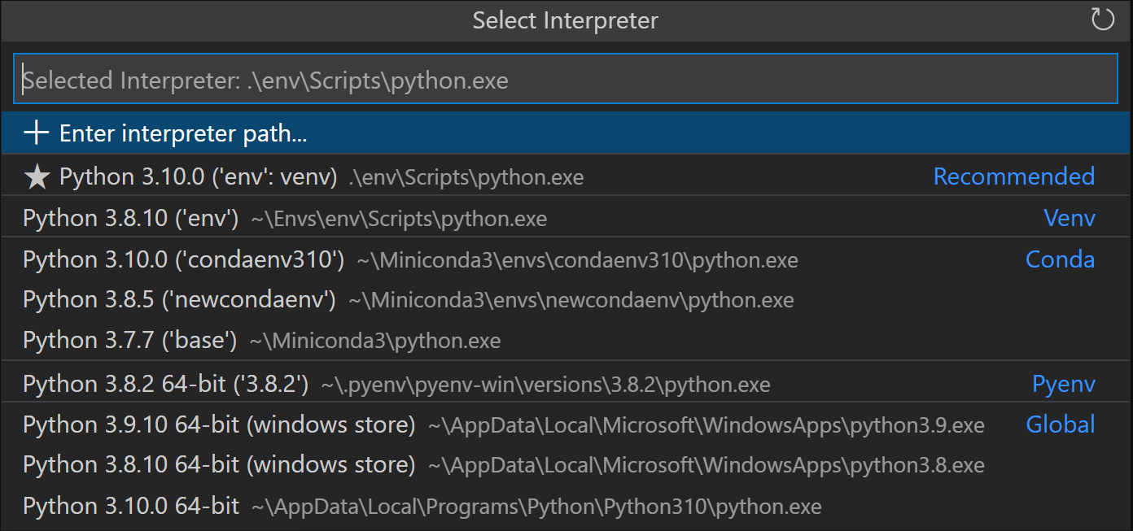

Note: On Windows, it can take a little time for VS Code to detect available conda environments. During that process, you may see "(cached)" before the path to an environment. The label indicates that VS Code is presently working with cached information for that environment.

If you have a folder or a workspace open in VS Code and you select an interpreter from the list, the Python extension will store that information internally. This ensures that the same interpreter will be used when you reopen the workspace.

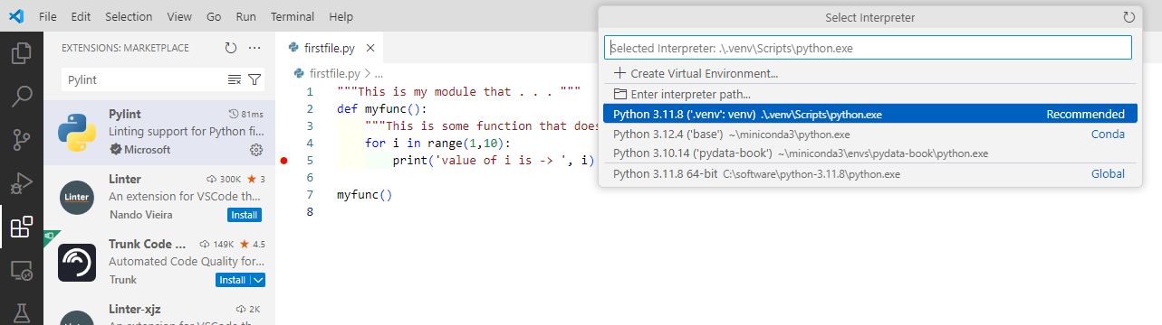

The selected environment is used by the Python extension for running Python code (using the Python: Run Python File in Terminal command), providing language services (auto-complete, syntax checking, linting, formatting, etc.) when you have a .py file open in the editor, and opening a terminal with the Terminal: Create New Terminal command. In the latter case, VS Code automatically activates the selected environment.

Tip: To prevent automatic activation of a selected environment, add "python.terminal.activateEnvironment": false to your settings.json file (it can be placed anywhere as a sibling to the existing settings).

Tip: If the activate command generates the message "Activate.ps1 is not digitally signed. You cannot run this script on the current system.", then you need to temporarily change the PowerShell execution policy to allow scripts to run (see About Execution Policies in the PowerShell documentation): Set-ExecutionPolicy -ExecutionPolicy RemoteSigned -Scope Process

Note: By default, VS Code uses the interpreter selected for your workspace when debugging code. You can override this behavior by specifying a different path in the python property of a debug configuration. See Choose a debugging environment.

The selected interpreter version will show on the right side of the Status Bar.



The Status Bar also reflects when no interpreter is selected.



In either case, clicking this area of the Status Bar is a convenient shortcut for the Python: Select Interpreter command.

Tip: If you have any problems with VS Code recognizing a virtual environment, please file an issue so we can help determine the cause.

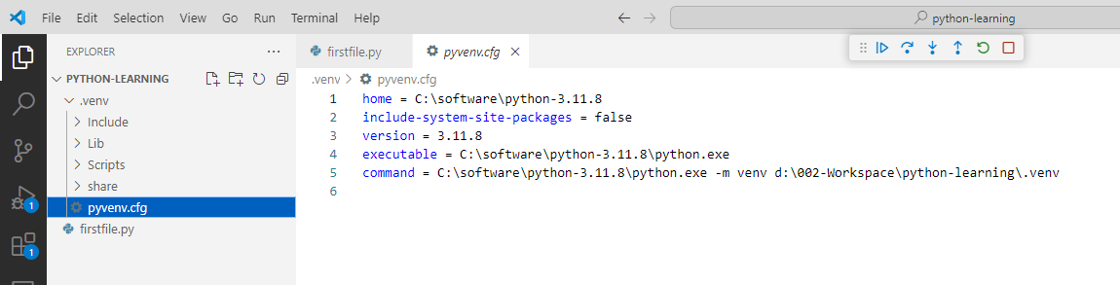

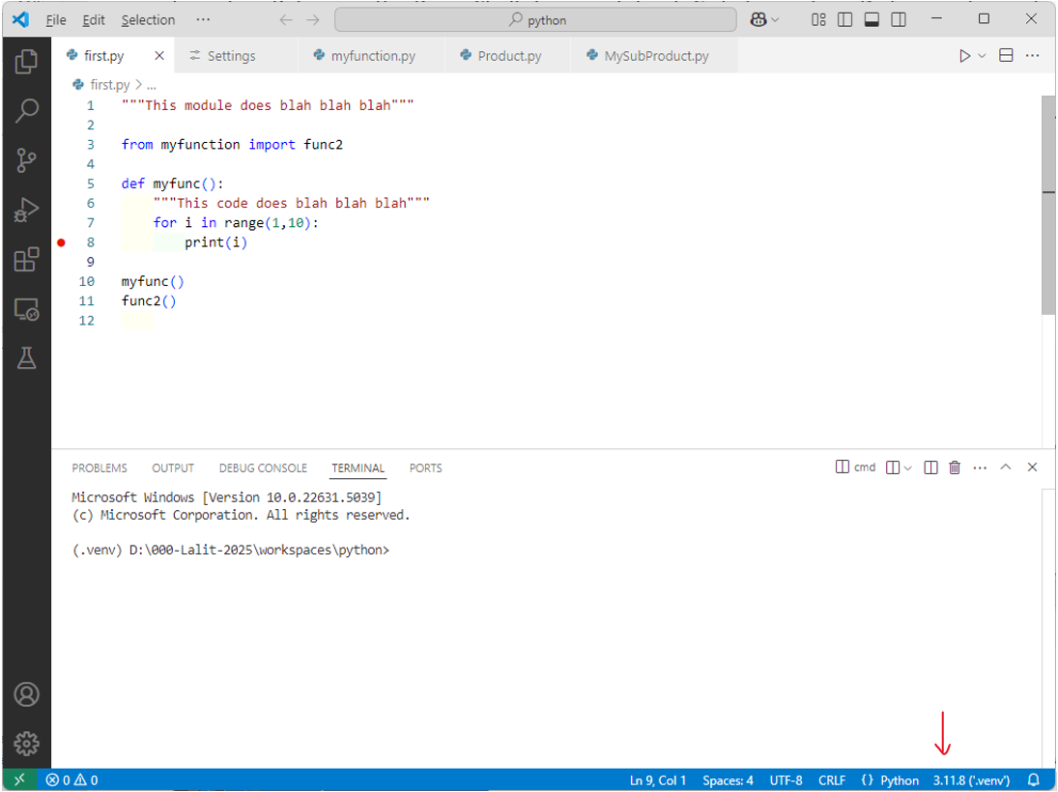

Manually specify an interpreter

If VS Code doesn't automatically locate an interpreter you want to use, you can browse for the interpreter on your file system or provide the path to it manually.

You can do so by running the Python: Select Interpreter command and select the Enter interpreter path... option that shows on the top of the interpreters list:

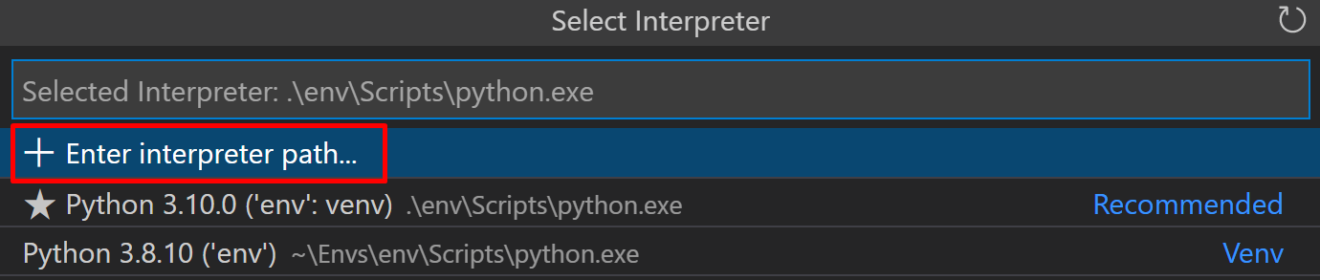

You can then either enter the full path of the Python interpreter directly in the text box (for example, ".venv/Scripts/python.exe"), or you can select the Find... button and browse your file system to find the python executable you wish to select.



If you want to manually specify a default interpreter that will be used when you first open your workspace, you can create or modify an entry for the python.defaultInterpreterPath setting.

Note: Changes to the python.defaultInterpreterPath setting are not picked up after an interpreter has already been selected for a workspace; any changes to the setting will be ignored once an initial interpreter is selected for the workspace.

Additionally, if you'd like to set up a default interpreter to all of your Python applications, you can add an entry for python.defaultInterpreterPath manually inside your User Settings. To do so, open the Command Palette (Ctrl+Shift+P) and enter Preferences: Open User Settings. Then set python.defaultInterpreterPath, which is in the Python extension section of User Settings, with the appropriate interpreter.

How the extension chooses an environment automatically

If an interpreter hasn't been specified, then the Python extension automatically selects the interpreter with the highest version in the following priority order:

* Virtual environments located directly under the workspace folder.
* Virtual environments related to the workspace but stored globally. For example, Pipenv or Poetry environments that are located outside of the workspace folder.
* Globally installed interpreters. For example, the ones found in /usr/local/bin, C:\\python38, etc.

Note: The interpreter selected may differ from what python refers to in your terminal.

If Visual Studio Code doesn't locate your interpreter automatically, you can manually specify an interpreter.

Where the extension looks for environments

The extension automatically looks for interpreters in the following locations, in no particular order:

* Standard install paths such as /usr/local/bin, /usr/sbin, /sbin, c:\\python36, etc.
* Virtual environments located directly under the workspace (project) folder.
* Virtual environments located in the folder identified by the python.venvPath setting (see General Python settings), which can contain multiple virtual environments. The extension looks for virtual environments in the first-level subfolders of venvPath.
* Virtual environments located in a ~/.virtualenvs folder for virtualenvwrapper.
* Interpreters created by pyenv, Pipenv, and Poetry.
* Virtual environments located in the path identified by WORKON_HOME (as used by virtualenvwrapper).
* Conda environments found by conda env list. Conda environments which do not have an interpreter will have one installed for them upon selection.
* Interpreters installed in a .direnv folder for direnv under the workspace folder.
* Environments and Terminal windows
* After using Python: Select Interpreter, that interpreter is applied when right-clicking a file and selecting Python: Run Python File in Terminal. The environment is also activated automatically when you use the Terminal: Create New Terminal command unless you change the python.terminal.activateEnvironment setting to false.

Please note that launching VS Code from a shell in which a specific Python environment is activated doesn't automatically activate that environment in the default Integrated Terminal.

Note: conda environments cannot be automatically activated in the integrated terminal if PowerShell is set as the integrated shell. See Integrated terminal - Terminal profiles for how to change the shell.

**Changing interpreters with the Python:** Select Interpreter command doesn't affect terminal panels that are already open. Thus, you can activate separate environments in a split terminal: select the first interpreter, create a terminal for it, select a different interpreter, then use the split button (Ctrl+Shift+5) in the terminal title bar.

Choose a debugging environment

By default, the debugger will use the Python interpreter chosen with the Python extension. However, if there is a python property specified in the debug configuration of launch.json, it takes precedence. If this property is not defined, it will fall back to using the Python interpreter path selected for the workspace.

For more details on debug configuration, see Debugging configurations.

### Environment variables

Environment variable definitions file

An environment variable definitions file is a text file containing key-value pairs in the form of environment_variable=value, with # used for comments. Multiline values aren't supported, but references to previously defined environment variables are allowed. Environment variable definitions files can be used for scenarios such as debugging and tool execution (including linters, formatters, IntelliSense, and testing tools), but aren't applied to the terminal.

Note: Environment variable definitions files are not necessarily cross-platform. For instance, while Unix uses : as a path separator in environment variables, Windows uses ;. There is no normalization of such operating system differences, and so you need to make sure any environment definitions file use values that are compatible with your operating system.

By default, the Python extension looks for and loads a file named .env in the current workspace folder, then applies those definitions. The file is identified by the default entry "python.envFile": "${workspaceFolder}/.env" in your user settings (see General Python settings). You can change the python.envFile setting at any time to use a different definitions file.

Note: Environment variable definitions files are not used in all situations where environment variables are available for use. Unless Visual Studio Code documentation states otherwise, these only affect certain scenarios as per their definition. For example, the extension doesn't use environment variable definitions files when resolving setting values.

A debug configuration also contains an envFile property that also defaults to the .env file in the current workspace (see Debugging - Set configuration options). This property allows you to easily set variables for debugging purposes that replace variables specified in the default .env file.

For example, when developing a web application, you might want to easily switch between development and production servers. Instead of coding the different URLs and other settings into your application directly, you could use separate definitions files for each. For example:

dev.env file

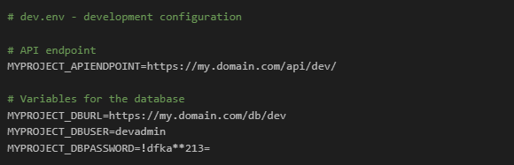

prod.env file

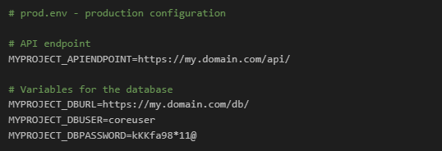

* You can then set the python.envFile setting to ${workspaceFolder}/prod.env, then set the envFile property in the debug configuration to ${workspaceFolder}/dev.env.

Note: When environment variables are specified using multiple methods, be aware that there is an order of precedence. All env variables defined in the launch.json file will override variables contained in the .env file, specified by the python.envFile setting (user or workspace). Similarly, env variables defined in the launch.json file will override the environment variables defined in the envFile that are specified in launch.json.

Use of the PYTHONPATH variable

The PYTHONPATH environment variable specifies additional locations where the Python interpreter should look for modules. In VS Code, PYTHONPATH can be set through the terminal settings (terminal.integrated.env.*) and/or within an .env file.

When the terminal settings are used, PYTHONPATH affects any tools that are run within the terminal by a user, as well as any action the extension performs for a user that is routed through the terminal such as debugging. However, in this case when the extension is performing an action that isn't routed through the terminal, such as the use of a linter or formatter, then this setting won't have an effect on module look-up

## Requirements.txt file

<https://www.geeksforgeeks.org/how-to-create-requirements-txt-file-in-python/>

Creating and maintaining a requirements.txt file is a fundamental best practice for Python development. It ensures that your project’s dependencies are well-documented and easily reproducible, making it easier for others to work on your code and reducing the likelihood of compatibility issues.

Create Requirements.txt File in Python

When working on Python projects, managing dependencies is a crucial part of the development process. Dependencies are external libraries or packages that your Python code relies on to function correctly. To ensure that your project is easily reproducible and maintainable, it’s a good practice to create a requirements.txt file. This file lists all the dependencies your project needs, making it easier for others to install and run your code.

Why Use a requirements.txt File?

A requirements.txt file serves several important purposes:

* **Reproducibility**: By specifying the exact versions of packages and libraries your project depends on, you ensure that anyone else working on your project can create the same environment and reproduce the same results.
* **Dependency** **Management**: Managing dependencies becomes more manageable. You can easily add, update, or remove packages as needed without keeping track of them manually.
* **Compatibility**: It helps avoid version conflicts between packages, ensuring that all dependencies work together harmoniously.
* **Deployment**: When deploying your application or sharing it with others, you can provide them with a requirements.txt file to install the necessary dependencies effortlessly.

### Generate requirements.txt

**Step 1: Activate Your Virtual Environment**

To create and activate a [virtual environment](https://www.geeksforgeeks.org/creating-python-virtual-environment-windows-linux/), open your terminal and run the following commands:

**# Create a virtual environment**

python -m venv myenv

**# Activate the virtual environment**

## Windows

myenv\Scripts\activate

## macOS and Linux

source myenv/bin/activate

**Step 2: Install Dependencies**

Before you can list your project’s dependencies in the requirements.txt file, you need to install them in your virtual environment. You can use pip, Python’s package manager, for this purpose. Here, Replace package-name with the actual name of the package you want to install.

pip install package-name

i.e. pip install pandas

**Step 3: Generate the requirements.txt File**

Now, you can generate the requirements.txt file by running the following command:

pip freeze > requirements.txt

Step 4: Review your requirement.txt file

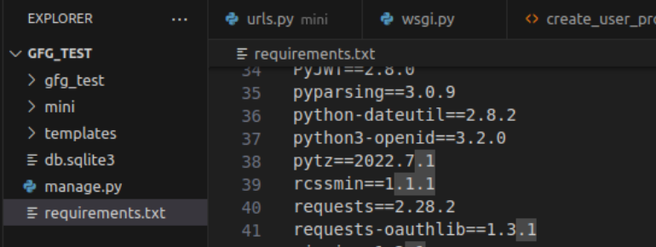

How to Create Requirements.txt File in Python – FAQs

**How to Generate requirements.txt File in Python?**

A requirements.txt file is typically used to list all of the dependencies needed for a Python project. This can be generated manually by writing out each package and its version, or automatically using tools like pip freeze.

Using pip freeze:

pip freeze > requirements.txt

This command lists all Python packages installed in the current environment and their versions, and redirects the output to a requirements.txt file.

### Setup using requirements.txt

Lets say someone takes our code including the requriements.txt file and wants to do the same setup

Starting with a blank folder to demonstrate this

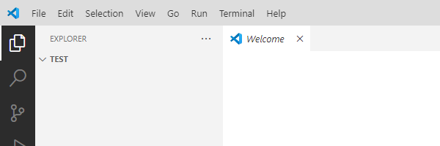

Make sure that the requirements.txt is there in the folder

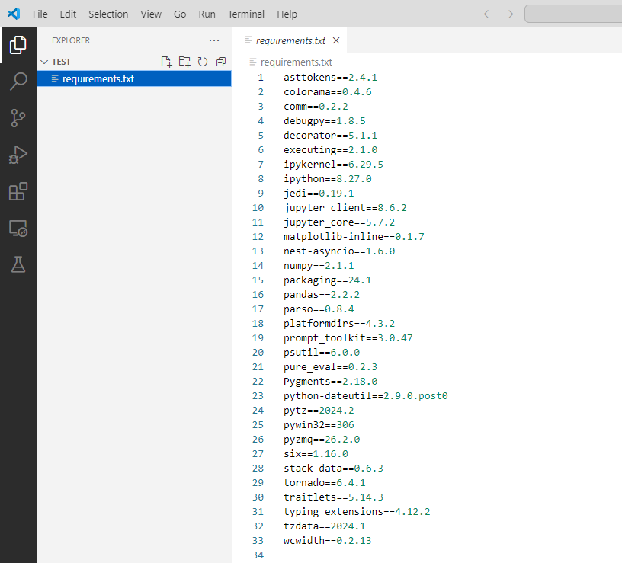

Open the command palette and click on Create Environment

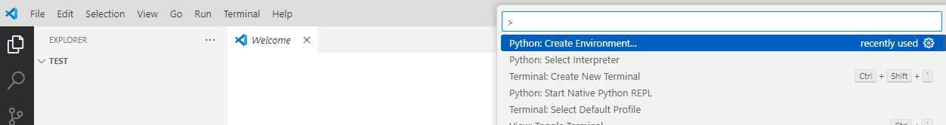

Select the .venv virtual environment in the current workspace

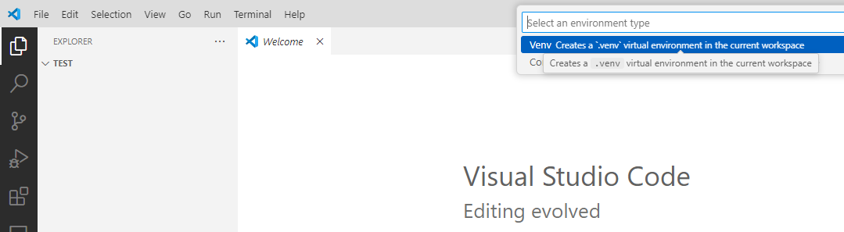

Select the Python Interpreter

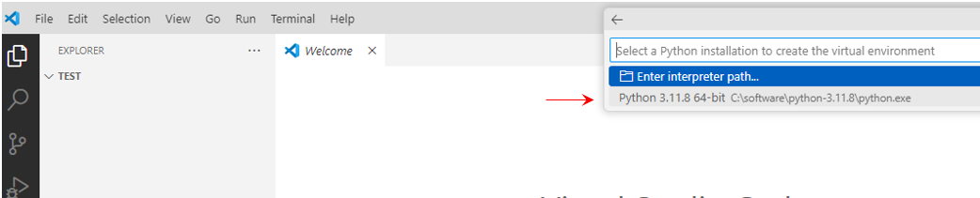

Select the requirements.txt file in the next prompt so that dependencies are installed with same version in your workspace

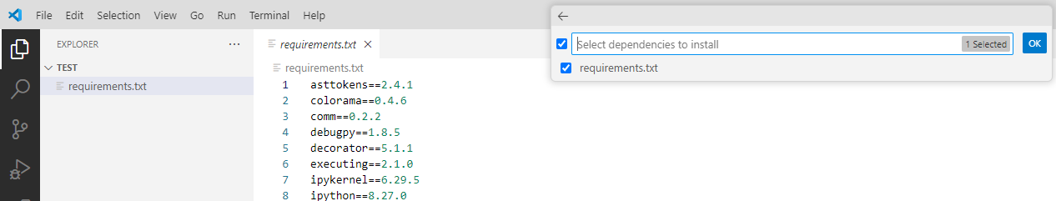

It starts creating your virtual environment with the same dependencies as in the requirements.txt file

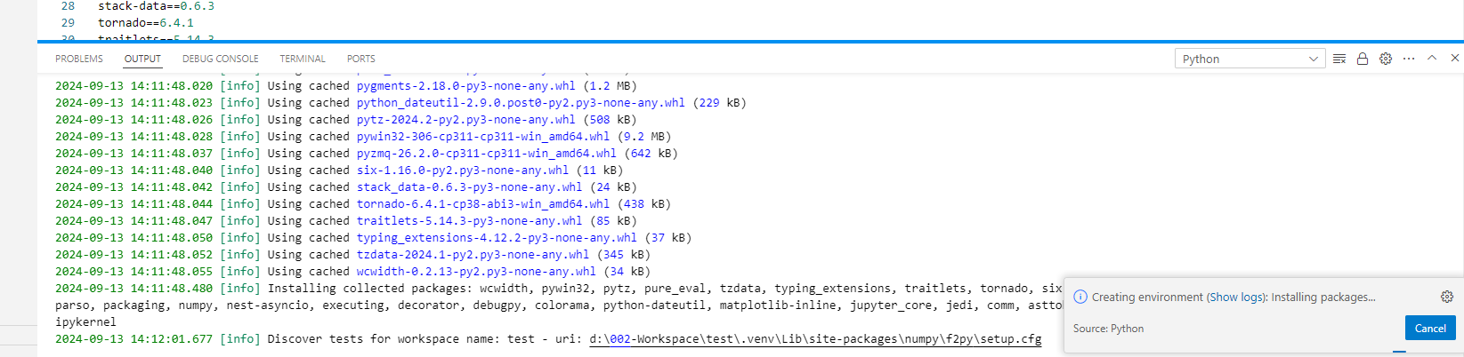

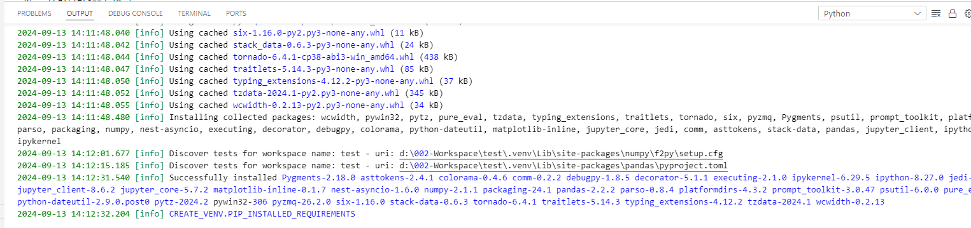

Workspace is ready now

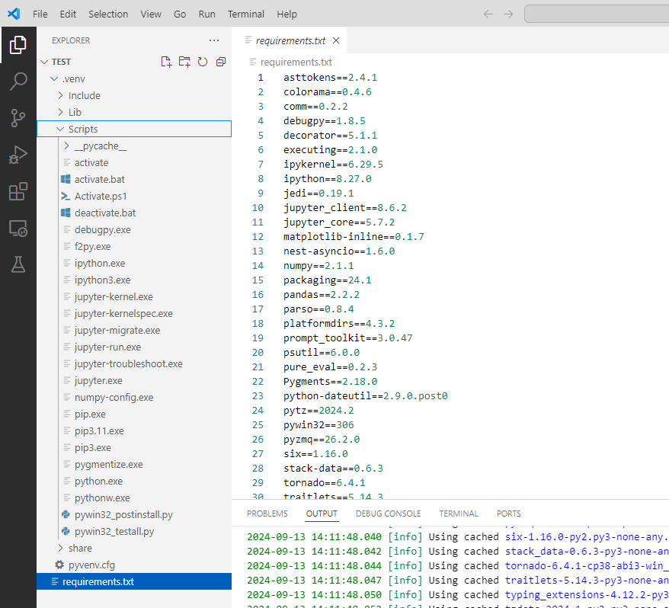

### Generate requirements.txt using pipreqs

pipreqs is a tool that generates a requirements.txt file for your Python project based on imports in your project and not just the packages installed in your Python environment. This often results in a cleaner and more accurate requirements.txt file.

**Installing pipreqs:**

pip install pipreqs

**Generating requirements.txt with pipreqs:**

pipreqs /path/to/project

This command will generate a requirements.txt file at the specified project directory based on actual usage of imports in the project files.

What is the Difference between requirements.txt and install_requires?

* Lists all the dependencies necessary for a project, often including version numbers.
* Is typically used by developers to create a consistent environment using pip install -r requirements.txt.
* This file can include dependencies not directly used by your project but by your development environment or testing framework.
* requirements.txt:
* install_requires:
* Specified in setup.py for Python packages.
* Defines a minimal set of dependencies required when installing a package using setup.py or pip install.
* It ensures that these dependencies are installed when your package is installed.
* The dependencies listed in install_requires are meant to be minimalistic, containing only those libraries that the package imports.

### Install Packages Using PIP With requirements.txt File in Python

[LINK](https://www.geeksforgeeks.org/install-packages-using-pip-with-requirements-txt-file-in-python/?ref=asr1)

Installing more than one package in Python simultaneously is a common requirement for any user migrating between operating systems. Most users are unaware of the availability of batch installing all the packages. They default to manually installing each library one after the other, which is time-consuming. This article will teach you how to install packages using pip according to the requirements.txt file from a local directory.

For installing packages from the file, the requirements.txt file would contain the following text:

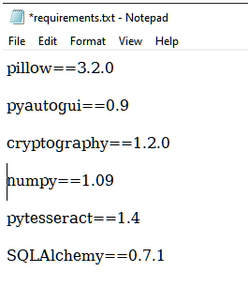

Copy the full path (absolute path) to the requirements.txt file.

Now open the command processor of your operating system. Run as administrator.

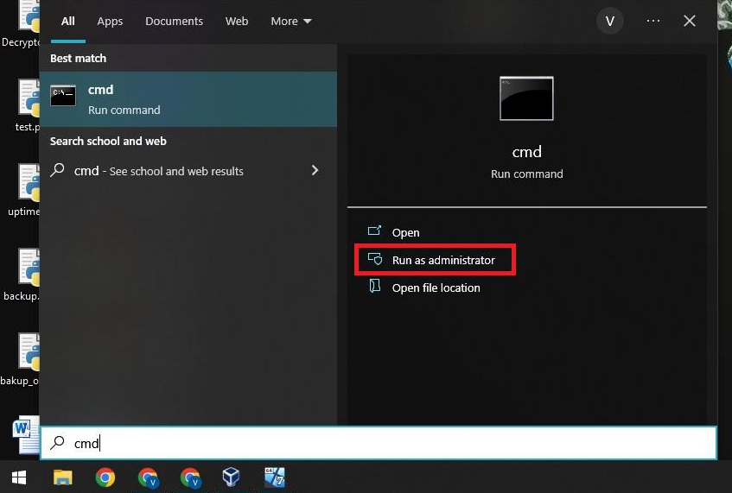

A new window similar to the above would have appeared. Now enter the following command:

pip install -r "_Path_to_requirements.txt"

Where _Path_to_requirements.txt is the full path of the file. In this case, the file resides at the following location:

C:\myproject\requirements.txt

Therefore, the command would be:

pip install -r "C:\myproject\requirements.txt"

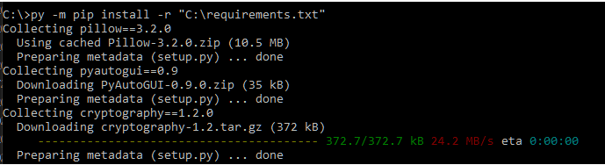

## Python in a Container

<https://code.visualstudio.com/docs/containers/quickstart-python>

## Deploy Python Web Apps

<https://code.visualstudio.com/docs/python/python-on-azure>

## Version Control – Git

Open up a folder with Visual Studio ( which has your files that are not in source control yet )

Go to Initialize Repository

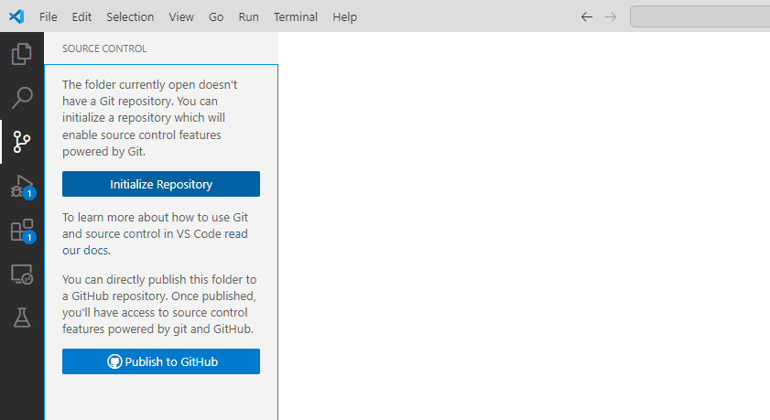

Added a .gitignore file to ignore the virtual environment folder and files in it

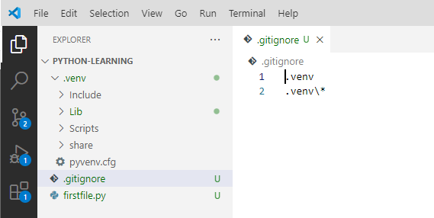

Now we see only two files in the git menu option to the left ( see image above and also the one below )

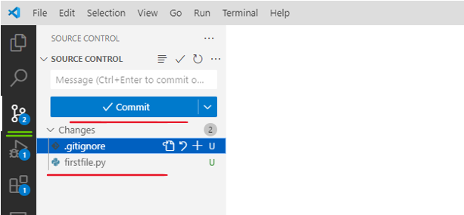

Notice at the bottom left that the branch is mentioned as main

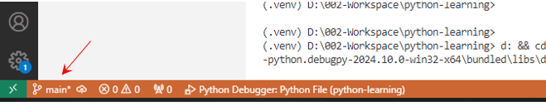

If we wanted to rename this we can simply go to the command palette and rename branch

Press F1 or Ctrl + Shift + P

|  |  |
| --- | --- |
| U stands for untracked files ( files not added to the repository yet ) |  |
| Click on the + sign here and it would become staged – has been added to the stage environment now |  |
| Observe that the letter next to the file has changed to A after clicking on the + sign, it is a staged file now |  |
| Hitting the – button here now would unstage this file again |  |

|  |  |
| --- | --- |
| To commit this file now, just add the commit message to the top text button and then hit the correct icon I have circled above it and it will commit. |  |

If this is a new code that we want to, we would first create a branch by going to the command palette

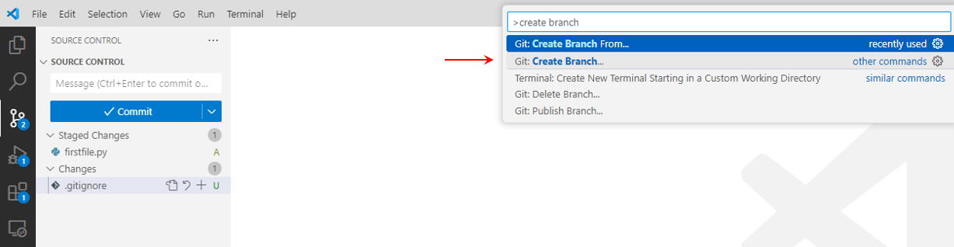

Any new lines that we add are reflected by a green line in the gutter

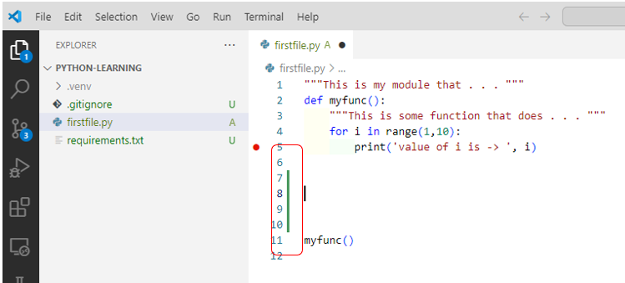

And any modifications done to a existing code ( like the highlighted text ) will be shown in dotted blue line

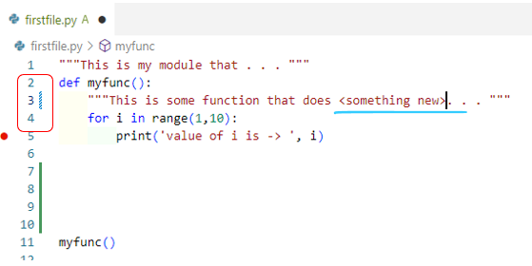

If we delete a line it will be reflected by a red arrow

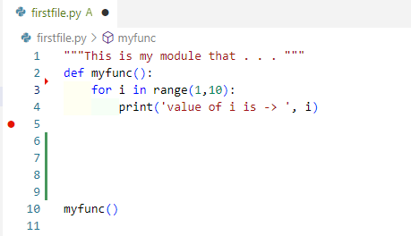

Expanding the arrow shows as below – the line we deleted

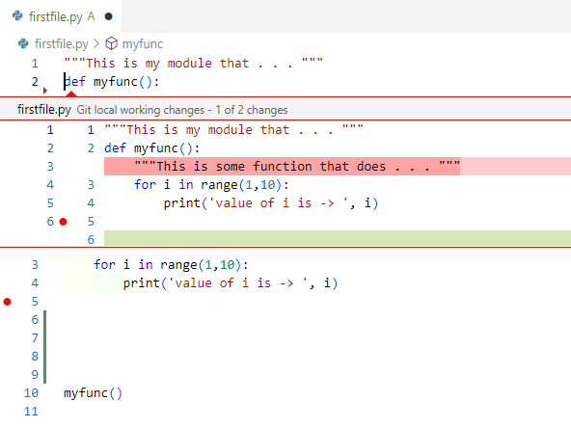

We can copy or revert the change that we made

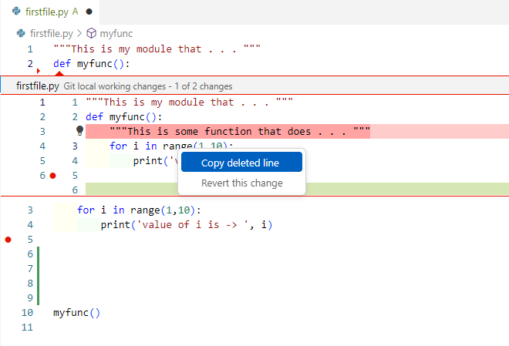

Adjacent to the file we can also see icons to open a file, discard changes that we did, stage your changes done

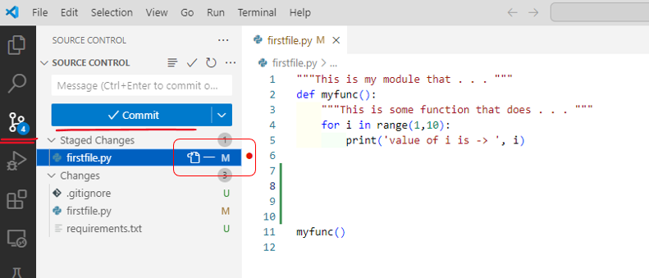

Observe that it also comes at a level above where it says staged changes – so that if there are multiple files then we can discard multiple changes or unstage multiple changes all at once

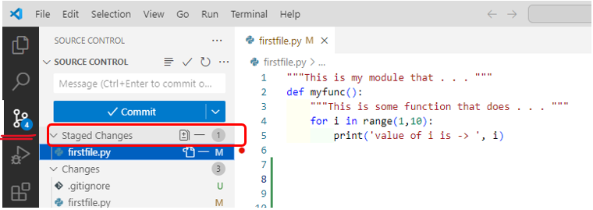

To see the changes you have done click on the “Open changes” button to the top right circled here

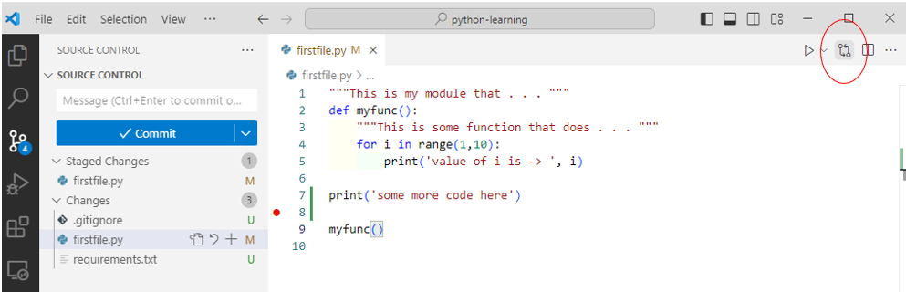

and you get a view like this

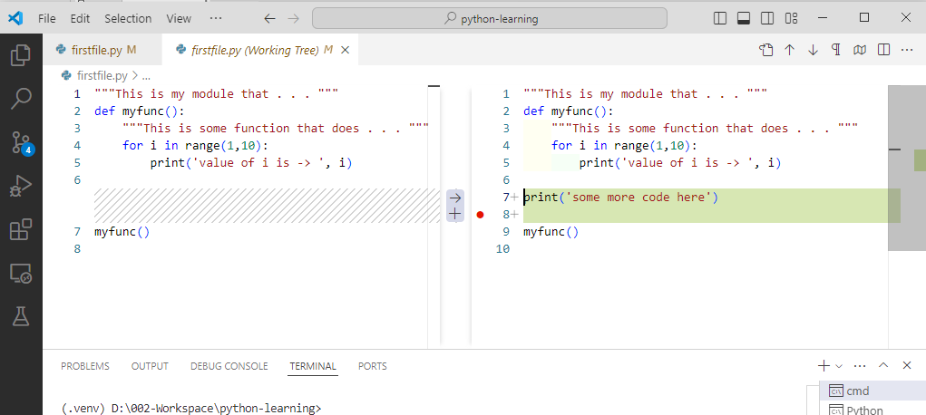

It consolidates all your changes

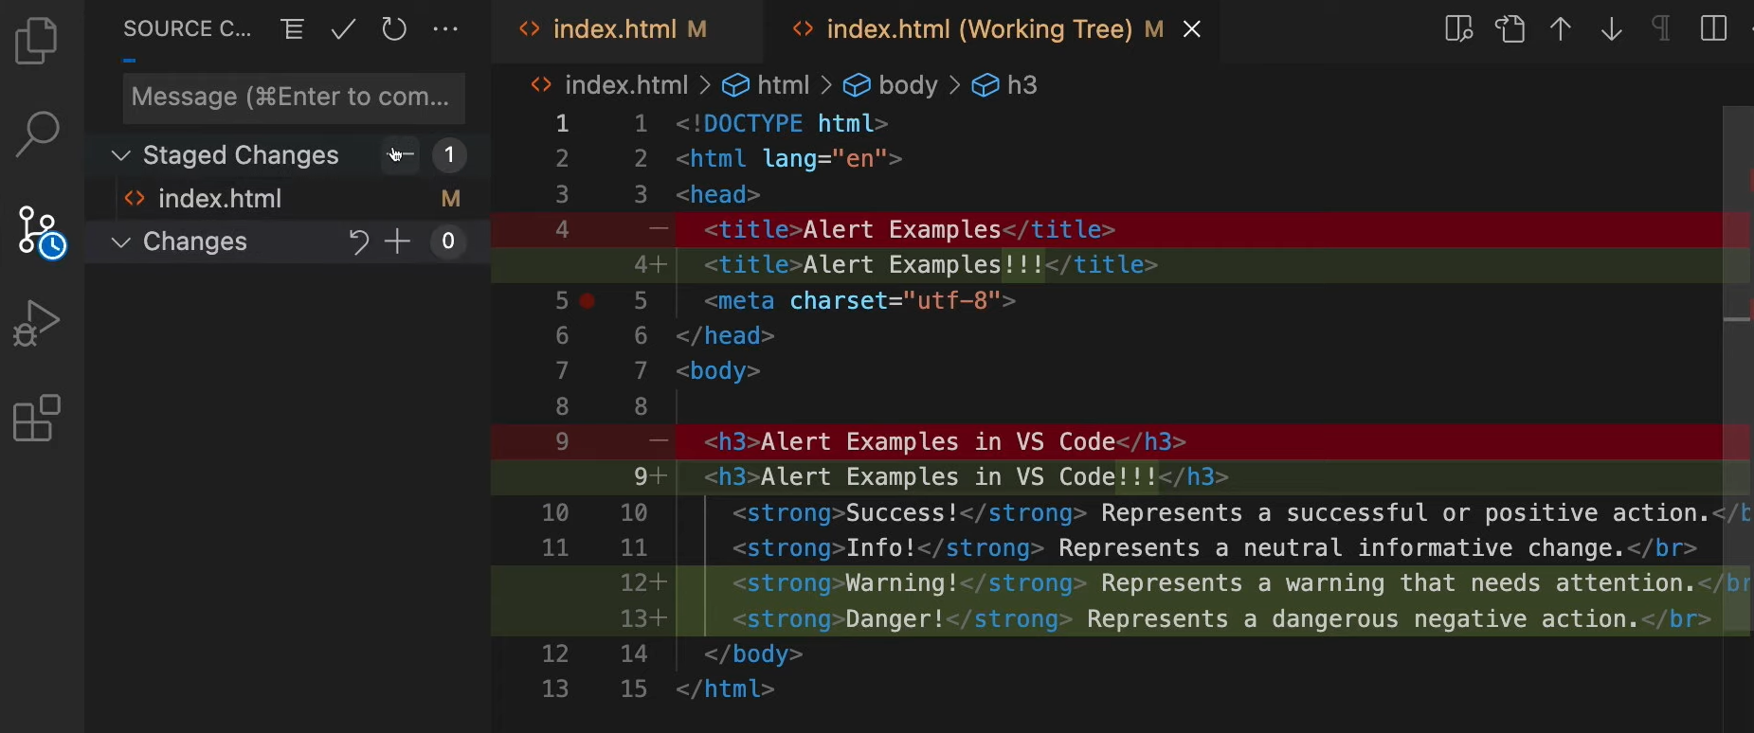

and at the bottom it says “New Feature” which is the new branch that we are working on, that is the only branch that has these changes now

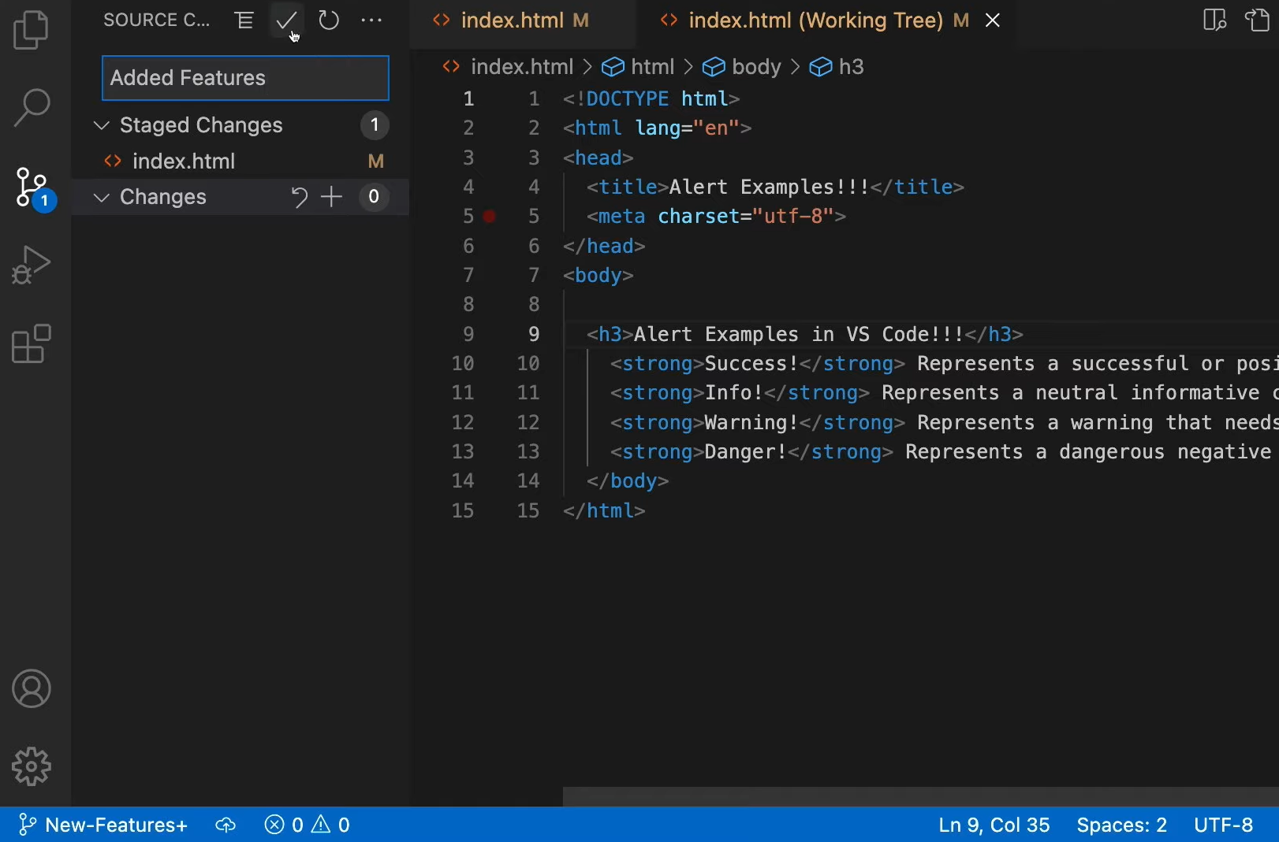

We can commit the changes to this

We can switch to the main branch now from the command palette

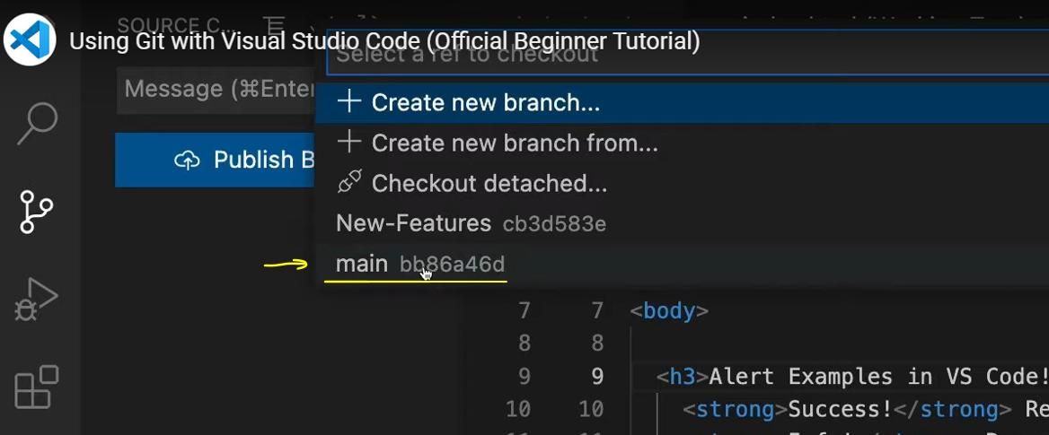

It will show us how the code was originally

If we want to put the new code to the main branch we will need to merge by going to the option highlighted below

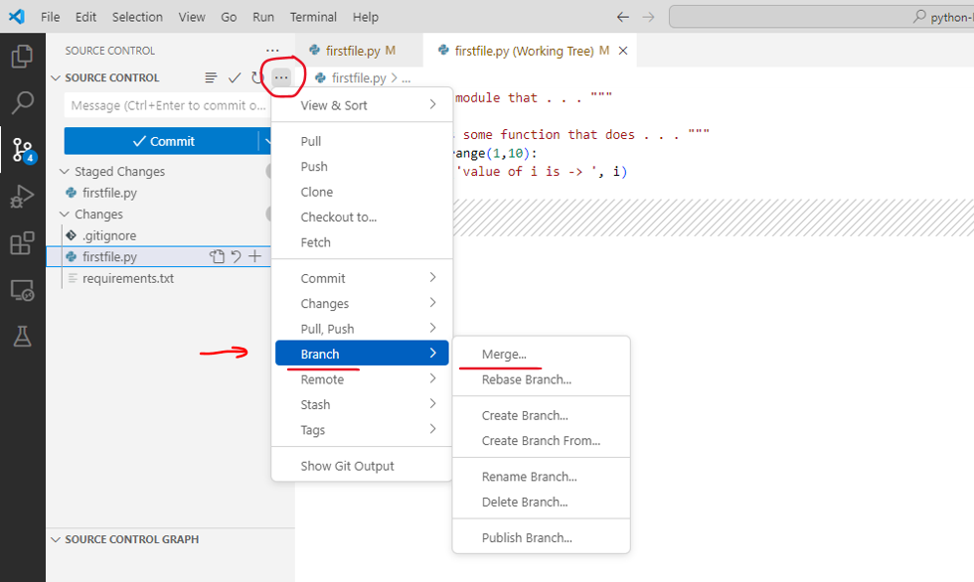

It will ask us from where

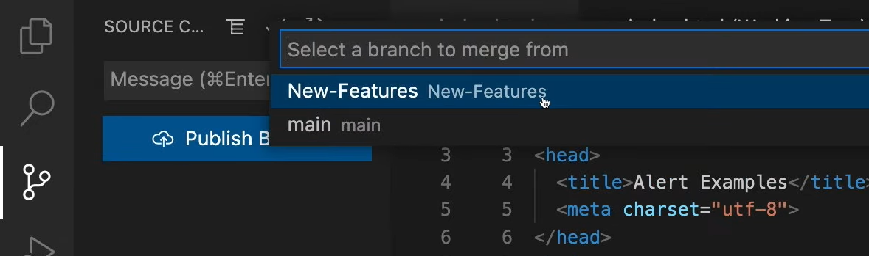

We should select New-Feature and it merge those changes after that.

Hit the publish branch button, it will pop the dialog below, allow it to connect to github

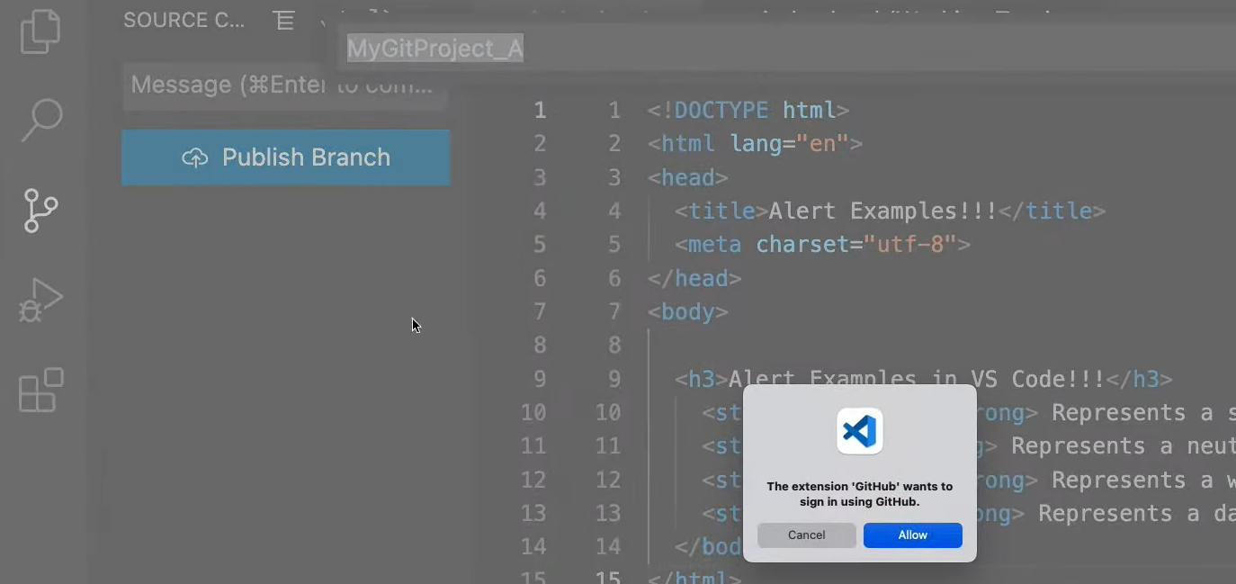

### GIT Credentials in VS Code?

<https://www.geeksforgeeks.org/how-to-add-git-credentials-in-vscode/>

We created a blank project in git repository called python

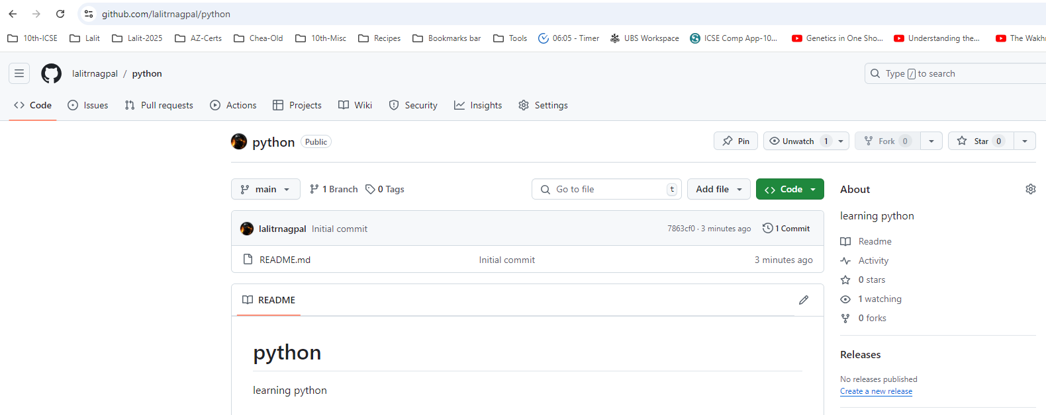

We did a git init in our workspace and it took the path of this git repository

It checked out the blank project called python in our workspace

We opened the Visual Studio in our workspace

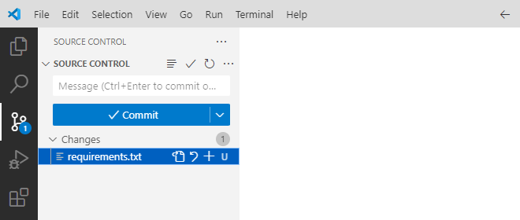

We added the requirements.txt file in the python project

Requriements.txt contained the following

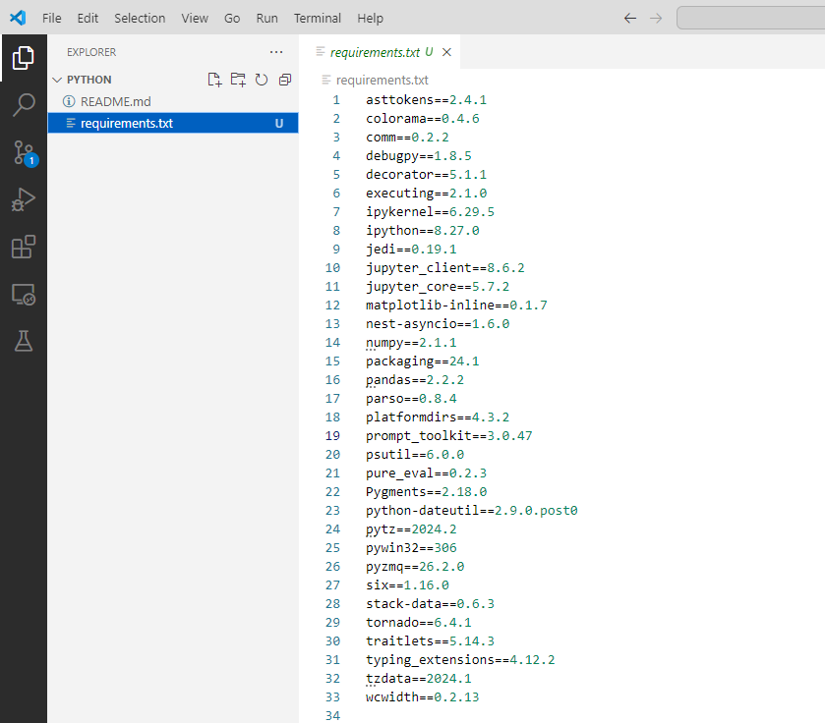

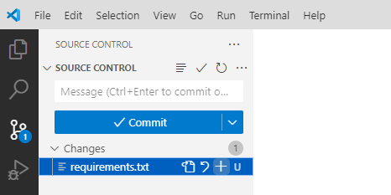

We moved the file from untracked to staged

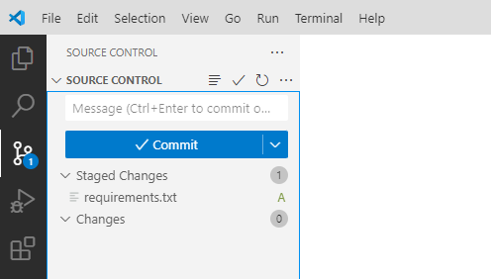

We tried to commit our code and got this error

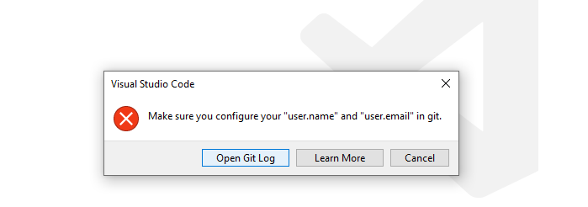

Start a new Terminal and configure your ‘user.name’ and ‘user.email’ in git with the help of the following commands.

Check the current global user.name and user.email settings

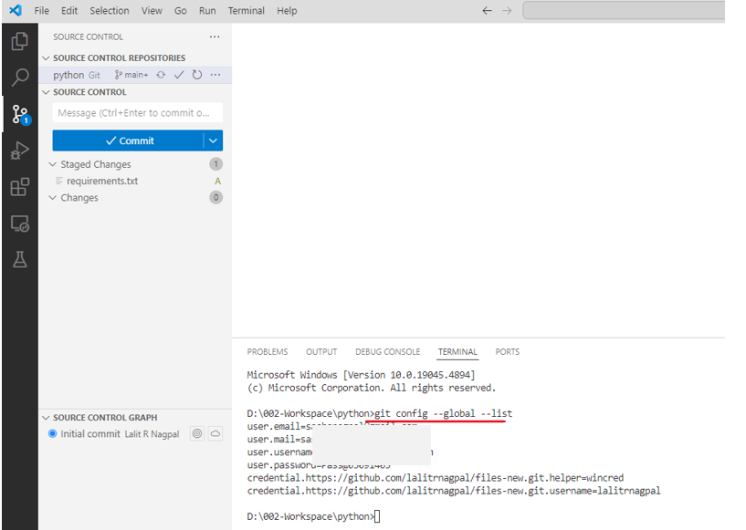

Set them correctly

git config –global user.email "you@example.com"

git config –global user.name "Your Name"

After configuring your details, you can check by using the following command.

git config --global --list

D:\002-Workspace\python>git config --global --list

user.email=lalit2801@gmail.com

user.name=lalitrnagpal

credential.https://github.com/lalitrnagpal/files-new.git.helper=wincred

credential.https://github.com/lalitrnagpal/files-new.git.username=lalitrnagpal

Add your credentials via the following steps

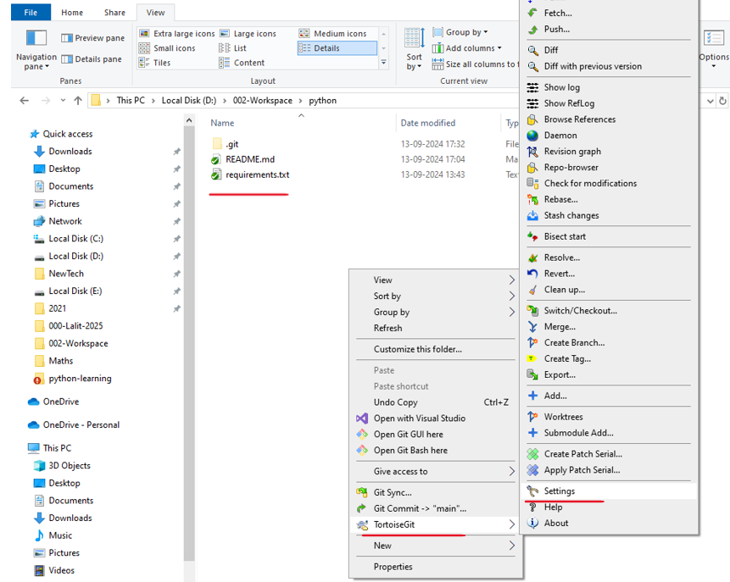

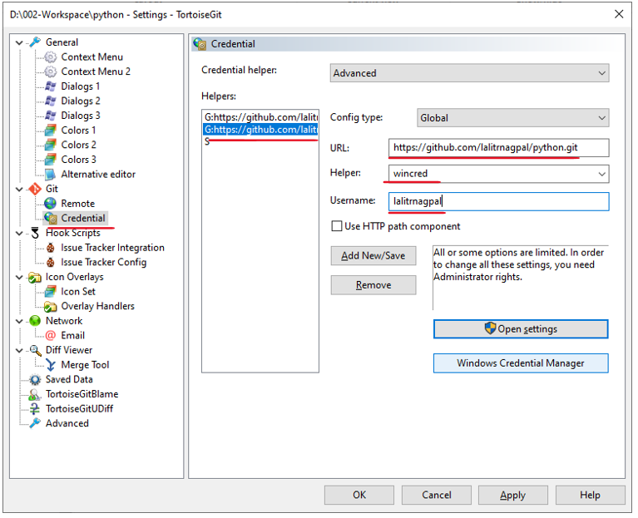

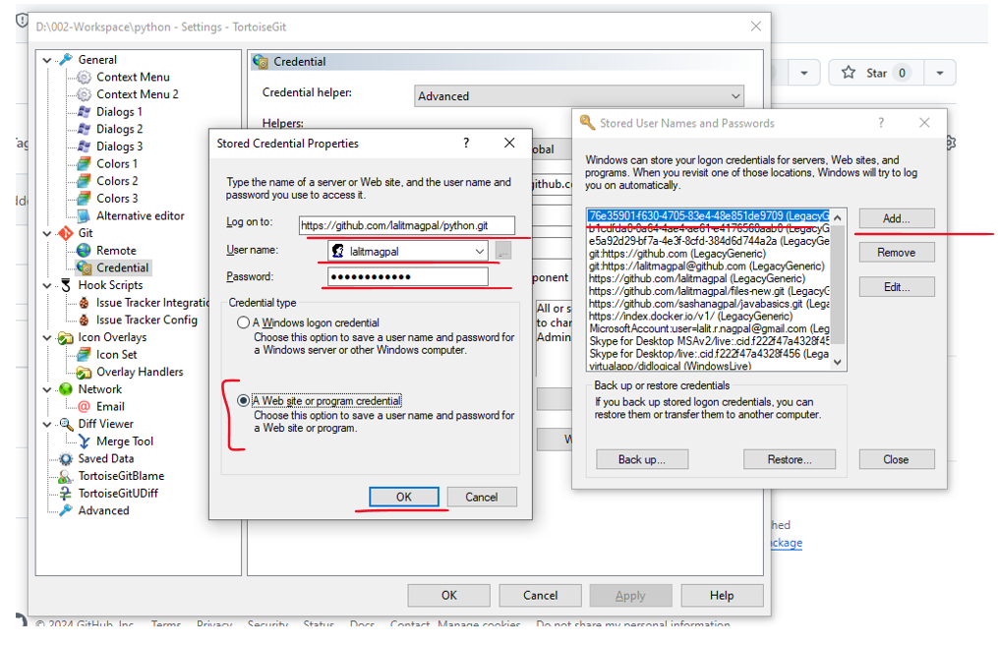

Add a new file

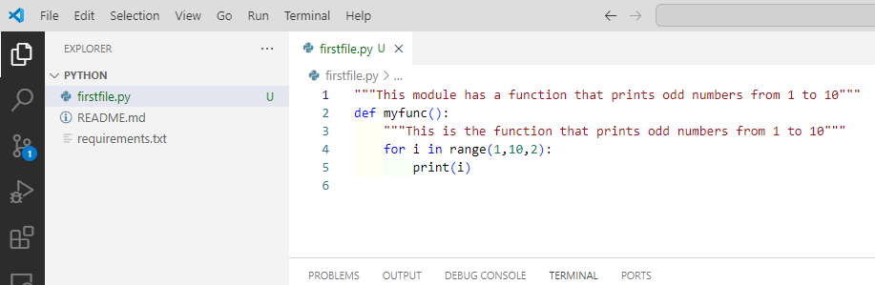

Stage it

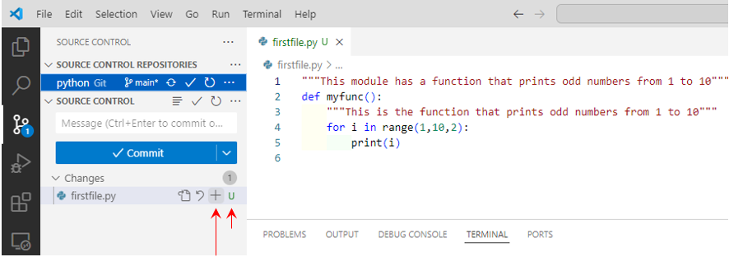

Commit it after adding the commit message

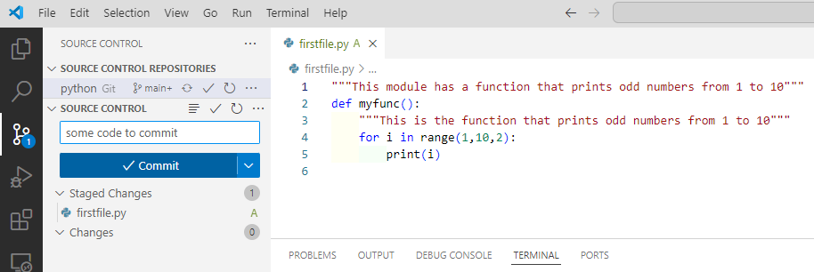

Authorize it to connect to github via a browser

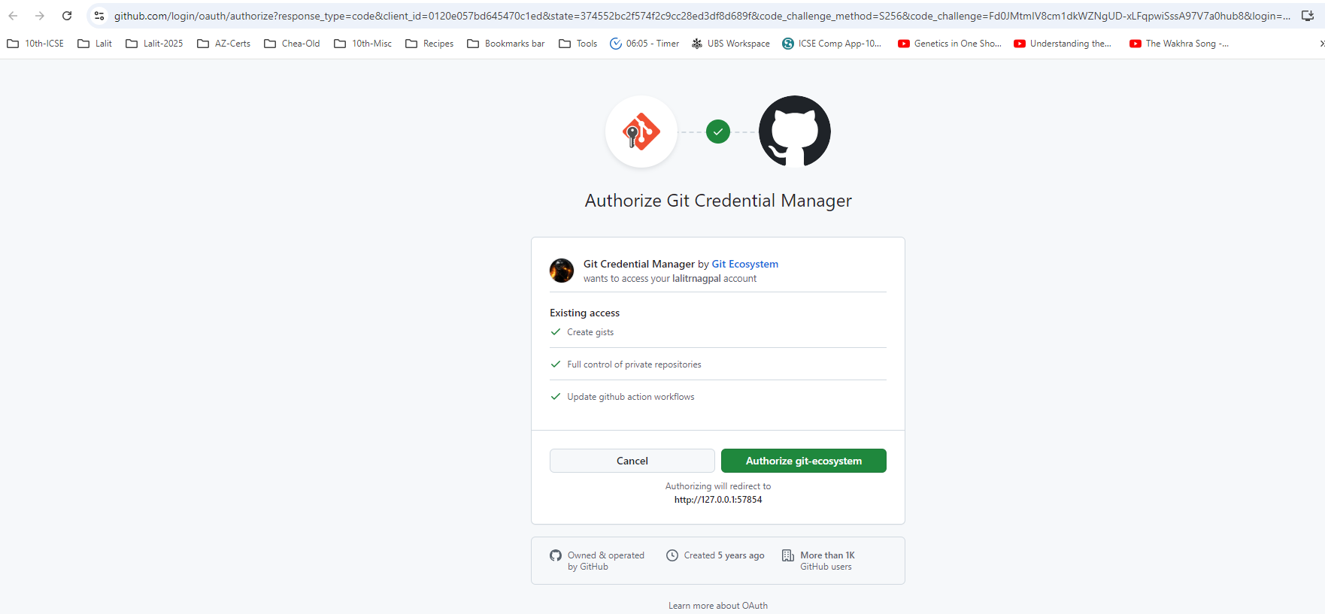

Changes are committed now

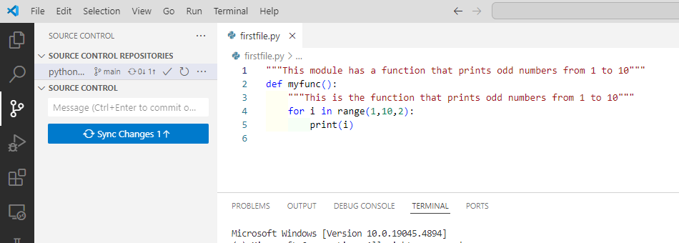

Sync the changes

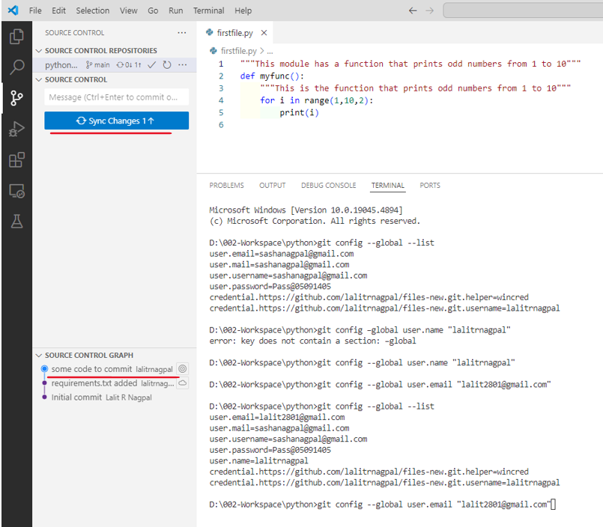

Say ok for below prompt

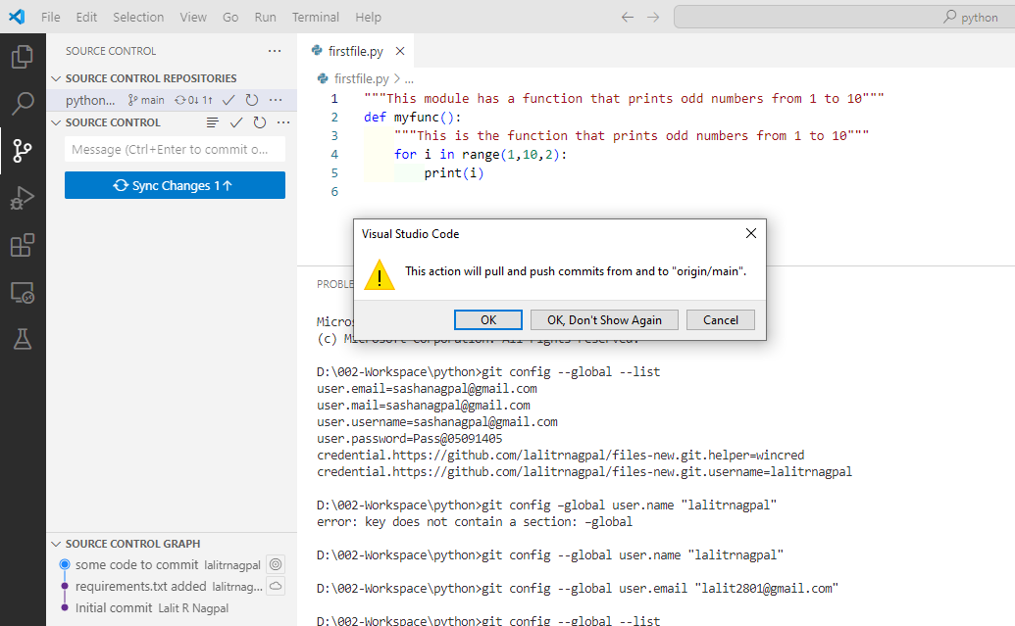

Changes are committed to the git repository now

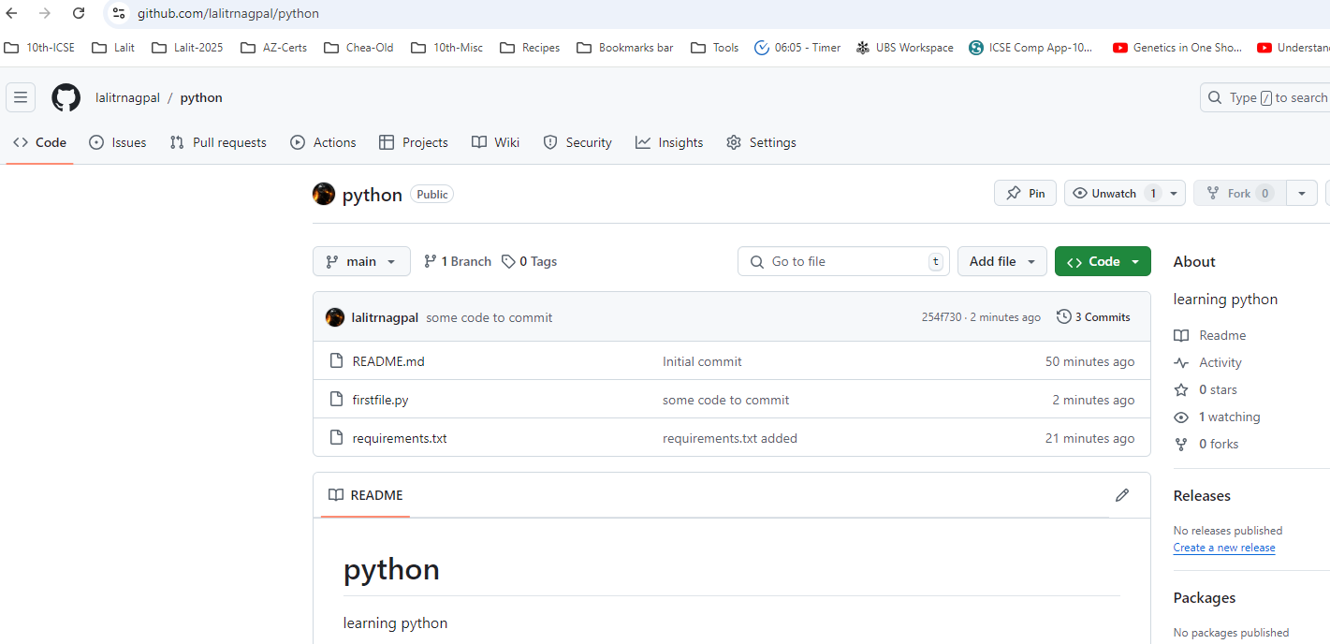

### Working with a Feature Branch

Notice that we are currently on the main branch, see at bottom left of your VS code

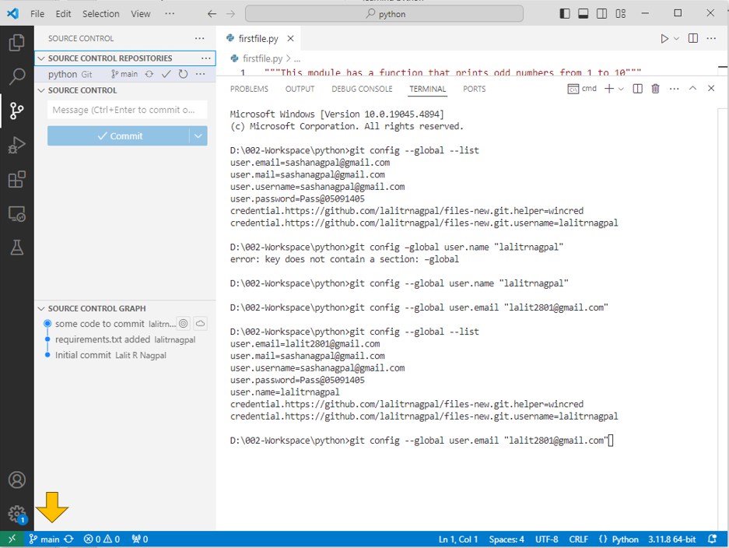

Assuming we are building a feature – lets create a new branch

Go to the command palette

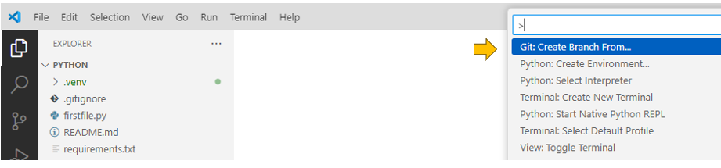

from the main branch that we were working from

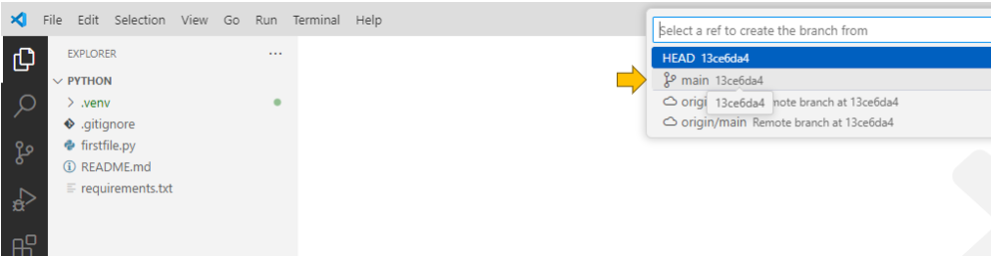

Give it a name like “some-feature”

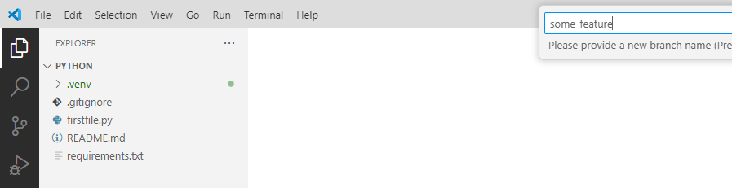

We are now on the “some-feature” branch

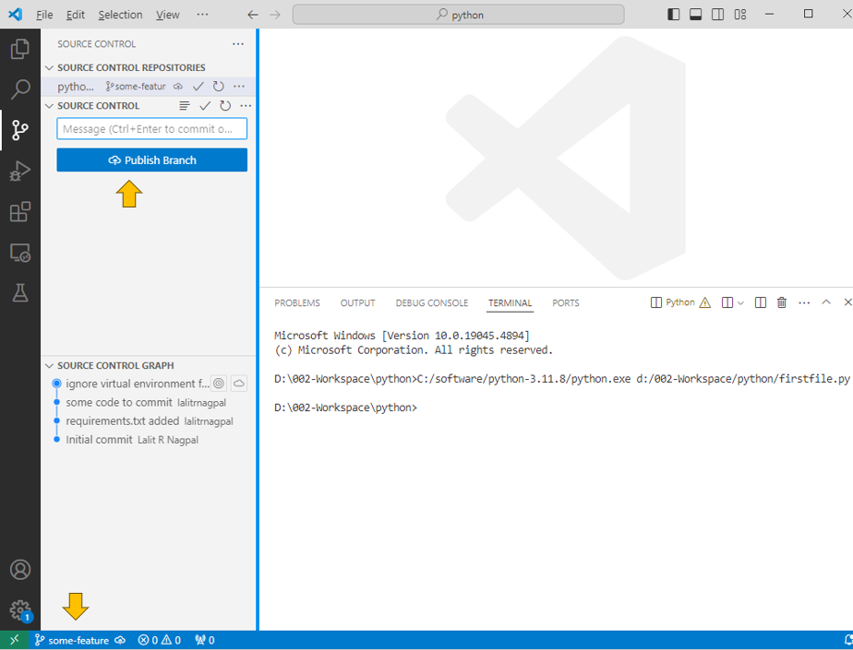

Publish the branch by hitting the publish branch button

Lets add another file ( as a part of the feature that we are developing )

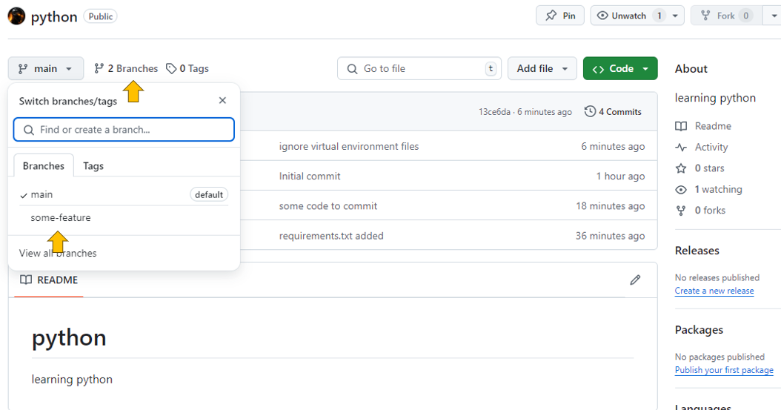

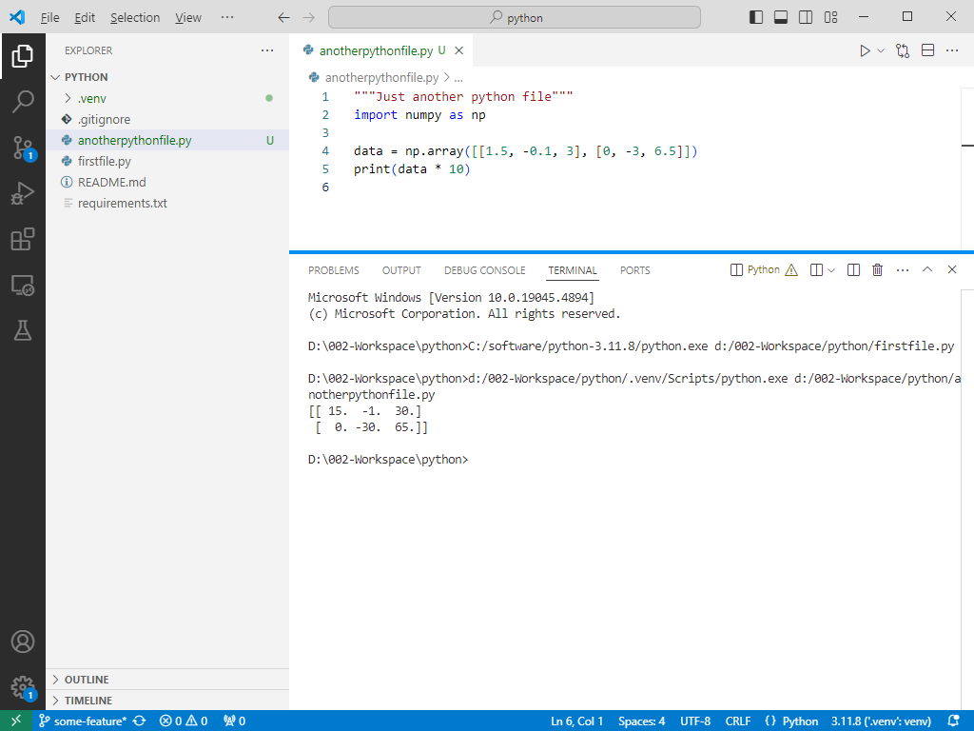

Stage the changes and commit them

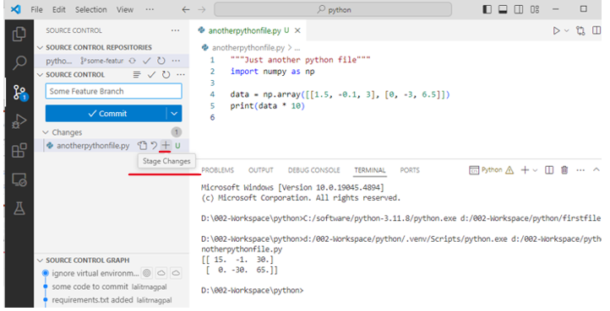

Put the commit message in the text and commit the file ( forgot to take the screenshot of that )

Sync the changes now

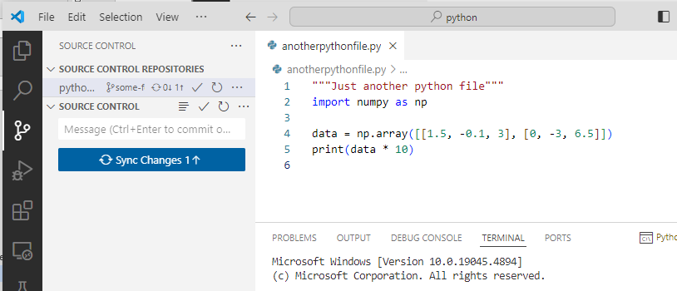

Say ok to the prompt

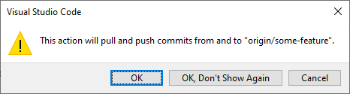

Commit is done and we can see that in the feature branch

Its not in the main branch

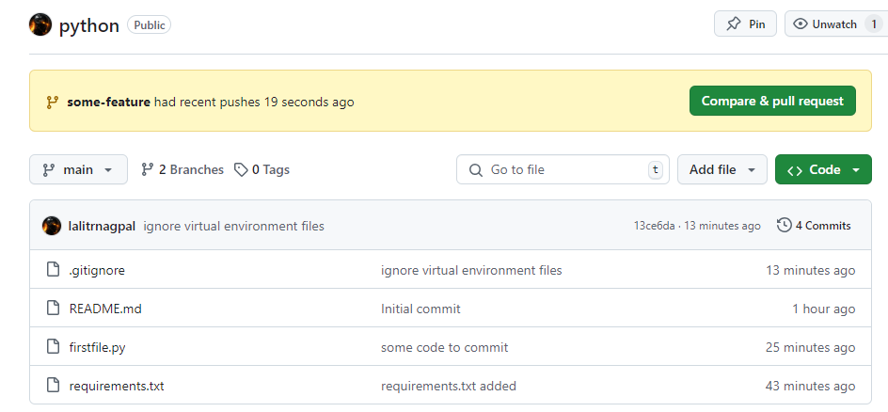

Its in the feature branch

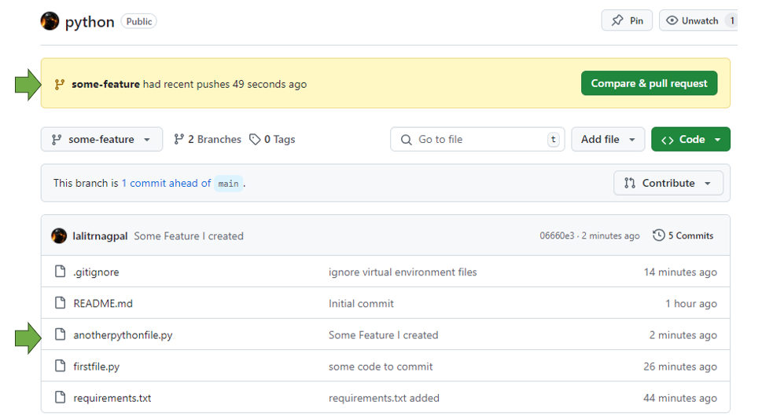

Time to merge our changes to the main branch – select the main branch in VS

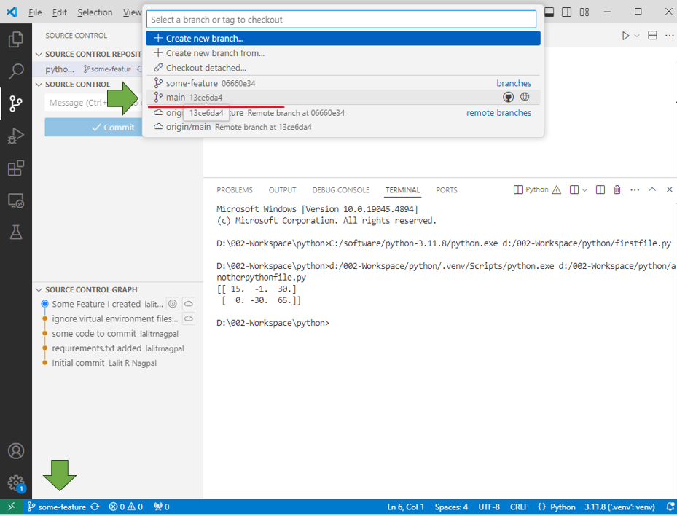

It does now show our new file now – as it is in the feature branch not in main

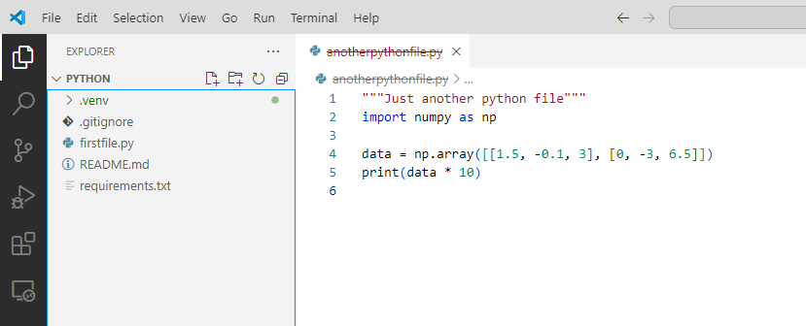

Lets merge by selecting merge from the 3 dot menu highlighted here

( Note you should be in the repositories view )

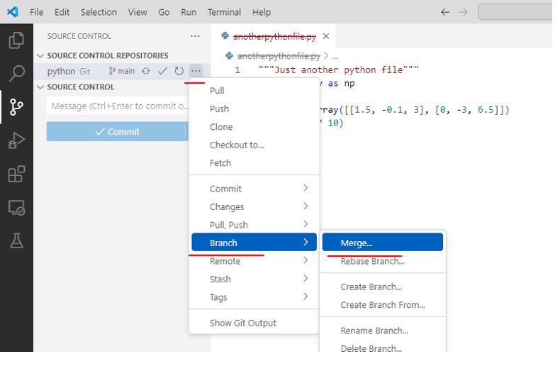

Select the feature branch

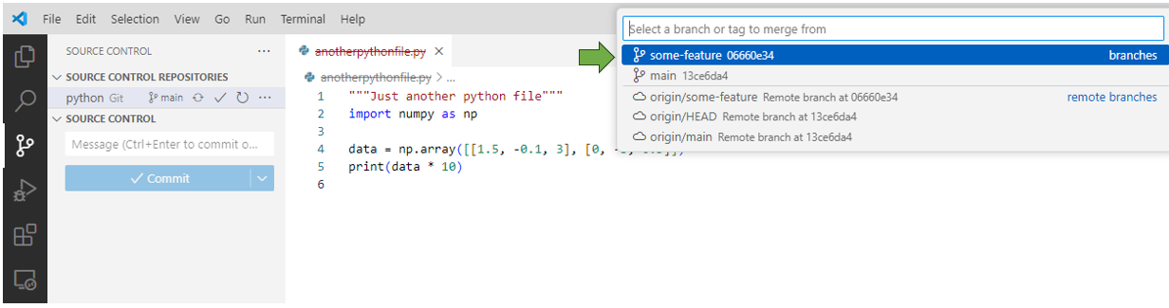

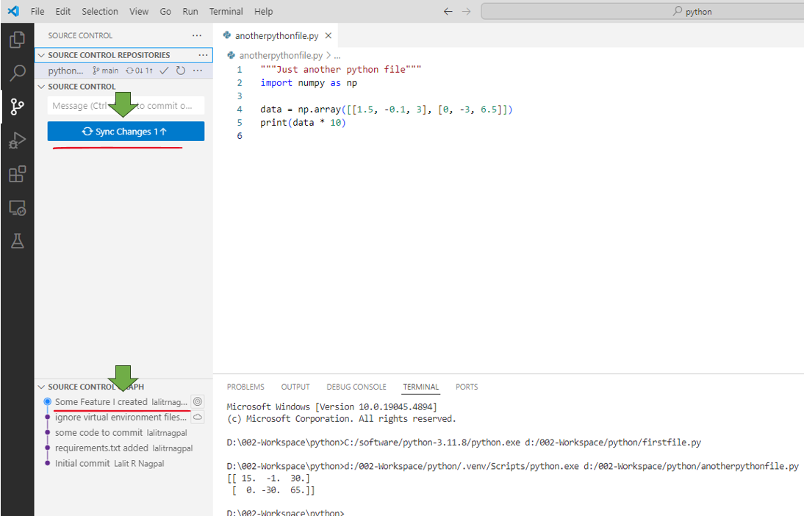

Sync changes, Say OK to below prompt and we are done

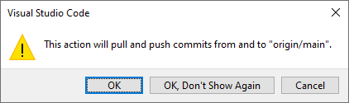

The file appeared in the main branch

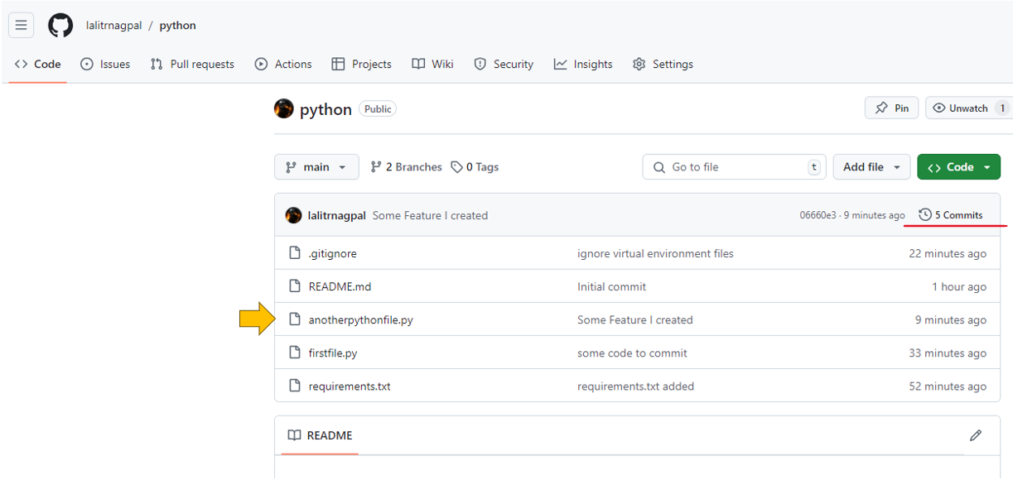

Click on the 5 commits link at right side and you can see the changes have been brought in

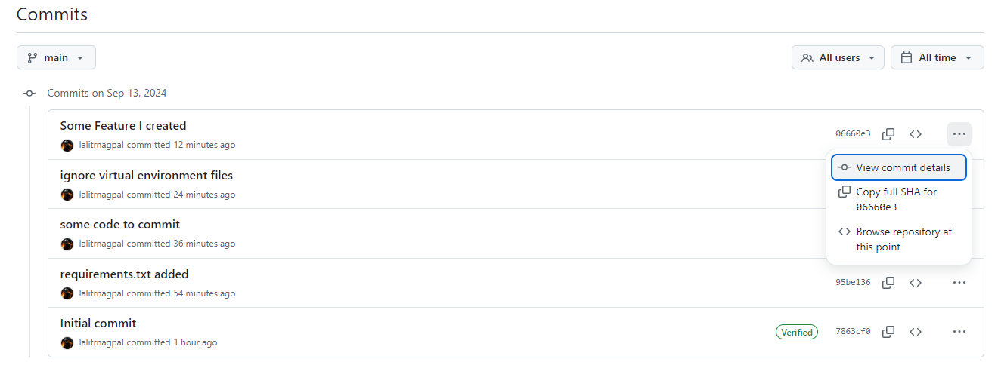

Click on View Commit details and you see

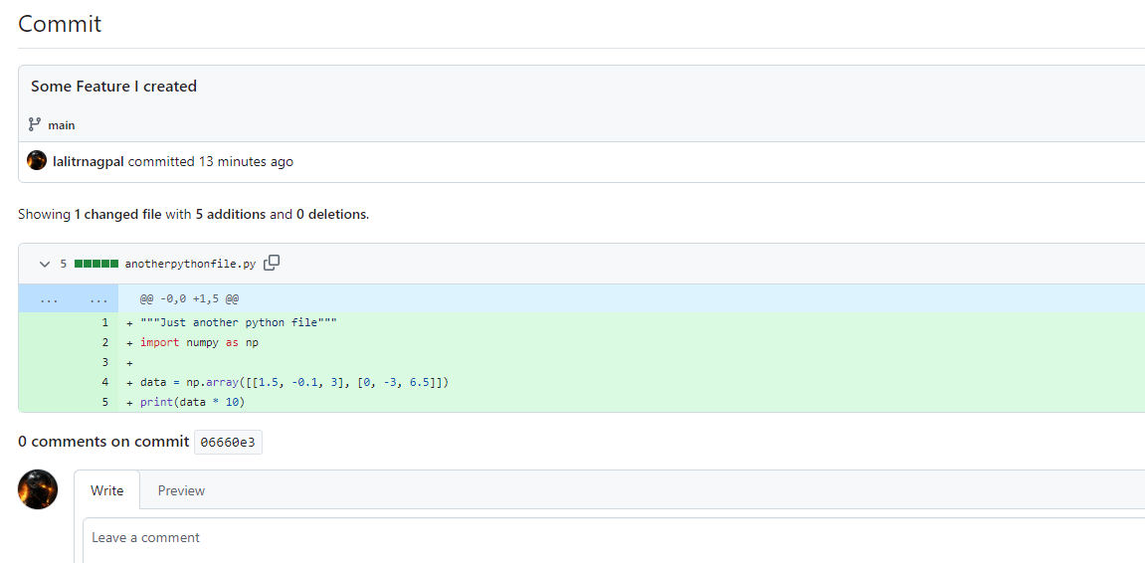

### Connecting Github with SSH

You can connect to GitHub using the Secure Shell Protocol (SSH), which provides a secure channel over an unsecured network.

<https://docs.github.com/en/authentication/connecting-to-github-with-ssh/checking-for-existing-ssh-keys>

Before you generate a new SSH key, you should check your local machine for existing keys.

Note: GitHub improved security by dropping older, insecure key types on March 15, 2022.

As of that date, DSA keys (ssh-dss) are no longer supported. You cannot add new DSA keys to your personal account on GitHub.

RSA keys (ssh-rsa) with a valid_after before November 2, 2021 may continue to use any signature algorithm. RSA keys generated after that date must use a SHA-2 signature algorithm. Some older clients may need to be upgraded in order to use SHA-2 signatures.

➊ Open Git Bash.

➋ Enter ls -al ~/.ssh to see if existing SSH keys are present.

$ ls -al ~/.ssh

# Lists the files in your .ssh directory, if they exist

➌ Check the directory listing to see if you already have a public SSH key. By default, the filenames of supported public keys for GitHub are one of the following.

id_rsa.pub

id_ecdsa.pub

id_ed25519.pub

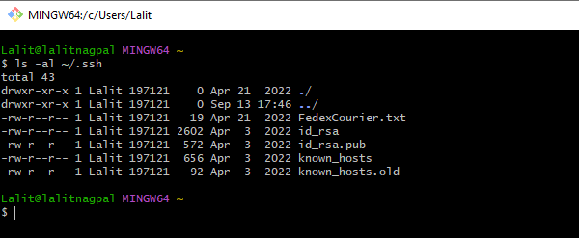

Tip: If you receive an error that ~/.ssh doesn't exist, you do not have an existing SSH key pair in the default location. You can create a new SSH key pair in the next step.

➍ Either generate a new SSH key or upload an existing key.

1. If you don't have a supported public and private key pair, or don't wish to use any that are available, generate a new SSH key.
2. If you see an existing public and private key pair listed (for example, id_rsa.pub and id_rsa) that you would like to use to connect to GitHub, you can add the key to the ssh-agent.
3. For more information about generation of a new SSH key or addition of an existing key to the ssh-agent, see "Generating a new SSH key and adding it to the ssh-agent."

Generating a new SSH key and adding it to the ssh-agent

You can access and write data in repositories on GitHub using SSH (Secure Shell Protocol). When you connect via SSH, you authenticate using a private key file on your local machine.

You can generate a new SSH key on your local machine. After you generate the key, you can add the public key to your account on GitHub.com to enable authentication for Git operations over SSH.

If you don't already have an SSH key, you must generate a new SSH key to use for authentication.

If you want to use a hardware security key to authenticate to GitHub, you must generate a new SSH key for your hardware security key. You must connect your hardware security key to your computer when you authenticate with the key pair.

For more information, see the [OpenSSH 8.2 release notes](https://www.openssh.com/txt/release-8.2).

➊ Open Git Bash.

➋ Paste the text below, replacing the email used in the example with your GitHub email address.

ssh-keygen -t ed25519 -C "your_email@example.com"

If you are using a legacy system that doesn't support the Ed25519 algorithm, use:

ssh-keygen -t rsa -b 4096 -C "your_email@example.com"

This creates a new SSH key, using the provided email as a label.

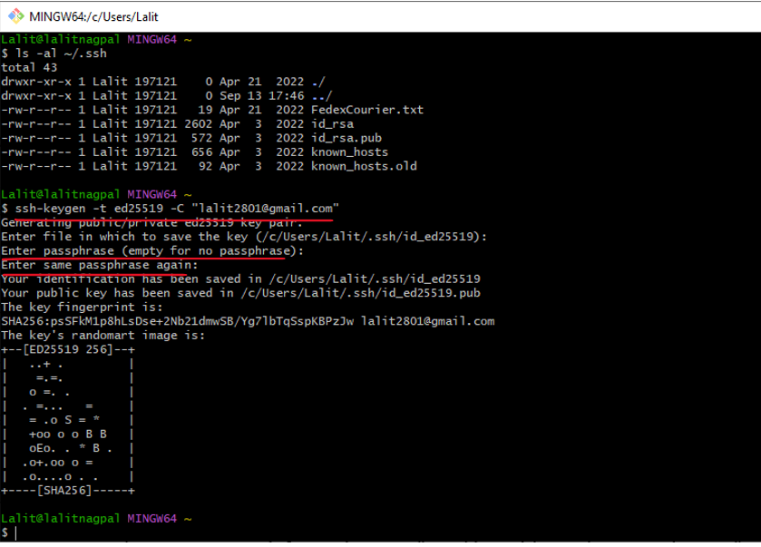

When you're prompted to "Enter a file in which to save the key", you can press Enter to accept the default file location. Please note that if you created SSH keys previously, ssh-keygen may ask you to rewrite another key, in which case we recommend creating a custom-named SSH key. To do so, type the default file location and replace id_ALGORITHM with your custom key name.

> Enter file in which to save the key (/c/Users/YOU/.ssh/id_ALGORITHM):[Press enter]

➌ At the prompt, type a secure passphrase. For more information, see "Working with SSH key passphrases."

> Enter passphrase (empty for no passphrase): [Type a passphrase]

> Enter same passphrase again: [Type passphrase again]

Adding your SSH key to the ssh-agent

<https://darraghoriordan.medium.com/how-to-use-ssh-with-git-and-ssh-agent-on-windows-7aeb1f64724>

Before adding a new SSH key to the ssh-agent to manage your keys, you should have checked for existing SSH keys and generated a new SSH key.

If you have GitHub Desktop installed, you can use it to clone repositories and not deal with SSH keys.

Configure git to use Windows ssh

# tell git to use ssh.exe

git config --global core.sshCommand "'C:\Windows\System32\OpenSSH\ssh.exe'"

➊ In a new admin elevated PowerShell window, ensure the ssh-agent is running. You can use the "Auto-launching the ssh-agent" instructions in "Working with SSH key passphrases", or start it manually:



If your powershell window closes immediately after opening do the following

<https://answers.microsoft.com/en-us/windows/forum/all/powershell-closes-immediately/a0dbc3a0-8ea6-468c-a891-a5a2a821befb>

1. Press on Win+X keys and select Control Panel.
2. From Control Panel switch to category.
3. And from the list that’s displayed choose Uninstall – located under Programs.
4. From the left panel of the main window click on the ‘Turn Windows features on or off’ link.
5. Scroll down and locate the Windows PowerShell entry.
6. Uncheck the PowerShell feature.
7. Save and apply your changes.
8. Restart your Windows 10 computer.
9. Afterwards, repeat the steps from above and re-enable the Windows PowerShell feature.

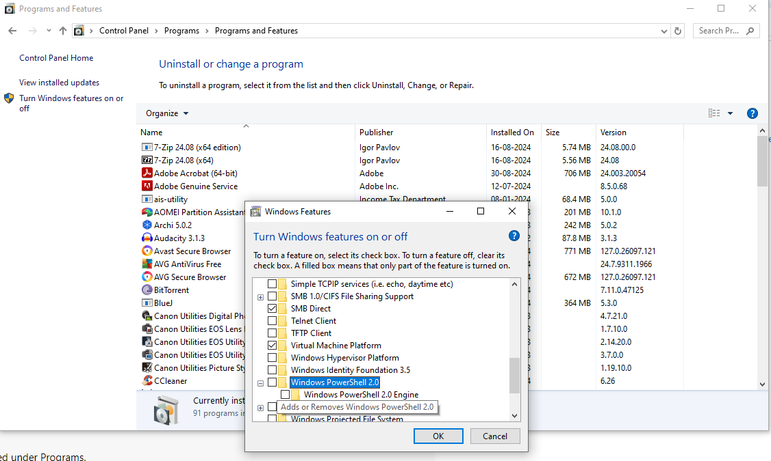

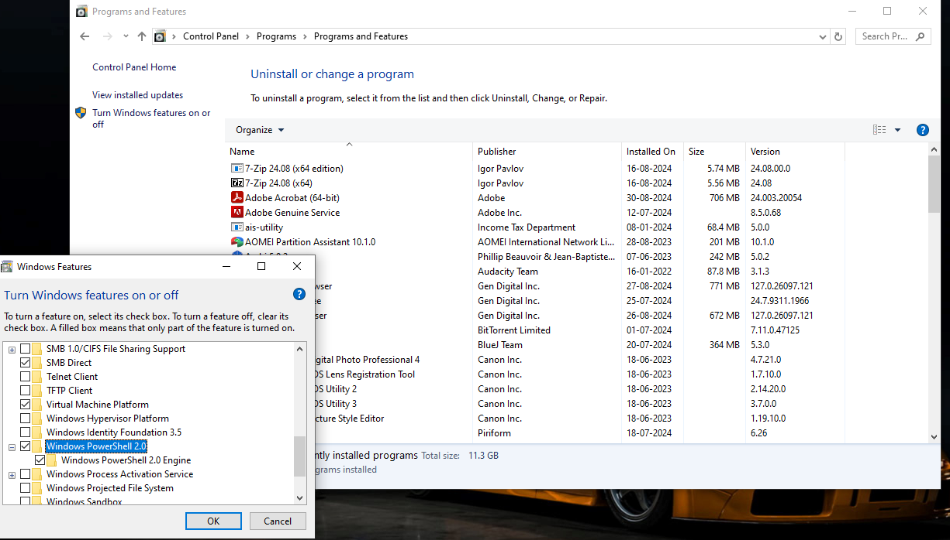

And then it should work

# start the ssh-agent in the background

Get-Service -Name ssh-agent | Set-Service -StartupType Manual

Start-Service ssh-agent

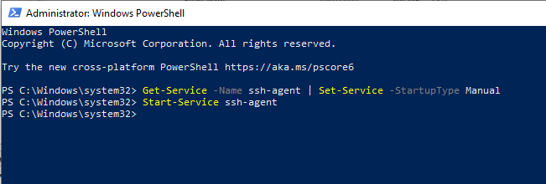

➋ In a terminal window without elevated permissions, add your SSH private key to the ssh-agent. If you created your key with a different name, or if you are adding an existing key that has a different name, replace id_ed25519 in the command with the name of your private key file.

ssh-add c:/Users/YOU/.ssh/id_ed25519

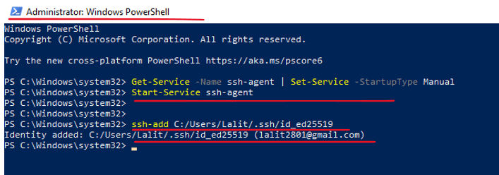

➌ Add the SSH public key to your account on GitHub. For more information, see "Adding a new SSH key to your GitHub account."

Need to verify if there is a PGP/ SSH option under Access tab on a paid premium account, doesn’t show on free public account

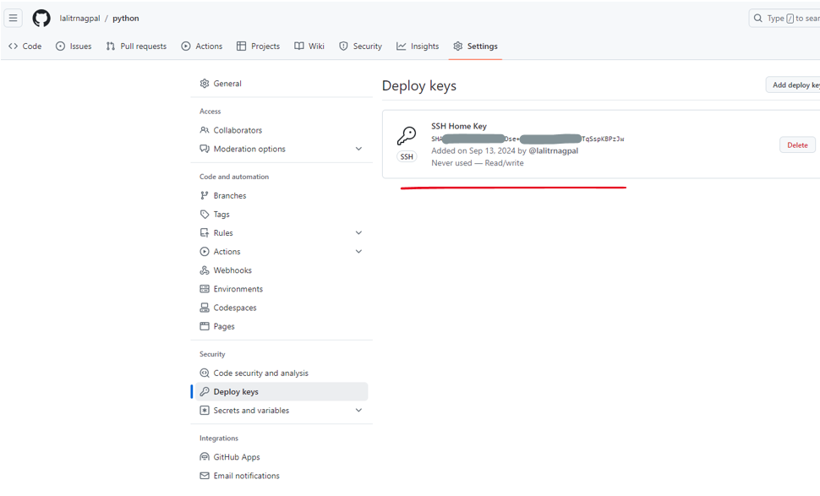

## Markdown Support

Documentation

<https://www.markdownguide.org/>

<https://www.markdownguide.org/basic-syntax/>

<https://www.markdownguide.org/extended-syntax/>

To preview a markdown file in Visual Source Code – press ctrl + shift + v

Sample markdowns and the preview

### > Syntax for expressions

### Dictionary Creation

```

{ key: expr, . . . }

```

### Set creation

```

{ expr, ... }

```

### List creation

```

[ expr, ... ]

```

Preview as follows ( Ctrl + Shift + V )

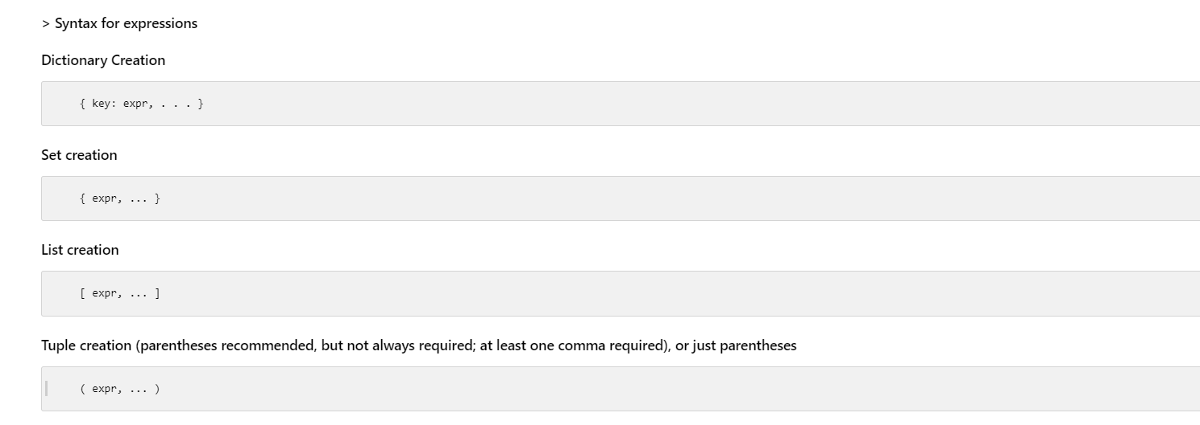

# Python Interpreter

The Python interpreter program is run as python. The program includes both the interpreter itself and the Python compiler,

which is implicitly invoked as needed on imported modules. On Windows, press the Windows key and start typing python. “Python 3.x” (the command-line version) appears, along with other choices, such as “IDLE” (the Python GUI).

|  |  |
| --- | --- |
|  |  |

## Environment Variables

Besides PATH, other environment variables affect the python program.

PYTHONHOME

The Python installation directory. A lib subdirectory, containing the Python standard library, must be under this directory. On Unix-like systems, standard library modules should be in lib/python-3.x for Python 3.x, where x is the minor Python version. If PYTHONHOME is not set, Python makes an informed guess about the installation directory

PYTHONPATH

A list of directories from which Python can import modules, separated by colons on Unix-like systems and by semicolons on Windows,. This list extends the initial value for Python’s sys.path variable

PYTHONSTARTUP

The name of a Python source file to run each time an interactive interpreter session starts. No such file runs if you don’t set this variable, or set it to the path of a file that is not found. The PYTHONSTARTUP file does not run when you run a Python script; it runs only when you start an interactive session.

The Python interpreter’s command-line syntax can be summarized as follows:

[path]python {options} [-c command | -m module | file | -] {args}

Brackets ([]) enclose what’s optional, braces ({}) enclose items of which zero or more may be present, and bars (|) mean a choice among alternatives. Python uses a slash (/) for filepaths, as in Unix. Running a Python script at a command line can be as simple as:

$ python hello.py

Hello World

You can also explicitly provide the path to the script:

$ python ./hello/hello.py

Hello World

The filename of the script can be an absolute or relative filepath, and need not have any specific extension (although it is conventional to use a .py extension).

## Options

**options** are case-sensitive short strings, starting with a hyphen, that ask python for nondefault behavior. python accepts only options that start with a hyphen (-). The most frequently used options are listed in Table 2-1. Each option’s description gives the environment variable (if any) that, when set, requests that behavior. Many options have longer versions, starting with two hyphens, as shown by python -h.

Frequently used python command-line options

|  |  |
| --- | --- |
| Option | Meaning (and corresponding environment variable, if any) |
| -B | Don’t save bytecode files to disk (PYTHONDONTWRITEBYTECODE) |
| -c | Gives Python statements within the command line |
| -E | Ignores all environment variables |
| -h | Shows the full list of options, then terminates |
| -i | Runs an interactive session after the file or command runs (PYTHONINSPECT) |
| -m | Specifies a Python module to run as the main script |
| -O | Optimizes bytecode (PYTHONOPTIMIZE)—note that this is an uppercase letter O, not the digit 0 |
| -OO | Like -O, but also removes docstrings from the bytecode |
| -S | Omits the implicit import site on startup (covered in “Per-Site Customization” on page 429) |
| -t, -tt | Issues warnings about inconsistent tab usage (-tt issues errors, rather than just warnings, for the same issues) |
| -u | Uses unbuffered binary files for standard output and standard error (PYTHONUNBUFFERED) |
| -v | Verbosely traces module import and cleanup actions (PYTHONVERBOSE) |
| -V | Prints the Python version number, then terminates |
| -W | arg Adds an entry to the warnings filter (see “The warnings Module” on page 538) |
| -x | Excludes (skips) the first line of the script’s source |

Use -i when you want to get an interactive session immediately after running some script, with top-level variables still intact and available for inspection. You do not need -i for normal interactive sessions, though it does no harm.

-O and -OO yield small savings of time and space in bytecode generated for modules you import, turning assert statements into no-operations, as covered in “The assert Statement” on page 219. -OO also discards documentation strings.2 After the options, if any, tell Python which script to run by adding the filepath to that script. Instead of a filepath, you can use -c command to execute a Python code string command. A command normally contains spaces, so you’ll need to add quotes around it to satisfy your operating system’s shell or command-line processor. Some shells (e.g., bash) let you enter multiple lines as a single argument, so that command can be a series of Python statements. Other shells (e.g., Windows shells) limit you to a single line; command can then be one or more simple statements separated by semicolons (;), as we discuss in “Statements” on page 39.

Another way to specify which Python script to run is with -m module. This option tells Python to load and run a module named module (or the __main__.py member of a package or ZIP file named module) from some directory that is part of Python’s sys.path; this is useful with several modules from Python’s standard library. For example, as covered in “The timeit module” on page 552, -m timeit is often the best way to perform micro-benchmarking of Python statements. A hyphen (-), or the lack of any token in this position, tells the interpreter to read the program source from standard input—normally, an interactive session. You need a hyphen only if further arguments follow. args are arbitrary strings; the Python you run can access these strings as items of the list sys.argv.

For example, enter the following at a command prompt to have Python show the current date and time:

$ python -c "import time; print(time.asctime())"

You can start the command with just python (you do not have to specify the full path to Python) if the directory of the Python executable is in your PATH environment variable. (If you have multiple versions of Python installed, you can specify the version with, for example, python3 or python3.10, as appropriate; then, the version used if you just say python is the one you installed most recently.)

## Windows py Launcher

On Windows, Python provides the py launcher to install and run multiple Python versions on a machine. At the bottom of the installer, you’ll find an option to install the launcher for all users (it’s checked by default). When you have multiple versions, you can select a specific version using py followed by a version option instead of the plain python command. Common py command options are listed in Table 2-2

**Frequently used py command-line options**

|  |  |
| --- | --- |
| Option | Meaning |
| -2 | Run the latest installed Python 2 version. |
| -3 | Run the latest installed Python 3 version. |
| -3.x or -3.x-nn | Run a specific Python 3 version. When referenced as just -3.10, uses the 64-bit version, or the 32-bit version if no 64-bit version is available. -3.10-32 or -3.10-64 picks a specific build when both are installed. |
| -0 or --list | List all installed Python versions, including an indication of whether a build is 32- or 64-bit, such as 3.10-64. |
| -h | List all py command options, followed by standard Python help. |

If no version option is given, py runs the latest installed Python. For example, to show the local time using the installed Python 3.9 64-bit version, you can run this command:

C:\> py -3.9 -c "import time; print(time.asctime())"

(Typically, there is no need to give a path to py, since installing Python adds py to the system PATH.)

## The PyPy Interpreter

PyPy, written in Python, implements its own compiler to generate LLVM intermediate code to run on an LLVM backend. The PyPy project offers some improvements over standard CPython, most notably in the areas of performance and multithreading.

(At this writing, PyPy is up-to-date with Python 3.9.)

pypy may be run similarly to python:

[path]pypy {options} [-c command | file | - ] {args}

See the PyPy home page for installation instructions and complete up-to-date information.

## Interactive Sessions

When you run python without a script argument, Python starts an interactive session and prompts you to enter Python statements or expressions. Interactive sessions are useful to explore, to check things out, and to use Python as a powerful, extensible interactive calculator. (Jupyter Notebook, discussed briefly at the end of this chapter, is like a “Python on steroids” specifically for interactive session usage.) This mode is often referred to as a REPL, or read–evaluate–print loop, since that’s

pretty much what the interpreter then does.

When you enter a complete statement, Python executes it. When you enter a complete expression, Python evaluates it. If the expression has a result, Python outputs a string representing the result and also assigns the result to the variable named _ (a single underscore) so that you can immediately use that result in another expression. The prompt string is >>> when Python expects a statement or expression, and ... when a statement or expression has been started but not completed. In particular, Python prompts with ... when you have opened a parenthesis, bracket, or brace on a previous line and haven’t closed it yet.

While working in the interactive Python environment, you can use the built-in help() function to drop into a help utility that offers useful information about Python’s keywords and operators, installed modules, and general topics. When paging through a long help description, press q to return to the help> prompt. To exit the utility and return to the Python >>> prompt, type quit. You can also get help on specific objects at the Python prompt without entering the help utility by typing help(obj), where obj is the program object you want more help with.

There are several ways you can end an interactive session. The most common are:

* Enter the end-of-file keystroke for your OS (Ctrl-Z on Windows, Ctrl-D on Unix-like systems).
* Execute either of the built-in functions quit or exit, using the form quit() or exit(). (Omitting the trailing () will display a message like “Use quit() or Ctrl-D (i.e., EOF) to exit,” but will still leave you in the interpreter.)
* Execute the statement raise SystemExit, or call sys.exit() (we cover System Exit and raise in Chapter 6, and the sys module in Chapter 8).

Use the Python Interactive Interpreter to Experiment

Trying out Python statements in the interactive interpreter is a quick way to experiment with Python and immediately see

the results. For example, here is a simple use of the built-in enumerate function:

>>> print(list(enumerate("abc")))

[(0, 'a'), (1, 'b'), (2, 'c')]

The interactive interpreter is a good introductory platform to learn core Python syntax and features. (Experienced Python

developers often open a Python interpreter to quickly check out an infrequently used command or function.)

In addition to the built-in Python interactive environment, and those offered as part of richer development environments covered in the next section, you can freely download other powerful interactive environments. The most popular one is Ipython. A simpler, lighter weight, but still quite handy alternative read-line interpreter is bpython

## Development Environments

The Python interpreter’s built-in interactive mode is the simplest development environment for Python. It is primitive, but it’s lightweight, has a small footprint, and starts fast. Together with a good text editor (as discussed in “Free Text Editors with Python Support” on page 28) and line-editing and history facilities, the interactive interpreter (or, alternatively, the much more powerful IPython/Jupyter command-line interpreter) is a usable development environment.

IDLE

Python’s Integrated Development and Learning Environment (IDLE) comes with standard Python distributions on most platforms. IDLE is a cross-platform, 100% pure Python application based on the Tkinter GUI. It offers a Python shell similar to the interactive Python interpreter, but richer. It also includes a text editor optimized to edit Python source code, an integrated interactive debugger, and several specialized browsers/viewers

Other Python IDEs

Some of these IDEs sport features such as static analysis, GUI builders, debuggers, and so on.

Eclipse has excellent Python support.

The single most popular third-party Python IDE today, is PyCharm by JetBrains.

Microsoft’s Visual Studio Code, an excellent, very popular cross-platform IDE with support (via plug-ins) for a number of languages, including Python. If you use Visual Studio, check out PTVS, an open source plug-in that’s particularly good at allowing mixed-language debugging in Python and C as and when needed.

Free Text Editors with Python Support

You can edit Python source code with any text editor, even simple ones such as Notepad on Windows or ed on Linux. Many powerful free editors support Python with extra features such as syntax-based colorization and automatic indentation. Cross-platform editors let you work in uniform ways on different platforms. Good text editors also let you run, from within the editor, tools of your choice on the source code you’re editing.

classic Emacs, the commercial editor Sublime Text, Vim, SciTE

Tools for Checking Python Programs

The Python compiler checks program syntax sufficiently to be able to run the program, or to report a syntax error. If you want more thorough checks of your Python code, you can download and install one or more third-party tools for the purpose. pyflakes is a very quick, lightweight checker: it’s not thorough, but it doesn’t import the modules it’s checking, which makes using it fast and safe. At the other end of the spectrum, pylint is very powerful and highly configurable; it’s not lightweight, but repays that by being able to check many style details in highly customizable ways based on editable configuration files.5 flake8 bundles pyflakes with other formatters and custom plug-ins, and can handle large codebases by spreading work across multiple processes. black and its variant blue are intentionally less configurable; this makes them popular with widely dispersed project teams and open source projects in order to enforce a common Python style. To make sure you don’t forget to run them, you can incorporate one or more of these checkers/formatters into your workflow using the pre-commit package.

## Running Python programs

Python source files, which are normal text files that typically have the extension .py. A script is a file that you can run directly. A module is a file that you can import. A Python file can be both a module (providing functionality when imported) and a script (OK to run directly). A useful and widespread convention is that Python files that are primarily intended to be imported as modules, when run directly, should execute some self-test operations, as covered in “Testing” on page 514.

The Python interpreter automatically compiles Python source files as needed. Python saves the compiled bytecode in a subdirectory called __pycache__ within the directory with the module’s source, with a version-specific extension annotated

to denote the optimization level.

To avoid saving compiled bytecode to disk, you can run Python with the option -B, which can be handy when you import modules from a read-only disk. Also, Python does not save the compiled bytecode form of a script when you run the script directly; instead, Python recompiles the script each time you run it. Python saves bytecode files only for modules you import. It automatically rebuilds each module’s bytecode file whenever necessary—for example, when you edit the module’s source. Eventually, for deployment, you may package Python modules using tools covered in Chapter 24

On Windows, you can also use the extension .pyw and interpreter program pythonw.exe instead of .py and python.exe. The w variants run Python without a text-mode console, and thus without standard input and output. This is good for scripts that rely on GUIs or run invisibly in the background. Use them only when a program is fully debugged, to keep standard output and error available for information, warnings, and error messages during development.

Running Python in the Browser

There are also options for running Python code within a browser session, executed in either the browser process or some separate server-based component. PyScript exemplifies the former approach, and Jupyter the latter.

PyScript

A recent development in the Python-in-a-browser endeavor is the release of PyScript by Anaconda. PyScript is built on top of Pyodide,7 which uses WebAssembly to bring up a full Python engine in the browser. PyScript introduces custom HTML tags so that you can write Python code without having to know or use JavaScript. Using these tags, you can create a static HTML file containing Python code that will run in a remote browser, with no additional installed software required.

A simple PyScript “Hello, World!” HTML file might look like this:

<html>

<head>

<link rel='stylesheet'

href='https://pyscript.net/releases/2022.06.1/pyscript.css' />

<script defer

src='https://pyscript.net/releases/2022.06.1/pyscript.js'></script>

</head>

<body>

<py-script>

import time

print('Hello, World!')

print(f'The current local time is {time.asctime()}')

print(f'The current UTC time is {time.asctime(time.gmtime())}')

</py-script>

</body>

</html>

You can save this code snippet as a static HTML file and successfully run it in a client browser, even if Python isn’t installed on your computer.

**Changes Are Coming to PyScript**

PyScript is still in early development at the time of publication, so the specific tags and APIs shown here are likely to change as the package undergoes further development.

[PyScript website](https://pyscript.net/)

Jupyter

The extensions to the interactive interpreter in IPython (covered in “IPython” on page 6) were further extended by the Jupyter project, best known for the Jupyter Notebook, which offers Python developers a “literate programming” tool. A notebook server, typically accessed via a website, saves and loads each notebook, creating a Python kernel process to execute its Python commands interactively.

Notebooks are a rich environment. Each one is a sequence of cells whose contents may either be code or rich text formatted with the Markdown language extended with LaTeX, allowing complex mathematics to be included. Code cells can produce rich outputs too, including most popular image formats as well as scripted HTML. Special integrations adapt the matplotlib library to the web, and there are an increasing number of mechanisms for interaction with notebook code.

Further integrations allow notebooks to appear in other ways. For example, with the right extension, you can easily format a Jupyter notebook as a reveal.js slideshow for presentations in which the code cells can be interactively executed. Jupyter Book allows you to collect notebooks together as chapters and publish the collection as a book. GitHub allows browsing (but not executing) of uploaded notebooks (a special renderer provides correct formatting of the notebook).

There are many examples of Jupyter notebooks available on the internet. For a good demonstration of its features, take a look at the Executable Books website; notebooks underpin its publishing format.

# Conventions and Best Practices

A hash sign (#) that is not inside a string literal starts a comment.

Unlike in other languages, you don’t normally terminate Python statements with a delimiter, such as a semicolon (;).

When a statement is too long to fit on a physical line, you can join two adjacent physical lines into a logical line by ensuring that the first physical line does not contain a comment and ends with a backslash (\).

Python also automatically joins adjacent physical lines into one logical line if an open parenthesis ((), bracket ([), or brace ({) has not yet been closed: take advantage of this mechanism to produce more readable code than you’d get with backslashes at line ends.

Triple-quoted string literals can also span physical lines. Physical lines after the first one in a logical line are known as continuation lines. Indentation rules apply to the first physical line of each logical line, not to continuation lines

Python uses indentation to express the block structure of a program. Python does not use braces, or other begin/end delimiters, around blocks of statements; indentation is the only way to denote blocks.

All statements in a block must have the same indentation, as must all clauses in a compound statement. The first statement in a source file must have no indentation (i.e., must not begin with any whitespace). Statements that you type at the interactive interpreter primary prompt, >>> (covered in “Interactive Sessions” on page 25), must also have no indentation.

Python treats each tab as if it was up to 8 spaces, so that the next character after the tab falls into logical column 9, 17, 25, and so on. Standard Python style is to use four spaces (never tabs) per indentation level.

If you must use tabs, Python does not allow mixing tabs and spaces for indentation

**Use Spaces, Not Tabs**

Configure your favorite editor to expand a Tab keypress to four spaces, so that all Python source code you write contains just spaces, not tabs. This way, all tools, including Python itself, are consistent in handling indentation in your Python source files. Optimal Python style is to indent blocks by exactly four spaces; use no tab characters.

Character Sets

A Python source file can use any Unicode character, encoded by default as UTF-8. (Characters with codes between 0 and 127, the 7-bit ASCII characters, encode in UTF-8 into the respective single bytes, so an ASCII text file is a fine Python source file, too.)

You may choose to tell Python that a certain source file is written in a different encoding. In this case, Python uses that encoding to read the file. To let Python know that a source file is written with a nonstandard encoding, start your source file with a comment whose form must be, for example:

# coding: iso-8859-1

After coding:, write the name of an ASCII-compatible codec from the codecs module, such as utf-8 or iso-8859-1. Note that this coding directive comment (also known as an encoding declaration) is taken as such only if it is at the start of a source file (possibly after the “shebang line” covered in “Running Python Programs” on page 29). Best practice is to use utf-8 for all of your text files, including Python source files.

Tokens

Python breaks each logical line into a sequence of elementary lexical components known as tokens. Each token corresponds to a substring of the logical line. The normal token types are identifiers, keywords, operators, delimiters, and literals,

Identifiers

An identifier is a name used to specify a variable, function, class, module, or other object. An identifier starts with a letter (that is, any character that Unicode classifies as a letter) or an underscore (_), followed by zero or more letters, underscores, digits, or other characters that Unicode classifies as letters, digits, or combining marks (as defined in Unicode Standard Annex #31).

For example, in the Unicode Latin-1 character range, the valid leading characters for an identifier are:

ABCDEFGHIJKLMNOPQRSTUVWXYZ_abcdefghijklmnopqrstuvwxyz

ªμºÀÁÂÃÄÅÆÇÈÉÊËÌÍÎÏÐÑÒÓÔÕÖØÙÚÛÜÝÞßàáâãäåæçèéêëìíîïðñòóôõöøùúûüýþÿ

After the leading character, the valid identifier body characters are just the same, plus the digits and · (Unicode MIDDLE DOT) character:

0123456789ABCDEFGHIJKLMNOPQRSTUVWXYZ_abcdefghijklmnopqrstuvwxyz

ªμ·ºÀÁÂÃÄÅÆÇÈÉÊËÌÍÎÏÐÑÒÓÔÕÖØÙÚÛÜÝÞßàáâãäåæçèéêëìíîïðñòóôõöøùúûüýþÿ

Case is significant: lowercase and uppercase letters are distinct. Punctuation characters such as @, $, and ! are not allowed in identifiers.

Beware of Using Unicode Characters That Are Homoglyphs

Some Unicode characters look very similar to, if not indistinguishable from, other characters. Such character pairs are called homoglyphs. For instance, compare the capital letter A and the capital Greek letter alpha (Α). These are actually two

different letters that just look very similar (or identical) in most fonts. In Python, they define two different variables:

>>> A = 100

>>> # this variable is GREEK CAPITAL LETTER ALPHA:

>>> Α = 200

>>> print(A, Α)

100 200

If you want to make your Python code widely usable, we recommend a policy that all identifiers, comments, and documentation

are written in English, avoiding, in particular, non-English homoglyph characters. For more information, see PEP 3131.

Unicode normalization strategies add further complexities (Python uses NFKC normalization when parsing identifiers containing Unicode characters). See Jukka K. Korpela’s Unicode Explained (O’Reilly) and other technical information provided on the Unicode website and in the books that site references for more information. Avoid Normalizable Unicode Characters in Identifiers Python may create unintended aliases between variables when names contain certain Unicode characters, by internally converting the name as shown in the Python script to one using normalized characters. For example, the letters ª and º normalize to the ASCII lowercase letters a and o, so variables using these letters could clash with other variables:

>>> a, o = 100, 101

>>> ª, º = 200, 201

>>> print(a, o, ª, º)

200 201 200 201 # expected "100 101 200 201"

It is best to avoid using normalizable Unicode characters in your Python identifiers.

* Normal Python style is to start class names with an uppercase letter
* Most ( Identifiers referring to constants are all uppercase, by convention ) other identifiers with a lowercase letter.
* Starting an identifier with a single leading underscore indicates by convention that the identifier is meant to be private.
* Starting an identifier with two leading underscores indicates a strongly private identifier;
* if the identifier also ends with two trailing underscores, however, this means that it’s a language-defined special name.
* Identifiers composed of multiple words should be all lowercase with underscores between words, as in login_password. This is sometimes referred to as snake case.

The Single Underscore (_) in the Interactive Interpreter

The identifier _ (a single underscore) is special in interactive interpreter sessions: the interpreter binds _ to the result of the last expression statement it has evaluated interactively, if any.

## Keywords

Python has 35 keywords, or identifiers that it reserves for special syntactic uses. Like identifiers, keywords are case-sensitive. You cannot use keywords as regular identifiers (thus, they’re sometimes known as “reserved words”). Some keywords begin simple statements or clauses of compound statements, while other keywords are operators. We cover all the keywords in detail in this book, either in this chapter or in Chapters 4, 6, and 7. The keywords in Python are:

and break elif from is pass with

as class else global lambda raise yield

assert continue except if nonlocal return False

async def finally import not try None

await del for in or while True

You can list them by importing the keyword module and printing keyword.kwlist.

In addition, Python 3.9 introduced the concept of soft keywords, which are keywords that are context sensitive. That is, they are language keywords for some specific syntax constructs, but outside of those constructs they may be used as variable or function names, so they are not reserved words. No soft keywords were defined in Python 3.9, but Python 3.10 introduced the following soft keywords:

_ case match

You can list them from the keyword module by printing keyword.softkwlist.

Operators

Python uses nonalphanumeric characters and character combinations as operators. Python recognizes the following operators, which are covered in detail in “Expressions and Operators”

+ - * / % ** // << >> & @

| ^ ~ < <= > >= != == @= :=

You can use @ as an operator (in matrix multiplication, covered in Chapter 16), although (pedantically speaking!) the character is actually a delimiter.

Delimiters

Python uses the following characters and combinations as delimiters in various statements, expressions, and list, dictionary, and set literals and comprehensions, among other purposes:

( ) [ ] { }

, : . = ; @

+= -= *= /= //= %=

&= |= ^= >>= <<= **=

The period (.) can also appear in floating-point literals (e.g., 2.3) and imaginary literals (e.g., 2.3j). The last two rows are the augmented assignment operators, which are delimiters but also perform operations. We discuss the syntax for the various delimiters when we introduce the objects or statements using them.

The following characters have special meanings as part of other tokens:

' " # \

' and " surround string literals. # outside of a string starts a comment, which ends at the end of the current line. \ at the end of a physical line joins the following physical line with it into one logical line; \ is also an escape character in strings. The characters $ and ?, and all control characters2 except whitespace, can never be part of the text of a Python program, except in comments or string literals.

< search for conventions and best practises in python and add here >

# Python Language

## Data Types

### Integers

Integer literals can be decimal, binary, octal, or hexadecimal. A decimal literal is a sequence of digits in which the first digit is nonzero. A binary literal is 0b followed by a sequence of binary digits (0 or 1). An octal literal is 0o followed by a sequence of octal digits (0 to 7). A hexadecimal literal is 0x followed by a sequence of hexadecimal digits (0 to 9 and A to F, in either upper- or lowercase). For example:

1, 23, 3493 # Decimal integer literals

0b010101, 0b110010, 0B01 # Binary integer literals

0o1, 0o27, 0o6645, 0O777 # Octal integer literals

0x1, 0x17, 0xDA5, 0xda5, 0Xff # Hexadecimal integer literals

Integers can represent values in the range ±2**sys.maxsize, or roughly ±102.8e18

Table 3-1 lists the methods supported by an int object i.

|  |  |
| --- | --- |
| as_integer_ratio | i.as_integer_ratio() 3.8+ Returns a tuple of two ints, whose exact ratio is the original integer value. (Since i is always int, the tuple is always (i, 1); compare with float.as_integer_ratio.) |
| bit_count | i.bit_count() 3.10+ Returns the number of ones in the binary representation of abs(i). |
| bit_length | i.bit_length() Returns the minimum number of bits needed to represent i. Equivalent to the length of the binary representation of abs(i), after removing 'b' and all leading zeros. (0).bit_length() returns 0. |
| from_bytes | int.from_bytes(bytes_value, byteorder, *, signed=False) Returns an int from the bytes in bytes_value following the same argument usage as in to_bytes. (Note that from_bytes is a class method of int.) |
| to_bytes | i.to_bytes(length, byteorder, *, signed=False) Returns a bytes value length bytes in size representing the binary value of i. byteorder must be the str value 'big' or 'little', indicating whether the return value should be big-endian (most significant byte first) or little-endian (least significant byte first). For example, (258).to_bytes(2, 'big') returns b'\x01\x02', and (258).to_bytes(2, 'little') returns b'\x02\x01'. When i < 0 and signed is True, to_bytes returns the bytes of i represented in two’s complement. When i < 0 and signed is False, to_bytes raises OverflowError. |

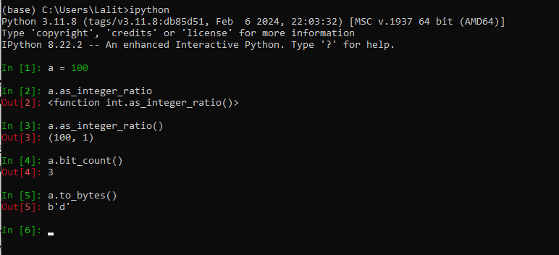

### Floating-point numbers

A floating-point literal is a sequence of decimal digits that includes a decimal point (.), an exponent suffix (e or E, optionally followed by + or -, followed by one or more digits), or both. The leading character of a floating-point literal cannot be e or

E; it may be any digit or a period (.) followed by a digit. For example:

0., 0.0, .0, 1., 1.0, 1e0, 1.e0, 1.0E0 # Floating-point literals

A Python floating-point value corresponds to a C double and shares its limits of range and precision: typically 53 bits—about 15 digits—of precision on modern platforms. (For the exact range and precision of floating-point values on the platform where the code is running, and many other details, see the online documentation on sys.float_info.)

Table 3-2 lists the methods supported by a float object f.

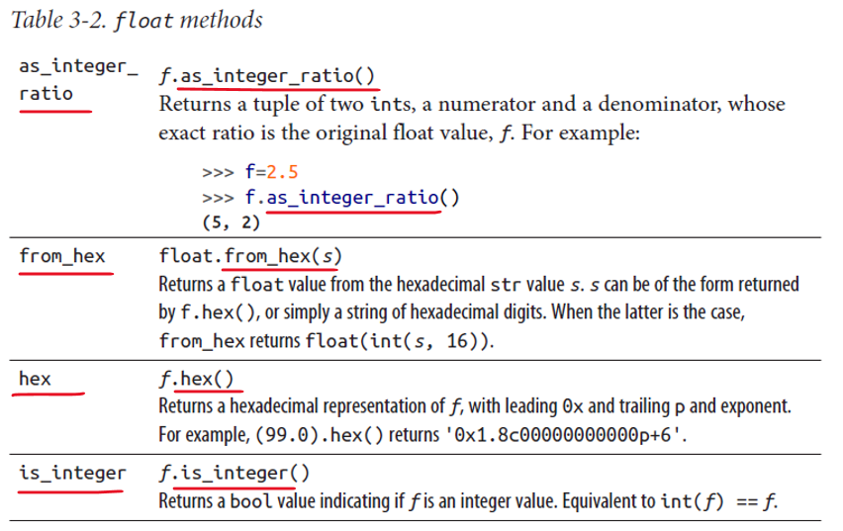

### Complex numbers

A complex number is made up of two floating-point values, one each for the real and imaginary parts. You can access the parts of a complex object z as read-only attributes z.real and z.imag. You can specify an imaginary literal as any floatingpoint or integer decimal literal followed by a j or J:

0j, 0.j, 0.0j, .0j, 1j, 1.j, 1.0j, 1e0j, 1.e0j, 1.0e0j

The j at the end of the literal indicates the square root of -1, as commonly used in electrical engineering (some other disciplines use i for this purpose, but Python uses j). There are no other complex literals. To denote any constant complex number, add or subtract a floating-point (or integer) literal and an imaginary one. For example, to denote the complex number that equals 1, use expressions like 1+0j or 1.0+0.0j. Python performs the addition at compile time, so there’s no need to worry about overhead.

A complex object c supports a single method:

conjugate c.conjugate()

Returns a new complex number complex(c.real, -c.imag) (i.e., the return value has c’s imag attribute with a sign change).

See “The math and cmath Modules” on page 488 for several other functions that use floats and complex numbers.

### Underscores in numeric literals

To aid with visual assessment of the magnitude of a number, numeric literals can include single underscore (_) characters between digits or after any base specifier. It’s not only decimal numeric constants that can benefit from this notational freedom, however, as these examples show:

>>> 100_000.000_0001, 0x_FF_FF, 0o7_777, 0b_1010_1010

(100000.0000001, 65535, 4095, 170)

There is no enforcement of location of the underscores (except that two may not occur consecutively), so 123_456 and 12_34_56 both represent the same int value as 123456.

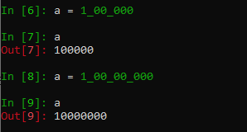

### Sequences

A sequence is an ordered container of items, indexed by integers. Python has built-in sequence types known as strings (bytes or str), tuples, and lists. Library and extension modules provide other sequence types, and you can write others yourself (as discussed in “Sequences” on page 43”). You can manipulate sequences in a variety of ways, as discussed in “Sequence Operations” on page 62.

### Iterables

A Python concept that captures in abstract the iteration behavior of sequences is that of iterables, covered in “The for Statement” on page 84. All sequences are iterable: whenever we say you can use an iterable, you can use a sequence (for example, a list). Also, when we say that you can use an iterable we usually mean a bounded iterable: an iterable that eventually stops yielding items. In general, sequences are bounded. Iterables can be unbounded, but if you try to use an unbounded iterable without special precautions, you could produce a program that never terminates, or one that exhausts all available memory.

### Strings

Python has two built-in string types, str and bytes. A str object is a sequence of characters used to store and represent text-based information. A bytes object stores and represents arbitrary sequences of binary bytes. Strings of both types in Python are immutable: when you perform an operation on strings, you always produce a new string object of the same type, rather than mutating an existing string. String objects provide many methods, as discussed in detail in “Methods of String Objects” on page 281.

A string literal can be quoted or triple-quoted. A quoted string is a sequence of zero or more characters within matching quotes, single (') or double ("). For example:

'This is a literal string'

"This is another string"

The two different kinds of quotes function identically; having both lets you include one kind of quote inside of a string specified with the other kind, with no need to escape quote characters with the backslash character (\):

'I\'m a Python fanatic' # You can escape a quote

"I'm a Python fanatic" # This way may be more readable

Many (but far from all) style guides that pronounce on the subject suggest that you use single quotes when the choice is otherwise indifferent. The popular code formatter black prefers double quotes; this choice is controversial enough to have been the main inspiration for a “fork,” blue, whose main difference from black is to prefer single quotes instead, as most of this book’s authors do.

To have a string literal span multiple physical lines, you can use a \ as the last character of a line to indicate that the next line is a continuation:

'A not very long string \

that spans two lines' # Comment not allowed on previous line

You can also embed a newline in the string to make it contain two lines rather than just one:

'A not very long string\n\

that prints on two lines' # Comment not allowed on previous line

A better approach, however, is to use a triple-quoted string, enclosed by matching

triplets of quote characters (''', or better, as mandated by PEP 8, """). In a

triple-quoted string literal, line breaks in the literal remain as newline characters in the resulting string object:

"""An even bigger

string that spans

three lines""" # Comments not allowed on previous lines

You can start a triple-quoted literal with an escaped newline, to avoid having the first line of the literal string’s content at a different indentation level from the rest.

For example:

|  |  |
| --- | --- |
| the_text = """\  First line  Second line  """ # Same as "First line\nSecond line\n" but more readable |  |

The only character that cannot be part of a triple-quoted string literal is an unescaped backslash, while a single-quoted string literal cannot contain unescaped backslashes, nor line ends, nor the quote character that encloses it. The backslash character starts an escape sequence, which lets you introduce any character in either kind of string literal. See Table 3-3 for a list of all of Python’s string escape sequences.

Table 3-3. String escape sequences

|  |  |  |
| --- | --- | --- |
| Sequence | Meaning | ASCII/ ISO Code |
|  |  |  |
| \<newline> | Ignore end of line | None |
| \\ | Backslash | 0x5c |
| \' | Single quote | 0x27 |
| \" | Double quote | 0x22 |
| \a | Bell | 0x07 |
| \b | Backspace | 0x08 |
| \f | Form feed | 0x0c |
| \n | Newline | 0x0a |
| \r | Carriage return | 0x0d |
| \t | Tab | 0x09 |
| \v | Vertical tab | 0x0b |
| \ DDD | Octal value DDD | As given |
| \x XX | Hexadecimal value | XX As given |
| \N{name} | Unicode character | As given |
| \ o | Any other character o: a two-character string | 0x5c + as given |

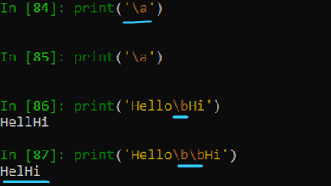

A variant of a string literal is a raw string literal. The syntax is the same as for quoted or triple-quoted string literals, except that an r or R immediately precedes the leading quote. In raw string literals, escape sequences are not interpreted as in Table 3-3, but are literally copied into the string, including backslashes and newline characters. Raw string literal syntax is handy for strings that include many backslashes, especially regular expression patterns (see “Pattern String Syntax” on page 306) and Windows absolute filenames (which use backslashes as directory separators). A raw string literal cannot end with an odd number of backslashes: the last one would be taken as escaping the terminating quote.

|  |  |
| --- | --- |
|  | Observe how we used r before the string  Observe how it escaped all special characters by itself using a backslash ahead of them |

import re

# Using raw string to define a regular expression pattern

pattern = r'\d{3}-\d{3}-\d{4}'

# Matching the pattern against a string

text = 'Phone number: 123-456-7890'

match = re.search( pattern, text )

if match:

print('Valid phone number')

else:

print('Invalid phone number')

Benefits of Using Raw Strings

* **Simplified Handling of Escape Sequences** − Raw strings make it easier to work with escape sequences in strings. Since backslashes are treated as literal characters in raw strings, you don't need to double backslashes or use additional escape characters. This simplifies the handling of escape sequences and avoids potential confusion or errors.
* **Enhanced Readability** − Raw strings can improve the readability of code that involves special characters, regular expressions, file paths, or any other scenario where backslashes are commonly used. By eliminating the need for additional escaping, raw strings make the code more intuitive and easier to understand.
* **Preserving Text Formatting** − Raw strings are particularly useful when dealing with text that contains a lot of backslashes, such as regular expressions or file paths. By using raw strings, you can ensure that the text retains its original formatting without unintentional modifications.
* **Platform Independence** − Raw strings are platform-independent, meaning they work consistently across different operating systems. This is because backslashes have special meanings in certain contexts, such as Windows file paths. By using raw strings, you can avoid any platform-specific issues related to backslash interpretation.
* **Convenient for Regular Expressions** − Regular expressions often involve the use of backslashes to define special characters or escape sequences. Using raw strings in regular expressions helps to avoid excessive backslash escaping and makes the expressions more readable and concise.

**Raw and Triple-Quoted String Literals Are Not Different Types**

Raw and triple-quoted string literals are not types different from other strings; they are just alternative syntaxes for literals of the usual two string types, bytes and str.

In str literals, you can use \u followed by four hex digits, or \U followed by eight hex digits, to denote Unicode characters; you can also include the escape sequences listed in Table 3-3. str literals can also include Unicode characters using the escape sequence \N{name}, where name is a standard Unicode name.

For example, \N{Copyright Sign} indicates a Unicode copyright sign character (©).

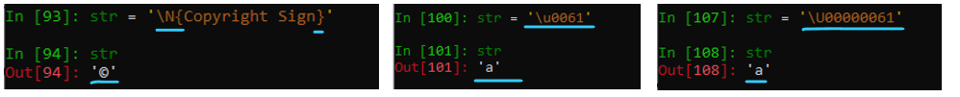

Formatted string literals (commonly called f-strings) let you inject formatted expressions into your string “literals,” which are therefore no longer constant, but rather are subject to evaluation at execution time. The formatting process is described in “String Formatting” on page 287. From a purely syntactic point of view, these new literals can be regarded as just another kind of string literal.

Multiple string literals of any kind—quoted, triple-quoted, raw, bytes, formatted— can be adjacent, with optional whitespace in between (as long as you do not mix strings containing text and bytes). The compiler concatenates such adjacent string literals into a single string object. Writing a long string literal in this way lets you present it readably across multiple physical lines and gives you an opportunity to insert comments about parts of the string. For example:

marypop = ('supercali' # '(' begins logical line,

'fragilistic' # indentation is ignored

'expialidocious') # until closing ')'

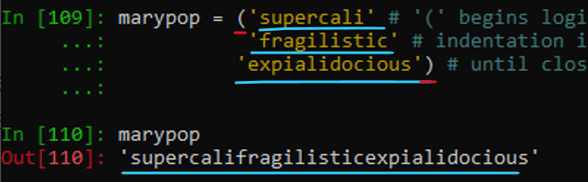

The string assigned to marypop is a single word of 34 characters.

### bytes objects

A bytes object is an ordered sequence of ints from 0 to 255. bytes objects are usually encountered when reading data from or writing data to a binary source (e.g, a file, a socket, or a network resource).

A bytes object can be initialized from a list of ints or from a string of characters. A bytes literal has the same syntax as a str literal, prefixed with 'b':

|  |  |
| --- | --- |
| b'abc'  bytes([97, 98, 99]) # Same as the previous line  rb'\ = solidus' # A raw bytes literal, containing a '\' |  |

To convert a bytes object to a str, use the bytes.decode method.

To convert a str object to a bytes object, use the str.encode method, as described in detail in Chapter 9.

### bytearray objects

A bytearray is a mutable ordered sequence of ints from 0 to 255; like a bytes object, you can construct it from a sequence of ints or characters. In fact, apart from mutability, it is just like a bytes object. As they are mutable, bytearray objects support methods and operators that modify elements within the array of byte values:

ba = bytearray([97, 98, 99]) # Like bytes, can take a sequence of ints

ba[1] = 97 # Unlike bytes, contents can be modified

print(ba.decode()) # Prints 'aac'

Chapter 9 has additional material on creating and working with bytearray objects.

### Tuples

A tuple is an immutable ordered sequence of items. The items of a tuple are arbitrary objects and may be of different types. You can use mutable objects (such as lists) as tuple items, but best practice is generally to avoid doing so.

To denote a tuple, use a series of expressions (the items of the tuple) separated by commas (,); if every item is a literal, the whole construct is a tuple literal. You may optionally place a redundant comma after the last item. You can group tuple items within parentheses, but the parentheses are necessary only where the commas would otherwise have another meaning (e.g., in function calls), or to denote empty or nested tuples. A tuple with exactly two items is also known as a pair. To create a tuple of one item, add a comma to the end of the expression. To denote an empty tuple, use an empty pair of parentheses. Here are some tuple literals, the second of which uses optional parentheses:

100, 200, 300 # Tuple with three items

(3.14,) # Tuple with one item, needs trailing comma

() # Empty tuple (parentheses NOT optional)

You can also call the built-in type tuple to create a tuple. For example:

|  |  |
| --- | --- |
| tuple('wow')  This builds a tuple equal to that denoted by the tuple literal:  ('w', 'o', 'w') |  |

tuple() without arguments creates and returns an empty tuple, like ().

When x is iterable, tuple(x) returns a tuple whose items are the same as those in x.

### Lists

A list is a mutable ordered sequence of items. The items of a list are arbitrary objects and may be of different types. To denote a list, use a series of expressions (the items of the list) separated by commas (,), within brackets ([]); if every item is a literal, the whole construct is a list literal.

You may optionally place a redundant comma after the last item.

To denote an empty list, use an empty pair of brackets. Here are some examples of list literals:

[42, 3.14, 'hello'] # List with three items

[100] # List with one item

[] # Empty list

You can also call the built-in type list to create a list. For example:

list('wow')

This builds a list equal to that denoted by the list literal:

['w', 'o', 'w']

list() without arguments creates and returns an empty list, like []. When x is iterable, list(x) returns a list whose items are the same as those in x. You can also build lists with list comprehensions, covered in “List comprehensions” on page 88.

### Sets

Python has two built-in set types, set and frozenset, to represent arbitrarily ordered collections of unique items. Items in a set may be of different types, but they must all be hashable (see hash in Table 8-2).

* Instances of type set are mutable, and thus not hashable;
* Instances of type frozenset are immutable and hashable.
* You can’t have a set whose items are sets, but
* You can have a set (or frozenset) whose items are frozensets.

Sets and frozensets are not ordered. To create a set, you can call the built-in type set with no argument (this means an empty set) or one argument that is iterable (this means a set whose items are those of the iterable). You can similarly build a frozenset by calling frozenset. Alternatively, to denote a (nonfrozen, nonempty) set, use a series of expressions (the items of the set) separated by commas (,) within braces ({}); if every item is a literal, the whole assembly is a set literal. This syntax is sometimes called a “set display”. You may optionally place a redundant comma after the last item. Here are some example sets (two literals, one not):

{42, 3.14, 'hello'} # Literal for a set with three items

{100} # Literal for a set with one item

set() # Empty set - no literal for empty set

# {} is an empty dict!

You can also build nonfrozen sets with set comprehensions, as discussed in “Set comprehensions”

Note that two sets or frozensets (or a set and a frozenset) may compare as equal, but since they are unordered, iterating over them can return their contents in differing order.

### Dictionaries

A mapping is an arbitrary collection of objects indexed by nearly arbitrary values called keys. Mappings are mutable and, like sets but unlike sequences, are not (necessarily) ordered.

Python provides a single built-in mapping type: the dictionary type dict. Library and extension modules provide other mapping types, and you can write others yourself (as discussed in “Mappings” on page 148). Keys in a dictionary may be of different types, but they must be hashable (see hash in Table 8-2). Values in a dictionary are arbitrary objects and may be of any type. An item in a dictionary is a key/value pair. You can think of a dictionary as an associative array (known in some other languages as a “map,” “hash table,” or “hash”).

|  |  |
| --- | --- |
|  | Keys in a dictionary may be of different types, but they must be hashable (see hash in Table 8-2). Values in a dictionary are arbitrary objects and may be of any type. |

To denote a dictionary, you can use a series of colon-separated pairs of expressions (the pairs are the items of the dictionary) separated by commas (,) within braces ({}); if every expression is a literal, the whole construct is a dictionary literal. You may optionally place a redundant comma after the last item. Each item in a dictionary is written as key:value, where key is an expression giving the item’s key and value is an expression giving the item’s value. If a key’s value appears more than once in a dictionary expression, only an arbitrary one of the items with that key is kept in the resulting dictionary object—dictionaries do not support duplicate keys.

For example:

{1:2, 3:4, 1:5} # The value of this dictionary is {1:5, 3:4}

The key for the last value is 1 and that replaced the 1st KV pair given as 1:2

To denote an empty dictionary, use an empty pair of braces.

Here are some dictionary literals:

{'x':42, 'y':3.14, 'z':7} # Dictionary with three items, str keys

{1:2, 3:4} # Dictionary with two items, int keys

{1:'za', 'br':23} # Dictionary with different key types

{} # Empty dictionary

You can also call the built-in type dict to create a dictionary in a way that, while less concise, can sometimes be more readable. For example, the dicts in the preceding snippet can also be written as:

dict(x=42, y=3.14, z=7) # Dictionary with three items, str keys

dict([(1, 2), (3, 4)]) # Dictionary with two items, int keys

dict([(1,'za'), ('br',23)]) # Dictionary with different key types

dict() # Empty dictionary

* dict() without arguments creates and returns an empty dictionary, like {}.
* When the argument x to dict is a mapping, dict returns a new dictionary object with the same keys and values as x.
* When x is iterable, the items in x must be pairs, and dict(x) returns a dictionary whose items (key/value pairs) are the same as the items in x.
* If a key value appears more than once in x, only the last item from x with that key value is kept in the resulting dictionary.

|  |  |
| --- | --- |
|  |  |

|  |  |
| --- | --- |
|  | Observe how when the list was in k, v pair ( list of tuples ) then it was able to create a dictionary with dict() method. Attempt before that when the list was just a sequence of single numbers it couldn’t create a dictionary out of it. |

When you call dict in addition to or instead of the positional argument x, you may pass named arguments, each with the syntax name=value, where name is an identifier to use as an item’s key and value is an expression giving the item’s value. When you call dict and pass both a positional argument and one or more named arguments, if a key appears both in the positional argument and as a named argument, Python associates to that key the named argument’s value (i.e., the named argument “wins”).

You can unpack a dict’s contents into another dict using the ** operator.

d1 = {'a': 1, 'x': 0}

d2 = {'c': 2, 'x': 5}

d3 = {**d1, **d2} # result is {'a':1, 'x': 5, 'c': 2}

3.9+ As of Python 3.9, this same operation can be performed using the | operator.

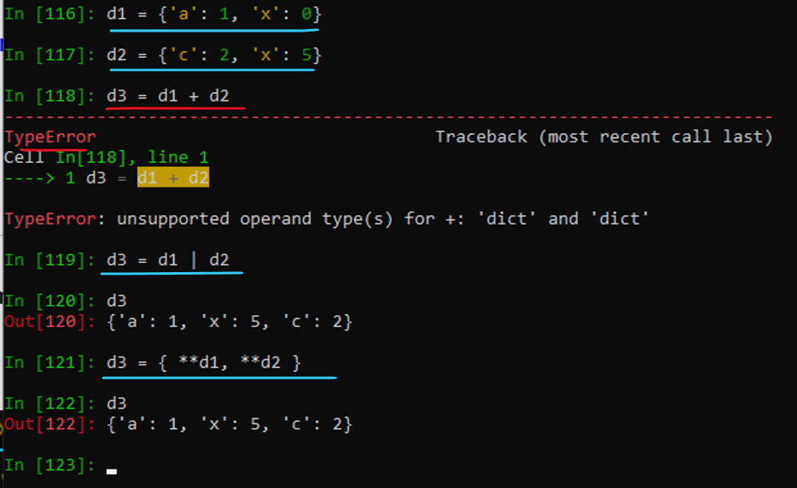

d4 = d1 **|** d2 # same result as d3

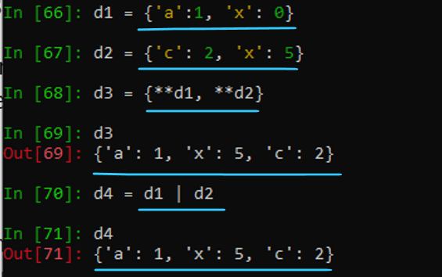

You can also create a dictionary by calling dict.fromkeys. The first argument is an iterable whose items become the keys of the dictionary; the second argument is the value that corresponds to each and every key (all keys initially map to the same value). If you omit the second argument, it defaults to None. For example:

dict.fromkeys('hello', 2) # Same as {'h':2, 'e':2, 'l':2, 'o':2}

dict.fromkeys([1, 2, 3]) # Same as {1:None, 2:None, 3:None}





You can also build a dict using a dictionary comprehension, as discussed in “Dictionary comprehensions” on page 90.

When comparing two dicts for equality, they will evaluate as equal if they have the same keys and corresponding values, even if the keys are not in the same order.

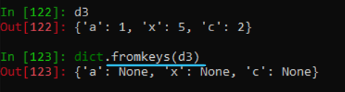

None

The built-in None denotes a null object. None has no methods or other attributes. You can use None as a placeholder when you need a reference but you don’t care what object you refer to, or when you need to indicate that no object is there. Functions return None as their result unless they have specific return statements coded to return other values. None is hashable and can be used as a dict key.

Ellipsis (...)

The Ellipsis, written as three periods with no intervening spaces, ..., is a special object in Python used in numerical applications,10 or as an alternative to None when None is a valid entry. For instance, to initialize a dict that may take None as a legitimate value, you can initialize it with ... as an indicator of “no value supplied, not even None.” Ellipsis is hashable and so can be used as a dict key:

tally = dict.fromkeys(['A', 'B', None, ...], 0)

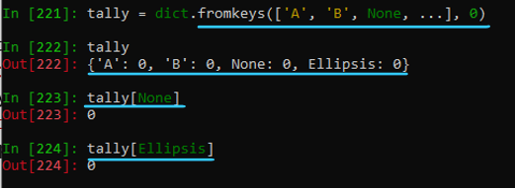

Callables

In Python, callable types are those whose instances support the function call operation (see “Calling Functions” on page 101). Functions are callable. Python provides numerous built-in functions (see “Built-in Functions” on page 251) and supports user-defined functions (see “Defining Functions: The def Statement” on page 94).

Generators are also callable (see “Generators” on page 109).

Types are callable too, as we saw for the dict, list, set, and tuple built-in types. (See “Built-in Types” on page 247 for a complete list of built-in types.) As we discuss in “Python Classes” on page 115, class objects (user-defined types) are also callable. Calling a type usually creates and returns a new instance of that type. Other callables include methods, which are functions bound as class attributes, and instances of classes that supply a special method named __call__.

Boolean Values

Any data value in Python can be used as a truth value: true or false. Any nonzero number or nonempty container (e.g., string, tuple, list, set, or dictionary) is true. Zero (0, of any numeric type), None, and empty containers are false. You may see the terms “truthy” and “falsy” used to indicate values that evaluate as either true or false. Beware Using a Float as a Truth Value Be careful about using a floating-point number as a truth value: that’s like comparing the number for exact equality with zero, and floating-point numbers should almost never be compared for exact equality.

The built-in type bool is a subclass of int. The only two values of type bool are True and False, which have string representations of 'True' and 'False', but also numerical values of 1 and 0, respectively. Several built-in functions return bool results, as do comparison operators.

You can call bool(x) with any x as the argument. The result is True when x is true and False when x is false. Good Python style is not to use such calls when they are redundant, as they most often are: always write if x:, never any of if bool(x):, if x is True:, if x == True:, or if bool(x) == True:.

However, you can use bool(x) to count the number of true items in a sequence. For example:

def count_trues(seq):

return sum(bool(x) for x in seq)

In this example, the bool call ensures each item of seq is counted as 0 (if false) or 1 (if true), so count_trues is more general than sum(seq) would be. When we say “expression is true” we mean that bool(expression) would return True. As we mentioned, this is also known as “expression being truthy” (the other possibility is that “expression is falsy”).

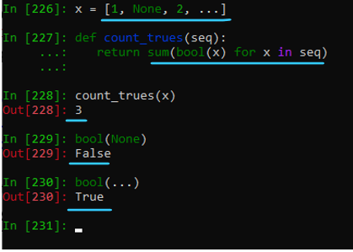

### Examples

""" Just playing with some basic data types """

# Text Type: str

# Numeric Types: int, float, complex

# Sequence Types: list, tuple, range

# Mapping Type: dict

# Set Types: set, frozenset

# Boolean Type: bool

# Binary Types: bytes, bytearray, memoryview

# None Type: NoneType

i = 100

print(type(i)) # <class 'int'>

i1 = 100.21

print(type(i1)) # <class 'float'>

print(type(i1).__name__) # float

print(type(i1).__class__) # <class 'type'>

f = 12.123

print(type(f)) # <class 'float'>

s = 'c'

print(type(s)) # <class 'str'>

s1 = "hello"

print(type(s1)) # <class 'str'>

print(type(s1) is str) # True

# Use isinstance() rather than type() for a typecheck.Pylint warning!

print(isinstance(s1, str)) # True

print(isinstance(i, (float, str, set, dict))) # False

name = None

print(type(name)) # <class 'NoneType'>

print(type(name).__name__) # NoneType

name = Exception()

print(type(name)) # <class 'Exception'>

print(type(name).__name__) # Exception

variable = "hello_world"

print(type(variable) is str) # True

print(isinstance(variable, str)) # True

L = [

"Hello World", # <class 'str'>

20, # <class 'int'>

20.5, # <class 'float'>

1j, # <class 'complex'>

["apple", "banana", "cherry"], # <class 'list'>

("apple", "banana", "cherry"), # <class 'tuple'>

range(6), # <class 'range'>

{"name" : "John", "age" : 36}, # <class 'dict'>

{"apple", "banana", "cherry"}, # <class 'set'>

frozenset({"apple", "banana", "cherry"}), # <class 'frozenset'>

True, # <class 'bool'>

b"Hello", # <class 'bytes'>

bytearray(5), # <class 'bytearray'>

memoryview(bytes(5)), # <class 'memoryview'>

None # <class 'NoneType'>

]

for _ in range(len(L)):

print(type(L[_]))

## Variables and Other References

A Python program accesses data values through references. A reference is a “name” that refers to a value (object). References take the form of variables, attributes, and items. In Python, a variable or other reference has no intrinsic type. The object to which a reference is bound at a given time always has a type, but a given reference may be bound to objects of various types in the course of the program’s execution.

### Variables

In Python, there are no “declarations.” The existence of a variable begins with a statement that binds the variable (in other words, sets a name to hold a reference to some object). You can also unbind a variable, resetting the name so it no longer holds a reference. Assignment statements are the usual way to bind variables and other references. The del statement unbinds a variable reference, although doing so is rare.

Binding a reference that was already bound is also known as rebinding it. Whenever we mention binding, we implicitly include rebinding (except where we explicitly exclude it). Rebinding or unbinding a reference has no effect on the object to which the reference was bound, except that an object goes away when nothing refers to it. The cleanup of objects with no references is known as garbage collection.

You can name a variable with any identifier except the 30-plus that are reserved as Python’s keywords (see “Keywords” on page 37). A variable can be global or local. A global variable is an attribute of a module object (see Chapter 7). A local variable lives in a function’s local namespace (see “Namespaces” on page 105).

Object attributes and items

The main distinction between the attributes and items of an object is in the syntax you use to access them. To denote an attribute of an object, use a reference to the object, followed by a period (.), followed by an identifier known as the attribute name. For example, x.y refers to one of the attributes of the object bound to name x; specifically, that attribute whose name is 'y'.

To denote an item of an object, use a reference to the object, followed by an expression within brackets []. The expression in brackets is known as the item’s index or key, and the object is known as the item’s container. For example, x[y] refers to the item at the key or index bound to name y, within the container object bound to name x.

Attributes that are callable are also known as methods. Python draws no strong distinctions between callable and noncallable attributes, as some other languages do. All general rules about attributes also apply to callable attributes (methods).

Accessing nonexistent references

A common programming error is to access a reference that does not exist. For example, a variable may be unbound, or an attribute name or item index may not be valid for the object to which you apply it. The Python compiler, when it analyzes and compiles source code, diagnoses only syntax errors. Compilation does not diagnose semantic errors, such as trying to access an unbound attribute, item, or variable. Python diagnoses semantic errors only when the errant code executes— that is, at runtime. When an operation is a Python semantic error, attempting it raises an exception (see Chapter 6). Accessing a nonexistent variable, attribute, or item—just like any other semantic error—raises an exception.

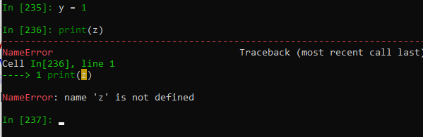

Assignment Statements

Assignment statements can be plain or augmented. Plain assignment to a variable (e.g., name = value) is how you create a new variable or rebind an existing variable to a new value. Plain assignment to an object attribute (e.g., x.attr = value) is a request to object x to create or rebind the attribute named 'attr'. Plain assignment to an item in a container (e.g., x[k] = value) is a request to container x to create or rebind the item with index or key k.

Augmented assignment (e.g., name += value) cannot, per se, create new references. Augmented assignment can rebind a variable, ask an object to rebind one of its existing attributes or items, or request the target object to modify itself. When you make any kind of request to an object, it is up to the object to decide whether and how to honor the request, and whether to raise an exception.

Plain assignment

A plain assignment statement in the simplest form has the syntax:

target = expression

The target is known as the lefthand side (LHS), and the expression is the righthand side (RHS). When the assignment executes, Python evaluates the RHS expression, then binds the expression’s value to the LHS target. The binding never depends on the type of the value. In particular, Python draws no strong distinction between callable and noncallable objects, as some other languages do, so you can bind functions, methods, types, and other callables to variables, just as you can numbers, strings, lists, and so on. This is part of functions and other callables being first-class objects.

Details of the binding do depend on the kind of target. The target in an assignment may be an identifier, an attribute reference, an indexing, or a slicing, where:

**An identifier** : Is a variable name. Assigning to an identifier binds the variable with this name.

**An attribute reference** : Has the syntax obj.name. obj is an arbitrary expression, and name is an identifier, known as an attribute name of the object. Assigning to an attribute reference asks the object obj to bind its attribute named 'name'.

**An indexing** : Has the syntax obj[expr]. obj and expr are arbitrary expressions. Assigning to an indexing asks the container obj to bind its item indicated by the value of expr, also known as the index or key of the item in the container (an indexing is an index applied to a container).

**A slicing** : Has the syntax obj[start:stop] or obj[start:stop:stride]. obj, start, stop, and stride are arbitrary expressions. start, stop, and stride are all optional (i.e., obj[:stop:] and obj[:stop] are also syntactically correct slicings, each being equivalent to obj[None:stop:None]). Assigning to a slicing asks the container obj to bind or unbind some of its items. Assigning to a slicing such as obj[start:stop:stride] is equivalent to assigning to the indexing obj[slice(start, stop, stride)]. See Python’s built-in type slice in (Table 8-1), whose instances represent slices (a slicing is a slice applied to a container).

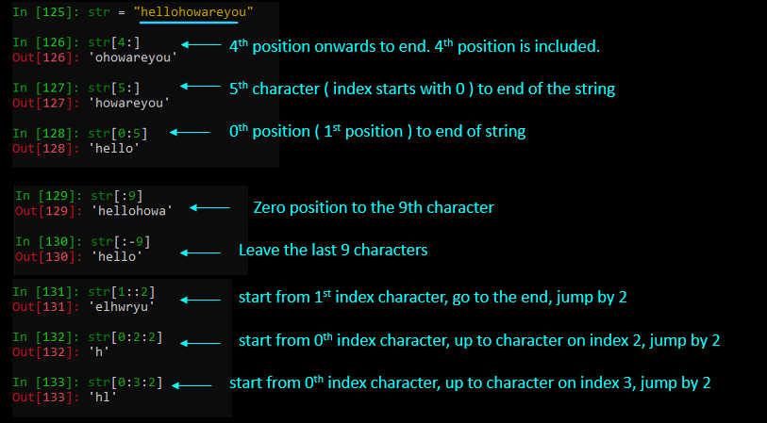

We’ll get back to indexing and slicing targets when we discuss operations on lists in “Modifying a list” on page 66, and on dictionaries in “Indexing a Dictionary” on page 71.

When the target of the assignment is an identifier, the assignment statement specifies the binding of a variable. This is never disallowed: when you request it, it takes place. In all other cases, the assignment statement denotes a request to an object to bind one or more of its attributes or items. An object may refuse to create or rebind some (or all) attributes or items, raising an exception if you attempt a disallowed creation or rebinding (see also __setattr__ in Table 4-1 and __setitem__ in “Container methods” on page 149).

A plain assignment can use multiple targets and equals signs (=). For example: a = b = c = 0 binds variables a, b, and c to the same value, 0. Each time the statement executes, the RHS expression evaluates just once, no matter how many targets are in the statement. Each target, left to right, is bound to the one object returned by the expression, just as if several simple assignments executed one after the other.

The target in a plain assignment can list two or more references separated by commas, optionally enclosed in parentheses or brackets. For example:

a, b, c = x

This statement requires x to be an iterable with exactly three items, and binds a to the first item, b to the second, and c to the third. This kind of assignment is known as an unpacking assignment. The RHS expression must be an iterable with exactly as many items as there are references in the target; otherwise, Python raises an exception. Python binds each reference in the target to the corresponding item in the RHS. You can use an unpacking assignment, for example, to swap references:

a, b = b, a

This assignment statement rebinds name a to what name b was bound to, and vice versa.

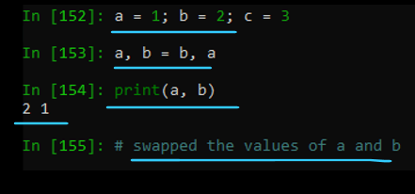

Exactly one of the multiple targets of an unpacking assignment may be preceded by *. That starred target, if present, is bound to a list of all items, if any, that were not assigned to other targets. For example, when x is a list, this:

first, *middle, last = x

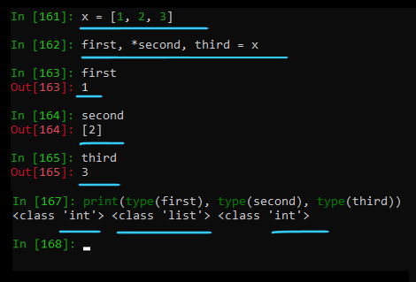

is the same as (but more concise, clearer, more general, and faster than) this:

first, middle, last = x[0], x[1:-1], x[-1]

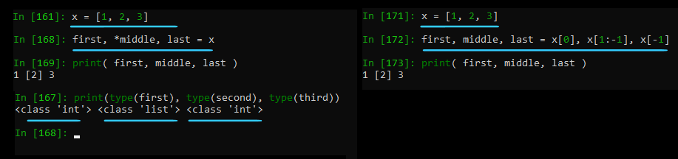

Each of these forms requires x to have at least two items. This feature is known as extended unpacking.

Augmented assignment

An augmented assignment (sometimes called an in-place assignment) differs from a plain assignment in that, instead of an equals sign (=) between the target and the expression, it uses an augmented operator, which is a binary operator followed by =. The augmented operators are +=, -=, *=, /=, //=, %=, **=, |=, >>=, <<=, &=, ^=, and @=. An augmented assignment can have only one target on the LHS; augmented assignment does not support multiple targets. In an augmented assignment, like in a plain one, Python first evaluates the RHS expression. Then, when the LHS refers to an object that has a special method for the appropriate in-place version of the operator, Python calls the method with the RHS value as its argument (it is up to the method to modify the LHS object appropriately and return the modified object; “Special Methods” on page 141 covers special methods). When the LHS object has no applicable in-place special method, Python uses the corresponding binary operator on the LHS and RHS objects, then rebinds the target to the result. For example, x += y is like x = x.__iadd_(y) when x has the special method __iadd__ for “in-place addition”; otherwise, x += y is like x = x + y.

Augmented assignment never creates its target reference; the target must already be bound when augmented assignment executes. Augmented assignment can rebind the target reference to a new object, or modify the same object to which the target reference was already bound. Plain assignment, in contrast, can create or rebind the LHS target reference, but it never modifies the object, if any, to which the target reference was previously bound. The distinction between objects and references to objects is crucial here. For example, x = x + y never modifies the object to which x was originally bound, if any. Rather, it rebinds x to refer to a new object. x += y, in contrast, modifies the object to which the name x is bound, when that object has the special method __iadd__; otherwise, x += y rebinds x to a new object, just like x = x + y.

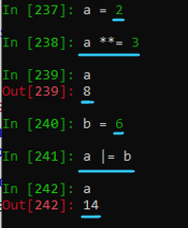

### del Statements

Despite its name, a del statement unbinds references—it does not, per se, delete objects. Object deletion may automatically follow, by garbage collection, when no more references to an object exist.

A del statement consists of the keyword del, followed by one or more target references separated by commas (,). Each target can be a variable, attribute reference, indexing, or slicing, just like for assignment statements, and must be bound at the time del executes. When a del target is an identifier, the del statement means to unbind the variable. If the identifier was bound, unbinding it is never disallowed; when requested, it takes place.

In all other cases, the del statement specifies a request to an object to unbind one or more of its attributes or items. An object may refuse to unbind some (or all) attributes or items, raising an exception if you attempt a disallowed unbinding (see also __delattr__ in “General-Purpose Special Methods” on page 142 and __delitem__ in “Container methods” on page 149). Unbinding a slicing normally has the same effect as assigning an empty sequence to that slicing, but it is up to the container object to implement this equivalence.

Containers are also allowed to have del cause side effects. For example, assuming del C[2] succeeds, when C is a dictionary, this makes future references to C[2] invalid (raising KeyError) until and unless you assign to C[2] again; but when C is a list, del C[2] implies that every following item of C “shifts left by one”—so, if C is long enough, future references to C[2] are still valid, but denote a different item than they did before the del (generally, what you’d have used C[3] to refer to, before the del statement).

## Expressions and Operators

An expression is a “phrase” of code, which Python evaluates to produce a value. The simplest expressions are literals and identifiers. You build other expressions by joining subexpressions with the operators and/or delimiters listed in Table 3-4. This table lists operators in decreasing order of precedence, higher precedence before lower. Operators listed together have the same precedence. The third column lists the associativity of the operator: L (left-to-right), R (right-to-left), or NA (nonassociative).

Operator precedence in expressions

|  |  |  |
| --- | --- | --- |
| **Operator** | **Description** | **Associativity** |
| { key : expr, ... } | Dictionary creation | NA |
| { expr, ... } | Set creation | NA |
| [ expr, ... ] | List creation | NA |
| ( expr, ... ) | Tuple creation (parentheses recommended, but not always required; at least one comma required), or just parentheses | NA |
| f ( expr, ... ) | Function call | L |
| x [ index: index: step ] | Slicing | L |
| x [ index ] | Indexing | L |
| x . attr | Attribute reference | L |
| x ** y | Exponentiation (x to the yth power) | R |
| ~ x, + x, - x | Bitwise NOT, unary plus and minus | NA |
| x * y, x @ y, x / y, x // y, x % y | Multiplication, matrix multiplication, division, floor division, remainder | L |
| x + y, x - y | Addition, subtraction | L |
| x << y, x >> y | Left-shift, right-shift | L |
| x & y | Bitwise AND | L |
| x ^ y | Bitwise XOR | L |
| x | y | Bitwise OR | L |
| x < y, x <= y, x > y, x >= y, x != y, x == y | Comparisons (less than, less than or equal, greater than, greater than or equal, inequality, equality) | NA |
| x is y, x is not y | Identity tests | NA |
| x in y, x not in y | Membership tests | NA |
| not x | Boolean NOT | NA |
| x and y | Boolean AND | L |
| x or y | Boolean OR | L |
| x if expr else y | Conditional expression (or ternary operator) | NA |

|  |  |  |
| --- | --- | --- |
| lambda arg, ...: expr | Anonymous simple function | NA |
| ( ident := expr ) | Assignment expression (parentheses recommended, but not always required) | NA |

In this table, expr, key, f, index, x, and y mean any expression, while attr, arg, and ident mean any identifier. The notation , ... means commas join zero or more repetitions; in such cases, a trailing comma is optional and innocuous.

**Division vs Floor division**

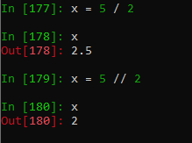

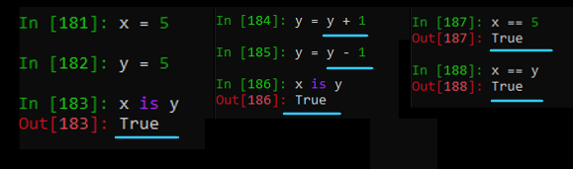

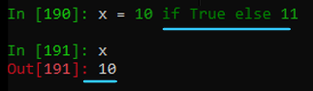 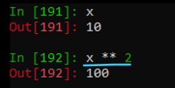

### Comparison Chaining

You can chain comparisons, implying a logical and. For example:

a < b <= c < d

where a, b, c, and d are arbitrary expressions, has (in the absence of evaluation side effects) the same value as:

a < b and b <= c and c < d

The chained form is more readable, and evaluates each subexpression at most once.

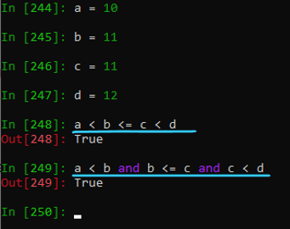

### Short-Circuiting Operators

The and and or operators short-circuit their operands’ evaluation: the righthand operand evaluates only when its value is needed to get the truth value of the entire and or or operation.

In other words, x and y first evaluates x. When x is false, the result is x; otherwise, the result is y. Similarly, x or y first evaluates x. When x is true, the result is x; otherwise, the result is y.

and and or don’t force their results to be True or False, but rather return one or the other of their operands. This lets you use these operators more generally, not just in Boolean contexts. and and or, because of their short-circuiting semantics, differ from other operators, which fully evaluate all operands before performing the operation. and and or let the left operand act as a guard for the right operand.

The conditional operator

Another short-circuiting operator is the conditional operator if/else:

when_true if condition else when_false

Sometimes referred to as the ternary operator, as it is so called in C (Python’s original implementation language).

# Program to demonstrate ternary operator

a = 10

b = 20

# python ternary operator

min = "a is minimum" if a < b else "b is minimum"

print(min)

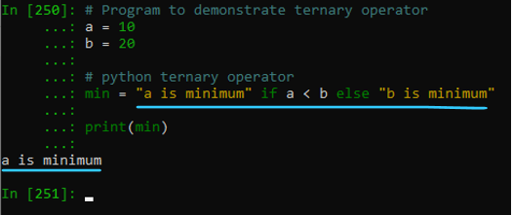

Each of when_true, when_false, and condition is an arbitrary expression. condition evaluates first. When condition is true, the result is when_true; otherwise, the result is when_false. Only one of the subexpressions when_true and when_false evaluates, depending on the truth value of condition.

The order of the subexpressions in this conditional operator may be a bit confusing.

The recommended style is to always place parentheses around the whole expression.

The ternary operator can also be used in Python nested if-else statement. the syntax for the same is as follows:

Syntax: true_value if condition1 else (true_value if condition2 else false_value)

# Python program to demonstrate nested ternary operator

a = 10

b = 20

print("Both are equal" if a == b else "a is greater" if a > b else "b is greater")

<https://www.geeksforgeeks.org/ternary-operator-in-python/>

Assignment Expressions

3.8+ You can combine evaluation of an expression and the assignment of its result using the := operator. There are several common cases where this is useful.

:= in an if/elif statement

Code that assigns a value and then checks it can be collapsed using :=:

re_match = re.match(r'Name: (\S)', input_string)

if re_match:

print(re_match.groups(1))

# collapsed version using :=

if (re_match := re.match(r'Name: (\S)', input_string)):

print(re_match.groups(1))

This is especially helpful when writing a sequence of if/elif blocks (you’ll find a more extended example in Chapter 10).

:= in a while statement

Use := to simplify code that uses a variable as its while condition. Consider this code that works with a sequence of values returned by some function get_next_value, which returns None when there are no more values to process:

current_value = get_next_value()

while current_value is not None:

if not filter_condition(current_value):

continue # BUG! Current_value is not advanced to next

# ... do some work with current_value ...

current_value = get_next_value()

This code has a couple of problems. First, there is the duplicated call to get_next_value, which carries extra maintenance costs when get_next_value changes. But more seriously, there is a bug when an early exiting filter is added: the continue statement jumps directly back to the while statement without advancing to the next value, creating an infinite loop.

When we use := to incorporate the assignment into the while statement itself, we fix the duplication problem, and calling continue does not cause an infinite loop:

while (current_value := get_next_value()) is not None:

if not filter_condition(current_value):

continue # no bug, current_value advances in while statement

# ... do some work with current_value ...

:= in a list comprehension filter

A list comprehension that converts an input item but must filter out some items based on their converted values can use := to do the conversion only once. In this example, a function to convert strs to ints returns None for invalid values. Without :=, the list comprehension must call safe_int twice for valid values, once to check for None and then again to add the actual int value to the list:

def safe_int(s):

try:

return int(s)

except Exception:

return None

input_strings = ['1','2','a','11']

valid_int_strings = [safe_int(s) for s in input_strings

if safe_int(s) is not None]

If we use an assignment expression in the condition part of the list comprehension, safe_int only gets called once for each value in input_strings:

valid_int_strings = [int_s for s in input_strings

if (int_s := safe_int(s)) is not None]

You can find more examples in the original PEP for this feature, PEP 572.

## Numeric Operations

Python offers the usual numeric operations, as we’ve just seen in Table 3-4. Numbers are immutable objects: when you perform operations on number objects, you always produce new objects and never modify existing ones. You can access the parts of a complex object z as read-only attributes z.real and z.imag. Trying to rebind these attributes raises an exception.

A number’s optional + or - sign, and the + or - that joins a floating-point literal to an imaginary one to make a complex number, are not part of the literals’ syntax. They are ordinary operators, subject to normal operator precedence rules (see Table 3-4). For example, -2 ** 2 evaluates to -4: exponentiation has higher precedence than unary minus, so the whole expression parses as -(2 ** 2), not as (-2) ** 2. (Again, parentheses are recommended, to avoid confusing a reader of the code.)

Numeric Conversions

You can perform arithmetic operations and comparisons between any two numbers of Python built-in types (integers, floating-point numbers, and complex numbers). If the operands’ types differ, Python converts the operand with the “narrower” type the “wider” type. ( This is not, strictly speaking, the “coercion” you observe in other languages; however, among built-in numeric types, it produces pretty much the same effect). The built-in numeric types, in order from narrowest to widest, are int, float, and complex. You can request an explicit conversion by passing a noncomplex numeric argument to any of these types. int drops its argument’s fractional part, if any (e.g., int(9.8) is 9). You can also call complex with two numeric arguments, giving real and imaginary parts. You cannot convert a complex to another numeric type in this way, because there is no single unambiguous way to convert a complex number into, for example, a float.

You can also call each built-in numeric type with a string argument with the syntax of an appropriate numeric literal, with small extensions: the argument string may have leading and/or trailing whitespace, may start with a sign, and—for complex numbers—may sum or subtract a real part and an imaginary one. int can also be called with two arguments: the first one a string to convert, and the second the radix, an integer between 2 and 36 to use as the base for the conversion (e.g., int('101', 2) returns 5, the value of '101' in base 2). For radices larger than 10, the appropriate subset of ASCII letters from the start of the alphabet (in either lower- or uppercase) are the extra needed “digits.” ( Hence the upper limit of 36 for the radix: 10 numeric digits plus 26 alphabetic characters )

### Arithmetic Operations

**HERE**

Arithmetic operations in Python behave in rather obvious ways, with the possible exception of division and exponentiation.

Division

When the right operand of /, //, or % is 0, Python raises an exception at runtime. Otherwise, the / operator performs true division, returning the floating-point result of division of the two operands (or a complex result if either operand is a complex

number). In contrast, the // operator performs floor division, which means it returns an integer result (converted to the same type as the wider operand) that’s the largest integer less than or equal to the true division result (ignoring the remainder, if any); e.g., 5.0 // 2 = 2.0 (not 2). The % operator returns the remainder of the (floor) division, i.e., the integer such that (x // y) * y + (x % y) == x.

–x // y Is Not the Same as int(–x / y)

Take care not to think of // as a truncating or integer form of division; this is only the case for operands of the same sign. When operands are of different signs, the largest integer less than or equal to the true division result will actually be a more

negative value than the result from true division (for example, -5 / 2 returns -2.5, so -5 // 2 returns -3, not -2).

The built-in divmod function takes two numeric arguments and returns a pair whose items are the quotient and remainder, so you don’t have to use both // for the quotient and % for the remainder. ( The second item of divmod’s result, just like the result of %, is the remainder, not the modulo, despite the function’s misleading name. The difference matters when the divisor is negative. In some other languages, such as C# and JavaScript, the result of a % operator is, in fact, the modulo; in others yet, such as C and C++, it is machine-dependent whether the result is the modulo or the remainder when either operand is negative. In Python, it’s the remainder.).

Exponentiation

The exponentiation ("raise to power") operation, when a is less than zero and b is a floating-point value with a nonzero fractional part, returns a complex number. The built-in pow(a, b) function returns the same result as a ** b. With three arguments, pow(a, b, c) returns the same result as (a ** b) % c but may sometimes be faster. Note that, unlike other arithmetic operations, exponentiation evaluates right to left: in other words, a ** b ** c evaluates as a ** (b ** c).

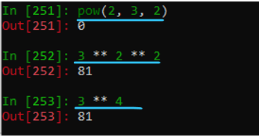

Comparisons

All objects, including numbers, can be compared for equality (==) and inequality (!=). Comparisons requiring order (<, <=, >, >=) may be used between any two numbers unless either operand is complex, in which case they raise exceptions at runtime. All these operators return Boolean values (True or False). Be careful when comparing floating-point numbers for equality, however, as discussed in Chapter 16 and the online tutorial on floating-point arithmetic.

Bitwise Operations on Integers

ints can be interpreted as strings of bits and used with the bitwise operations shown in Table 3-4. Bitwise operators have lower priority than arithmetic operators. Positive ints are conceptually extended by an unbounded string of bits on the left, each bit being 0. Negative ints, as they’re held in two’s complement representation, are conceptually extended by an unbounded string of bits on the left, each bit being 1.

## Sequence Operations

Python supports a variety of operations applicable to all sequences, including strings, lists, and tuples. Some sequence operations apply to all containers (including sets and dictionaries, which are not sequences); some apply to all iterables (meaning “any object over which you can loop”—all containers, be they sequences or not, are iterable, and so are many objects that are not containers, such as files, covered in “The io Module” on page 322, and generators, covered in “Generators” on page 109). In the following we use the terms sequence, container, and iterable quite precisely, to indicate exactly which operations apply to each category.

Sequences in General

Sequences are ordered containers with items that are accessible by indexing and slicing. The built-in len function takes any container as an argument and returns the number of items in the container.

The built-in min and max functions take one argument, an iterable whose items are comparable, and return the smallest and largest items, respectively. You can also call min and max with multiple arguments, in which case they return the smallest and

largest arguments, respectively.

min and max also accept two keyword-only optional arguments: key, a callable to apply to each item (the comparisons are then performed on the callable’s results rather than on the items themselves); and default, the value to return when the iterable is empty (when the iterable is empty and you supply no default argument, the function raises ValueError). For example, max('who', 'why', 'what', key=len) returns 'what'.

The built-in sum function takes one argument, an iterable whose items are numbers, and returns the sum of the numbers.

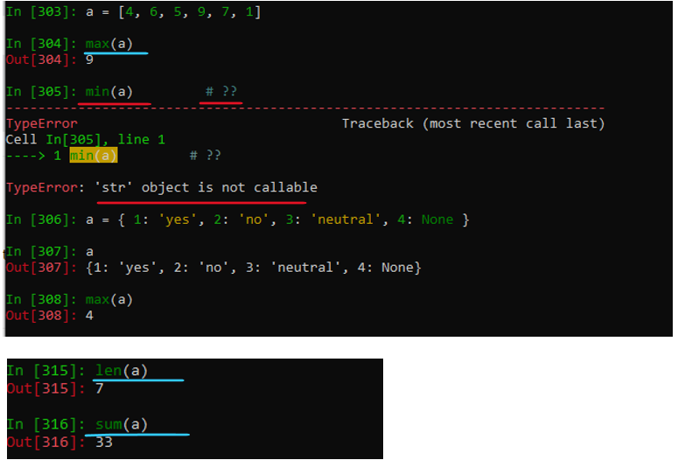

Sequence conversions

There is no implicit conversion between different sequence types. You can call the built-ins tuple and list with a single argument (any iterable) to get a new instance of the type you’re calling, with the same items, in the same order, as in the argument.

Concatenation and repetition

You can concatenate sequences of the same type with the + operator.

You can multiply a sequence S by an integer n with the * operator.

S*n is the concatenation of n copies of S. When n <= 0, S * n is an empty sequence of the same type as S.

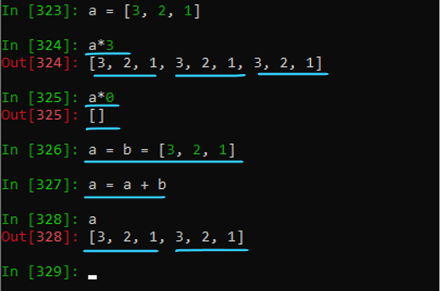

Membership testing

The x in S operator tests to check whether the object x equals any item in the sequence (or other kind of container or iterable) S. It returns True when it does and False when it doesn’t.

The x not in S operator is equivalent to not (x in S).

For dictionaries, x in S tests for the presence of x as a key.

In the specific case of strings, x in S may match more than expected; in this case, x in S tests whether x equals any substring of S, not just any single character.

Indexing a sequence

To denote the nth item of a sequence S, use indexing: S[n]. Indexing is zero-based: S’s first item is S[0].

If S has L items, the index n may be 0, 1… up to and including L-1, but no larger. n may also be –1, –2… down to and including -L, but no smaller.

A negative n (e.g., –1) denotes the same item in S as L+n (e.g., L-1) does. In other words, S[-1], like S[L-1], is the last element of S, S[-2] is the next-to-last one, and so on. For example:

x = [10, 20, 30, 40]

x[1] # 20

x[-1] # 40

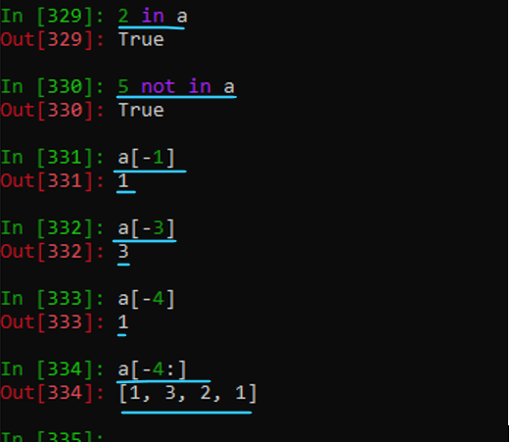

Using an index >=L or <-L raises an exception.

Assigning to an item with an invalid index also raises an exception.

You can add elements to a list, but to do so you assign to a slice, not to an item, as we’ll discuss shortly.

Slicing a sequence

To indicate a subsequence of S, you can use slicing, with the syntax S[i:j], where i and j are integers. S[i:j] is the subsequence of S from the ith item, included, to the jth item, excluded (in Python, ranges always include the lower bound and exclude the upper bound). A slice is an empty subsequence when j is less than or equal to i, or when i is greater than or equal to L, the length of S. You can omit i when it is equal to 0, so that the slice begins from the start of S. You can omit j when it is greater than or equal to L, so that the slice extends all the way to the end of S. You can even omit both indices, to mean a shallow copy of the entire sequence:

S[:]. Either or both indices may be less than zero. Here are some examples:

x = [10, 20, 30, 40]

x[1:3] # [20, 30]

x[1:] # [20, 30, 40]

x[:2] # [10, 20]

A negative index n in slicing indicates the same spot in S as L+n, just like it does in indexing. An index greater than or equal to L means the end of S, while a negative index less than or equal to -L means the start of S.

Slicing can use the extended syntax S[i:j:k]. k is the stride of the slice, meaning the distance between successive indices. S[i:j] is equivalent to S[i:j:1], S[::2] is the subsequence of S that includes all items that have an even index in S, and S[::-1] is a slicing, also whimsically known as “the Martian smiley,” with the same items as S but in reverse order. With a negative stride, in order to have a nonempty slice, the second (“stop”) index needs to be smaller than the first (“start”) one—the reverse of the condition that must hold when the stride is positive. A stride of 0 raises an exception. Here are some examples:

>>> y = list(range(10)) # values from 0-9

>>> y[-5:] # last five items

[5, 6, 7, 8, 9]

>>> y[::2] # every other item – step 2

[0, 2, 4, 6, 8]

>>> y[10:0:-2] # every other item, in reverse order

[9, 7, 5, 3, 1]

>>> y[:0:-2] # every other item, in reverse order (simpler)

[9, 7, 5, 3, 1]

>>> y[::-2] # every other item, in reverse order (best)

[9, 7, 5, 3, 1]

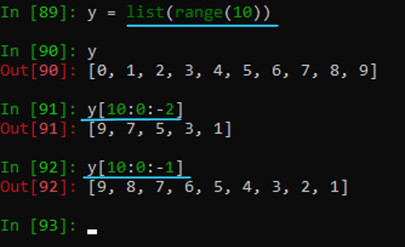

### Strings

String objects (both str and bytes) are immutable: attempting to rebind or delete an item or slice of a string raises an exception. (Python also has a built-in type that is mutable but otherwise equivalent to bytes: bytearray (see “bytearray objects” on page 47). The items of a text string (each of the characters in the string) are themselves text strings, each of length 1—Python has no special data type for “single characters” (the items of a bytes or bytearray object are ints). All slices of a string are strings of the same kind. String objects have many methods, covered in “Methods of String Objects” on page 281

s = "Hello There 123"

# Converts the first character to upper case

print( s.capitalize() )

# Converts string into lower case

print( s.casefold() )

# Returns a centered string

# s = s.center()

# Returns the number of times a specified value occurs in a string

print( s.count('e') )

# Returns true if the string ends with the specified value

print( s.endswith('re') )

# Searches the string for a specified value and returns

# the position of where it was found

print( s.find('llo') )

# Returns True if all characters in the string are alphanumeric

print ( s.isalnum() )

# Returns True if all characters in the string are in the alphabet

print( s.isalpha() )

# Returns True if all characters in the string are ascii characters

print( s.isascii() )

# Returns True if all characters in the string are decimals

print( s.isdecimal() )

# Returns True if all characters in the string are digits

print( s.isdigit() )

# Returns True if the string is an identifier

print( s.isidentifier() )

# Returns True if all characters in the string are lower case

print( s.islower() )

# Returns True if all characters in the string are numeric

print( s.isnumeric() )

# Returns True if all characters in the string are whitespaces

print( s.isspace() )

# Returns True if the string follows the rules of a title

print( s.istitle() )

# Returns True if all characters in the string are upper case

print( s.isupper() )

# Converts the elements of an iterable into a string

# .join() - Output is John#Peter#Vicky

myTuple = ("John", "Peter", "Vicky")

x = "#".join(myTuple)

print(x)

# Returns a left justified version of the string

# .ljust()

# Converts a string into lower case

print( s.lower() )

# Returns a left trim version of the string

print( s.lstrip() )

# Returns a string where a specified value is replaced with a specified value

# Output is 'Hillo Thiri 123'

print( s.replace('e', 'i') )

# Searches the string for a specified value and returns the last position of where

# it was found. Output is 10 - the last e in 'Hello There 123'

print( s.rfind('e') )

# Searches the string for a specified value and returns the last position

# of where it was found

print( s.rindex('e') )

# Returns a right justified version of the string.

# Output is '*****Hello'

y = 'Hello'

print(y.rjust(10, '*'))

# .rpartition example, splits at last occurence of 'is'

# Returns a tuple where the string is parted into three parts

z = "Python is fun, isn't it"

print(z.rpartition('is'))

# Splits the string at the specified separator, and returns a list

# Output is ['Python', 'is', 'fun']

z = 'Python is fun'

print( z.rsplit() )

# Returns a right trim version of the string. Output is ': python :'

z = 'python '

print( ':', z.rstrip(), ':' )

# Splits the string at the specified separator, and returns a list

# Output i ['Python', 'is', 'fun']

z = 'Python is fun'

print( z.split() )

# Splits the string at line breaks and returns a list

z = 'Python \nis \nfun'

print( 'splitlines() ', z.splitlines() )

# Returns true if the string starts with the specified value

print( s.startswith('a') )

# Returns a trimmed version of the string

z = ' python '

print( z.strip() )

# Swaps cases, lower case becomes upper case and vice versa

# Output would be SWAPCASE

z = 'swapcase'

print( z.swapcase() )

# Converts the first character of each word to upper case

# Output would be Title

z = 'title'

print( z.title() )

# Returns a translated string

# print( s.translate() )

# Converts a string into upper case

z= 'upper'

print( s.upper() )

# Fills the string with a specified number of 0 values at the beginning

s.zfill(30)

print( 'zfill effect ', s, '\'' )

### Tuples

Tuple objects are immutable: therefore, attempting to rebind or delete an item or slice of a tuple raises an exception. The items of a tuple are arbitrary objects and may be of different types; tuple items may be mutable, but we recommend not mutating them, as doing so can be confusing. The slices of a tuple are also tuples. Tuples have no normal (nonspecial) methods, except count and index, with the same meanings as for lists; they do have many of the special methods covered in “Special Methods” on page 141. Tuples are similar to lists, but unlike lists, they cannot be changed after their creation (i.e., they are immutable).

**Tuple objects are immutable**: therefore, attempting to rebind or delete an item or slice of a tuple raises an exception.

**Items of a tuple are arbitrary objects** and may be of **different types**; tuple items may be mutable, but we recommend not mutating them

**Slices of a tuple are also tuples**. Tuples have no normal (nonspecial) methods, except count and index, with the same meanings as for lists

**Tuples are similar to lists**, **but unlike lists, they cannot be changed** after their creation (i.e., they are immutable).

Main characteristics are being **ordered** , **heterogeneous** & **immutable**.

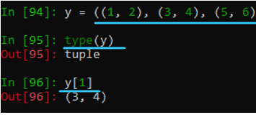

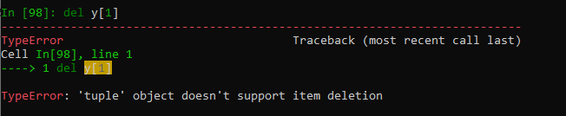



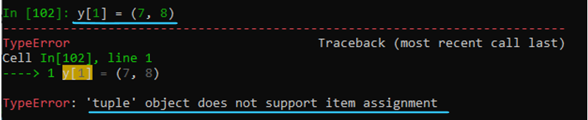

**Iterate Through a Tuple**

We use the for loop to iterate over the items of a tuple. For example,

fruits = ('apple','banana','orange')

# iterate through the tuple

for fruit in fruits:

print(fruit)

Examples of Usage

# Creating an empty Tuple

tup = ()

print(tup) # Output is ()

# Using String

tup = ('Geeks', 'For')

print(tup) # Output is ('Geeks', 'For')

# Using List

li = [1, 2, 4, 5, 6]

print(tuple(li)) # Output is (1, 2, 4, 5, 6)

# Using Built-in Function

tup = tuple('Geeks')

print(tup) # Output is ('G', 'e', 'e', 'k', 's')

# Creating a Tuple with Mixed Datatype

tup = (5, 'Welcome', 7, 'Geeks')

print(tup) # Output is (5, 'Welcome', 7, 'Geeks')

# Creating a Tuple with nested tuples

tup1 = (0, 1, 2, 3)

tup2 = ('python', 'geek')

tup3 = (tup1, tup2)

print(tup3) # Output is ((0, 1, 2, 3), ('python', 'geek'))

# Creating a Tuple with repetition

tup1 = ('Geeks',) * 3

print(tup1) # Output is ('Geeks', 'Geeks', 'Geeks')

# Creating a Tuple with the use of loop

tup = ('Geeks')

n = 5

for i in range(int(n)):

tup = (tup,)

print(tup)

# Output of above is

# ('Geeks',)

# (('Geeks',),)

# ((('Geeks',),),)

# (((('Geeks',),),),)

# ((((('Geeks',),),),),)

# Accessing Tuple with Indexing

tup = tuple("Geeks")

print(tup[0]) # Output is G

# Accessing a range of elements using slicing

print(tup[1:4]) # Output is ('e', 'e', 'k')

print(tup[:3]) # Output is ('G', 'e', 'e')

# Tuple unpacking

tup = ("Geeks", "For", "Geeks")

# This line unpack values of Tuple1

a, b, c = tup

print(a) # Output is Geeks

print(b) # Output is for

print(c) # Output is Geeks

y = (1, 2, 3)

print(type(y)) # output is <class 'tuple'>

print(type(y).__name__) # output is tuple

y = ((1, 2,), (3, 4), (5, 6))

print(type(y).__name__) # output is tuple

print(y[1]) # output is (3, 4) on index 1

print(type(y[1]).__name__) # output is tuple

# TypeError: 'tuple' object doesn't support item deletion

# del y[1]

# TypeError: 'tuple' object does not support item assignment

# y[1] = (7, 8)

# Returns the number of times a specified value occurs in a tuple. Output is 1

print( y.count((3,4)) )

# Searches the tuple and returns position of where it was found. Output is 1

print(y.index((3,4)))

# Concatenation of Tuples

tup1 = (0, 1, 2, 3)

tup2 = ('Geeks', 'For', 'Geeks')

tup3 = tup1 + tup2

print(tup3)

# Output is (0, 1, 2, 3, 'Geeks', 'For', 'Geeks')

# Slicing of a Tuple with Numbers

tup = tuple('GEEKSFORGEEKS')

# Removing First element

# Output is ('E', 'E', 'K', 'S', 'F', 'O', 'R', 'G', 'E', 'E', 'K', 'S')

print(tup[1:])

# Reversing the Tuple

# Output is ('S', 'K', 'E', 'E', 'G', 'R', 'O', 'F', 'S', 'K', 'E', 'E', 'G')

print(tup[::-1])

# Printing elements of a Range

# Output is ('S', 'F', 'O', 'R', 'G')

print(tup[4:9])

# Deleting a Tuple. Printing of Tuple after deletion results in an Error.

tup = (0, 1, 2, 3, 4)

del tup

# Below print will result in error - name 'tup' is not defined. Did you mean: 'tup1'?

# print(tup)

# Built-In Methods for Tuples

tup = (0, 1, True, True, False)

# Returns true if all element are true or if tuple is empty

print( all(tup) ) # Output - False

# return true if any element of the tuple is true. if tuple is empty, return false

print( any( (0, 1, True, False) ) ) # Output - True

# Returns length of the tuple or size of the tuple

print( len(tup) ) # Output - 5

# Returns enumerate object of tuple

print( enumerate(tup) ) # Output - <enumerate object at 0x000001522D7E7560>

# return maximum element of given tuple

print( max(tup) ) # Output - 4

# return minimum element of given tuple

print( min(tup) ) # Output - 0

# Sums up the numbers in the tuple

print( sum(tup) ) # Output - 10

# input elements in the tuple and return a new sorted list

print( sorted( tup ) ) # Output - [0, 1, 2, 3, 4]

# Convert an iterable to a tuple.

a = [1, 2, 3, 4, 5] # list

tup = tuple(a)

print('tuple:', tup) # tuple: (1, 2, 3, 4, 5)

# Unpacking a tuple

# If we don’t need certain values, use _ as a throwaway variable or placeholder:

# Output 100 300

a, _, c = (100, 200, 300)

print(a)

print(c)

# Using * for Variable-Length Unpacking

# Python allows catching multiple elements using *, known as the extended unpacking technique:

# Output is 1 and [2, 3, 4, 5]

a, *b = (1, 2, 3, 4, 5)

print(a)

print(b)

# Unpacking Nested Tuples. Tuples inside tuples can also be unpacked.

nested_tuple = (1, (2, 3), 4)

a, (b, c), d = nested_tuple

print(a) # Output 1

print(b) # Output 2

print(c) # Output 3

print(d) # Output 4

# Tuple Unpacking with * in Function Arguments

# using *args: When defining a function, *args allows passing multiple arguments as a tuple

def add(*args):

return sum(args)

print(add(1, 2, 3, 4)) # Output is 10

# Using * for Argument Unpacking: Tuple unpacking can also be used when calling a function:

def add(a, b, c):

return a + b + c

nums = (1, 2, 3)

print(add(*nums))

### Lists

List objects are mutable: you may rebind or delete items and slices of a list. Items of a list are arbitrary objects and may be of different types. Slices of a list are lists.

Modifying a list

You can modify (rebind) a single item in a list by assigning to an indexing. For instance:

x = [1, 2, 3, 4]

x[1] = 42 # x is now [1, 42, 3, 4]

Another way to modify a list object L is to use a slice of L as the target (LHS) of an assignment statement. The RHS of the assignment must be an iterable. When the LHS slice is in extended form (i.e., the slicing specifies a stride other than 1), then the RHS must have just as many items as the number of items in the LHS slice.

When the LHS slicing does not specify a stride, or explicitly specifies a stride of 1, the LHS slice and the RHS may each be of any length; assigning to such a slice of a list can make the list longer or shorter. For example:

x = [10, 20, 30, 40, 50]

# replace items 1 and 2

x[1:3] = [22, 33, 44] # x is now [10, 22, 33, 44, 40, 50]

# replace items 1-3

x[1:4] = [88, 99] # x is now [10, 88, 99, 40, 50]

There are some important special cases of assignment to slices:

• Using the empty list [] as the RHS expression removes the target slice from L. In other words, L[i:j] = [] has the same effect as del L[i:j] (or the peculiar statement L[i:j] *= 0).

• Using an empty slice of L as the LHS target inserts the items of the RHS at the appropriate spot in L. For example, L[i:i] = ['a', 'b'] inserts 'a' and 'b' before the item that was at index i in L prior to the assignment.

• Using a slice that covers the entire list object, L[:], as the LHS target totally replaces the contents of L.

You can delete an item or a slice from a list with del. For instance:

x = [1, 2, 3, 4, 5]

del x[1] # x is now [1, 3, 4, 5]

del x[::2] # x is now [3, 5]

In-place operations on a list

List objects define in-place versions of the + and * operators, which you can use via augmented assignment statements. The augmented assignment statement L += L1 has the effect of adding the items of the iterable L1 to the end of L, just like

L.extend(L1). L *= n has the effect of adding n-1 copies of L to the end of L; if n <= 0, L *= n makes L empty, like L[:] = [] or del L[:].

List methods

List objects provide several methods, as shown in Table 3-5. Nonmutating methods return a result without altering the object to which they apply, while mutating methods may alter the object to which they apply. Many of a list’s mutating methods behave like assignments to appropriate slices of the list. In this table, L indicates any list object, i any valid index in L, s any iterable, and x any object.

Table 3-5. List object methods

All mutating methods of list objects, except pop, return None.

Nonmutating

|  |  |  |
| --- | --- | --- |
| count | L.count(x) | Returns the number of items of L that are equal to x. |
| index | L.index(x) | Returns the index of the first occurrence of an item in L that is equal to x, or raises an exception if L has no such item. |

Mutating

|  |  |  |
| --- | --- | --- |
| append | L.append(x) | Appends item x to the end of L ; like L[len(L):] = [x]. |
| clear | L.clear() | Removes all items from L, leaving L empty. |
| extend | L.extend(s) | Appends all the items of iterable s to the end of L; like L[len(L):] = s or L += s. |
| insert | L.insert(i, x) | Inserts item x in L before the item at index i, moving following items of L (if any) “rightward” to make space (increases len(L) by one, does not replace any item, does not raise exceptions; acts just like L[i:i]=[x]). |
| pop | L.pop(i=-1) | Returns the value of the item at index i and removes it from L; when you omit i, removes and returns the last item; raises an exception when L is empty or i is an invalid index in L. |
| remove | L.remove(x) | Removes from L the first occurrence of an item in L that is equal to x, or raises an exception when L has no such item. |
| reverse | L.reverse() | Reverses, in place, the items of L. |
| sort | L.sort(key=None,  reverse=False) | Sorts, in place, the items of L (in ascending order, by default; in descending order, if the argument reverse is True). When the argument key is not None, what gets compared for each item x is key(x), not x itself. For more details, see the following section. |

Sorting a list

A list’s sort method causes the list to be sorted in place (reordering items to place them in increasing order) in a way that is guaranteed to be stable (elements that compare equal are not exchanged). In practice, sort is extremely fast—often preternaturally fast, as it can exploit any order or reverse order that may be present in any sublist (the advanced algorithm sort uses, known as timsort17 to honor its inventor, great Pythonista Tim Peters, is a “non-recursive adaptive stable natural mergesort/binary insertion sort hybrid”—now there’s a mouthful for you!).

The sort method takes two optional arguments, which may be passed with either positional or named-argument syntax. The argument key, if not None, must be a function that can be called with any list item as its only argument. In this case, to compare any two items x and y, Python compares key(x) and key(y) rather than x and y (internally, Python implements this in the same way as the decorate–sort– undecorate idiom presented in “Searching and sorting” on page 556, but it’s much faster). The argument reverse, if True, causes the result of each comparison to be reversed; this is not exactly the same thing as reversing L after sorting, because the sort is stable (elements that compare equal are never exchanged) whether the argument reverse is True or False. In other words, Python sorts the list in ascending order by default, or in descending order if reverse is True:

mylist = ['alpha', 'Beta', 'GAMMA']

mylist.sort() # ['Beta', 'GAMMA', 'alpha']

mylist.sort(key=str.lower) # ['alpha', 'Beta', 'GAMMA']

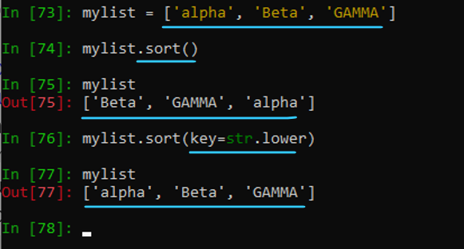 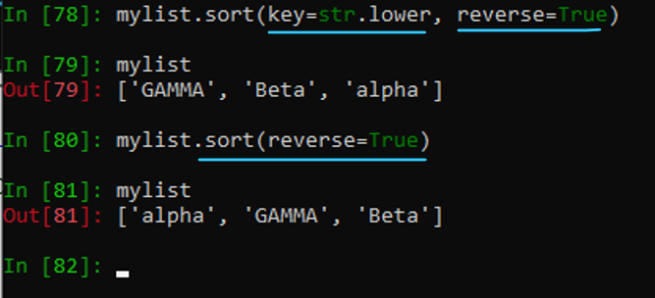

Python also provides the built-in function sorted (covered in Table 8-2) to produce a sorted list from any input iterable. sorted, after the first argument (which is the iterable supplying the items), accepts the same two optional arguments as a list’s sort method.

The standard library module operator (covered in “The operator Module” on page 493) supplies higher-order functions attrgetter, itemgetter, and methodcaller, which produce functions particularly suitable for the optional key argument of the list’s sort method and the built-in function sorted. This optional argument also exists, with exactly the same meaning, for the built-in functions min and max, as well as for the functions nsmallest, nlargest, and merge in the standard library module heapq (covered in “The heapq Module” on page 271) and the class groupby in the standard library module itertools (covered in “The itertools Module” on page 275).

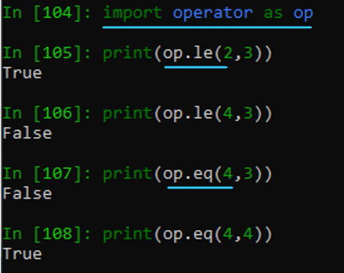

Examples of usage

from collections import deque

**List**

## a list is a built-in dynamic sized array

## We can store all types of items (including another list) in a list

## A list may contain mixed type of items, this is possible because a list mainly

## stores references at contiguous locations and actual items maybe stored at different locations.

## List can contain duplicate items.

## List in Python are Mutable. Hence, we can modify, replace or delete the items.

## List are ordered. It maintain the order of elements based on how they are added.

## Accessing items in List can be done directly using their position (index), starting from 0.

fruits = ['orange', 'apple', 'pear', 'banana', 'kiwi', 'apple', 'banana']

morefruits = ['pineapple', 'chickoo']

# append() - Adds an element at the end of the list

fruits.append('grape')

print(fruits) # Output ['orange', 'apple', 'pear', 'banana', 'kiwi', 'apple', 'banana', 'grape']

# clear() and copy() - Removes all the elements from the list. copy() - Returns a copy of the list

copy_of_fruits = fruits.copy()

copy_of_fruits.clear()

print('copy_of_fruits: ', copy_of_fruits)

# Output - copy_of_fruits: []

print('fruits: ', fruits)

# Output - ['orange', 'apple', 'pear', 'banana', 'kiwi', 'apple', 'banana', 'grape', 'pineapple', 'chickoo']

# count() - Returns the number of elements with the specified value

fruits.count('apple') # Output is 2

fruits.count('tangerine') # Output is 0

# extend() - Add the elements of a list (or any iterable), to the end of the current list

fruits.extend( morefruits )

print(fruits)

# index() - Returns the index of the first element with the specified value

fruits.index('banana') # Output is 3

fruits.index('banana', 4) # Find next banana starting at position 4. Output is 6

# insert() - Adds an element at the specified position

fruits.insert(4, 'papaya')

print('after adding papaya: ', fruits)

# Output is after adding papaya:

# ['orange', 'apple', 'pear', 'banana', 'papaya', 'kiwi', 'apple', 'banana', 'grape', 'pineapple', 'chickoo']

# pop() - Removes the element at the specified position

fruits.pop() # Output 'pear'

# remove() - Removes the first item with the specified value

fruits.remove('kiwi')

print('After removing kiwi', fruits )

# reverse() - Reverses the order of the list

fruits.reverse()

print( fruits )

# Output - ['pineapple', 'grape', 'banana', 'apple', 'banana', 'pear', 'apple', 'orange']

# sort() - Sorts the list

fruits.sort()

print( fruits )

# Output - ['apple', 'apple', 'banana', 'banana', 'grape', 'orange', 'pear', 'pineapple']

**### Using **Lists as Stacks\*\***

stack = [3, 4, 5]

stack.append(6)

stack.append(7)

print( stack )

# Output is [3, 4, 5, 6, 7]

print( stack.pop() )

# Output is 7

print( stack )

# Output is [3, 4, 5, 6]

print( stack.pop() )

# Output is 6

print( stack.pop() )

# Output is 5

print( stack )

# Output is [3, 4]

**### Using **Lists as Queues\*\***

# from collections import deque - specified at the top

queue = deque(["Eric", "John", "Michael"])

queue.append("Terry") # Terry arrives

queue.append("Graham") # Graham arrives

print( queue.popleft() ) # The first to arrive now leaves

# Output is 'Eric'

print( queue.popleft() ) # The second to arrive now leaves

# Output is 'John'

print( queue ) # Remaining queue in order of arrival

# Output is deque(['Michael', 'Terry', 'Graham'])

#### List comprehensions

# List Comprehensions

List comprehensions provide a concise way to create lists. Common applications are to make new lists where each element is the result of some operations applied to each member of another sequence or iterable, or to create a subsequence of those elements that satisfy a certain condition.

**A simple example is creating a list of numbers from 0 to 9.**

# Creates a list of numbers from 0 to 9

a = [i for i in range(10)]

print(a)

**Using nested loops**

# Creates a list of tuples representing all combinations of (x, y)

# where both x and y range from 0 to 2.

coordinates = [(x, y) for x in range(3) for y in range(3)]

print(coordinates)

# Output: [(0, 0), (0, 1), (0, 2), (1, 0), (1, 1), (1, 2), (2, 0), (2, 1), (2, 2)]

**for loop vs. list comprehension**

squares = []

for x in range(10):

squares.append(x**2)

squares

# Output is [0, 1, 4, 9, 16, 25, 36, 49, 64, 81]

**We can calculate the list of squares without any side effects using:**

squares = list( map( lambda x: x**2, range(10) ) )

**or, equivalently:**

squares = [x**2 for x in range(10)]

**which is more concise and readable.**

**Conditional statements in list comprehension**

a = [1, 2, 3, 4, 5]

res = [val for val in a if val % 2 == 0]

print(res)

# Output: [2, 4]

**Flattening a list of lists**

mat = [[1, 2, 3], [4, 5, 6], [7, 8, 9]]

res = [val for row in mat for val in row]

print(res)

# Output: [1, 2, 3, 4, 5, 6, 7, 8, 9]

**combine the elements of two lists** if they are not equal:**

[(x, y) for x in [1,2,3] for y in [3,1,4] if x != y]

# Output is [(1, 3), (1, 4), (2, 3), (2, 1), (2, 4), (3, 1), (3, 4)]

**and it’s equivalent to:**

combs = []

for x in [1,2,3]:

for y in [3,1,4]:

if x != y:

combs.append((x, y))

combs

# Output is [(1, 3), (1, 4), (2, 3), (2, 1), (2, 4), (3, 1), (3, 4)]

**Note how the order of the for and if statements is the same in both these snippets. If the expression is a tuple (e.g. the (x, y) in the previous example), it must be parenthesized.**

vec = [-4, -2, 0, 2, 4]

# create a new list with the values doubled

[x*2 for x in vec]

**filter the list to exclude negative numbers**

[x for x in vec if x >= 0]

**apply a function to all the elements**

[abs(x) for x in vec]

**call a method on each element**

freshfruit = [' banana', ' loganberry ', 'passion fruit ']

[weapon.strip() for weapon in freshfruit]

**create a list of 2-tuples like (number, square)**

[(x, x**2) for x in range(6)]

**the tuple must be parenthesized, otherwise an error is raised**

[x, x**2 for x in range(6)]

File "<stdin>", line 1

[x, x**2 for x in range(6)]

^^^^^^^

SyntaxError: did you forget parentheses around the comprehension target?

**flatten a list using a listcomp with two 'for'**

vec = [[1,2,3], [4,5,6], [7,8,9]]

[num for elem in vec for num in elem]

# print( [x, x**2 for x in range(6)] )

**List comprehensions **can contain complex expressions and nested functions**:**

from math import pi - imported above

print( [str(round(pi, i)) for i in range(1, 6)] )

# Output is ['3.1', '3.14', '3.142', '3.1416', '3.14159']

Nested List Comprehensions. The initial expression in a list comprehension can be any arbitrary expression, including another list comprehension. Consider the following example of a 3x4 matrix implemented as a list of 3 lists of length 4:

matrix = [

[1, 2, 3, 4],

[5, 6, 7, 8],

[9, 10, 11, 12],

]

The following list comprehension will **transpose rows and columns**:

[[row[i] for row in matrix] for i in range(4)]

# Output is [[1, 5, 9], [2, 6, 10], [3, 7, 11], [4, 8, 12]]

**As we saw in the previous section, the inner list comprehension is evaluated in the context of the for that follows it, so this example is equivalent to:**

transposed = []

for i in range(4):

transposed.append([row[i] for row in matrix])

transposed

**which, in turn, is the same as:**

transposed = []

for i in range(4):

# the following 3 lines implement the nested listcomp

transposed_row = []

for row in matrix:

transposed_row.append(row[i])

transposed.append(transposed_row)

transposed

**In the real world, **you should prefer built-in functions** to complex flow statements.**

**The** zip() **function would do a great job for this use case:**

list(zip(*matrix))

list(range(3, 6)) # normal call with separate arguments

args = [3, 6]

list(range(*args)) # call with arguments unpacked from a list

In the same fashion, **dictionaries** can deliver keyword arguments with the **-operator:

def parrot(voltage, state='a stiff', action='voom'):

print("-- This parrot wouldn't", action, end=' ')

print("if you put", voltage, "volts through it.", end=' ')

print("E's", state, "!")

d = {"voltage": "four million", "state": "bleedin' demised", "action": "VOOM"}

parrot(**d)

### Set Operations

Python provides a variety of operations applicable to sets (both plain and frozen). Since sets are containers, the built-in len function can take a set as its single argument and return the number of items in the set. A set is iterable, so you can pass it to any function or method that takes an iterable argument. In this case, iteration yields the items of the set in some arbitrary order. For example, for any set S, min(S) returns the smallest item in S, since min with a single argument iterates on that argument (the order does not matter, because the implied comparisons are transitive).

Set Membership

The k in S operator checks whether the object k equals one of the items in the set S. It returns True when the set contains k, and False when it doesn’t. k not in S is like not (k in S).

Set Methods

Set objects provide several methods, as shown in Table 3-6. Nonmutating methods return a result without altering the object to which they apply, and can also be called on instances of frozenset; mutating methods may alter the object to which they apply, and can be called only on instances of set. In this table, s denotes any set object, s1 any iterable with hashable items (often but not necessarily a set or frozenset), and x any hashable object.

Set object methods

Nonmutating

|  |  |  |
| --- | --- | --- |
| copy | s.copy() | Returns a shallow copy of s (a copy whose items are the same objects as s’s, not copies thereof); like set(s) |
| difference | s.difference(s1) | Returns the set of all items of s that aren’t in s1; can be written as s - s1 |
| intersection | s.intersection(s1) | Returns the set of all items of s that are also in s1; can be written as s & s1 |
| isdisjoint | s.isdisjoint(s1) | Returns True if the intersection of s and s1 is the empty set (they have no items in common), and otherwise returns False |
| issubset | s.issubset(s1) | Returns True when all items of s are also in s1, and otherwise returns False; can be written as s <= s1 |
| issuperset | s.issuperset(s1) | Returns True when all items of s1 are also in s, and otherwise returns False (like s1.issubset(s)); can be written as s >= s1 |

|  |  |  |
| --- | --- | --- |
| symmetric_difference | s.symmetric_difference(s1) | Returns the set of all items that are in either s or s1, but not both; can be written s ^ s1 |
| union | s.union(s1) | Returns the set of all items that are in s, s1, or both; can be written as s | s1 |

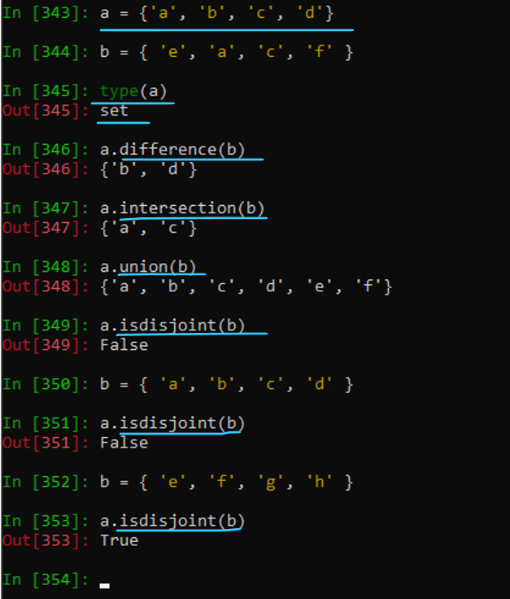

Mutating

|  |  |  |
| --- | --- | --- |
| add | s.add(x) | Adds x as an item to s; no effect if x was already an item in s |
| clear | s.clear() | Removes all items from s, leaving s empty |
| discard | s.discard(x) | Removes x as an item of s; no effect when x was not an item of s |
| pop | s.pop() | Removes and returns an arbitrary item of s |
| remove | s.remove(x) | Removes x as an item of s; raises a KeyError exception when x was not an item of s |

All mutating methods of set objects, except pop, return None.

The pop method can be used for destructive iteration on a set, consuming little extra memory. The memory savings make pop usable for a loop on a huge set, when what you want is to “consume” the set in the course of the loop. Besides saving memory, a potential advantage of a destructive loop such as this:

while S:

item = S.pop()

# ...handle item...

in comparison to a nondestructive loop such as this:

for item in S:

# ...handle item...

is that in the body of the destructive loop you’re allowed to modify S (adding and/or removing items), which is not allowed in the nondestructive loop. Sets also have mutating methods named difference_update, intersection_update, symmetric_difference_update, and update (corresponding to the nonmutating method union). Each such mutating method performs the same operation as the corresponding nonmutating method, but it performs the operation in place, altering the set on which you call it, and returns None.

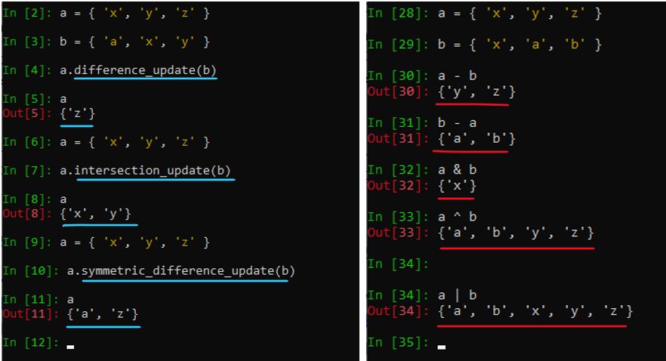

The four corresponding nonmutating methods are also accessible with operator syntax (where S2 is a set or frozenset, respectively, S - S2, S & S2, S ^ S2, and S | S2) and the mutating methods are accessible with augmented assignment syntax (respectively, S -= S2, S &= S2, S ^= S2, and S |= S2). In addition, sets and frozensets also support comparison operators: == (the sets have the same items; that is, they’re “equal” sets), != (the reverse of ==), >= (issuperset), <= (issubset), < (issubset and not equal), and > (issuperset and not equal).

When you use operator or augmented assignment syntax, both operands must be sets or frozensets; however, when you call named methods, argument S1 can be any iterable with hashable items, and it works just as if the argument you passed was set(S1).

Examples of Usage

**A set is a container. A set is iterable, so you can pass it to any function or method that takes an iterable argument**

## Methods

s = { 'a', 'c', 'e', 'b', 'd' }

s1 = {'b', 'e', 'd'}

s3 = {'z', 'y', 'x'}

**.copy() method**

s_copy = s.copy()

print(s_copy) # Output {'d', 'a', 'b', 'e', 'c'}

**.difference() method**

print( s.difference(s1) ) # Output {'a', 'c'}

**.intersection() method**

print( s.intersection(s1) ) # Output {'b', 'e', 'd'}

**.isdisjoint()** **method**

print( s.isdisjoint(s1) ) # Output False

.issubset() **method**

print( s1.issubset(s) ) # Output True

**.issuperset() method**

print( s.issuperset(s1) ) # Output True

.symmetric_difference() **method**

s.symmetric_difference(s1)

**.union() method**

s.union(s1) # Output {'a', 'c', 'd', 'b', 'e'}

**.add() method**

x = 'r'

s.add(x)

print(s) # Output {'e', 'c', 'b', 'r', 'd', 'a'}

**.clear() method**

s.clear()

print(s) # Output set()

s = { 'a', 'c', 'e', 'b', 'd' }

s1 = {'b', 'e', 'd'}

s3 = {'z', 'y', 'x'}

**.discard() method**

x = 'r'

s.discard(x)

print(s) # Output {'e', 'c', 'b', 'd', 'a'}

**.pop() method**

print( s.pop() ) # Output 'e'

**.remove() method**

# s.remove(x) # KeyError: 'r' - there is no 'r'

s.add(x)

s.remove(x) # can remove now

print(s) # Output is {'c', 'b', 'd', 'a'}

pop() **method can be used for destructive iteration on a set**

while S:

item = S.pop()

print(s)

# Output set()

### Dictionary Operations

Python provides a variety of operations applicable to dictionaries. Since dictionaries are containers, the built-in len function can take a dictionary as its argument and return the number of items (key/value pairs) in the dictionary. A dictionary is iterable, so you can pass it to any function that takes an iterable argument. In this case, iteration yields only the keys of the dictionary, in insertion order. For example, for any dictionary D, min(D) returns the smallest key in D (the order of keys in the iteration doesn’t matter here).

Dictionary Membership

The k in D operator checks whether the object k is a key in the dictionary D. It returns True if the key is present, and False otherwise. k not in D is like not (k in D).

Indexing a Dictionary

To denote the value in a dictionary D currently associated with the key k, use an indexing: D[k]. Indexing with a key that is not present in the dictionary raises an exception. For example:

d = {'x':42, 'h':3.14, 'z':7}

d['x'] # 42

d['z'] # 7

d['a'] # raises KeyError exception

Plain assignment to a dictionary indexed with a key that is not yet in the dictionary (e.g., D[newkey]=value) is a valid operation and adds the key and value as a new item in the dictionary. For instance:

d = {'x':42, 'h':3.14}

d['a'] = 16 # d is now {'x':42, 'h':3.14, 'a':16}

The del statement, in the form del D[k], removes from the dictionary the item whose key is k. When k is not a key in dictionary D, del D[k] raises a KeyError exception.

Dictionary Methods

Dictionary objects provide several methods, as shown in Table 3-7. Nonmutating methods return a result without altering the object to which they apply, while mutating methods may alter the object to which they apply. In this table, d and d1 indicate any dictionary objects, k any hashable object, and x any object.

Dictionary object methods

**Nonmutating methods**

|  |  |  |
| --- | --- | --- |
| copy | d.copy() | Returns a shallow copy of the dictionary (a copy whose items are the same objects as D’s, not copies thereof, just like dict(d)) |
| get | d.get(k[, x]) | Returns d[k] when k is a key in d; otherwise, returns x (or None, when you don’t pass x) |
| items | d.items() | Returns an iterable view object whose items are all current items (key/value pairs) in d |
| keys | d.keys() | Returns an iterable view object whose items are all current keys in d |
| values | d.values() | Returns an iterable view object whose items are all current values in d |

**Mutating methods**

|  |  |  |
| --- | --- | --- |
| clear | d.clear() | Removes all items from d, leaving d empty |
| pop | d.pop(k[, x]) | Removes and returns d[k] when k is a key in d; otherwise, returns x (or raises a KeyError exception when you don’t pass x) |
| popitem | d.popitem() | Removes and returns the items from d in last-in, first-out order set |
| default | d.setdefault(k, x) | Returns d[k] when k is a key in d; otherwise, sets d[k] equal to x (or None, when you don’t pass x), then returns d[k] |
| update | d.update(d1) | For each k in mapping d1, sets d[k] equal to d1[k] |

>>> thisdict = {

"brand": "Ford",

"model": "Mustang",

"year": 1964

}

print(thisdict["brand"])

Duplicate values will overwrite existing values:

>>> thisdict = {

"brand": "Ford",

"model": "Mustang",

"year": 1964,

"year": 2020

}

Year will be 2020 in this case

print(len(thisdict))

String, int, boolean, and list data types:

thisdict = {

"brand": "Ford",

"electric": False,

"year": 1964,

"colors": ["red", "white", "blue"]

}

Type

print(type(thisdict))

dict() constructor

thisdict = dict(name = "John", age = 36, country = "Norway")

print(thisdict)

Sorting the dictionary

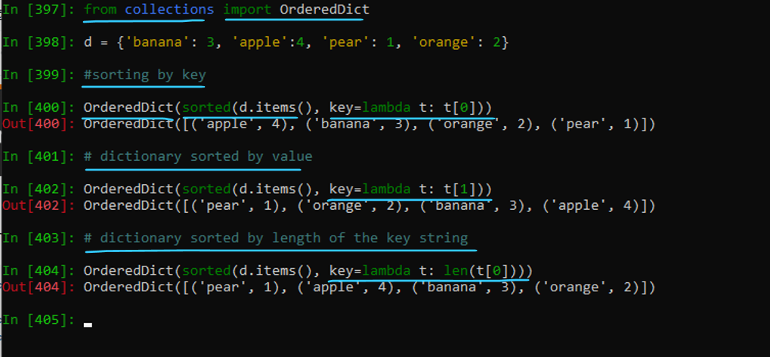

The items, keys, and values methods return values known as view objects. If the underlying dict changes, the retrieved view also changes; Python doesn’t allow you to alter the set of keys in the underlying dict while using a for loop on any of its view objects.

Iterating on any of the view objects yields values in insertion order. In particular, when you call more than one of these methods without any intervening change to the dict, the order of the results is the same for all of them.

Dictionaries also support the class method fromkeys(seq, value), which returns a dictionary containing all the keys of the given iterable seq, each identically initialized with value.

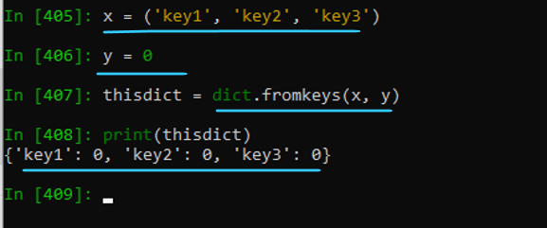

**Never Modify a dict’s Keys While Iterating on It**

Don’t ever modify the set of keys in a dict (i.e., add or remove keys) while iterating over that dict or any of the iterable views returned by its methods. If you need to avoid such constraints against mutation during iteration, iterate instead on a list explicitly built from the dict or view (i.e., on list(D)). Iterating directly on a dict D is exactly like iterating on D.keys().

The return values of the items and keys methods also implement set nonmutating methods and behave much like frozensets; the return value of the method values doesn’t, since, in contrast to the others (and to sets), it may contain duplicates. The popitem method can be unsed for destructive iteration on a dictionary. Both items and popitem return dictionary items as key/value pairs. popitem is usable for a loop on a huge dictionary, when what you want is to “consume” the dictionary in the course of the loop.

D.setdefault(k, x) returns the same result as D.get(k, x); but, when k is not a key in D, setdefault also has the side effect of binding D[k] to the value x. (In modern Python, setdefault is not often used, since the type collections.defaultdict, covered in “defaultdict” on page 267, often offers similar, faster, clearer functionality.)

The pop method returns the same result as get, but when k is a key in D, pop also has the side effect of removing D[k] (when x is not specified, and k is not a key in D, get returns None, but pop raises an exception). d.pop(key, None) is a useful shortcut for removing a key from a dict without having to first check if the key is present, much like s.discard(x) (as opposed to s.remove(x)) when s is a set. 3.9+ The update method is accessible with augmented assignment syntax: where D2 is a dict, D |= D2 is the same as D.update(D2). Operator syntax, D | D2, mutates neither dictionary: rather, it returns a new dictionary result, such that D3 = D | D2 is equivalent to D3 = D.copy(); D3.update(D2).

The update method (but not the | and |= operators) can also accept an iterable of key/value pairs as an alternative argument instead of a mapping, and can accept named arguments instead of—or in addition to—its positional argument; the semantics are the same as for passing such arguments when calling the built-in dict type, as covered in “Dictionaries” on page 49.

Examples of Usage

# Dictionary

* Python provides a variety of operations applicable to dictionaries. Since dictionaries are containers, the built-in len function can take a dictionary as its argument and return the number of items (key/value pairs) in the dictionary
* The k in D operator checks whether the object k is a key in the dictionary D
* k not in D is like not (k in D).
* Dictionary keys must be immutable, such as tuples, strings, integers, etc. We cannot use mutable (changeable) objects such as lists as keys.
* Keys of a dictionary must be unique

**Creating a Dictionary**

d = {'x':42, 'h':3.14, 'z':7}

**Adding a item** to a dictionary**

country_capitals["Italy"] = "Rome"

**Remove dictionary item**

del country_capitals["Germany"]

**Change dictionary item**

country_capitals["Italy"] = "Rome"

**Iterate through a dictionary**

country_capitals = {

"United States": "Washington D.C.",

"Italy": "Rome"

}

**# print dictionary keys one by one**

for country in country_capitals:

print(country) # Output as United States Italy

print()

**# print dictionary values one by one**

for country in country_capitals:

capital = country_capitals[country] # Output as Washington D.C. Rome

print(capital)

**Dictionary Length**

country_capitals = {"England": "London", "Italy": "Rome"}

print(len(country_capitals)) # Output: 2

**Membership Test**

file_types = {

".txt": "Text File",

".pdf": "PDF Document",

".jpg": "JPEG Image",

}

**# use of in and not in operators**

print(".pdf" in file_types) # Output: True

print(".mp3" in file_types) # Output: False

print(".mp3" not in file_types) # Output: True

**Merge two dictionaries**

d1 = {'x': 1, 'y': 2}

d2 = {'y': 3, 'z': 4}

d1.update(d2)

print(d1) # Output: {'x': 1, 'y': 3, 'z': 4}

**Merge using the | operator**

d1 = {'x': 1, 'y': 2}

d2 = {'y': 3, 'z': 4}

d3 = d1 | d2

print(d3) # Output {'x': 1, 'y': 3, 'z': 4}

**Accessing elements by key**

d['x'] # 42

d['z'] # 7

d['a'] # raises KeyError exception

**Assigning a value using the key**

d['a'] = 16 # d is now {'x':42, 'h':3.14, 'a':16}

**Creating Dictionaries**

thisdict = {

"brand": "Ford",

"model": "Mustang",

"year": 1964

}

print(thisdict["brand"])

**Duplicate values will overwrite existing values:**

thisdict = {

"brand": "Ford",

"model": "Mustang",

"year": 1964,

"year": 2020

}

print( len(thisdict) )

**dict() constructor**

thisdict = dict(name = "John", age = 36, country = "Norway")

print(thisdict)

Sorting the dictionary

from collections import OrderedDict

d = {'banana': 3, 'apple':4, 'pear': 1, 'orange': 2}

**sorted by key**

OrderedDict(sorted(d.items(), key-lambda t: t[0]))

# Output: OrderedDict([('apple', 4), ('banana', 3), ('orange', 2), ('pear', 1)])

**sorted by value**

OrderedDict(sorted(d.items(), key-lambda t: t[1]))

# Output: OrderedDict([('pear', 1), ('orange', 2), ('banana", 3), ('apple', 4)])

**dictionary sorted by length of the key string**

OrderedDict(sorted(d.items(), key-lambda t: len(t[0]))) OrderedDict([('pear', 1), ('apple', 4), ('banana', 3), ('orange', 2)])

The items, keys, and values methods return values known as view objects. If the underlying dict changes, <br>

the retrieved view also changes; Python doesn’t allow you to alter the set of keys in the underlying dict <br>

while using a for loop on any of its view objects

**fromKeys() method**

Dictionaries also support the class method fromkeys(seq, value), which returns a dictionary containing all the keys of the given iterable seq

x = ('key1', 'key2', 'key3')

y = 0

thisdict = dict.fromkeys(x, y)

print(thisdict) # Output: {'key1': 0, 'key2': 0, 'key3': 0}

**Never Modify a dict’s Keys While Iterating on It**

Don’t ever modify the set of keys in a dict (i.e., add or remove keys) while iterating over that dict or any of the iterable views returned by its methods

**Non Mutating Methods**

d1 = d.copy() # Returns a shallow copy of the dictionary

print(d1)

d.get(k[, x]) # Returns d[k] when k is a key in d; otherwise, returns x

d.items() # dict_items([('x', 42), ('h', 3.14), ('z', 7)])

d.keys() # dict_keys(['x', 'h', 'z'])

d.values() # dict_values([42, 3.14, 7])

d.clear() # Removes all items from d, leaving d empty

d.pop(k[, x]) # Removes and returns d[k] when k is a key in d; otherwise, returns x

d.popitem() # Removes and returns the items from d in last-in, first-out order set

d.setdefault(k, x) # Returns d[k] when k is a key in d; otherwise, sets d[k] equal to x

d.update(d1) # For each k in mapping d1, sets d[k] equal to d1[k]

pop() method returns the same result as get, but when k is a key in D, pop also has the side effect of removing D[k]

update() method (but not the | and |= operators) can also accept an iterable of key/value pairs as an alternative argument

The return values of the items and keys methods also implement set nonmutating methods and behave much like frozensets

The popitem method can be unsed for destructive iteration on a dictionary. Both items and popitem return dictionary items as key/value pairs.

popitem is usable for a loop on a huge dictionary, when what you want is to “consume” the dictionary in the course of the loop.

**Dictionary Unpacking**

```

d1 = {'x': 1, 'y': 2}

d2 = {'y': 3, 'z': 4}

d3 = {**d1, **d2}

print(d3) # Output: {'x': 1, 'y': 3, 'z': 4}

# **d1 and **d2 unpack the key-value pairs of d1 and d2 into the new dictionary d3.

# Keys from d2 overwrite duplicates from d1.

**Using a loop**

d1 = {'x': 1, 'y': 2}

d2 = {'y': 3, 'z': 4}

d3 = d1.copy()

for key, value in d2.items():

d3[key] = value

print(d3) # Output: {'x': 1, 'y': 3, 'z': 4}

**\*\*Convert key-values list to flat dictionary** using the **dict()** constructor**

a = [("name", "Alice"), ("age", 25), ("city", "New York")] # List of key-value pairs as tuples

# Convert the list of key-value pairs into a flat dictionary using the dict() constructor

res = dict(a)

print(res)

**> **Using Dictionary Comprehension\*\***

# List of key-value pairs as tuples

a = [("name", "Alice"), ("age", 25), ("city", "New York")]

# Use dictionary comprehension to create a dictionary by unpacking each tuple into key and value

res = {key: value for key, value in a}

print(res)

# Output: {'name': 'Alice', 'age': 25, 'city': 'New York'}

# Dictionary comprehension iterates over the list a, unpacking each tuple into key and value.

# Each key is mapped to its corresponding value, and the comprehension directly constructs the dictionary res.

**\*\*Using zip() function\*\***

a = ["name", "age", "city"] # List of keys

b = ["Alice", 25, "New York"] # List of values

# Use zip to pair each key from 'a' with the corresponding value from 'b', then convert the pairs to a dictionary

res = dict( zip(a, b) )

print(res)

# Output: {'name': 'Alice', 'age': 25, 'city': 'New York'}

# zip() function combines elements from the lists a (keys) and b (values) into key-value pairs.

# dict() constructor then converts the paired elements into a dictionary, mapping each key to its corresponding value.

### Control Flow Statements

A program’s control flow regulates the order in which the program’s code executes. The control flow of a Python program mostly depends on conditional statements, loops, and function calls. (This section covers the if and match conditional statements, and for and while loops; we cover functions in the following section.) Raising and handling exceptions also affects control flow (via the try and with statements); we cover exceptions in Chapter 6.

#### The if Statement

Often, you’ll need to execute some statements only when some condition holds, or choose statements to execute depending on mutually exclusive conditions. The compound statement if—comprising if, elif, and else clauses—lets you conditionally execute blocks of statements. The syntax for the if statement is:

if expression:

statement(s)

elif expression:

statement(s)

elif expression:

statement(s)

...

else:

statement(s)

The elif and else clauses are optional. Before the introduction of the match construct, which we’ll look at next, using if, elif, and else was the most common approach for all conditional processing (although at times a dict with callables as values might provide a good alternative).

Here’s a typical if statement with all three kinds of clauses:

if x < 0:

print('x is negative')

elif x % 2:

print('x is positive and odd')

else:

print('x is even and nonnegative')

Each clause controls one or more statements (known as a block): place the block’s statements on separate logical lines after the line containing the clause’s keyword (known as the header line of the clause), indented four spaces past the header line.

The block terminates when the indentation returns to the level of the clause header, or further left from there (this is the style mandated by PEP 8).

You can use any Python expression18 as the condition in an if or elif clause. Using an expression this way is known as using it in a Boolean context. In this context, any value is taken as being either true or false. As mentioned earlier, any nonzero number or nonempty container (string, tuple, list, dictionary, set, etc.) evaluates as true, while zero (0, of any numeric type), None, and empty containers evaluate as false. To test a value x in a Boolean context, use the following coding style:

if x: This is the clearest and most Pythonic form.

Do not use any of the following:

if x is True:

if x == True:

if bool(x):

There is a crucial difference between saying that an expression returns True (meaning the expression returns the value 1 with the bool type) and saying that an expression evaluates as true (meaning the expression returns any result that is true in a Boolean context). When testing an expression, for example in an if clause, you only care about what it evaluates as, not what, precisely, it returns. As we previously mentioned, “evaluates as true” is often expressed informally as “is truthy,” and “evaluated as false” as “is falsy.”

When the if clause’s condition evaluates as true, the statements within the if clause execute, then the entire if statement ends. Otherwise, Python evaluates each elif clause’s condition, in order. The statements within the first elif clause whose condition evaluates as true, if any, execute, and the entire if statement ends. Otherwise, when an else clause exists, it executes. In any case, statements following the entire if construct, at the same level, execute next.

#### The match Statement

3.10+ The match statement brings structural pattern matching to the Python language.

You might think of this as doing for other Python types something similar to what the re module (see “Regular Expressions and the re Module” on page 305) does for strings: it allows easy testing of the structure and contents of Python objects. ( It is notable that the match statement specifically excludes matching values of type str, bytes, and bytearray with sequence patterns. ) Resist the temptation to use match unless there is a need to analyze the structure of an object.

The overall syntactic structure of the statement is the new (soft) keyword match followed by an expression whose value becomes the matching subject. This is followed by one or more indented case clauses, each of which controls the execution of the indented code block it contains:

|  |  |
| --- | --- |
| match parameter:  case pattern [if guard]:  statement(s)  # ... | match num:  # pattern 1  case num if num > 0:  print("Positive")  # pattern 2  case num if num < 0:  print("Negative")  # default pattern  case _:  print("Zero") |

In execution, Python first evaluates the expression, then tests the resulting subject value against the pattern in each case in turn, in order from first to last, until one matches: then, the block indented within the matching case clause evaluates. A pattern can do two things:

* Verify that the subject is an object with a particular structure.
* Bind matched components to names for further use (usually within the associated case clause).

When a pattern matches the subject, the guard allows a final check before selection of the case for execution. All the pattern’s name bindings have occurred, and you can use them in the guard. When there is no guard, or when the guard evaluates as true, the case’s indented code block executes, after which the match statement’s execution is complete and no further cases are checked.

The match statement, per se, provides no default action. If one is needed, the last case clause must specify a wildcard pattern—one whose syntax ensures it matches any subject value. It is a SyntaxError to follow a case clause having such a wildcard pattern with any further case clauses.

Pattern elements cannot be created in advance, bound to variables, and (for example) reused in multiple places. Pattern syntax is only valid immediately following the (soft) keyword case, so there is no way to perform such an assignment. For each execution of a match statement, the interpreter is free to cache pattern expressions that repeat inside the cases, but the cache starts empty for each new execution. We’ll first describe the various types of pattern expressions, before discussing guards and providing some more complex examples.

|  |  |
| --- | --- |
| # simple match case statement  def runMatch():  num = int(input("Enter between 1 and 3: "))    # match case  match num:  # pattern 1  case 1:  print("One")  # pattern 2  case 2:  print("Two")  # pattern 3  case 3:  print("Three")  # default pattern  case _:  print("Number not between 1 and 3")    runMatch() |  |

|  |  |
| --- | --- |
|  | |
| match num:  # pattern 1  case 1 | 2:  print("One or Two")  # pattern 2  case 3 | 4:  print("Three or Four")  # pattern 3  case 5 | 6:  print("Five or Six")  # default pattern  case _:  print("Number not betw 1 & 6") | match mystr:  # pattern 1  case ["a"]:  print("a")  # pattern 2  case ["a", *b]:  print(f"a and {b}")  # pattern 3  case [*a, "e"] | (*a, "e"):  print(f"{a} and e")  # default pattern  case _:  print("No data") |
| match num:  # pattern 1  case num if num > 0:  print("Positive")  # pattern 2  case num if num < 0:  print("Negative")  # default pattern  case _:  print("Zero") |  |
|  | match dictionary:  # pattern 1  case {"name": n, "age": a}:  print(f"Name:{n}, Age:{a}")  # pattern 2  case {"name": n, "salary": s}:  print(f"Name:{n}, Salary:{s}")  # default pattern  case _ :  print("Data does not exist") |
| match instance:  # pattern 1  case Programmer("Om", language="Python", framework="Django"):  print(f"Name: Om, Language:Python, Framework:Django")  # pattern 2  case Programmer("Rishabh", "C++"):  print("Name:Rishabh, Language:C++")  # pattern 3  case Person("Vishal", age=5, salary=100):  print("Name:Vishal")  # pattern 4  case Programmer(name, language, framework):  print(f"Name:{name}, Language:{language}, Framework:{framework}")  # pattern 5  case Person():  print("He is just a person !")  # default case  case _:  print("This person is nothiing!") | |
|  | |

**Pattern Expressions Have Their Own Semantics**

The syntax of pattern expressions might seem familiar, but their interpretation is sometimes quite different from that of nonpattern expressions, which could mislead readers unaware of those differences. Specific syntactic forms are used in the case clause to indicate matching of particular structures. A complete summary of this syntax would require more than the simplified notation we use in this book; ( Indeed, the syntax notation used in the Python online documentation required, and got, updates to concisely describe some of Python’s more recent syntax additions ) we therefore prefer to explain this new feature in plain language, with examples. For more detailed examples, refer to the Python documentation.

Building patterns

Patterns are expressions, though with a syntax specific to the case clause, so familiar grammatical rules apply even though certain features are interpreted differently. They can be enclosed in parentheses to let elements of a pattern be treated as a single expression unit. Like other expressions, patterns have a recursive syntax and can be combined to form more complex patterns. Let’s start with the simplest patterns first.

Literal patterns

Most literal values are valid patterns. Integer, float, complex number, and string literals (but not formatted string literals) are all permissible, ( Although comparing float or complex numbers for exact equality is often dubious practice. ) and all succeed in matching subjects of the same type and value:

>>> for subject in (42, 42.0, 42.1, 1+1j, b'abc', 'abc'):

... print(subject, end=': ')

... match subject:

... case 42: print('integer') # note this matches 42.0, too!

... case 42.1: print('float')

... case 1+1j: print('complex')

... case b'abc': print('bytestring')

... case 'abc': print('string')

42: integer

42.0: integer

42.1: float

(1+1j): complex

b'abc': bytestring

abc: string

For most matches, the interpreter checks for equality without type checking, which is why 42.0 matches integer 42. If the distinction is important, consider using class matching (see “Class patterns” on page 81) rather than literal matching. True, False, and None being singleton objects, each matches itself.

The wildcard pattern

In pattern syntax, the underscore ( _ ) plays the role of a wildcard expression. As the simplest wildcard pattern, _ matches any value at all:

>>> for subject in 42, 'string', ('tu', 'ple'), ['list'], object:

... match subject:

... case _: print('matched', subject)

...

matched 42

matched string

matched ('tu', 'ple')

matched ['list']

matched <class 'object'>

Capture patterns

The use of unqualified names (names with no dots in them) is so different in patterns that we feel it necessary to begin this section with a warning.

Simple Names Bind to Matched Elements Inside Patterns

Unqualified names—simple identifiers (e.g., color) rather than attribute references (e.g., name.attr)—do not necessarily have their usual meaning in pattern expressions. Some names, rather than being references to values, are instead bound to elements of the subject value during pattern matching.

Unqualified names, except _, are capture patterns. They’re wildcards, matching anything, but with a side effect: the name, in the current local namespace, gets bound to the object matched by the pattern. Bindings created by matching remain after the statement has executed, allowing the statements in the case clause and subsequent code to process extracted portions of the subject value.

The following example is similar to the preceding one, except that the name x, instead of the underscore, matches the subject. The absence of exceptions shows that the name captures the whole subject in each case:

>>> for subject in 42, 'string', ('tu', 'ple'), ['list'], object:

... match subject:

... case x: assert x == subject

...

Value patterns

This section, too, begins with a reminder to readers that simple names can’t be used to inject their bindings into pattern values to be matched. Represent Variable Values in Patterns with Qualified Names Because simple names capture values during pattern matching, you must use attribute references (qualified names like name.attr) to express values that may change between different executions of the same match statement.

Though this feature is useful, it means you can’t reference values directly with simple names. Therefore, in patterns, values must be represented by qualified names, which are known as value patterns—they represent values, rather than capturing them as simple names do. While slightly inconvenient, to use qualified names you can just set attribute values on an otherwise empty class. ( For this unique use case, it’s common to break the normal style conventions about starting class names with an uppercase letter and avoiding using semicolons to stash multiple assignments within one line; however, the authors haven’t yet found a style guide that blesses this peculiar, rather new usage. )

For example:

>>> class m: v1 = "one"; v2 = 2; v3 = 2.56

...

>>> match ('one', 2, 2.56):

... case (m.v1, m.v2, m.v3): print('matched')

...

matched

It is easy to give yourself access to the current module’s “global” namespace, like this:

>>> import sys

>>> g = sys.modules[__name__]

>>> v1 = "one"; v2 = 2; v3 = 2.56

>>> match ('one', 2, 2.56):

... case (g.v1, g.v2, g.v3): print('matched')

...

matched

OR patterns

When P1 and P2 are patterns, the expression P1 | P2 is an OR pattern, matching anything that matches either P1 or P2, as shown in the following example. Any number of alternate patterns can be used, and matches are attempted from left to right:

>>> for subject in range(5):

... match subject:

... case 1 | 3: print('odd')

... case 0 | 2 | 4: print('even')

...

even

odd

even

odd

even

It is a syntax error to follow a wildcard pattern with further alternatives, however, since they can never be activated. While our initial examples are simple, remember that the syntax is recursive, so patterns of arbitrary complexity can replace any of the subpatterns in these examples.

Group patterns

If P1 is a pattern, then (P1) is also a pattern that matches the same values. This addition of “grouping” parentheses is useful when patterns become complicated, just as it is with standard expressions. Like in other expressions, take care to distinguish between (P1), a simple grouped pattern matching P1, and (P1,), a sequence pattern (described next) matching a sequence with a single element matching P1.

Sequence patterns

A list or tuple of patterns, optionally with a single starred wildcard (*_) or starred capture pattern (*name), is a sequence pattern. When the starred pattern is absent, the pattern matches a fixed-length sequence of values of the same length as the pattern. Elements of the sequence are matched one at a time, until all elements have matched (then matching succeeds) or an element fails to match (then matching fails).

When the sequence pattern includes a starred pattern, that subpattern matches a sequence of elements sufficiently long to allow the remaining unstarred patterns to match the final elements of the sequence. When the starred pattern is of the form

*name, name is bound to the (possibly empty) list of the elements in the middle that don’t correspond to individual patterns at the beginning or end.

You can match a sequence with patterns that look like tuples or lists—it makes no difference to the matching process. The next example shows an unnecessarily complicated way to extract the first, middle, and last elements of a sequence:

>>> for sequence in (["one", "two", "three"], range(2), range(6)):

... match sequence:

... case (first, *vars, last): print(first, vars, last)

...

one ['two'] three

0 [] 1

0 [1, 2, 3, 4] 5

as patterns

You can use so-called as patterns to capture values matched by more complex patterns, or components of a pattern, that simple capture patterns (see “Capture patterns” on page 77) cannot.

When P1 is a pattern, then P1 as name is also a pattern; when P1 succeeds, Python binds the matched value to the name name in the local namespace. The interpreter tries to ensure that, even with complicated patterns, the same bindings always take place when a match occurs. Therefore, each of the next two examples raises SyntaxError, because the constraint cannot be guaranteed:

>>> match subject:

... case ((0 | 1) as x) | 2: print(x)

...

SyntaxError: alternative patterns bind different names

>>> match subject:

... case (2 | x): print(x)

...

SyntaxError: alternative patterns bind different names

But this one works:

>>> match 42:

... case (1 | 2 | 42) as x: print(x)

...

|  |  |
| --- | --- |
|  |  |

Mapping patterns

Mapping patterns match mapping objects, usually dictionaries, that associate keys with values. The syntax of mapping patterns uses key: pattern pairs. The keys must be either literal or value patterns.

The interpreter iterates over the keys in the mapping pattern, processing each as follows:

* Python looks up the key in the subject mapping; a lookup failure causes an immediate match failure.
* Python then matches the extracted value against the pattern associated with the key; if the value fails to match the pattern, then the whole match fails.

When all keys (and associated values) in the mapping pattern match, the whole match succeeds:

>>> match {1: "two", "two": 1}:

... case {1: v1, "two": v2}: print(v1, v2)

...

two 1

You can also use a mapping pattern together with an as clause:

>>> match {1: "two", "two": 1}:

... case {1: v1} as v2: print(v1, v2)

...

two {1: 'two', 'two': 1}

The as pattern in the second example binds v2 to the whole subject dictionary, not just the matched keys.

The final element of the pattern may optionally be a double-starred capture pattern such as **name. When that is the case, Python binds name to a possibly empty dictionary whose items are the (key, value) pairs from the subject mapping whose keys were not present in the pattern:

>>> match {1: 'one', 2: 'two', 3: 'three'}:

... case {2: middle, **others}: print(middle, others)

...

two {1: 'one', 3: 'three'}

Class patterns

The final and maybe the most versatile kind of pattern is the class pattern, offering the ability to match instances of particular classes and their attributes.

A class pattern is of the general form:

name_or_attr(patterns)

where name_or_attr is a simple or qualified name bound to a class—specifically, an instance of the built-in type type (or of a subclass thereof, but no super-fancy metaclasses need apply!)—and patterns is a (possibly empty) comma-separated list of pattern specifications. When no pattern specifications are present in a class pattern, the match succeeds whenever the subject is an instance of the given class, so for example the pattern int() matches any integer.

Like function arguments and parameters, the pattern specifications can be positional (like pattern) or named (like name=pattern). If a class pattern has positional pattern specifications, they must all precede the first named pattern specification. User-defined classes cannot use positional patterns without setting the class’s __match_args__ attribute (see “Configuring classes for positional matching” on page 83).

The built-in types bool, bytearray, bytes, dict, float, frozenset, int, list, set, str, and tuple, as well as any namedtuple and any dataclass, are all configured to take a single positional pattern, which is matched against the instance value. For example, the pattern str(x) matches any string and binds its value to x by matching the string’s value against the capture pattern—as does str() as x.

You may remember a literal pattern example we presented earlier, showing that literal matching could not discriminate between the integer 42 and the float 42.0 because 42 == 42.0. You can use class matching to overcome that issue:

>>> for subject in 42, 42.0:

... match subject:

... case int(x): print('integer', x)

... case float(x): print('float', x)

...

integer 42

float 42.0

|  |  |
| --- | --- |
|  |  |
|  |  |

Once the type of the subject value has matched, for each of the named patterns name=pattern, Python retrieves the attribute name from the instance and matches its value against pattern. If all named pattern matches succeed, the whole match succeeds. Python handles positional patterns by converting them to named patterns, as you’ll see momentarily.

Guards

When a case clause’s pattern succeeds, it is often convenient to determine on the basis of values extracted from the match whether this case should execute. When a guard is present, it executes after a successful match. If the guard expression evaluates as false, Python abandons the current case, despite the match, and moves on to consider the next case. This example uses a guard to exclude odd integers by checking the value bound in the match:

>>> for subject in range(5):

... match subject:

... case int(i) if i % 2 == 0: print(i, "is even")

...

0 is even

2 is even

4 is even

Configuring classes for positional matching

When you want your own classes to handle positional patterns in matching, you have to tell the interpreter which attribute of the instance (not which argument to __init__) each positional pattern corresponds to. You do this by setting the class’s __match_args__ attribute to a sequence of names. The interpreter raises a TypeError exception if you attempt to use more positional patterns than you defined:

>>> class Color:

... __match_args__ = ('red', 'green', 'blue')

... def __init__(self, r, g, b, name='anonymous'):

... self.name = name

... self.red, self.green, self.blue = r, g, b

...

>>> color_red = Color(255, 0, 0, 'red')

>>> color_blue = Color(0, 0, 255)

>>> for subject in (42.0, color_red, color_blue):

... match subject:

... case float(x):

... print('float', x)

... case Color(red, green, blue, name='red'):

... print(type(subject).__name__, subject.name, red, green, blue)

... case Color(red, green, 255) as color:

... print(type(subject).__name__, color.name, red, green, color.blue)

... case _: print(type(subject), subject)

...

float 42.0

Color red 255 0 0

Color anonymous 0 0 255

>>> match color_red:

... case Color(red, green, blue, name):

... print("matched")

...

Traceback (most recent call last):

File "<stdin>", line 2, in <module>

TypeError: Color() accepts 3 positional sub-patterns (4 given)

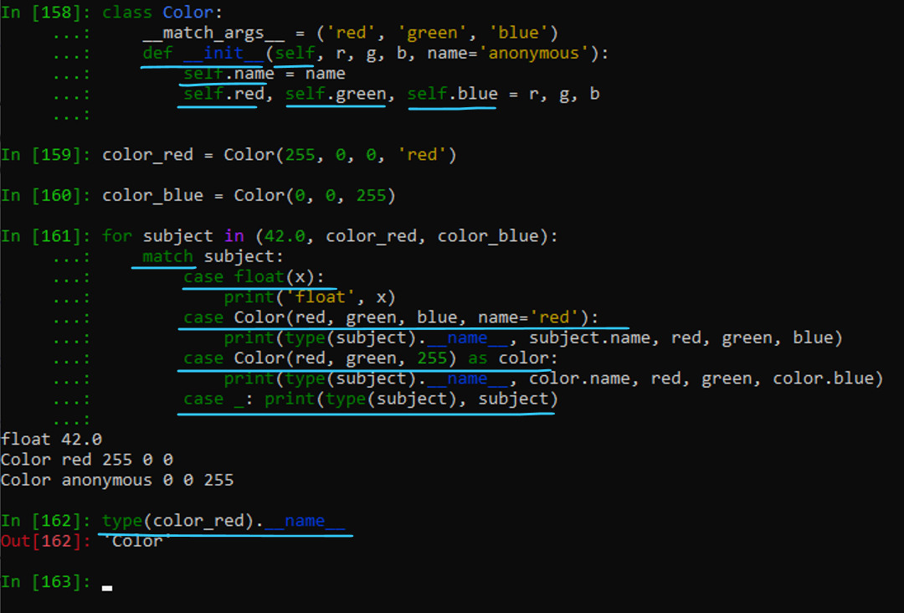

The while Statement

The while statement repeats execution of a statement or block of statements for as long as a conditional expression evaluates as true. Here’s the syntax of the while statement:

while expression:

statement(s)

A while statement can also include an else clause and break and continue statements, all of which we’ll discuss after we look at the for statement.

Here’s a typical while statement:

count = 0

while x > 0:

x //= 2 # floor division

count += 1

print('The approximate log2 is', count)

First Python evaluates expression, which is known as the loop condition, in a Boolean context. When the condition evaluates as false, the while statement ends. When the loop condition evaluates as true, the statement or block of statements that make up the loop body executes. Once the loop body finishes executing, Python evaluates the loop condition again, to check whether another iteration should execute. This process continues until the loop condition evaluates as false, at which point the while statement ends.

The loop body should contain code that eventually makes the loop condition false, since otherwise the loop never ends (unless the body raises an exception or executes a break statement). A loop within a function’s body also ends if the loop body executes a return statement, since in this case the whole function ends.

The for Statement

The for statement repeats execution of a statement or block of statements controlled by an iterable expression. Here’s the syntax:

for target in iterable:

statement(s)

The in keyword is part of the syntax of the for statement; its purpose here is distinct from the in operator, which tests membership.

|  |  |
| --- | --- |
| Here’s a rather typical for statement:  for letter in 'ciao':  print(f'give me a {letter}...') |  |

A for statement can also include an else clause and break and continue statements; we’ll discuss all of these shortly, starting with “The else Clause on Loop Statements” on page 92. As mentioned previously, iterable may be any iterable Python expression. In particular, any sequence is iterable. The interpreter implicitly calls the built-in iter on the iterable, producing an iterator (discussed in the following subsection), which it then iterates over.

target is normally an identifier naming the control variable of the loop; the for statement successively rebinds this variable to each item of the iterator, in order. The statement or statements that make up the loop body execute once for each item in iterable (unless the loop ends because of an exception or a break or return statement). Since the loop body may terminate before the iterator is exhausted, this is one case in which you may use an unbounded iterable—one that, per se, would never cease yielding items.

You can also use a target with multiple identifiers, as in an unpacking assignment. In this case, the iterator’s items must themselves be iterables, each with exactly as many items as there are identifiers in the target. For example, when d is a dictionary, this is a typical way to loop on the items (key/value pairs) in d:

for key, value in d.items():

if key and value: # print only truthy keys and values

print(key, value)

The items method returns another kind of iterable (a view), whose items are key/ value pairs; so, we use a for loop with two identifiers in the target to unpack each item into key and value.

Precisely one of the identifiers may be preceded by a star, in which case the starred identifier is bound to a list of all items not assigned to other targets. Although components of a target are commonly identifiers, values can be bound to any acceptable LHS expression, as covered in “Assignment Statements” on page 53—so, the following is correct, although not the most readable style:

prototype = [1, 'placeholder', 3]

for prototype[1] in 'xyz':

print(prototype)

# prints [1, 'x', 3], then [1, 'y', 3], then [1, 'z', 3]

|  |  |
| --- | --- |
| fruits = ["apple", "banana", "cherry"]  for x in fruits:  print(x) | for x in "banana":  print(x) |
| Exit the loop when x is "banana":  fruits = ["apple", "banana", "cherry"]  for x in fruits:  print(x)  if x == "banana":  break | Do not print banana:  fruits = ["apple", "banana", "cherry"]  for x in fruits:  if x == "banana":  continue  print(x) |
| for x in range(6):  print(x) | for x in range(2, 30, 3):  print(x) |
| Print all numbers from 0 to 5, and print a message when the loop has ended:  for x in range(6):  print(x)  else:  print("Finally finished!") | Break the loop when x is 3, and see what happens with the else block:  for x in range(6):  if x == 3: break  print(x)  else:  print("Finally finished!") |
| adj = ["red", "big", "tasty"]  fruits = ["apple", "banana", "cherry"]  for x in adj:  for y in fruits:  print(x, y) | for loops cannot be empty, but if you for some reason have a for loop with no content, put in the pass statement to avoid getting an error.  for x in [0, 1, 2]:  pass |

**Don’t Alter Mutable Objects While Looping on Them**

When an iterator has a mutable underlying iterable, don’t alter that underlying object during the execution of a for loop on

the iterable. For example, the preceding key/value printing example cannot altered. The items method returns a “view” iterable whose underlying object is d, so the loop body cannot mutate the set of keys in d (e.g., by executing del d[key]). To ensure that d is not the underlying object of the iterable, you may, for example, iterate over list(d.items()) to allow the loop body to mutate d. Specifically:

• When looping on a list, do not insert, append, or delete items (rebinding an item at an existing index is OK).

• When looping on a dictionary, do not add or delete items (rebinding the value for an existing key is OK).

• When looping on a set, do not add or delete items (no alteration is permitted).

The loop body may rebind the control target variable(s), but the next iteration of the loop always rebinds them again. If the iterator yields no items, the loop body does not execute at all. In this case, the for statement does not bind or rebind its control variable in any way. If the iterator yields at least one item, however, then when the loop statement ends, the control variable remains bound to the last value to which the loop statement bound it. The following code is therefore correct only when someseq is not empty:

for x in someseq:

process(x)

# potential NameError if someseq is empty

print(f'Last item processed was {x}')

Iterators

An iterator is an object i such that you can call next(i), which returns the next item of iterator i or, when exhausted, raises a StopIteration exception. Alternatively, you can call next(i, default), in which case, when iterator i has no more items, the call returns default.

When you write a class (see “Classes and Instances” on page 115), you can let instances of the class be iterators by defining a special method __next__ that takes no argument except self, and returns the next item or raises Stop Iteration. Most iterators are built by implicit or explicit calls to the built-in function iter, covered in Table 8-2. Calling a generator also returns an iterator, as we discuss in “Generators” on page 109.

As pointed out previously, the for statement implicitly calls iter on its iterable to get an iterator. The statement:

for x in c:

statement(s)

is exactly equivalent to:

_temporary_iterator = iter(c)

while True:

try:

x = next(_temporary_iterator)

except StopIteration:

break

statement(s)

where _temporary_iterator is an arbitrary name not used elsewhere in the current scope.

Thus, when iter(c) returns an iterator i such that next(i) never raises StopIteration (an unbounded iterator), the loop for x in c continues indefinitely unless the loop body includes suitable break or return statements, or raises or propagates exceptions. iter(c), in turn, calls the special method c.__iter__() to obtain and return an iterator on c. We’ll talk more about __iter__ in the following subsection and in “Container methods” on page 149.

Many of the best ways to build and manipulate iterators are found in the standard library module itertools, covered in “The itertools Module” on page 275.

Iterables versus iterators

Python’s built-in sequences, like all iterables, implement an __iter__ method, which the interpreter calls to produce an iterator over the iterable. Because each call to the built-in’s __iter__ method produces a new iterator, it is possible to nest multiple iterations over the same iterable:

>>> iterable = [1, 2]

>>> for i in iterable:

... for j in iterable:

... print(i, j)

...

1 1

1 2

2 1

2 2

Iterators also implement an __iter__ method, but it always returns self, so nesting iterations over an iterator doesn’t work as you might expect:

>>> iterator = iter([1, 2])

>>> for i in iterator:

... for j in iterator:

... print(i, j)

...

1 2

Here, both the inner and outer loops are iterating over the same iterator. By the time the inner loop first gets control, the first value from the iterator has already been consumed. The first iteration of the inner loop then exhausts the iterator, making both loops end upon attempting the next iteration.

range

Looping over a sequence of integers is a common task, so Python provides the built-in function range to generate an iterable over integers. The simplest way to loop n times in Python is:

for i in range(n):

statement(s)

range(x) generates the consecutive integers from 0 (included) up to x (excluded).

range(x, y) generates a list whose items are consecutive integers from x (included) up to y (excluded). range(x, y, stride) generates a list of integers from x (included) up to y (excluded), such that the difference between each two adjacent items is stride. If stride < 0, range counts down from x to y.

range generates an empty iterator when x >= y and stride >0, or when x <= y and stride <0. When stride ==0, range raises an exception.

range returns a special-purpose object, intended just for use in iterations like the for statement shown previously. Note that range returns an iterable, not an iterator; you can easily obtain such an iterator, should you need one, by calling iter(range(...)). The special-purpose object returned by range consumes less memory (for wide ranges, much less memory) than the equivalent list object would. If you really need a list that’s an arithmetic progression of ints, call list(range(...)). You will most often find that you don’t, in fact, need such a complete list to be fully built in memory.

List comprehensions

A common use of a for loop is to inspect each item in an iterable and build a new list by appending the results of an expression computed on some or all of the items. The expression form known as a list comprehension or listcomp lets you code this common idiom concisely and directly. Since a list comprehension is an expression (rather than a block of statements), you can use it wherever you need an expression (e.g., as an argument in a function call, in a return statement, or as a subexpression of some other expression).

A list comprehension has the following syntax:

[ expression for target in iterable lc-clauses ]

and iterable in each for clause of a list comprehension have the same syntax and meaning as those in a regular for statement, and the expression in each if clause of a list comprehension has the same syntax and meaning as the expression in a regular if statement. When expression denotes a tuple, you must enclose it in parentheses.

lc-clauses is a series of zero or more clauses, each with either this form:

for target in iterable

or this form:

if expression

A list comprehension is equivalent to a for loop that builds the same list by repeated calls to the resulting list’s append method. ( Except that the loop variables’ scope is within the comprehension only, different from the way scoping works in a for statement ) For example (assigning the list comprehension result to a variable for clarity), this:

result = [x+1 for x in some_sequence]

is just the same as the for loop:

result = []

for x in some_sequence:

result.append(x+1)

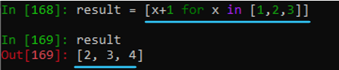

Don’t Build a List Unless You Need To

If you are just going to loop once over the items, you don’t need an actual indexable list: use a generator expression instead (covered in “Generator expressions” on page 111). This avoids list creation and uses less memory. In particular, resist the temptation to use a list comprehension as a not particularly readable “single-line loop,” like this:

[fn(x) for x in seq]

and then ignore the resulting list—just use a normal for loop instead!

Here’s a list comprehension that uses an if clause:

result = [x+1 for x in some_sequence if x>23]

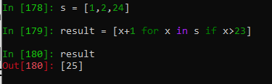

This list comprehension is the same as a for loop that contains an if statement:

result = []

for x in some_sequence:

if x>23:

result.append(x+1)

Here’s a list comprehension using a nested for clause to flatten a “list of lists” into a single list of items:

result = [x for sublist in listoflists for x in sublist]

This is the same as a for loop with another for loop nested inside:

result = []

for sublist in listoflists:

for x in sublist:

result.append(x)I

As these examples show, the order of for and if in a list comprehension, is the same as in the equivalent loop, but, in the list comprehension the nesting remains implicit. If you remember “order for clauses as in a nested loop,” that can help you get the ordering of the list comprehension’s clauses right.

**List Comprehension Examples**

Syntax:

newlist = [expression for item in iterable if condition == True]

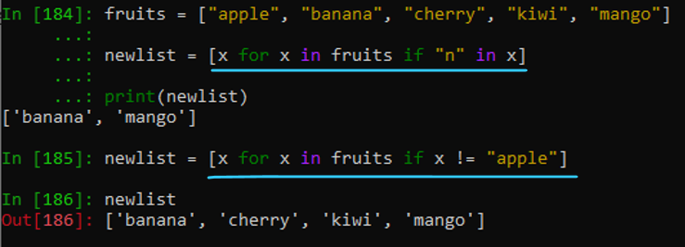

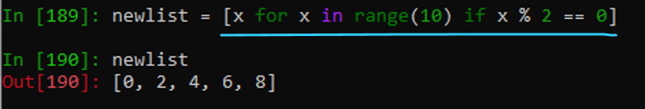

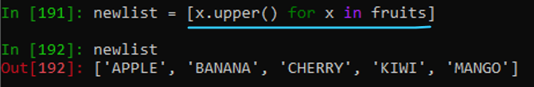

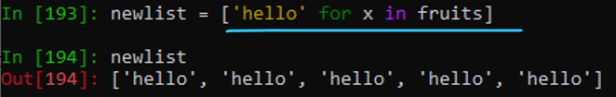

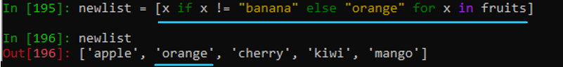

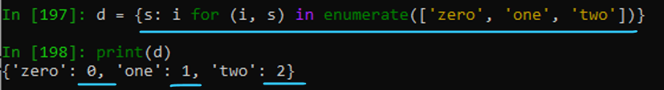

List Comprehensions and Variable Scope

A list comprehension expression evaluates in its own scope (as do set and dictionary comprehensions, described in the following sections, and generator expressions, discussed toward the end of this chapter). When a target component in the for statement is a name, the name is defined solely within the expression scope and is not available outside it.

Set comprehensions

A set comprehension has exactly the same syntax and semantics as a list comprehension, except that you enclose it in braces ({}) rather than in brackets ([]). The result is a set; for example:

s = {n//2 for n in range(10)}

print(sorted(s)) # prints: [0, 1, 2, 3, 4]

A similar list comprehension would have each item repeated twice, but building a set removes duplicates.

Dictionary comprehensions

A dictionary comprehension has the same syntax as a set comprehension, except that instead of a single expression before the for clause, you use two expressions with a colon (:) between them: key:value. The result is a dict, which retains insertion order. For example:

d = {s: i for (i, s) in enumerate(['zero', 'one', 'two'])}

print(d) # prints: {'zero': 0, 'one': 1, 'two': 2}



The break Statement

You can use a break statement only within a loop body. When break executes, the loop terminates without executing any else clause on the loop. When loops are nested, a break terminates only the innermost nested loop. In practice, a break is typically within a clause of an if (or, occasionally, match) statement in the loop body, so that break executes conditionally.

One common use of break is to implement a loop that decides whether it should keep looping only in the middle of each loop iteration (what Donald Knuth called the “loop and a half ” structure in his great 1974 paper “Structured Programming with go to Statements”25). For example:

while True: # this loop can never terminate "naturally"

x = get_next()

y = preprocess(x)

if not keep_looping(x, y):

break

process(x, y)

The continue Statement

Like break, the continue statement can exist only within a loop body. It causes the current iteration of the loop body to terminate, and execution continues with the next iteration of the loop. In practice, a continue is usually within a clause of an

if (or, occasionally, a match) statement in the loop body, so that continue executes conditionally.

Sometimes, a continue statement can take the place of nested if statements within a loop. For example, here each x has to pass multiple tests before being completely processed:

for x in some_container:

if seems_ok(x):

lowbound, highbound = bounds_to_test()

if lowbound <= x < highbound:

pre_process(x)

if final_check(x):

do_processing(x)

Nesting increases with the number of conditions. Equivalent code with continue “flattens” the logic:

for x in some_container:

if not seems_ok(x):

continue

lowbound, highbound = bounds_to_test()

if x < lowbound or x >= highbound:

continue

pre_process(x)

if final_check(x):

do_processing(x)

Flat Is Better Than Nested

Both versions work the same way, so which one you use is a matter of personal preference and style. One of the principles

of The Zen of Python (which you can see at any time by typing import this at an interactive Python interpreter prompt) is “Flat is better than nested.” The continue statement is just one way Python helps you move toward the goal of a less nested structure in a loop, when you choose to follow this tip.

The else Clause on Loop Statements

while and for statements may optionally have a trailing else clause. The statement or block under that clause executes when the loop terminates naturally (at the end of the for iterator, or when the while loop condition becomes false), but not when the loop terminates prematurely (via break, return, or an exception). When a loop contains one or more break statements, you’ll often want to check whether it terminates naturally or prematurely. You can use an else clause on the loop for this purpose:

for x in some_container:

if is_ok(x):

break # item x is satisfactory, terminate loop

else:

print('Beware: no satisfactory item was found in container')

x = None

The pass Statement

The body of a Python compound statement cannot be empty; it must always contain at least one statement. You can use a pass statement, which performs no action, as an explicit placeholder when a statement is syntactically required but you have

nothing to do. Here’s an example of using pass in a conditional statement as a part of some rather convoluted logic to test mutually exclusive conditions:

if condition1(x):

process1(x)

elif x>23 or (x<5 and condition2(x)):

pass # nothing to be done in this case

elif condition3(x):

process3(x)

else:

process_default(x)

Empty def or class Statements: Use a Docstring, Not pass You can also use a docstring, covered in “Docstrings” on page 99, as the body of an otherwise empty def or class statement. When you do this, you do not need to also add a pass statement (you can do so if you wish, but it’s not optimal Python style).

The try and raise Statements

Python supports exception handling with the try statement, which includes try, except, finally, and else clauses. Your code can also explicitly raise an exception with the raise statement. When code raises an exception, normal control flow of the program stops and Python looks for a suitable exception handler. We discuss all of this in detail in “Exception Propagation” on page 204.

The with Statement

A with statement can often be a more readable, useful alternative to the try/ finally statement. We discuss it in detail in “The with Statement and Context Managers” on page 201. A good grasp of context managers can often help you structure your code more clearly without compromising efficiency.

|  |  |
| --- | --- |
| # without using with statement  file = open('file_path', 'w')  try:  file.write('hello world')  finally:  file.close() | # using with statement  with open('file_path', 'w') as file:  file.write('hello world !') |

## Functions

Most statements in a typical Python program are part of some function. Code in a function body may be faster than at a module’s top level, as covered in “Avoid exec and from ... import *” on page 556, so there are excellent practical reasons to put most of your code into functions—and there are no disadvantages: clarity, readability and code reusability all improve when you avoid having any substantial chunks of module-level code.

A function is a group of statements that execute upon request. Python provides many built-in functions and lets programmers define their own functions. A request to execute a function is known as a function call. When you call a function, you can pass arguments that specify data upon which the function performs its computation. In Python, a function always returns a result: either None or a value, the result of the computation. Functions defined within class statements are also known as methods. We cover issues specific to methods in “Bound and Unbound Methods” on page 126; the general coverage of functions in this section, however, also applies to methods.

Python is somewhat unusual in the flexibility it affords the programmer in defining and calling functions. This flexibility does mean that some constraints are not adequately expressed solely by the syntax. In Python, functions are objects (values), handled just like other objects. Thus, you can pass a function as an argument in a call to another function, and a function can return another function as the result of a call. A function, just like any other object, can be bound to a variable, can be an item in a container, and can be an attribute of an object. Functions can also be keys in a dictionary. The fact that functions are ordinary objects in Python is often expressed by saying that functions are first-class objects.

For example, given a dict keyed by functions, with the values being each function’s inverse, you could make the dictionary bidirectional by adding the inverse values as keys, with their corresponding keys as values. Here’s a small example of this idea,

using some functions from the module math (covered in “The math and cmath Modules” on page 488), that takes a one-way mapping of inverse pairs and then adds the inverse of each entry to complete the mapping:

def add_inverses(i_dict):

for f in list(i_dict): # iterates over keys while mutating i_dict

i_dict[i_dict[f]] = f

math_map = {sin:asin, cos:acos, tan:atan, log:exp}

add_inverses(math_map)

Note that in this case the function mutates its argument (whence its need to use a list call for looping). In Python, the usual convention is for such functions not to return a value (see “The return Statement” on page 100).

Defining Functions: The def Statement

The def statement is the usual way to create a function. def is a single-clause compound statement with the following syntax:

def function_name(parameters):

statement(s)

function_name is an identifier, and the nonempty indented statement(s) are the function body. When the interpreter encounters a def statement, it compiles the function body, creating a function object, and binds (or rebinds, if there was an existing binding) function_name to the compiled function object in the containing namespace (typically the module namespace, or a class namespace when defining methods).

parameters is an optional list specifying the identifiers that will be bound to values that each function call provides. We distinguish between those identifiers, and the values provided for them in calls, as usual in computer science by referring to the former as parameters and the latter as arguments.

In the simplest case, a function defines no parameters, meaning the function won’t accept any arguments when you call it. In this case, the def statement has empty parentheses after function_name, as must all calls. Otherwise, parameters will be a list of specifications (see “Parameters” on page 95). The function body does not execute when the def statement executes; rather, Python compiles it into bytecode, saves it as the function object’s __code__ attribute, and executes it later on each call to the function. The function body can contain zero or more occurrences of the return statement, as we’ll discuss shortly.

Each call to the function supplies argument expressions corresponding to parameters in the function definition. The interpreter evaluates the argument expressions from left to right and creates a new namespace in which it binds the argument values to the parameter names as local variables of the function call (as we discuss in “Calling Functions” on page 101). Then Python executes the function body, with the function call namespace as the local namespace.

Here’s a simple function that returns a value that is twice the value passed to it each time it’s called:

def twice(x):

return x*2

The argument can be anything that you can multiply by two, so you could call the function with a number, string, list, or tuple as an argument. Each call returns a new value of the same type as the argument: twice('ciao'), for example, returns 'ciaociao'.

The number of parameters of a function, together with the parameters’ names, the number of mandatory parameters, and the information on whether and where unmatched arguments should be collected, are a specification known as the function’s

signature. A signature defines how you can call the function.

Parameters

Parameters (pedantically, formal parameters) name the values passed into a function call, and may specify default values for them. Each time you call the function, the call binds each parameter name to the corresponding argument value in a new local

namespace, which Python later destroys on function exit. Besides letting you name individual arguments, Python also lets you collect argument values not matched by individual parameters, and lets you specifically require that some arguments be positional, or be named.

Positional parameters

A positional parameter is an identifier, name, which names the parameter. You use these names inside the function body to access the argument values to the call. Callers can normally provide values for these parameters with either positional or

named arguments (see “Matching arguments to parameters” on page 104).

Named parameters

Named parameters normally take the form name=expression ( 3.8+ or come after a positional argument collector, often just *, as discussed shortly). They are also often known (when written in the traditional name=expression form) as default, optional, and even—confusingly, since they do not involve any Python keywords— keyword parameters. When it executes a def statement, the interpreter evaluates each such expression and saves the resulting value, known as the default value for the parameter, among the attributes of the function object. A function call thus need not provide an argument value for a named parameter written in the traditional form: the call uses the default value given as the expression. You may provide positional arguments as values for some named parameters ( 3.8+ except for parameters that are identified as named ones by appearing after a positional argument collector; see also “Matching arguments to parameters” on page 104). Python computes each default value exactly once, when the def statement executes, not each time you call the resulting function. In particular, this means that Python binds exactly the same object, the default value, to the named parameter whenever the caller does not supply a corresponding argument.

Avoid Mutable Default Values

A function can alter a mutable default value, such as a list, each time you call the function without an argument corresponding

to the respective parameter. This is usually not the behavior you want; for details, see “Mutable default parameter values” on page 97.

Positional-only marker

3.8+ A function’s signature may contain a single positional-only marker (/) as a dummy parameter. The parameters preceding the marker are known as positionalonly parameters, and must be provided as positional arguments, not named arguments, when calling the function; using named arguments for these parameters raises a TypeError exception.

The built-in int type, for example, has the following signature:

int(x, /, base=10)

When calling int, you must pass a value for x and you must pass it positionally. base (used when x is a string to be converted to int) is optional, and you may pass it either positionally or as a named argument (it’s an error to pass x as a number and also pass base, but the notation cannot capture that quirk).

Positional argument collector

The positional argument collector can take one of two forms, either *name or 3.8+ just *. In the former case, name is bound at call time to a tuple of unmatched positional arguments (when all positional arguments are matched, the tuple is empty). In the latter case (the * is a dummy parameter), a call with unmatched positional arguments raises a TypeError exception.

When a function’s signature has either kind of positional argument collector, no call can provide a positional argument for a named parameter coming after the collector: the collector prohibits (in the * form) or gives a destination for (in the *name form) positional arguments that do not correspond to parameters coming before it.

For example, consider this function from the random module:

def sample(population, k, *, counts=None):

When calling sample, values for population and k are required, and may be passed positionally or by name. counts is optional; if you do pass it, you must pass it as a named argument.

Named argument collector

This final, optional parameter specification has the form **name. When the function is called, name is bound to a dictionary whose items are the (key, value) pairs of any unmatched named arguments, or an empty dictionary if there are no such arguments.

Parameter sequence

Generally speaking, positional parameters are followed by named parameters, with the positional and named argument collectors (if present) last. The positional-only marker, however, may appear at any position in the list of parameters.

Mutable default parameter values

When a named parameter’s default value is a mutable object, and the function body alters the parameter, things get tricky. For example:

def f(x, y=[]):

y.append(x)

return id(y), y

print(f(23)) # prints: (4302354376, [23])

print(f(42)) # prints: (4302354376, [23, 42])

The second print prints [23, 42] because the first call to f altered the default value of y, originally an empty list [], by appending 23 to it. The id values (always equal to each other, although otherwise arbitrary) confirm that both calls return the same object. If you want y to be a new, empty list object, each time you call f with a single argument (a far more frequent need!), use the following idiom instead:

def f(x, y=None):

if y is None:

y = []

y.append(x)

return id(y), y

print(f(23)) # prints: (4302354376, [23])

print(f(42)) # prints: (4302180040, [42])

There may be cases in which you explicitly want a mutable default parameter value that is preserved across multiple function calls, most often for caching purposes, as in the following example:

def cached_compute(x, _cache={}):

if x not in _cache:

_cache[x] = costly_computation(x)

return _cache[x]

Such caching behavior (also known as memoization) is usually best obtained by decorating the underlying costly_computation function with functools.lru_cache, covered in Table 8-7 and discussed in detail in Chapter 17.

Argument collector parameters

The presence of argument collectors (the special forms *, *name, or **name) in a function’s signature allows a function to prohibit (*) or collect positional (*name) or named (**name) arguments that do not match any parameters (see “Matching arguments to parameters” on page 104). There is no requirement to use specific names—you can use any identifier you want in each special form. *args and **kwds or **kwargs, as well as *a and **k, are popular choices.

The presence of the special form * causes calls with unmatched positional arguments to raise a TypeError exception.

*args specifies that any extra positional arguments to a call (i.e., positional arguments not matching positional parameters in the function signature) get collected into a (possibly empty) tuple, bound in the call’s local namespace to the name args. Without a positional argument collector, unmatched positional arguments raise a TypeError exception.

For example, here’s a function that accepts any number of positional arguments and returns their sum (and demonstrates the use of an identifier other than *args):

def sum_sequence(*numbers):

return sum(numbers)

print(sum_sequence(23, 42)) # prints: 65

Similarly, **kwds specifies that any extra named arguments (i.e., those named arguments not explicitly specified in the signature) get collected into a (possibly empty) dictionary whose items are the names and values of those arguments, bound

to the name kwds in the function call namespace. For example, the following function takes a dictionary whose keys are strings and whose values are numeric, and adds given amounts to certain values:

def inc_dict(d, **values):

for key, value in values.items():

if key in d:

d[key] += value

else:

d[key] = value

my_dict = {'one': 1, 'two': 2}

inc_dict(my_dict, one=3, new=42)

print(my_dict) # prints: {'one': 4, 'two': 2, 'new':42}

Without a named argument collector, unmatched named arguments raise a Type Error exception.

### Attributes of Function Objects

The def statement sets some attributes of a function object f. The string attribute f.__name__ is the identifier that def uses as the function’s name. You may rebind __name__ to any string value, but trying to unbind it raises a TypeError exception. f.__defaults__, which you may freely rebind or unbind, is the tuple of default values for named parameters (empty, if the function has no named parameters).

#### Docstrings

Another function attribute is the documentation string, or docstring. You may use or rebind a function f’s docstring attribute as f.__doc__. When the first statement in the function body is a string literal, the compiler binds that string as the function’s docstring attribute. A similar rule applies to classes and modules (see “Class documentation strings” on page 119 and “Module documentation strings” on page 225). Docstrings can span multiple physical lines, so it’s best to specify them in triple-quoted string literal form. For example:

def sum_sequence(*numbers):

"""Return the sum of multiple numerical arguments.

The arguments are zero or more numbers.

The result is their sum.

"""

return sum(numbers)

Documentation strings should be part of any Python code you write. They play a role similar to that of comments, but they are even more useful, since they remain available at runtime (unless you run your program with python -OO, as covered in “Command-Line Syntax and Options” on page 22). Python’s help function (see “Interactive Sessions” on page 25), development environments, and other tools can use the docstrings from function, class, and module objects to remind the programmer how to use those objects. The doctest module (covered in “The doctest Module” on page 517) makes it easy to check that sample code present in docstrings, if any, is accurate and correct, and remains so as the code and docs get edited and maintained.

To make your docstrings as useful as possible, respect a few simple conventions, as detailed in PEP 257. The first line of a docstring should be a concise summary of the function’s purpose, starting with an uppercase letter and ending with a period.

It should not mention the function’s name, unless the name happens to be a naturallanguage word that comes naturally as part of a good, concise summary of the function’s operation. Use imperative rather than descriptive form: e.g., say “Return xyz…” rather than “Returns xyz…” If the docstring is multiline, the second line should be empty, and the following lines should form one or more paragraphs, separated by empty lines, describing the function’s parameters, preconditions, return value, and side effects (if any). Further explanations, bibliographical references, and usage examples—which you should always check with doctest—can optionally (and often very usefully!) follow toward the end of the docstring.

Other attributes of function objects

In addition to its predefined attributes, a function object may have other arbitrary attributes. To create an attribute of a function object, bind a value to the appropriate attribute reference in an assignment statement after the def statement executes. For example, a function could count how many times it gets called:

def counter():

counter.count += 1

return counter.count

counter.count = 0

Note that this is not common usage. More often, when you want to group together some state (data) and some behavior (code), you should use the object-oriented mechanisms covered in Chapter 4. However, the ability to associate arbitrary attributes with a function can sometimes come in handy.

#### Function Annotations

Every parameter in a def clause can be annotated with an arbitrary expression—that is, wherever within the def’s parameter list you can use an identifier, you can alternatively use the form identifier:expression, and the expression’s value becomes the annotation for that parameter.

You can also annotate the return value of the function, using the form ->expression between the ) of the def clause and the : that ends the def clause; the expression’s value becomes the annotation for the name 'return'. For example:

>>> def f(a:'foo', b)->'bar':

pass

...

>>> f.__annotations__

{'a': 'foo', 'return': 'bar'}

As shown in this example, the __annotations__ attribute of the function object is a dict mapping each annotated identifier to the respective annotation.

You can currently, in theory, use annotations for whatever purpose you wish:

Python itself does nothing with them, except construct the __annotations__ attribute. For detailed information about annotations used for type hinting, which is now normally considered their key use, see Chapter 5.

The return Statement

You can use the return keyword in Python only inside a function body, and you can optionally follow it with an expression. When return executes, the function terminates, and the value of the expression is the function’s result. A function returns None when it terminates by reaching the end of its body, or by executing a return statement with no expression (or by explicitly executing return None).

Good Style in return Statements

As a matter of good style, when some return statements in a function have an expression, then all return statements in the

function should have an expression. return None should only ever be written explicitly to meet this style requirement. Never

write a return statement without an expression at the end of a function body. Python does not enforce these stylistic conventions, but your code is clearer and more readable when you follow them.

Calling Functions

A function call is an expression with the following syntax:

function_object(arguments)

function_object may be any reference to a function (or other callable) object; most often, it’s just the function’s name. The parentheses denote the function call operation itself. arguments, in the simplest case, is a series of zero or more expressions

separated by commas (,), giving values for the function’s corresponding parameters.

When the function call executes, the parameters are bound to the argument values in a new namespace, the function body executes, and the value of the function call expression is whatever the function returns. Objects created inside and returned by the function are liable to garbage collection unless the caller retains a reference to them.

Don’t Forget the Trailing () to Call a Function Just mentioning a function (or other callable object) does not, per se, call it. To call a function (or other object) without arguments, you must use () after the function’s name (or other reference to the callable object).

### Positional and named arguments

Arguments can be of two types. Positional arguments are simple expressions; named (also known, alas, as keyword ( “Alas” because they have nothing to do with Python keywords, so the terminology is confusing; if you use an actual Python keyword to name a named parameter, that raises SyntaxError ) ) arguments take the form:

identifier=expression

It is a syntax error for named arguments to precede positional ones in a function call. Zero or more positional arguments may be followed by zero or more named arguments. Each positional argument supplies the value for the parameter that corresponds to it by position (order) in the function definition. There is no requirement for positional arguments to match positional parameters, or vice versa—if there are more positional arguments than positional parameters, the additional

arguments are bound by position to named parameters, if any, for all parameters preceding an argument collector in the signature. For example:

def f(a, b, c=23, d=42, *x):

print(a, b, c, d, x)

f(1,2,3,4,5,6) # prints: 1 2 3 4 (5, 6)

Note that it matters where in the function signature the argument collector appears (see “Matching arguments to parameters” on page 104 for all the gory details):

def f(a, b, *x, c=23, d=42):

print(a, b, x, c, d)

f(1,2,3,4,5,6) # prints: 1 2 (3, 4, 5, 6) 23 42

In the absence of any named argument collector (**name) parameter, each argument’s name must be one of the parameter names used in the function’s signature. ( Python developers introduced positional-only arguments when they realized that parameters to many built-in functions effectively had no valid names as far as the interpreter was concerned. ) The expression supplies the value for the parameter of that name. Many built-in functions do not accept named arguments: you must call such functions with positional arguments only. However, functions coded in Python usually accept named as well as positional arguments, so you may call them in different ways. Positional parameters can be matched by named arguments, in the absence of matching positional arguments.

A function call must supply, via a positional or a named argument, exactly one value for each mandatory parameter, and zero or one value for each optional parameter. ( An “optional parameter” being one for which the function’s signature supplies a default value )

For example:

def divide(divisor, dividend=94):

return dividend // divisor

print(divide(12)) # prints: 7

print(divide(12, 94)) # prints: 7

print(divide(dividend=94, divisor=12)) # prints: 7

print(divide(divisor=12)) # prints: 7

As you can see, the four calls to divide here are equivalent. You can pass named arguments for readability purposes whenever you think that identifying the role of each argument and controlling the order of arguments enhances your code’s clarity. A common use of named arguments is to bind some optional parameters to specific values, while letting other optional parameters take default values:

def f(middle, begin='init', end='finis'):

return begin+middle+end

print(f('tini', end='')) # prints: inittini

print(f('tini', end='ooo')) # prints: inittiniooo

With the named argument end='', the caller specifies a value (the empty string '') for f’s third parameter, end, and still lets f’s second parameter, begin, use its default value, the string 'init'. You may pass the arguments as positional even when parameters are named; for example, with the preceding function:

print(f('a','c','t')) # prints: cat

* At the end of the arguments in a function call, you may optionally use either or both of the special forms *seq and **dct.
* If both forms are present, the form with two asterisks must be last.
* *seq passes the items of iterable seq to the function as positional arguments (after the normal positional arguments, if any, that the call gives with the usual syntax). seq may be any iterable.
* **dct passes the items of dct to the function as named arguments, where dct must be a mapping whose keys are all strings. Each item’s key is a parameter name, and the item’s value is the argument’s value.

You may want to pass an argument of the form *seq or **dct when the parameters use similar forms, as discussed in “Parameters” on page 95. For example, using the function sum_sequence defined in that section (and shown again here), you may want to print the sum of all the values in the dictionary d. This is easy with *seq:

def sum_sequence(*numbers):

return sum(numbers)

d = {'a': 1, 'b': 100, 'c': 1000}

print(sum_sequence(*d.values()))

(Of course, print(sum(d.values())) would be simpler and more direct.) A function call may have zero or more occurrences of *seq and/or **dct, as specified in PEP 448. You may even pass *seq or **dct when calling a function that does not use the corresponding form in its signature. In that case, you must ensure that the iterable seq has the right number of items, or that the dictionary dct uses the right identifier strings as keys; otherwise, the call raises an exception. As noted in the following section, a positional argument cannot match a “keyword-only” parameter; only a named argument, explicit or passed via **kwargs, can do that.

#### “Keyword-only” parameters

Parameters after a positional argument collector (*name or 3.8+ *) in the function’s signature are known as keyword-only parameters: the corresponding arguments, if any, must be named arguments. In the absence of any match by name, such a parameter is bound to its default value, as set at function definition time.

Keyword-only parameters can be either positional or named. However, you must pass them as named arguments, not as positional ones. It’s more usual and readable to have simple identifiers, if any, at the start of the keyword-only parameter specifications, and identifier=default forms, if any, following them, though this is not a requirement of the Python language.

Functions requiring keyword-only parameter specifications without collecting “surplus” positional arguments indicate the start of the keyword-only parameter specifications with a dummy parameter consisting solely of an asterisk (*), to which no

argument corresponds. For example:

def f(a, *, b, c=56): # b and c are keyword only

return a, b, c

f(12, b=34) # Returns (12, 34, 56) c is optional, it has a default

f(12) # Raises a TypeError exception, since you didn't pass b

# Error message is: missing 1 required keyword-only argument: 'b'

If you also specify the special form **kwds, it must come at the end of the parameter list (after the keyword-only parameter specifications, if any). For example:

def g(x, *a, b=23, **k): # b is keyword only

return x, a, b, k

g(1, 2, 3, c=99) # Returns (1, (2, 3), 23, {'c': 99})

#### Matching arguments to parameters

A call must provide an argument for all positional parameters, and may do so for named parameters that are not keyword only.

The matching proceeds as follows:

1. Arguments of the form *expression are internally replaced by a sequence of positional arguments obtained by iterating over expression.
2. Arguments of the form **expression are internally replaced by a sequence of keyword arguments whose names and values are obtained by iterating over expression’s items().
3. Say that the function has N positional parameters and the call has M positional arguments:

* When M≤N, bind all the positional arguments to the first M positional parameter names; the remaining positional parameters, if any, must be matched by named arguments.
* When M>N, bind the remaining positional arguments to named parameters in the order in which they appear in the signature. This process terminates in one of three ways:

1. All positional arguments have been bound.
2. The next item in the signature is a * argument collector: the interpreter raises a TypeError exception.
3. The next item in the signature is a *name argument collector: the remaining positional arguments are collected in a tuple that is then bound to name in the function call namespace.
4. The named arguments are then matched, in the order of the arguments’ occurrences in the call, by name with the parameters—both positional and named.

Attempts to rebind an already bound parameter name raise a TypeError exception.

1. If unmatched named arguments remain at this stage:
2. When the function signature includes a **name collector, the interpreter creates a **dictionary with key/value pairs** (argument's_name, argu ment's_value), and binds it to name in the function call namespace.
3. In the absence of such an argument collector, Python raises a **TypeError** exception.
4. Any **remaining unmatched named parameters** are bound to their default values.

At this point, the function call namespace is fully populated, and the interpreter executes the function’s body using that “call namespace” as the local namespace for the function.

The semantics of argument passing

In traditional terms, all argument passing in Python is by value (although, in modern terminology, to say that argument passing is by object reference is more precise and accurate; check out the synonym call by sharing). When you pass a variable as an argument, Python passes to the function the object (value) to which the variable currently refers (not “the variable itself ”!), binding this object to the parameter name in the function call namespace. Thus, a function cannot rebind the caller’s variables. Passing a mutable object as an argument, however, allows the function to make changes to that object, because Python passes a reference to the object itself, not a copy. Rebinding a variable and mutating an object are totally disjoint concepts. For example:

def f(x, y):

x = 23

y.append(42)

a = 77

b = [99]

f(a, b)

print(a, b) # prints: 77 [99, 42]

print shows that a is still bound to 77. Function f’s rebinding of its parameter x to 23 has no effect on f’s caller, nor, in particular, on the binding of the caller’s variable that happened to be used to pass 77 as the parameter’s value.

However, print also shows that b is now bound to [99, 42]. b is still bound to the same list object as before the call, but f has appended 42 to that list object, mutating it. In neither case has f altered the caller’s bindings, nor can f alter the number 77, since numbers are immutable. f can alter a list object, though, since list objects are mutable.

### Namespaces

A function’s parameters, plus any names that are bound (by assignment or by other binding statements, such as def) in the function body, make up the function’s local namespace, also known as its local scope. Each of these variables is known as a local variable of the function.

Variables that are not local are known as global variables (in the absence of nested function definitions, which we’ll discuss shortly). Global variables are attributes of the module object, as covered in “Attributes of module objects” on page 223. Whenever a function’s local variable has the same name as a global variable, that name, within the function body, refers to the local variable, not the global one. We express this by saying that the local variable hides the global variable of the same name throughout the function body.

#### The global statement

By default, any variable bound in a function body is local to the function. If a function needs to bind or rebind some global variables (not best practice!), the first statement of the function’s body must be:

global identifiers

where identifiers is one or more identifiers separated by commas (,). The identifiers listed in a global statement refer to the global variables (i.e., attributes of the module object) that the function needs to bind or rebind. For example, the function counter could be implemented using global and a global variable, rather than an attribute of the function object:

_count = 0

def counter():

global _count

_count += 1

return _count

Without the global statement, the counter function would raise an UnboundLocalError exception when called, because _count would then be an uninitialized (unbound) local variable. While the global statement enables this kind of programming, this style is inelegant and ill-advised. As we mentioned earlier, when you want to group together some state and some behavior, the object-oriented mechanisms covered in Chapter 4 are usually best.

### Eschew global

Never use global if the function body just uses a global variable (including mutating the object bound to that variable, when the object is mutable). Use a global statement only if the function body rebinds a global variable (generally by assigning to the variable’s name). As a matter of style, don’t use global unless it’s strictly necessary, as its presence causes readers of your program to assume the statement is there for some useful purpose. Never use global except as the first statement in a function body.

Nested functions and nested scopes

A def statement within a function body defines a nested function, and the function whose body includes the def is known as an outer function to the nested one. Code in a nested function’s body may access (but not rebind) local variables of an outer function, also known as **free variables** of the nested function.

The simplest way to let a nested function access a value is often not to rely on nested scopes, but rather to pass that value explicitly as one of the function’s arguments. If need be, you can bind the argument’s value at nested-function def time: just use the value as the default for an optional argument. For example:

def percent1(a, b, c):

def pc(x, total = a + b + c):

return ( x * 100.0 ) / total

print('Percentages are:', pc(a), pc(b), pc(c))

Here’s the same functionality using nested scopes:

def percent2(a, b, c):

def pc(x):

return ( x * 100.0 ) / ( a + b + c)

print('Percentages are:', pc(a), pc(b), pc(c))

In this specific case, percent1 has one tiny advantage: the computation of a+b+c happens only once, while percent2’s inner function pc repeats the computation three times. However, when the outer function rebinds local variables between calls to the nested function, repeating the computation can be necessary: be aware of both approaches, and choose the appropriate one on a case-by-case basis.

A nested function that accesses values from local variables of “outer” (containing) functions is also known as a closure. The following example shows how to build a closure:

def make_adder(augend):

def add(addend):

return addend + augend

return add

add5 = make_adder(5)

add9 = make_adder(9)

print(add5(100)) # prints: 105

print(add9(100)) # prints: 109

Closures are sometimes an exception to the general rule that the object-oriented mechanisms covered in the next chapter are the best way to bundle together data and code. When you specifically need to construct callable objects, with some parameters fixed at object construction time, closures can be simpler and more direct than classes. For example, the result of make_adder(7) is a function that accepts a single argument and returns 7 plus that argument. An outer function that returns a closure is a “factory” for members of a family of functions distinguished by some parameters, such as the value of the argument augend in the previous example, which may often help you avoid code duplication.

The nonlocal keyword acts similarly to global, but it refers to a name in the namespace of some lexically surrounding function. When it occurs in a function definition nested several levels deep (a rarely needed structure!), the compiler searches the namespace of the most deeply nested containing function, then the function containing that one, and so on, until the name is found or there are no further containing functions, in which case the compiler raises an error (a global name, if any, does not match).

Here’s a nested functions approach to the “counter” functionality we implemented in previous sections using a function attribute, then a global variable:

def make_counter():

count = 0

def counter():

nonlocal count

count += 1

return count

return counter

c1 = make_counter()

c2 = make_counter()

print( c1(), c1(), c1() ) # prints: 1 2 3

print( c2(), c2() ) # prints: 1 2

print( c1(), c2(), c1() ) # prints: 4 3 5

A key advantage of this approach versus the previous ones is that these two nested functions, just like an object-oriented approach would, let you make independent counters—here c1 and c2. Each closure keeps its own state and doesn’t interfere

with the other one.

### lambda Expressions

If a function body is a single return expression statement, you may (very optionally!) choose to replace the function with the special lambda expression form:

lambda parameters: expression

A lambda expression is the anonymous equivalent of a normal function whose body is a single return statement. The lambda syntax does not use the return keyword. You can use a lambda expression wherever you could use a reference to a function. Lambda can sometimes be handy when you want to use an extremely simple function as an argument or return value. Here’s an example that uses a lambda expression as an argument to the built-in sorted function (covered in Table 8-2):

a_list = [-2, -1, 0, 1, 2]

sorted( a_list, key = lambda x: x * x ) # returns: [0, -1, 1, -2, 2]

Alternatively, you can always use a local def statement to give the function object a name, then use this name as an argument or return value. Here’s the same sorted example using a local def statement:

a_list = [-2, -1, 0, 1, 2]

def square(value):

return value * value

sorted( a_list, key = square ) # returns: [0, -1, 1, -2, 2]

While lambda can at times be handy, def is usually better: it’s more general and helps you make your code more readable, since you can choose a clear name for the function.

Example Usage

Lambda Expressions

Syntax

lambda argument(s) : expression

Example:

greet_user = lambda name : print('Hey there,', name)

# Call the lambda

greet('Dolly') # Output- Hey there, Dolly

An anonymous function means that a function is without a name.

def keyword is used to define the normal functions and the lambda keyword is used to create anonymous functions.

List Comprehension is used to create lists.

Lambda is function that can process like other functions and thus return values or lists.

This function can have any number of arguments but only one expression, which is evaluated and returned.

One is free to use lambda functions wherever function objects are required.

You need to keep in your knowledge that lambda functions are syntactically restricted to a single expression.

It has various uses in particular fields of programming, besides other types of expressions in functions.

**Simple Examples**

**Multiply two numbers**

x = lambda a, b : a * b

print( x( 5, 6 ) ) # Output 30

**Add 3 numbers**

x = lambda a, b, c : a + b + c

print( x( 5, 6, 2 ) ) # Output 13

The power of lambda is better shown when you use them as an anonymous function inside another function.

Say you have a function definition that takes one argument, and that argument will be multiplied with an unknown number:

def myfunc( n ):

return lambda a : a * n

mydoubler = myfunc(2)

print( mydoubler( 11 ) ) # Output 22

Use lambda functions when an anonymous function is required for a short period of time.

list from range 0 to 10

list_ = [ 0, 1, 2, 3, 4, 5, 6, 7, 8, 9 ]

print( list_ )

A lambda function to filter out even numbers from a list

my_list = [1, 2, 3, 4, 5]

new_list = list( filter( lambda x: x % 2 != 0, my_list ) )

print( new_list )

**Simple Examples**

filter_nums = lambda s: ''.join([ch for ch in s if not ch.isdigit()])

print("filter_nums():", filter_nums("Geeks101"))

# Output: filter_nums(): Geeks

**A cube lambda example**

cubo = lambda num : num ** 3

[ cubo(x) for x in range(10) ]

#Output: [0, 1, 8, 27, 64, 125, 216, 343, 512, 729]

Just adding a exclamation mark to a sentence

do_exclaim = lambda s: s + '!'

print("do_exclaim():", do_exclaim("I am tired"))

# Output: do_exclaim(): I am tired!

lambda function gets more helpful when used inside a function

We can use lambda function inside map(), filter(), sorted() and many other functions.

l = ["1", "2", "9", "0", "-1", "-2"]

print("Sorted numerically:", sorted(l, key=lambda x: int(x)))

# Output: Sorted numerically: ['-2', '-1', '0', '1', '2', '9']

Add 10 to each str in the list. Added 10 to each item after type and # casting to int, then convert items to string again

l = ["1", "2", "9", "0", "-1", "-2"]

print("Operation on each item using lambda & map()",

list( map( lambda x: str( int(x) + 10 ), l) ) )

# Output: Operation on each item using lambda and map() ['11', '12', '19', '10', '9', '8']

Sum of all digits in a str ( str is a sequence of characters ). Typecastes n to str, iterates on characters in it and type castes to int, all come under a list due to [] which is passed to sum function

find_sum = lambda n: sum([int(x) for x in str(n)])

print("find_sum():", find_sum(101))

# Output: find_sum(): 2

lambda function Map basically iterates every element in the list_ and returns the lambda function result

lambda_list = list( map( lambda x: x * 2, list_ ) )

print( lambda_list )

# Output:

# [ 0, 2, 4, 6, 8, 10, 12, 14, 16, 18 ]

list comprehension

list_comp = [ x * 2 for x in list_ ]

print( list_comp )

# Output:

# [ 0, 2, 4, 6, 8, 10, 12, 14, 16, 18 ]

### Generators

When the body of a function contains one or more occurrences of the keyword yield, the function is known as a generator, or more precisely a generator function. When you call a generator, the function body does not execute. Instead, the generator function returns a special iterator object, known as a generator object (sometimes, quite confusingly, also called just “a generator”), wrapping the function body, its local variables (including parameters), and the current point of execution (initially, the start of the function).

When you ( implicitly or explicitly ) call next on a generator object, the function body executes from the current point up to the next yield, which takes the form:

yield expression

A bare yield without the expression is also legal, and equivalent to yield None. When yield executes, the function execution is “frozen,” preserving the current point of execution and local variables, and the expression following yield becomes the result of next. When you call next again, execution of the function body resumes where it left off, again up to the next yield. When the function body ends, or executes a return statement, the iterator raises a StopIteration exception to indicate that the iteration is finished. The expression after return, if any, is the argument to the StopIteration exception.

yield is an expression, not a statement. When you call g.send( value ) on a generator object g, the value of yield is value; when you call next(g), the value of yield is None. We’ll talk more about this shortly: it’s an elementary building block for implementing coroutines in Python.

A generator function is often a handy way to build an iterator. Since the most common way to use an iterator is to loop on it with a for statement, you typically call a generator like this (with the call to next being implicit in the for statement):

for avariable in somegenerator(arguments):

For example, say that you want a sequence of numbers counting up from 1 to N and then down to 1 again. A generator can help:

def updown(N):

for x in range(1, N):

yield x

for x in range(N, 0, -1):

yield x

for i in updown(3): # Iterator

print(i) # prints: 1 2 3 2 1

Here is a generator that works somewhat like built-in range, but returns an iterator on floating-point values rather than on integers:

def frange(start, stop, stride=1.0):

start = float(start) # force all yielded values to be floats

while start < stop:

yield start

start += stride

This example is only somewhat like range because, for simplicity, it makes the arguments start and stop mandatory, and assumes that stride is positive.

Generator functions are more flexible than functions that return lists. A generator function may return an unbounded iterator, meaning one that yields an infinite stream of results ( to use only in loops that terminate by other means, e.g., via a conditionally executed break statement ). Further, a generator object iterator performs lazy evaluation: the iterator can compute each successive item only when and if needed, “just in time,” while the equivalent function does all computations in advance and may require large amounts of memory to hold the results list. Therefore, if all you need is the ability to iterate on a computed sequence, it is usually best to compute the sequence in a generator object, rather than in a function returning a list. If the caller needs a list of all the items produced by some bounded generator object built by g(arguments), the caller can simply use the following code to explicitly request that Python build a list:

resulting_list = list( g( arguments ) )

yield from

To improve execution efficiency and clarity when multiple levels of iteration are yielding values, you can use the form yield from expression, where expression is iterable. This yields the values from expression one at a time into the calling environment, avoiding the need to yield repeatedly. We can thus simplify the updown generator we defined earlier:

def updown(N):

yield from range( 1, N )

yield from range( N, 0, -1 )

for i in updown(3):

print(i) # prints: 1 2 3 2 1

Moreover, using yield from lets you use generators as coroutines, discussed next.

### Generators as near-coroutines

Generators are further enhanced with the possibility of receiving a value (or an exception) back from the caller as each yield executes. This lets generators implement coroutines, as explained in PEP 342. When a generator object resumes (i.e., you call next on it), the corresponding yield’s value is None. To pass a value x into some generator object g (so that g receives x as the value of the yield on which it’s suspended), instead of calling next(g), call g.send(x) (g.send(None) is just like next(g)).

Other enhancements to generators regard exceptions: we cover them in “Generators and Exceptions” on page 203.

Generator expressions

Python offers an even simpler way to code particularly simple generators: generator expressions, commonly known as genexps. The syntax of a genexp is just like that of a list comprehension (as covered in “List comprehensions” on page 88), except that a genexp is within parentheses (()) instead of brackets ([]). The semantics of a genexp are the same as those of the corresponding list comprehension, except that a genexp produces an iterator yielding one item at a time, while a list comprehension produces a list of all results in memory (therefore, using a genexp, when appropriate, saves memory). For example, to sum the squares of all single-digit integers, you could code sum([x*x for x in range(10)]), but you can express this better as sum(x*x for x in range(10)) (just the same, but omitting the brackets): you get the same result but consume less memory. The parentheses that indicate the function call also do “double duty” and enclose the genexp. Parentheses are, however, required when the genexp is not the sole argument. Additional parentheses don’t hurt, but are usually best omitted, for clarity.

**Warning: Don’t Iterate over a Generator Multiple Times**

A limitation of generators and generator expressions is that you can iterate over them only once. Calling next on a generator that has been consumed will just raise StopIteration again, which most functions will take as an indication that the generator returns no values. If your code is not careful about reusing a consumed generator, this can introduce bugs:

# create a generator and list its items and their sum

squares = (x*x for x in range(5))

print(list(squares)) # prints [0, 1, 4, 9, 16]

print(sum(squares)) # Bug! Prints 0

You can write code to guard against accidentally iterating over a consumed generator by using a class to wrap the generator, like the following: class ConsumedGeneratorError(Exception):

"""Raised if a generator is accessed after

already consumed.

"""

class StrictGenerator:

"""Wrapper for generator that will only permit it

to be consumed once. Additional accesses will

raise ConsumedGeneratorError.

"""

def __init__(self, gen):

self._gen = gen

self._gen_consumed = False

def __iter__(self):

return self

def __next__(self):

try:

return next(self._gen)

except StopIteration:

if self._gen_consumed:

raise ConsumedGeneratorError() from None

self._gen_consumed = True

raise

Now an erroneous reuse of a generator will raise an exception:

squares = StrictGenerator( x*x for x in range(5) )

print( list(squares) ) # prints: [0, 1, 4, 9, 16]

print( sum(squares) ) # raises ConsumedGeneratorError

### Recursion

Python supports recursion (i.e., a Python function can call itself, directly or indirectly), but there is a limit to how deep the recursion can go. By default, Python interrupts recursion and raises a RecursionLimitExceeded exception (covered in “Standard Exception Classes” on page 207) when it detects that recursion has exceeded a depth of 1,000. You can change this default recursion limit by calling the setrecursionlimit function in the module sys, covered in Table 8-3.

Note that changing the recursion limit does not give you unlimited recursion. The absolute maximum limit depends on the platform on which your program is running, and particularly on the underlying operating system and C runtime library, but it’s typically a few thousand levels. If recursive calls get too deep, your program crashes. Such runaway recursion, after a call to setrecursionlimit that exceeds the platform’s capabilities, is one of the few things that can cause a Python program to crash—really crash, hard, without the usual safety net of Python’s exception mechanism. Therefore, beware of “fixing” a program that is getting RecursionLimitExceeded exceptions by raising the recursion limit with setrecursionlimit. While this is a valid technique, most often you’re better advised to look for ways to remove the recursion unless you are confident you’ve been able to limit the depth of recursion that your program needs.

Readers who are familiar with Lisp, Scheme, or functional programming languages must in particular be aware that Python does not implement the optimization of tail-call elimination, which is so crucial in those languages. In Python, any call, recursive or not, has the same “cost” in terms of both time and memory space, dependent only on the number of arguments: the cost does not change, whether the call is a “tail call” (meaning that it’s the last operation that the caller executes) or not. This makes recursion removal even more important.

For example, consider a classic use for recursion: walking a binary tree. Suppose you represent a binary tree structure as nodes, where each node is a three-item tuple (payload, left, right), and left and right are either similar tuples or None, representing the left-side and right-side descendants. A simple example might be (23, (42, (5, None, None), (55, None, None)), (94, None, None)) to represent the tree shown in Figure 3-1.



Figure 3-1. An example of a binary tree

To write a generator function that, given the root of such a tree, “walks” the tree, yielding each payload in top-down order, the simplest approach is recursion:

def rec(t):

yield t[0]

for i in (1, 2):

if t[i] is not None:

yield from rec(t[i])

But if a tree is very deep, recursion can become a problem. To remove recursion, we can handle our own stack—a list used in last-in, first-out (LIFO) fashion, thanks to its append and pop methods. To wit:

def norec(t):

stack = [t]

while stack:

t = stack.pop()

yield t[0]

for i in (2, 1):

if t[i] is not None:

stack.append(t[i])

The only small issue to be careful about, to keep exactly the same order of yields as rec, is switching the (1, 2) index order in which to examine descendants to (2, 1), adjusting to the “reversed” (last-in, first-out) behavior of stack.

## Object Oriented Python

Python is an object-oriented (OO) programming language. Unlike some other object-oriented languages, however, Python doesn’t force you to use the objectoriented paradigm exclusively: it also supports procedural programming, with modules and functions, so that you can select the best paradigm for each part of your program. The object-oriented paradigm helps you group state (data) and behavior (code) together in handy packets of functionality. Moreover, it offers some useful specialized mechanisms covered in this chapter, like inheritance and special methods. The simpler procedural approach, based on modules and functions, may be more suitable when you don’t need the pluses1 of object-oriented programming. With Python, you can mix and match paradigms.

In addition to core OO concepts, this chapter covers abstract base classes, decorators, and metaclasses.

Classes and Instances

If you’re familiar with object-oriented programming in other OO languages such as C++ or Java, you probably have a good grasp of classes and instances: a class is a user-defined type, which you instantiate to build instances, i.e., objects of that type. Python supports this through its class and instance objects.

Python Classes

A class is a Python object with the following characteristics:

You can call a class object just like you’d call a function. The call, known as instantiation, returns an object known as an instance of the class; the class is also known as the instance’s type.

* A class has arbitrarily named attributes that you can bind and reference.
* The values of class attributes can be descriptors (including functions), covered in “Descriptors” on page 119, or ordinary data objects.
* Class attributes bound to functions are also known as methods of the class.
* A method can have any one of many Python-defined names with two leading and two trailing underscores (known as dunder names, short for “doubleunderscore names”—the name __init__, for example, is pronounced “dunder init”). Python implicitly calls such special methods, when a class supplies them, when various kinds of operations occur on that class or its instances.
* A class can inherit from one or more classes, meaning it delegates to other class objects the lookup of some attributes (including regular and dunder methods) that are not in the class itself.

An instance of a class is a Python object with arbitrarily named attributes that you can bind and reference. Every instance object delegates attribute lookup to its class for any attribute not found in the instance itself. The class, in turn, may delegate the lookup to classes from which it inherits, if any.

In Python, classes are objects (values), handled just like other objects. You can pass a class as an argument in a call to a function, and a function can return a class as the result of a call. You can bind a class to a variable, an item in a container, or an attribute of an object. Classes can also be keys into a dictionary. Since classes are perfectly ordinary objects in Python, we often say that classes are first-class objects.

The class Statement

The class statement is the most usual way you create a class object. class is a single-clause compound statement with the following syntax:

class Classname(base-classes, *, **kw):

statement(s)

Classname is an identifier: a variable that the class statement, when finished, binds (or rebinds) to the just-created class object. Python naming conventions advise using title case for class names, such as Item, PrivilegedUser, MultiUseFacility, etc.

base-classes is a comma-delimited series of expressions whose values are class objects. Various programming languages use different names for these class objects: you can call them the bases, superclasses, or parents of the class. You can say the class created inherits from, derives from, extends, or subclasses its base classes; in this book, we generally use extend. This class is a direct subclass or descendant of its

base classes. **kw can include a named argument metaclass= to establish the class’s metaclass, ( When that’s the case, it’s also OK to have other named arguments after metaclass=. Such arguments, if any, are passed on to the metaclass. ) as covered in “How Python Determines a Class’s Metaclass” on page 160. Syntactically, including base-classes is optional: to indicate that you’re creating a class without bases, just omit base-classes (and, optionally, also omit the parentheses around it, placing the colon right after the class name). Every class inherits from object, whether you specify explicit bases or not.

The subclass relationship between classes is transitive: if C1 extends C2, and C2 extends C3, then C1 extends C3. The built-in function issubclass(C1, C2) accepts two class objects: it returns True when C1 extends C2, and otherwise it returns False. Any class is a subclass of itself; therefore, issubclass(C, C) returns True for any class C. We cover how base classes affect a class’s functionality in “Inheritance” on page 129.

The nonempty sequence of indented statements that follows the class statement is the class body. A class body executes immediately as part of the class statement’s execution. Until the body finishes executing, the new class object does not yet exist, and the Classname identifier is not yet bound (or rebound). “How a Metaclass Creates a Class” on page 160 provides more details about what happens when a class statement executes. Note that the class statement does not immediately create any instance of the new class, but rather defines the set of attributes shared by all instances when you later create instances by calling the class.

### The Class Body

The body of a class is where you normally specify class attributes; these attributes can be descriptor objects (including functions) or ordinary data objects of any type. An attribute of a class can be another class—so, for example, you can have a class statement “nested” inside another class statement.

Attributes of class objects

You usually specify an attribute of a class object by binding a value to an identifier within the class body. For example:

class C1:

x = 23

print(C1.x) # prints: 23

Here, the class object C1 has an attribute named x, bound to the value 23, and C1.x refers to that attribute. Such attributes may also be accessed via instances: c = C1(); print(c.x). However, this isn’t always reliable in practice. For example, when the class instance c has an x attribute, that’s what c.x accesses, not the class-level one. So, to access a class-level attribute from an instance, using, say, print(c.__class__.x) may be best.

You can also bind or unbind class attributes outside the class body. For example:

class C2:

pass

C2.x = 23

print(C2.x) # prints: 23

Your program is usually more readable if you bind class attributes only with statements inside the class body. However, rebinding them elsewhere may be necessary if you want to carry state information at a class, rather than instance, level; Python lets you do that, if you wish. There is no difference between a class attribute bound in the class body and one bound or rebound outside the body by assigning to an attribute.

As we’ll discuss shortly, all class instances share all of the class’s attributes. The class statement implicitly sets some class attributes. The attribute __name__ is the Classname identifier string used in the class statement. The attribute __bases__ is the tuple of class objects given (or implied) as the base classes in the class statement. For example, using the class C1 we just created:

print(C1.__name__, C1.__bases__) # prints: C1 (<class 'object'>,)

A class also has an attribute called __dict__, which is the read-only mapping that the class uses to hold other attributes (also known, informally, as the class’s namespace).

In statements directly in a class’s body, references to class attributes must use a simple name, not a fully qualified name. For example:

class C3:

x = 23

y = x + 22 # must use just x, not C3.x

However, in statements within methods defined in a class body, references to class attributes must use a fully qualified name, not a simple name. For example:

class C4:

x = 23

def amethod(self):

print(C4.x) # must use C4.x or self.x, not just x!

Attribute references (i.e., expressions like C.x) have semantics richer than attribute bindings. We cover such references in detail in “Attribute Reference Basics” on page 124.

Function definitions in a class body

Most class bodies include some def statements, since functions (known as methods in this context) are important attributes for most class instances. A def statement in a class body obeys the rules covered in “Functions” on page 93. In addition, a method defined in a class body has a mandatory first parameter, conventionally always named self, that refers to the instance on which you call the method. The self parameter plays a special role in method calls, as covered in “Bound and

Unbound Methods” on page 126.

Here’s an example of a class that includes a method definition:

class C5:

def hello(self):

print('Hello')

A class can define a variety of special dunder methods relating to specific operations on its instances. We discuss these methods in detail in “Special Methods” on page 141.

Class-private variables

When a statement in a class body (or in a method in the body) uses an identifier starting (but not ending) with two underscores, such as __ident, Python implicitly changes the identifier to _Classname__ident, where Classname is the name of the class. This implicit change lets a class use “private” names for attributes, methods, global variables, and other purposes, reducing the risk of accidentally duplicating names used elsewhere (particularly in subclasses).

By convention, identifiers starting with a single underscore are private to the scope that binds them, whether that scope is or isn’t a class. The Python compiler does not enforce this privacy convention: it is up to programmers to respect it.

Class documentation strings

If the first statement in the class body is a string literal, the compiler binds that string as the documentation string (or docstring) for the class. The docstring for the class is available in the __doc__ attribute; if the first statement in the class

body is not a string literal, its value is None. See “Docstrings” on page 99 for more information on documentation strings.

Descriptors

A descriptor is an object whose class supplies one or more special methods named __get__, __set__, or __delete__. Descriptors that are class attributes control the semantics of accessing and setting attributes on instances of that class. Roughly speaking, when you access an instance attribute, Python gets the attribute’s value by calling __get__ on the corresponding descriptor, if any. For example:

class Const: # class with an overriding descriptor, see later

def __init__(self, value):

self.__dict__['value'] = value

def __set__(self, *_):

# silently ignore any attempt at setting

# (a better design choice might be to raise AttributeError)

pass

def __get__(self, *_):

# always return the constant value

return self.__dict__['value']

def __delete__(self, *_):

# silently ignore any attempt at deleting

# (a better design choice might be to raise AttributeError)

pass

class X:

c = Const(23)

x = X()

print(x.c) # prints: 23

x.c = 42 # silently ignored (unless you raise AttributeError)

print(x.c) # prints: 23

del x.c # silently ignored again (ditto)

print(x.c) # prints: 23

For more details, see “Attribute Reference Basics” on page 124.

Overriding and nonoverriding descriptors

When a descriptor’s class supplies a special method named __set__, the descriptor is known as an overriding descriptor (or, using the older, confusing terminology, a data descriptor); when the descriptor’s class supplies __get__ and not __set__, the

descriptor is known as a nonoverriding descriptor.

For example, the class of function objects supplies __get__, but not __set__; therefore, function objects are nonoverriding descriptors. Roughly speaking, when you assign a value to an instance attribute with a corresponding descriptor that is overriding, Python sets the attribute value by calling __set__ on the descriptor. For more details, see “Attributes of instance objects” on page 121.

The third dunder method of the descriptor protocol is __delete__, called when the del statement is used on the descriptor instance. If del is not supported, it is still a good idea to implement __delete__, raising a proper AttributeError exception; otherwise, the caller will get a mysterious AttributeError: __delete__ exception.

The online docs include many more examples of descriptors and their related methods.

Instances

To create an instance of a class, call the class object as if it were a function. Each call returns a new instance whose type is that class:

an_instance = C5()

The built-in function isinstance(i, C), with a class as argument C, returns True when i is an instance of class C or any subclass of C. Otherwise, isinstance returns False. If C is a tuple of types ( 3.10+ or multiple types joined using the | operator), isinstance returns True if i is an instance or subclass instance of any of the given types, and False otherwise.

__init__

When a class defines or inherits a method named __init__, calling the class object executes __init__ on the new instance to perform per instance initialization. Arguments passed in the call must correspond to __init__’s parameters, except for the parameter self. For example, consider the following class definition:

class C6:

def __init__(self, n):

self.x = n

Here’s how you can create an instance of the C6 class:

another_instance = C6(42)

As shown in the C6 class definition, the __init__ method typically contains statements that bind instance attributes. An __init__ method must not return a value other than None; if it does, Python raises a TypeError exception.

The main purpose of __init__ is to bind, and thus create, the attributes of a newly created instance. You may also bind, rebind, or unbind instance attributes outside __init__. However, your code is more readable when you initially bind all class instance attributes in the __init__ method. When __init__ is absent (and not inherited from any base class), you must call the class without arguments, and the new instance has no instance-specific attributes.

Attributes of instance objects

Once you have created an instance, you can access its attributes (data and methods) using the dot (.) operator. For example:

an_instance.hello() # prints: Hello

print(another_instance.x) # prints: 42

Attribute references such as these have fairly rich semantics in Python; we cover them in detail in “Attribute Reference Basics” on page 124.

You can give an instance object an attribute by binding a value to an attribute reference. For example:

class C7:

pass

z = C7()

z.x = 23

print(z.x) # prints: 23

Instance object z now has an attribute named x, bound to the value 23, and z.x refers to that attribute. The __setattr__ special method, if present, intercepts every attempt to bind an attribute. (We cover __setattr__ in Table 4-1.)

When you attempt to bind to an instance attribute whose name corresponds to an overriding descriptor in the class, the descriptor’s __set__ method intercepts the attempt: if C7.x were an overriding descriptor, z.x=23 would execute type(z).x.__set__(z, 23).

Creating an instance sets two instance attributes. For any instance z, z.__class__ is the class object to which z belongs, and z.__dict__ is the mapping z uses to hold its other attributes. For example, for the instance z we just created:

print(z.__class__.__name__, z.__dict__) # prints: C7 {'x':23}

You may rebind (but not unbind) either or both of these attributes, but this is rarely necessary.

For any instance z, any object x, and any identifier S (except __class__ and __dict__), z.S=x is equivalent to z.__dict__['S']=x (unless a __setattr__ special method, or an overriding descriptor’s __set__ special method, intercepts the binding attempt). For example, again referring to the z we just created:

z.y = 45

z.__dict__['z'] = 67

print(z.x, z.y, z.z) # prints: 23 45 67

There is no difference between instance attributes created by assigning to attributes and those created by explicitly binding an entry in z.__dict__.

The factory function idiom

It’s often necessary to create instances of different classes depending on some condition, or avoid creating a new instance if an existing one is available for reuse. A common misconception is that such needs might be met by having __init__ return a particular object. However, this approach is infeasible: Python raises an exception if __init__ returns any value other than None. The best way to implement flexible object creation is to use a function rather than calling the class object directly. A function used this way is known as a factory function.

Calling a factory function is a flexible approach: a function may return an existing reusable instance or create a new instance by calling whatever class is appropriate. Say you have two almost interchangeable classes, SpecialCase and NormalCase, and want to flexibly generate instances of either one of them, depending on an argument. The following appropriate_case factory function, as a “toy” example, allows you to do just that (we’ll talk more about the self parameter in “Bound and Unbound Methods” on page 126):

class SpecialCase:

def amethod(self):

print('special')

class NormalCase:

def amethod(self):

print('normal')

def appropriate_case(isnormal=True):

if isnormal:

return NormalCase()

else:

return SpecialCase()

aninstance = appropriate_case(isnormal=False)

aninstance.amethod() # prints: special

__new__

Every class has (or inherits) a class method named __new__ (we cover class methods in “Class methods” on page 135). When you call C(*args, **kwds) to create a new instance of class C, Python first calls C.__new__(C, *args, **kwds), and uses __new__’s return value x as the newly created instance. Then Python calls C.__init__(x, *args, **kwds), but only when x is indeed an instance of C or any of its subclasses (otherwise, x’s state remains as __new__ had left it). Thus, for example, the statement x=C(23) is equivalent to:

x = C.__new__(C, 23)

if isinstance(x, C):

type(x).__init__(x, 23)

object.__new__ creates a new, uninitialized instance of the class it receives as its first argument. It ignores other arguments when that class has an __init__ method, but it raises an exception when it receives other arguments beyond the first, and the class that’s the first argument does not have an __init__ method. When you override __new__ within a class body, you do not need to add __new__=class method(__new__), nor use an @classmethod decorator, as you normally would:

Python recognizes the name __new__ and treats it as special in this context. In those sporadic cases in which you rebind C.__new__ later, outside the body of class C, you do need to use C.__new__=classmethod(whatever).

__new__ has most of the flexibility of a factory function, as covered in the previous section. __new__ may choose to return an existing instance or make a new one, as appropriate. When __new__ does create a new instance, it usually delegates creation

to object.__new__ or the __new__ method of another superclass of C. The following example shows how to override the class method __new__ in order to implement a version of the Singleton design pattern:

class Singleton:

_singletons = {}

def __new__(cls, *args, **kwds):

if cls not in cls._singletons:

cls._singletons[cls] = obj = super().__new__(cls)

obj._initialized = False

return cls._singletons[cls]

(We cover the built-in super in “Cooperative superclass method calling” on page 132.)

Any subclass of Singleton (that does not further override __new__) has exactly one instance. When the subclass defines __init__, it must ensure __init__ is safe to call repeatedly (at each call of the subclass) on the subclass’s only instance.

( That need arises because __init__, on any subclass of Singleton that defines this special method, repeatedly executes, each time you instantiate the subclass, on the only instance that exists for each subclass of Singleton )

In this example, we insert the _initialized attribute, set to False, when __new__ actually creates a new instance. Subclasses’ __init__ methods can test if self._initialized is False and, if so, set it to True and continue with the rest of the __init__ method. When subsequent “creates” of the singleton instance call __init__ again, self._initialized will be True, indicating the instance is already initialized, and __init__ can typically just return, avoiding some repetitive work.

Attribute Reference Basics

An attribute reference is an expression of the form x.name, where x is any expression and name is an identifier called the attribute name. Many Python objects have attributes, but an attribute reference has special, rich semantics when x refers to a

class or instance. Methods are attributes, too, so everything we say about attributes in general also applies to callable attributes (i.e., methods).

Say that x is an instance of class C, which inherits from base class B. Both classes and the instance have several attributes (data and methods), as follows:

class B:

a = 23

b = 45

def f(self):

print('method f in class B')

def g(self):

print('method g in class B')

class C(B):

b = 67

c = 89

d = 123

def g(self):

print('method g in class C')

def h(self):

print('method h in class C')

x = C()

x.d = 77

x.e = 88

A few attribute dunder names are special. C.__name__ is the string 'C', the class’s name. C.__bases__ is the tuple (B,), the tuple of C’s base classes. x.__class__ is the class C to which x belongs. When you refer to an attribute with one of these special names, the attribute reference looks directly into a dedicated slot in the class or instance object and fetches the value it finds there. You cannot unbind these attributes. You may rebind them on the fly, changing the name or base classes of a class or the class of an instance, but this advanced technique is rarely necessary.

Class C and instance x each have one other special attribute: a mapping named __dict__ (typically mutable for x, but not for C). All other attributes of a class or instance, ( Except for instances of a class defining __slots__, covered in “__slots__” on page 139. ) except the few special ones, are held as items in the __dict__ attribute of the class or instance.

Getting an attribute from a class

When you use the syntax C.name to refer to an attribute on a class object C, lookup proceeds in two steps:

1. When 'name' is a key in C.__dict__, C.name fetches the value v from C.__dict__['name']. Then, when v is a descriptor (i.e., type(v) supplies a method named __get__), the value of C.name is the result of calling type(v).__get__(v, None, C). When v is not a descriptor, the value of C.name is v.
2. When 'name' is not a key in C.__dict__, C.name delegates the lookup to C’s base classes, meaning it loops on C’s ancestor classes and tries the name lookup on each (in method resolution order, as covered in “Inheritance” on page 129).

Getting an attribute from an instance

When you use the syntax x.name to refer to an attribute of instance x of class C, lookup proceeds in three steps:

1. When 'name' is in C (or in one of C’s ancestor classes) as the name of an overriding descriptor v (i.e., type(v) supplies methods __get__ and __set__), the value of x.name is the result of type(v).__get__(v, x, C).
2. Otherwise, when 'name' is a key in x.__dict__, x.name fetches and returns the value at x.__dict__['name'].
3. Otherwise, x.name delegates the lookup to x’s class (according to the same two-step lookup process used for C.name, as just detailed):

* When this finds a descriptor v, the overall result of the attribute lookup is, again, type(v).__get__(v, x, C).
* When this finds a nondescriptor value v, the overall result of the attribute lookup is just v

When these lookup steps do not find an attribute, Python raises an AttributeError exception. However, for lookups of x.name, when C defines or inherits the special method __getattr__, Python calls C.__getattr__(x, 'name') rather than raising the exception. It’s then up to __getattr__ to return a suitable value or raise the appropriate exception, normally AttributeError.

Consider the following attribute references, defined previously:

print(x.e, x.d, x.c, x.b, x.a) # prints: 88 77 89 67 23

x.e and x.d succeed in step 2 of the instance lookup process, since no descriptors are involved and 'e' and 'd' are both keys in x.__dict__. Therefore, the lookups go no further but rather return 88 and 77. The other three references must proceed to step 3 of the instance lookup process and look in x.__class__ (i.e., C). x.c and x.b succeed in step 1 of the class lookup process, since 'c' and 'b' are both keys in C.__dict__. Therefore, the lookups go no further but rather return 89 and 67. x.a gets all the way to step 2 of the class lookup process, looking in C.__bases__[0] (i.e., B). 'a' is a key in B.__dict__; therefore, x.a finally succeeds and returns 23.

Setting an attribute

Note that the attribute lookup steps happen as just described only when you refer to an attribute, not when you bind an attribute. When you bind to a class or instance attribute whose name is not special (unless a __setattr__ method, or the __set__ method of an overriding descriptor, intercepts the binding of an instance attribute), you affect only the __dict__ entry for the attribute (in the class or instance, respectively).

In other words, for attribute binding, there is no lookup procedure involved, except for the check for overriding descriptors.

Bound and Unbound Methods

The method __get__ of a function object can return the function object itself, or a bound method object that wraps the function; a bound method is associated with the specific instance it’s obtained from.

In the code in the previous section, the attributes f, g, and h are functions; therefore, an attribute reference to any one of them returns a method object that wraps the respective function. Consider the following:

print(x.h, x.g, x.f, C.h, C.g, C.f)

This statement outputs three bound methods, represented by strings like:

<bound method C.h of <__main__.C object at 0x8156d5c>>

and then three function objects, represented by strings like:

<function C.h at 0x102cabae8>

Bound Methods Versus Function Objects

We get bound methods when the attribute reference is on instance x, and function objects when the attribute reference

is on class C. Because a bound method is already associated with a specific instance, you can call the method as follows:

x.h() # prints: method h in class C

The key thing to notice here is that you don’t pass the method’s first argument, self, by the usual argument-passing syntax. Rather, a bound method of instance x implicitly binds the self parameter to object x. Thus, the method’s body can access the instance’s attributes as attributes of self, even though we don’t pass an explicit argument to the method.

Let’s take a closer look at bound methods. When an attribute reference on an instance, in the course of the lookup, finds a function object that’s an attribute in the instance’s class, the lookup calls the function’s __get__ method to get the attribute’s

value. The call, in this case, creates and returns a bound method that wraps the function.

Note that when the attribute reference’s lookup finds a function object directly in x.__dict__, the attribute reference operation does not create a bound method. In such cases, Python does not treat the function as a descriptor and does not call the function’s __get__ method; rather, the function object itself is the attribute’s value.

Similarly, Python creates no bound methods for callables that are not ordinary functions, such as built-in (as opposed to Python-coded) functions, since such callables are not descriptors.

A bound method has three read-only attributes in addition to those of the function object it wraps: im_class is the class object that supplies the method, im_func is the wrapped function, and im_self refers to x, the instance from which you got the method.

You use a bound method just like its im_func function, but calls to a bound method do not explicitly supply an argument corresponding to the first parameter (conventionally named self). When you call a bound method, the bound method passes im_self as the first argument to im_func before other arguments (if any) given at the point of call.

Let’s follow, in excruciatingly low-level detail, the conceptual steps involved in a method call with the normal syntax x.name(arg). In the following context:

def f(a, b): ... # a function f with two arguments

class C:

name = f

x = C()

x is an instance object of class C, name is an identifier that names a method of x’s (an attribute of C whose value is a function, in this case function f), and arg is any expression. Python first checks if 'name' is the attribute name in C of an overriding descriptor, but it isn’t—functions are descriptors, because their type defines the method __get__, but not overriding ones, because their type does not define the method __set__. Python next checks if 'name' is a key in x._dict__, but it isn’t.

So, Python finds name in C (everything would work just the same if name were found, by inheritance, in one of C’s __bases__). Python notices that the attribute’s value, function object f, is a descriptor. Therefore, Python calls f.__get__(x, C), which returns a bound method object with im_func set to f, im_class set to C, and im_self set to x. Then Python calls this bound method object, with arg as the only argument. The bound method inserts im_self (i.e., x) as the first argument, and arg becomes the second one in a call to the bound method’s im_func (i.e., function f).

The overall effect is just like calling:

x.__class__.__dict__['name'](x, arg)

When a bound method’s function body executes, it has no special namespace relationship to either its self object or any class. Variables referenced are local or global, just like any other function, as covered in “Namespaces” on page 105. Variables do not implicitly indicate attributes in self, nor do they indicate attributes in any class object. When the method needs to refer to, bind, or unbind an attribute of its self object, it does so by standard attribute reference syntax (e.g., self.name).5 The lack of implicit scoping may take some getting used to (simply because Python differs in this respect from many, though far from all, other object-oriented languages), but it results in clarity, simplicity, and the removal of potential ambiguities.

Bound method objects are first-class objects: you can use them wherever you can use a callable object. Since a bound method holds references to both the function it wraps and the self object on which it executes, it’s a powerful and flexible alternative to a closure (covered in “Nested functions and nested scopes” on page 107). An instance object whose class supplies the special method __call__ (covered in Table 4-1) offers another viable alternative. These constructs let you bundle some behavior (code) and some state (data) into a single callable object. Closures are simplest, but they are somewhat limited in their applicability. Here’s the closure from the section on nested functions and nested scopes:

def make_adder_as_closure(augend):

def add(addend, _augend=augend):

return addend + _augend

return add

Bound methods and callable instances are richer and more flexible than closures. Here’s how to implement the same functionality with a bound method:

def make_adder_as_bound_method(augend):

class Adder:

def __init__(self, augend):

self.augend = augend

def add(self, addend):

return addend+self.augend

return Adder(augend).add

And here’s how to implement it with a callable instance (an instance whose class supplies the special method __call__):

def make_adder_as_callable_instance(augend):

class Adder:

def __init__(self, augend):

self.augend = augend

def __call__(self, addend):

return addend+self.augend

return Adder(augend)

From the viewpoint of the code that calls the functions, all of these factory functions are interchangeable, since all of them return callable objects that are polymorphic (i.e., usable in the same ways). In terms of implementation, the closure is simplest; the object-oriented approaches—i.e., the bound method and the callable instance —use more flexible, general, and powerful mechanisms, but there is no need for that extra power in this simple example (since no other state is required beyond the augend, which is just as easily carried in the closure as in either of the objectoriented approaches).

Inheritance

When you use an attribute reference C.name on a class object C, and 'name' is not a key in C.__dict__, the lookup implicitly proceeds on each class object that is in C.__bases__ in a specific order (which for historical reasons is known as the method resolution order, or MRO, but in fact applies to all attributes, not just methods). C’s base classes may in turn have their own bases. The lookup checks direct and indirect ancestors, one by one, in MRO, stopping when 'name' is found. Method resolution order The lookup of an attribute name in a class essentially occurs by visiting ancestor classes in left-to-right, depth-first order. However, in the presence of multiple inheritance (which makes the inheritance graph a general directed acyclic graph, or DAG,

rather than specifically a tree), this simple approach might lead to some ancestor classes being visited twice. In such cases, the resolution order leaves in the lookup sequence only the rightmost occurrence of any given class.

Each class and built-in type has a special read-only class attribute called __mro__, which is the tuple of types used for method resolution, in order. You can reference __mro__ only on classes, not on instances, and, since __mro__ is a read-only attribute, you cannot rebind or unbind it. For a detailed and highly technical explanation of all aspects of Python’s MRO, you may want to study Michele Simionato’s essay “The Python 2.3 Method Resolution Order”6 and Guido van Rossum’s article on “The History of Python”. In particular, note that it is quite possible that Python cannot determine any unambiguous MRO for a certain class: in this case, Python raises a TypeError exception when it executes that class statement.

Overriding attributes

As we’ve just seen, the search for an attribute proceeds along the MRO (typically, up the inheritance tree) and stops as soon as the attribute is found. Descendant classes are always examined before their ancestors, so that when a subclass defines an attribute with the same name as one in a superclass, the search finds the definition in the subclass and stops there. This is known as the subclass overriding the definition in the superclass. Consider the following code:

class B:

a = 23

b = 45

def f(self):

print('method f in class B')

def g(self):

print('method g in class B')

class C(B):

b = 67

c = 89

d = 123

def g(self):

print('method g in class C')

def h(self):

print('method h in class C')

Here, class C overrides attributes b and g of its superclass B. Note that, unlike in some other languages, in Python you may override data attributes just as easily as callable attributes (methods).

Delegating to superclass methods

When subclass C overrides a method f of its superclass B, the body of C.f often wants to delegate some part of its operation to the superclass’s implementation of the method. This can sometimes be done using a function object, as follows:

class Base:

def greet(self, name):

print('Welcome', name)

class Sub(Base):

def greet(self, name):

print('Well Met and', end=' ')

Base.greet(self, name)

x = Sub()

x.greet('Alex')

The delegation to the superclass, in the body of Sub.greet, uses a function object obtained by attribute reference Base.greet on the superclass, and therefore passes all arguments normally, including self. (If it seems a bit ugly explicitly using the base class, bear with us; you’ll see a better way to do this shortly, in this very section). Delegating to a superclass implementation is a frequent use of such function objects.

One common use of delegation occurs with the special method __init__. When Python creates an instance, it does not automatically call the __init__ methods of any base classes, unlike some other object-oriented languages. It is up to a subclass to initialize its superclasses, using delegation as necessary. For example:

class Base:

def __init__(self):

self.anattribute = 23

class Derived(Base):

def __init__(self):

Base.__init__(self)

self.anotherattribute = 45

If the __init__ method of class Derived didn’t explicitly call that of class Base, instances of Derived would miss that portion of their initialization. Thus, such instances would violate the Liskov substitution principle (LSP), since they’d lack the attribute anattribute. This issue does not arise if a subclass does not define __init__, since in that case it inherits it from the superclass. So, there is never any reason to code:

class Derived(Base):

def __init__(self):

Base.__init__(self)

Never Code a Method That Just Delegates to the Superclass You should never define a semantically empty __init__ (i.e., one that just delegates to the superclass). Instead, inherit __init__ from the superclass. This advice applies to all methods, special or not, but for some reason the bad habit of coding such semantically empty methods seems to show up most often for __init__.

The preceding code illustrates the concept of delegation to an object’s superclass, but it is actually a poor practice, in today’s Python, to code these superclasses explicitly by name. If the base class is renamed, all the call sites to it must be updated. Or, worse, if refactoring the class hierarchy introduces a new layer between the Derived and Base class, the newly inserted class’s method will be silently skipped.

The recommended approach is to call methods defined in a superclass using the super built-in type. To invoke methods up the inheritance chain, just call super(), without arguments:

class Derived(Base):

def __init__(self):

super().__init__()

self.anotherattribute = 45

Cooperative superclass method calling

Explicitly calling the superclass’s version of a method using the superclass’s name is also quite problematic in cases of multiple inheritance with so-called “diamondshaped” graphs. Consider the following code:

class A:

def met(self):

print('A.met')

class B(A):

def met(self):

print('B.met')

A.met(self)

class C(A):

def met(self):

print('C.met')

A.met(self)

class D(B,C):

def met(self):

print('D.met')

B.met(self)

C.met(self)

When we call D().met(), A.met ends up being called twice. How can we ensure that each ancestor’s implementation of the method is called once and only once? The solution is to use super:

class A:

def met(self):

print('A.met')

class B(A):

def met(self):

print('B.met')

super().met()

class C(A):

def met(self):

print('C.met')

super().met()

class D(B,C):

def met(self):

print('D.met')

super().met()

Now, D().met() results in exactly one call to each class’s version of met. If you get into the good habit of always coding superclass calls with super, your classes will fit smoothly even in complicated inheritance structures—and there will be no ill effects if the inheritance structure instead turns out to be simple.

The only situation in which you may prefer to use the rougher approach of calling superclass methods through the explicit syntax is when various classes have different and incompatible signatures for the same method. This is an unpleasant situation in many respects; if you do have to deal with it, the explicit syntax may sometimes be the least of the evils. Proper use of multiple inheritance is seriously hampered; but then, even the most fundamental properties of OOP, such as polymorphism between base and subclass instances, are impaired when you give methods of the same name different signatures in a superclass and its subclass.

Dynamic class definition using the type built-in function

In addition to the type(obj) use, you can also call type with three arguments to define a new class:

NewClass = type(name, bases, class_attributes, **kwargs)

where name is the name of the new class (which should match the target variable), bases is a tuple of immediate superclasses, class_attributes is a dict of classlevel methods and attributes to define in the new class, and **kwargs are optional named arguments to pass to the metaclass of one of the base classes.

For example, with a simple hierarchy of Vehicle classes (such as LandVehicle, WaterVehicle, AirVehicle, SpaceVehicle, etc.), you can dynamically create hybrid classes at runtime, such as:

AmphibiousVehicle = type('AmphibiousVehicle', (LandVehicle, WaterVehicle), {})

This would be equivalent to defining a multiply inherited class:

class AmphibiousVehicle(LandVehicle, WaterVehicle): pass

When you call type to create classes at runtime, you do not need to manually define the combinatorial expansion of all combinations of Vehicle subclasses, and adding new subclasses does not require massive extension of defined mixed classes.7 For more notes and examples, see the online documentation.

“Deleting” class attributes

Inheritance and overriding provide a simple and effective way to add or modify (override) class attributes (such as methods) noninvasively—i.e., without modifying the base class defining the attributes—by adding or overriding the attributes in

subclasses. However, inheritance does not offer a way to delete (hide) base classes’ attributes noninvasively. If the subclass simply fails to define (override) an attribute, Python finds the base class’s definition. If you need to perform such deletion, possibilities include the following:

* Override the method and raise an exception in the method’s body.
* Eschew inheritance, hold the attributes elsewhere than in the subclass’s __dict__, and define __getattr__ for selective delegation.
* Override __getattribute__ to similar effect.

The last of these techniques is demonstrated in “__getattribute__” on page 140.

Consider Using Aggregation Instead of Inheritance

An alternative to inheritance is to use aggregation: instead of inheriting from a base class, hold an instance of that base class as a private attribute. You then get complete control over the attribute’s life cycle and public interface by providing public methods in the containing class that delegate to the contained attribute (i.e., by calling equivalent methods on the attribute).

This way, the containing class has more control over the creation and deletion of the attribute; also, for any unwanted methods that the attribute’s class provides, you simply don’t write delegating methods in the containing class.

The Built-in object Type

The built-in object type is the ancestor of all built-in types and classes. The object type defines some special methods (documented in “Special Methods” on page 141) that implement the default semantics of objects:

__new__, __init__

You can create a direct instance of object by calling object() without any arguments. The call uses object.__new__ and object.__init__ to make and return an instance object without attributes (and without even a __dict__ in which to hold attributes). Such instance objects may be useful as “sentinels,” guaranteed to compare unequal to any other distinct object.

__delattr__, __getattr__, __getattribute__, __setattr__

By default, any object handles attribute references (as covered in “Attribute Reference Basics” on page 124) using these methods of object.

__hash__, __repr__, __str__

Passing an object to hash, repr, or str calls the object’s corresponding dunder method.

A subclass of object (i.e., any class) may—and often will!—override any of these methods and/or add others.

Class-Level Methods

Python supplies two built-in nonoverriding descriptor types, which give a class two distinct kinds of “class-level methods”: static methods and class methods.

Static methods

A static method is a method that you can call on a class, or on any instance of the class, without the special behavior and constraints of ordinary methods regarding the first parameter. A static method may have any signature; it may have no parameters, and the first parameter, if any, plays no special role. You can think of a static method as an ordinary function that you’re able to call normally, despite the fact that it happens to be bound to a class attribute.

While it is never necessary to define static methods (you can always choose to instead define a normal function, outside the class), some programmers consider them to be an elegant syntax alternative when a function’s purpose is tightly bound to some specific class.

To build a static method, call the built-in type staticmethod and bind its result to a class attribute. Like all binding of class attributes, this is normally done in the body of the class, but you may also choose to perform it elsewhere. The only argument

to staticmethod is the function to call when Python calls the static method. The following example shows one way to define and call a static method:

class AClass:

def astatic():

print('a static method')

astatic = staticmethod(astatic)

an_instance = AClass()

print(AClass.astatic()) # prints: a static method

print(an_instance.astatic()) # prints: a static method

This example uses the same name for the function passed to staticmethod and for the attribute bound to staticmethod’s result. This naming convention is not mandatory, but it’s a good idea, and we recommend you always use it. Python offers a special, simplified syntax to support this style, covered in “Decorators” on page 157.

Class methods

A class method is a method you can call on a class or on any instance of the class. Python binds the method’s first parameter to the class on which you call the method, or the class of the instance on which you call the method; it does not bind it to the instance, as for normal bound methods. The first parameter of a class method is conventionally named cls. As with static methods, while it is never necessary to define class methods (you can always choose to define a normal function, outside the class, that takes the class object as its first parameter), class methods are an elegant alternative to such functions (particularly since they can usefully be overridden in subclasses, when that is necessary).

To build a class method, call the built-in type classmethod and bind its result to a class attribute. Like all binding of class attributes, this is normally done in the body of the class, but you may choose to perform it elsewhere. The only argument to classmethod is the function to call when Python calls the class method. Here’s one way you can define and call a class method:

class ABase:

def aclassmet(cls):

print('a class method for', cls.__name__)

aclassmet = classmethod(aclassmet)

class ADeriv(ABase):

pass

b_instance = ABase()

d_instance = ADeriv()

print(ABase.aclassmet()) # prints: a class method for ABase

print(b_instance.aclassmet()) # prints: a class method for ABase

print(ADeriv.aclassmet()) # prints: a class method for ADeriv

print(d_instance.aclassmet()) # prints: a class method for ADeriv

This example uses the same name for the function passed to classmethod and for the attribute bound to classmethod’s result. Again, this naming convention is not mandatory, but it’s a good idea, and we recommend that you always use it. Python’s simplified syntax to support this style is covered in “Decorators” on page 157.

Properties

Python supplies a built-in overriding descriptor type, usable to give a class’s instances properties. A property is an instance attribute with special functionality. You reference, bind, or unbind the attribute with the normal syntax (e.g., print(x.prop), x.prop=23, del x.prop). However, rather than following the usual semantics for attribute reference, binding, and unbinding, these accesses call on instance x the methods that you specify as arguments to the built-in type property. Here’s one way to define a read-only property:

class Rectangle:

def __init__(self, width, height):

self.width = width

self.height = height

def area(self):

return self.width * self.height

area = property(area, doc='area of the rectangle')

Each instance r of class Rectangle has a synthetic read-only attribute r.area, which the method r.area() computes on the fly by multiplying the sides. The docstring Rectangle.area.__doc__ is 'area of the rectangle'. The r.area attribute is read-only (attempts to rebind or unbind it fail) because we specify only a get method in the call to property, and no set or del methods.

Properties perform tasks similar to those of the special methods __getattr__, __setattr__, and __delattr__ (covered in “General-Purpose Special Methods” on page 142), but properties are faster and simpler. To build a property, call the built-in

type property and bind its result to a class attribute. Like all binding of class attributes, this is normally done in the body of the class, but you may choose to do it elsewhere. Within the body of a class C, you can use the following syntax:

attrib = property(fget=None, fset=None, fdel=None, doc=None)

When x is an instance of C and you reference x.attrib, Python calls on x the method you passed as argument fget to the property constructor, without arguments. When you assign x.attrib = value, Python calls the method you passed as argument fset, with value as the only argument. When you execute del x.attrib, Python calls the method you passed as argument fdel, without arguments. Python uses the argument you passed as doc as the docstring of the attribute. All parameters to property are optional. When an argument is missing, Python raises an exception when some code attempts that operation. For example, in the Rectangle example, we made the property area read-only because we passed an argument only for the parameter fget, and not for the parameters fset and fdel.

An elegant syntax to create properties in a class is to use property as a decorator (see “Decorators” on page 157):

class Rectangle:

def __init__(self, width, height):

self.width = width

self.height = height

@property

def area(self):

"""area of the rectangle"""

return self.width * self.height

To use this syntax, you must give the getter method the same name as you want the property to have; the method’s docstring becomes the docstring of the property. If you want to add a setter and/or a deleter as well, use decorators named (in this example) area.setter and area.deleter, and name the methods thus decorated the same as the property, too. For example:

import math

class Rectangle:

def __init__(self, width, height):

self.width = width

self.height = height

@property

def area(self):

"""area of the rectangle"""

return self.width * self.height

@area.setter

def area(self, value):

scale = math.sqrt(value/self.area)

self.width *= scale

self.height *= scale

Why properties are important

The crucial importance of properties is that their existence makes it perfectly safe (and indeed advisable) for you to expose public data attributes as part of your class’s public interface. Should it ever become necessary, in future versions of your class or other classes that need to be polymorphic to it, to have some code execute when the attribute is referenced, rebound, or unbound, you will be able to change the plain attribute into a property and get the desired effect without any impact on any code that uses your class (aka “client code”). This lets you avoid goofy idioms, such as accessor and mutator methods, required by OO languages lacking properties. For example, client code can use natural idioms like this:

some_instance.widget_count += 1

rather than being forced into contorted nests of accessors and mutators like this:

some_instance.set_widget_count(some_instance.get_widget_count() + 1)

If you’re ever tempted to code methods whose natural names are something like get_this or set_that, wrap those methods into properties instead, for clarity.

Properties and inheritance

Inheritance of properties works just like for any other attribute. However, there’s a little trap for the unwary: the methods called upon to access a property are those defined in the class in which the property itself is defined, without intrinsic use of

further overriding that may happen in subclasses. Consider this example:

class B:

def f(self):

return 23

g = property(f)

class C(B):

def f(self):

return 42

c = C()

print(c.g) # prints: 23, not 42

Accessing the property c.g calls B.f, not C.f, as you might expect. The reason is quite simple: the property constructor receives (directly or via the decorator syntax) the function object f (and that happens at the time the class statement for B executes, so the function object in question is the one also known as B.f). The fact that the subclass C later redefines the name f is therefore irrelevant, since the property performs no lookup for that name, but rather uses the function object it at creation time. If you need to work around this issue, you can do it by adding the extra level of lookup indirection yourself:

class B:

def f(self):

return 23

def _f_getter(self):

return self.f()

g = property(_f_getter)

class C(B):

def f(self):

return 42

c = C()

print(c.g) # prints: 42, as expected

Here, the function object held by the property is B._f_getter, which in turn does perform a lookup for the name f (since it calls self.f()); therefore, the overriding of f has the expected effect. As David Wheeler famously put it, “All problems in computer science can be solved by another level of indirection.”8

__slots__

Normally, each instance object x of any class C has a dictionary x.__dict__ that Python uses to let you bind arbitrary attributes on x. To save a little memory (at the cost of letting x have only a predefined set of attribute names), you can define in class C a class attribute named __slots__, a sequence (normally a tuple) of strings (normally identifiers). When class C has __slots__, instance x of class C has no __dict__: trying to bind on x an attribute whose name is not in C.__slots__ raises an exception.

Using __slots__ lets you reduce memory consumption for small instance objects that can do without the powerful and convenient ability to have arbitrarily named attributes. __slots__ is worth adding only to classes that can have so many instances that saving a few tens of bytes per instance is important—typically classes that could have millions, not mere thousands, of instances alive at the same time. Unlike most other class attributes, however, __slots__ works as we’ve just described only if an assignment in the class body binds it as a class attribute. Any later alteration, rebinding, or unbinding of __slots__ has no effect, nor does inheriting __slots__ from a base class. Here’s how to add __slots__ to the Rectangle class defined earlier to get smaller (though less flexible) instances:

class OptimizedRectangle(Rectangle):

__slots__ = 'width', 'height'

There’s no need to define a slot for the area property: __slots__ does not constrain properties, only ordinary instance attributes, which would reside in the instance’s __dict__ if __slots__ wasn’t defined.

3.8+ __slots__ attributes can also be defined using a dict with attribute names for the keys and docstrings for the values. OptimizedRectangle could be declared more fully as:

class OptimizedRectangle(Rectangle):

__slots__ = {'width': 'rectangle width in pixels',

'height': 'rectangle height in pixels'}

__getattribute__

All references to instance attributes go through the special method __getattri bute__. This method comes from object, where it implements attribute reference semantics (as documented in “Attribute Reference Basics” on page 124). You may override __getattribute__ for purposes such as hiding inherited class attributes for a subclass’s instances. For instance, the following example shows one way to implement a list without append:

class listNoAppend(list):

def __getattribute__(self, name):

if name == 'append':

raise AttributeError(name)

return list.__getattribute__(self, name)

An instance x of class listNoAppend is almost indistinguishable from a built-in list object, except that its runtime performance is substantially worse, and any reference to x.append raises an exception.

Implementing __getattribute__ can be tricky; it is often easier to use the built-in functions getattr and setattr and the instance’s __dict__ (if any), or to reimplement __getattr__ and __setattr__. Of course, in some cases (such as the preceding example), there is no alternative.

Per Instance Methods

An instance can have instance-specific bindings for all attributes, including callable attributes (methods). For a method, just like for any other attribute (except those bound to overriding descriptors), an instance-specific binding hides a class-level binding: attribute lookup does not consider the class when it finds a binding directly in the instance. An instance-specific binding for a callable attribute does not perform any of the transformations detailed in “Bound and Unbound Methods” on page 126: the attribute reference returns exactly the same callable object that was earlier bound directly to the instance attribute.

However, this does not work as you might expect for per instance bindings of the special methods that Python calls implicitly as a result of various operations, as covered in “Special Methods” on page 141. Such implicit uses of special methods always rely on the class-level binding of the special method, if any. For example:

def fake_get_item(idx):

return idx

class MyClass:

pass

n = MyClass()

n.__getitem__ = fake_get_item

print(n[23]) # results in:

# Traceback (most recent call last):

# File "<stdin>", line 1, in ?

# TypeError: unindexable object

Inheritance from Built-in Types

A class can inherit from a built-in type. However, a class may directly or indirectly extend multiple built-in types only if those types are specifically designed to allow this level of mutual compatibility. Python does not support unconstrained inheritance from multiple arbitrary built-in types. Normally, a new-style class only extends at most one substantial built-in type. For example, this:

class noway(dict, list):

pass

raises a TypeError exception, with a detailed explanation of “multiple bases have instance lay-out conflict.” When you see such error messages, it means that you’re trying to inherit, directly or indirectly, from multiple built-in types that are not specifically designed to cooperate at such a deep level.